Core Data Demo for iOS Training

Summary: This workflow build a very simple application from scratch that demonstrates how to build an iOS application with a pre-packaged SQLite Database. This application will display a list of artists, queried by their birthdate, and only show those artists whose birthdate match a given date. The end-user can change the date and drill down to see further details about a particular artists.

This exercise and application are based on Xcode 4.2.1 and iOS 5.0 on OS X Lion.

Exercise 1:

- Create a new Single View Application project using the project wizard in XCode with the following parameters:

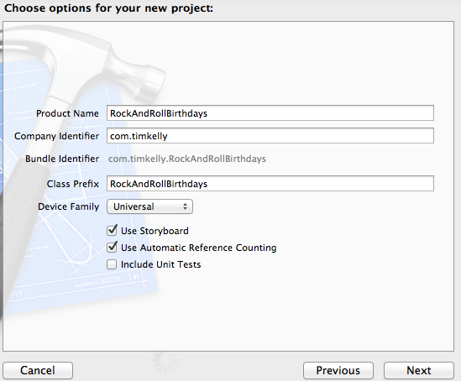

- Add some starter files to the project.
- From the git repo find /iOS/demos/coreDataDemoStarterFiles and copy all those files to your project:
- CoreDataTableViewController.h|m – A Core Data table view controller that came from the Stanford iOS course.
- NSDate+Utils.h|m – Some convenience NSDate category utils to help with calculations.
- rrdb.csv – The foundation for our SQLite DB we will import with Navicat
- Open RockAndRollBirthdaysViewController.h and make it inherit from CoreDataTableViewController and set up the UIManagedDocument for your birthday’s database. Don’t forget to @synthesize the birthdaysDB in the .m file

#import <UIKit/UIKit.h>
#import "CoreDataTableViewController.h"

@interface RockAndRollBirthdaysViewController : CoreDataTableViewController

@property (nonatomic, strong) UIManagedDocument *birthdaysDB;

@end

- Create the Core Data RRDBModel.xcdatamodeld

- Choose File > New File > Core Data > Data Model and call your model RRDBModel.
- Open RRDBModel.xcdatamoldeld and create the following Entities and Attributes:

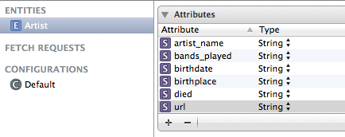

- Create the Artist model by selecting the RRDBModel.xcdatamodeld in the project and choose Editor > Create NSManagedObject subclass...

- Make sure to check the Artist check box in the wizard and save the generated files in your project directory.
- Inspect the new Artist.h|m files in your project.

- Create a new Artist category to handle manipulating the artist.

- Choose File > New > File > Cocoa Touch > Objective-C category with:
    - Category: Extension
    - Category on: Artist

Inspect the new Artist+Extension.h|m files in your project.

- Add two public methods to the Artist+Extension.h file:

@interface Artist (Extension)

+ (Artist *)artistWithName:(NSString *)name bands:(NSArray *)bands birth:(NSDate *)birth birthPlace:(NSString *)place death:(NSDate *)death url:(NSURL *)url inManagedContext:(NSManagedObjectContext *)context;

+ (Artist *)artistWithName:(NSString *)name birth:(NSDate *)birth inManagedContext:(NSManagedObjectContext *)context;

@end

- Add the implementation to the Artist+Extension.m file:

+ (NSString *)stringForDate:(NSDate *)date
{
NSDateFormatter *dateFormatter = [[NSDateFormatter alloc] init];
[dateFormatter setDateStyle:NSDateFormatterLongStyle];
return [dateFormatter stringFromDate:date];
}

+ (Artist *)artistWithName:(NSString *)name bands:(NSArray *)bands birth:(NSDate *)birth birthPlace:(NSString *)place death:(NSDate *)death url:(NSURL *)url inManagedContext:(NSManagedObjectContext *)context
{
Artist *artist = [NSEntityDescription insertNewObjectForEntityForName:@"Artist" inManagedObjectContext:context];
artist.artist_name = [name copy];
artist.bands_played = [bands componentsJoinedByString:@", "];
artist.birthplace = [place copy];
artist.birthdate = [self stringForDate:birth];
artist.died = [self stringForDate:death];
artist.url = [url absoluteString];

return artist;
}

+ (Artist *)artistWithName:(NSString *)name birth:(NSDate *)birth inManagedContext:(NSManagedObjectContext *)context
{
return [self artistWithName:name bands:nil birth:birth birthPlace:nil death:nil url:nil inManagedContext:context];
}

- Build your project. Hopefully you only get some link errors about NSManagedObject. Let’s fix that by selecting the project root in XCode and then Build Phases. Once you add the CoreData.framework your project should build successfully and look like this:

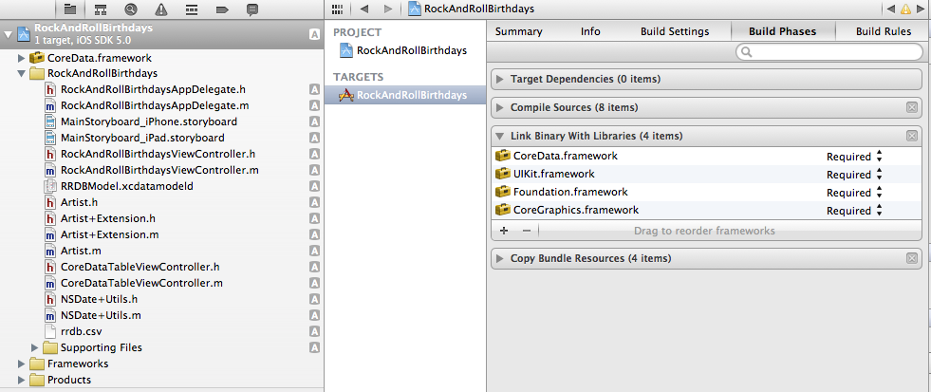

- Open the RockAndRollBirthdaysViewController.m file and synthesize the birthdaysDB UIManagedDocument and override the setter:

- (void)setBirthdaysDB:(UIManagedDocument *)birthdaysDB {
if (_birthdaysDB != birthdaysDB) {
_birthdaysDB = birthdaysDB;
[self useDocument];
}
}

- Set up the fetchedResultsController. This will allow us to fetch the Core Data from a given entity, and sort on an Attribute or supply a predicate for filtering a query.

// Create an NSFetchRequest to get all Artists and hook it up to our table via an NSFetchedResultsController
// (we inherited the code to integrate with NSFRC from CoreDataTableViewController)
- (void)setupFetchedResultsController // attaches an NSFetchRequest to this UITableViewController
{
NSFetchRequest *request = [NSFetchRequest fetchRequestWithEntityName:@"Artist"];
request.sortDescriptors = [NSArray arrayWithObject:[NSSortDescriptor sortDescriptorWithKey:@"artist_name" ascending:YES selector:@selector(localizedCaseInsensitiveCompare:)]];

self.fetchedResultsController = [[NSFetchedResultsController alloc] initWithFetchRequest:request
managedObjectContext:self.birthdaysDB.managedObjectContext
sectionNameKeyPath:nil
cacheName:nil];
}

- Now implement the RockAndRollBirthdaysViewController#useDocument method and we’ll write the empty database and inspect it:

#define FAKE_DATA

- (void)useDocument
{
#ifdef FAKE_DATA
// remove an existing database files
if ([[NSFileManager defaultManager] fileExistsAtPath:[self.birthdaysDB.fileURL path]]) {
NSError *error;
[[NSFileManager defaultManager] removeItemAtURL:self.birthdaysDB.fileURL error:&error];
}
#endif

if (![[NSFileManager defaultManager] fileExistsAtPath:[self.birthdaysDB.fileURL path]]) {
// does not exist on disk, so create it
NSLog(@"ERROR: We didn't find the DB. This should not happen: %@", self.birthdaysDB.fileURL.debugDescription);
[self.birthdaysDB saveToURL:self.birthdaysDB.fileURL forSaveOperation:UIDocumentSaveForCreating completionHandler:^(BOOL success) {
NSError *error = nil;
#ifdef FAKE_DATA
// add some fake data
[Artist artistWithName:@"Jimmy" birth:[NSDate date] inManagedContext:self.birthdaysDB.managedObjectContext];
[Artist artistWithName:@"Homer" birth:[NSDate date] inManagedContext:self.birthdaysDB.managedObjectContext];
[self.birthdaysDB.managedObjectContext save:&error];
#endif

if (!error ) {
[self setupFetchedResultsController];
} else {
NSLog(@"Error saving DB=%@", error);
}
}];
} else if (self.birthdaysDB.documentState == UIDocumentStateClosed) {
// exists on disk, but we need to open it
[self.birthdaysDB openWithCompletionHandler:^(BOOL success) {
[self setupFetchedResultsController];
}];
} else if (self.birthdaysDB.documentState == UIDocumentStateNormal) {
// already open and ready to use
[self setupFetchedResultsController];
}
}

- Write the data to the table view by implementing cellForRowAtIndexPath.

#pragma mark UITableViewCell

- (UITableViewCell *)tableView:(UITableView *)tableView cellForRowAtIndexPath:(NSIndexPath *)indexPath
{
static NSString *CellIdentifier = @"Birthday Cell";

UITableViewCell *cell = [tableView dequeueReusableCellWithIdentifier:CellIdentifier];
if (cell == nil) {
cell = [[UITableViewCell alloc] initWithStyle:UITableViewCellStyleDefault reuseIdentifier:CellIdentifier];
}

// ask NSFetchedResultsController for the NSMO at the row in question
Artist *artist = [self.fetchedResultsController objectAtIndexPath:indexPath];

// Then configure the cell using it ...
cell.textLabel.text = artist.artist_name;
cell.detailTextLabel.text = artist.bands_played;

return cell;
}

- Fix your viewDidLoad method to look like this:

- (void)viewDidLoad
{
[super viewDidLoad];
// Do any additional setup after loading the view, typically from a nib.

if (!self.birthdaysDB){
NSURL *url = [[[NSFileManager defaultManager] URLsForDirectory:NSDocumentDirectory inDomains:NSUserDomainMask] lastObject];
url = [url URLByAppendingPathComponent:@"rrdb.sqlite"];
// url is now "<Documents Directory>/rrdb.sqlite"
self.birthdaysDB = [[UIManagedDocument alloc] initWithFileURL:url]; // setter will create this for us on disk
}

}

- Fix the user interface by opening MainStoryboard_iPhone.storyboard

- Delete the existing view on the storyboard.
- In the Object Inspector, drag out a new Table View Controller. This will automatically become the default view and have a table view set up.
- Now you need to set some properties for the view controller:
  - Custom class: RockAndRollBirthdaysViewController
- Properties for the Table View Cell:
  - Style: Subtitle
  - Identifier: Birthday Cell

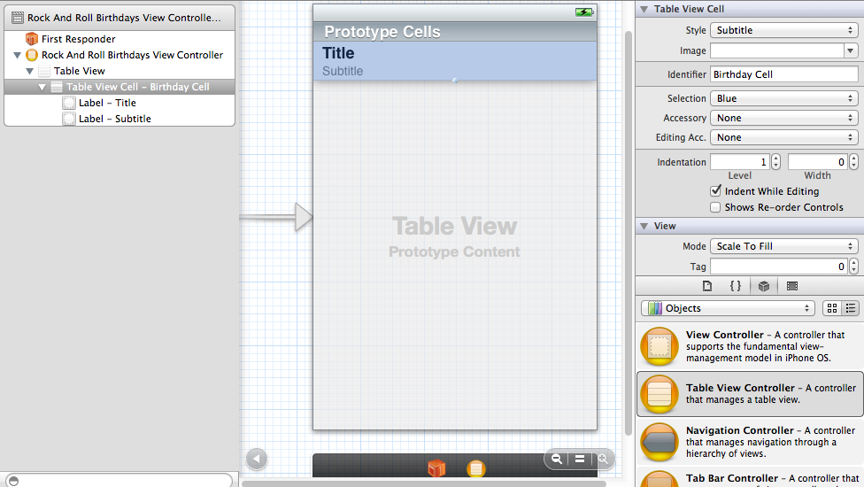

- Build and run the application and you should see our fake data in the emulator.

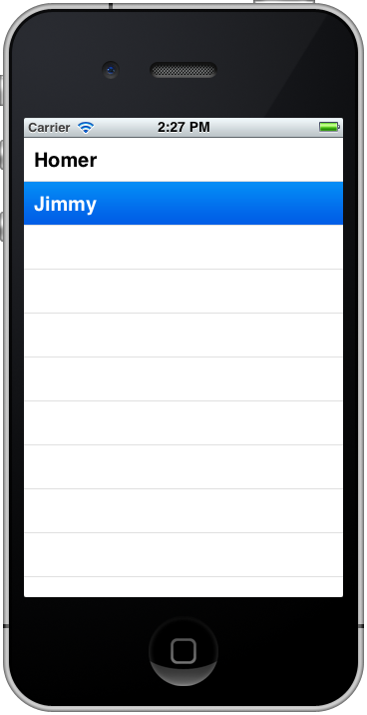

- Check the log and find out where the persistentStore database was written. You should see something like this:

file://localhost/Users/timothy.c.kelly/Library/Application%20Support/iPhone%20Simulator/5.0/Applications/44707445-9223-400B-A14E-F19D17BB033E/Documents/rrdb.sqlite/

- Open your Finder and location the persistentStore and copy it to your home directory.
- Launch Navicat and inspect the database table.

- Choose Window > Navicat for SQLite.
- Click the Connection icon.
- In the Database File Field, choose the persistentStore you saved off.

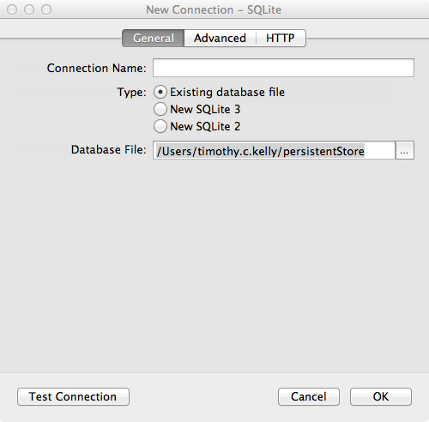

- Choose OK and you can now view the database inspected and some of the minimum requirements for Core Data to access an SQLite database.
