Core Data Demo for iOS Training

Summary: In this exercise we will import our csv data into the SQLite database we created in the previous exercise. Then we will hook up the copy of the database to the Documents directory and requesting the Core Data and adding a predicate for filtering data on the current date.

You can start with the project found under iOS/demos/coreDataDemoPart2Complete.

Exercise 2: Creating a prepopulated SQLite Database for iOS

- Rename the persistentStore (in the Finder) and call it rrdb.
- Open the rrdb database with Navicat by creating a new connection to the existing database.
- Rename the ZARTIST table to ZARTIST_ORIG. We will import a new table with the .csv data.
- Right click on Tables in the ZARTIST hierarchy and choose Import Wizard

- Select the following values form each wizard page:
  - Choose Data Format: CSV File (*.csv)
  - Paths and encoding:
    - Import From: rrdb.csv
    - Encoding: Unicode (UTF-8)
  - Format Options (take the defaults)
  - Additional Options (take the defaults)
  - Tables Mapping (take the defaults)
  - Fields Mapping. Create these target fields (in order)
    - Z_PK (integer)
    - Z_ENT (integer)
    - Z_OPT (integer)
    - ZBIRTHPLACE (text)
    - ZDIED (text)
    - _id (text) – This is for Android
    - ZARTIST_NAME (text)
    - ZBIRTHDATE (text)
    - ZBANDS_PLAYED (text)
    - ZURL (text)
  - Mode (take the default)
  - Import – Click Start, then Close when it’s finished.

- Back in the Navicat for SQLite window, refresh the database and open the rrbd table that was created.
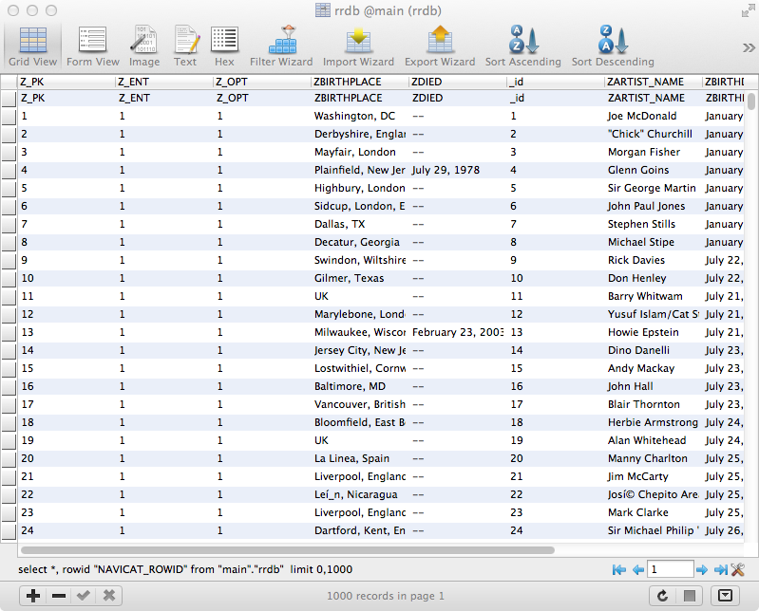

- In the rrdb table that you just opened, delete the first row (you can see the column labels are duplicated). You can context-click on the row and select Delete. Close the table.

- Rename the rrbd table with the newly imported .csv files and name it ZARTIST.

- From the Finder, now drag and drop the rrdb file into your project.

- Open the RockAndRollBirthdaysViewController.m file and comment out the macro to include the dummy data test:

//#define FAKE_DATA

- Now we will set up the code to write the real database to the proper persistentStore. Open up RockAndRollBirthdaysAppDelegate.m and add the following macros:

@implementation RockAndRollBirthdaysAppDelegate

#define DB_NAME @"persistentStore"
#define DB_RESOURCE_NAME @"rrdb"
#define DB_PACKAGE @"rrdb.sqlite/StoreContent"

- Now we need to create and access to the database. Still in the RockAndRollBirthdaysAppDelegate.m

@interface RockAndRollBirthdaysAppDelegate()

- (void) createAndCheckDatabase;

@property (strong, nonatomic) NSString *dbPath;

@end

- Make sure to synthesize the dbPath property.
- Add the method to actually check if the DB exists and copy it to the correct persistent store:

- (void) createAndCheckDatabase {
BOOL success;

NSFileManager *fileManager = [NSFileManager defaultManager];
success = [fileManager fileExistsAtPath:self.dbPath];
if (success) {
return;
}

NSString *databasePathFromApp = [[[NSBundle mainBundle] resourcePath] stringByAppendingPathComponent:DB_RESOURCE_NAME];

NSError *error;
NSString *folder = [self.documentsDir stringByAppendingPathComponent:DB_PACKAGE];
[fileManager createDirectoryAtPath:folder withIntermediateDirectories:YES attributes:nil error:&error];
[fileManager copyItemAtPath:databasePathFromApp toPath:self.dbPath error:&error];
if (error) {
NSLog(@"Error copying file=%@", error);
}

}

- Add a helper method (still in RockAndRollBirthdaysAppDelegate.m) to get the documents directory:

- (NSString *)documentsDir
{
NSArray *documentPaths = NSSearchPathForDirectoriesInDomains(NSDocumentDirectory, NSUserDomainMask, YES);
return [documentPaths lastObject];
}

- Now we can copy the database to the correct location. Add this code to the didFinishLaunchingWithOptions method.

- (BOOL)application:(UIApplication *)application didFinishLaunchingWithOptions:(NSDictionary *)launchOptions
{
// Override point for customization after application launch.
NSString *documentDir = self.documentsDir;

self.dbPath = [[documentDir stringByAppendingPathComponent:DB_PACKAGE] stringByAppendingPathComponent:DB_NAME];

[self createAndCheckDatabase];

return YES;
}

- Run the simulator and you should see the full list of Artists in the Table View.

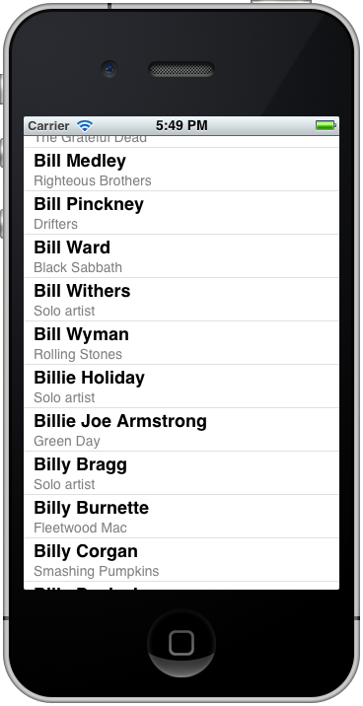

- Now let’s filter the data with a predicate so we only see the artists for the current date. Open up the RockAndRollBirthdaysViewControllerm file and insert this code just before the call to initWithFetchRequrest:

// Add predicate based on the current day and Month
NSString *dateExp = [self.selectedDate convertDateToExcel_m_ddd];
self.title = dateExp;
dateExp = [dateExp stringByAppendingString:@"*"]; // add wildcard
request.predicate = [NSPredicate predicateWithFormat:@"birthdate like %@", dateExp];

- Now we have a method above called convertDateToExcel_m_ddd to deal with some Y2K bug in our database so we need to import the NSDate+Utils category so we can do some manipulation on the date object.

#import "NSDate+Utils.h"

- Now we’ll get a syntax error so we’ll create the NSDate properly to track the currently selected date. Create a private member in the RockAndRollBirthdaysViewController.m file.

@interface RockAndRollBirthdaysViewController ()

@property (nonatomic, strong) NSDate *selectedDate;

@end

- Again, don’t forget to synthesize the property you just added, selectedDate.

- Now we need to make sure that the NSDate we will base our predicate on is set when the view loads. In viewDidLoad, add this line of code:

self.selectedDate = [NSDate date];

- Run the simulator and see the filtered results for the selected date.

