**Arts Walk Mobile App Maintenance Guide**

This guide is intended to explain how to maintain the Arts Walk mobile app.

The Arts Walk application is a series of .html files that support viewing on mobile devices. These pages use the jQuery mobile framework to provide the overall look and feel of the application.

**Managing the data on ArcGIS Online**

All of the data for the Arts Walk application is stored and managed in the cloud. The data is hosted on the City of Olympia’s ArcGIS Online subscription. There are three pieces of data that are needed for the application. The first of these has the locations of the businesses. It should have the fields: ID, Business, Address, Artist, City, and State. The addresses can then be geocoded in ArcGIS Desktop. The second dataset includes the list of artists that are performing or have art on display. The artist table has the fields: ID, and Artist. The last table contains the events that are occurring during Arts Walk. The event table has the fields: Day, Time, Event, ID, and Sort (the order you wish the events to be listed in). The two tables are then related to the businesses with a relate operation in ArcGIS Desktop before being published to ArcGIS Online as a feature service. Once the data has been published, the related tables will not be editable unless a query (post) operation is used. The businesses can be edited using the editing tools on ArcGIS Online.

**Editing Metadata**

Maintaining proper metadata is important so that the data remains usable and accessible to a larger audience. This data will most likely go unchanged for long periods of time, but it may be necessary to modify it at some point. To edit the metadata, begin by clicking the “Edit” button located in the toolbar below the thumbnail image, exposing the text fields for editing.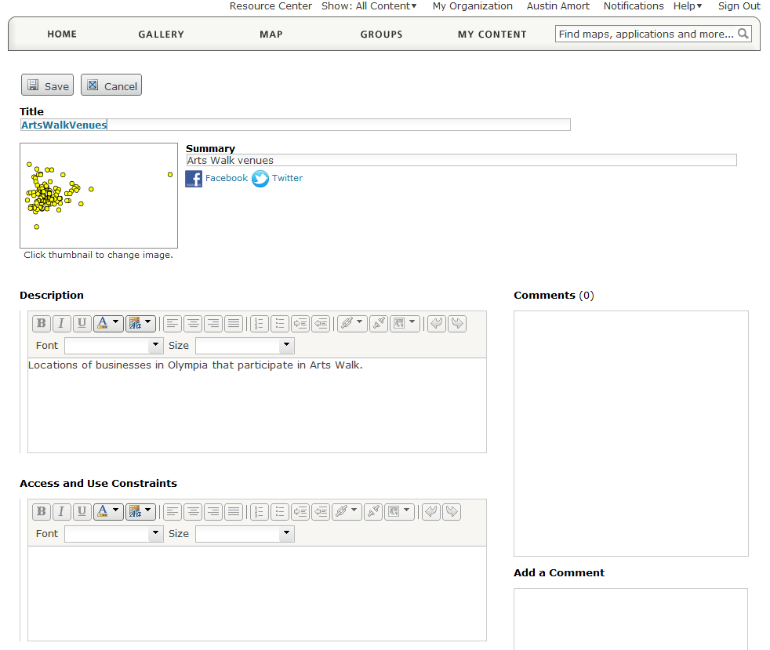

**Editing Feature Data**

To edit the features and their data, open the feature service using the ArcGIS Online map viewer. Click the “Edit” button in the toolbar above the map view. A new panel will open on the left side of the screen titled “Add Features”. If you wish to add new features to the data, click on the appropriate icon for the layer you wish to edit. You can now place new points by clicking on the map. When you add a new point to the map, you will be prompted to enter data in the pop-up that appears.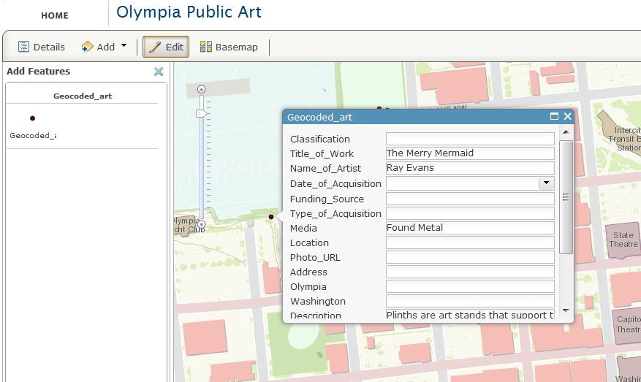 To edit existing data, click on an existing feature in the map instead of using the “Add Features” panel. This will open a pop-up displaying the attributes for that point. If multiple points exist at that location, there will be two sideways arrows at the top of the pop-up that enable you to cycle through the features. When you are finished editing, click the “Edit” button again and your edits will be saved automatically.

**Working with jQuery Mobile**

jQuery Mobile automatically styles all hyperlinks on a page to appear as large clickable buttons and provides a header and footer for all pages. jQuery uses Ajax to load new pages. Ajax is designed to provide a faster, more responsive user experience that feels akin to a native application. Because the Arts Walk app uses a great deal of Javascript and dynamic content, Ajax has to be disabled most of the time because it has a tendency to cause the Javascript to load incorrectly. This is done by adding data-ajax=”false” or rel=external to an anchor tag. You can disable Ajax for an entire page with $.mobile.ajaxEnabled=false. You can insert dynamic content into div tags using jQuery by using the following line.

$(“#divname”).append(‘content to add’)

Since jQuery is not very supportive of dynamic content, the dynamic content that is loaded into the page needs to be styled manually. This is done by adding .trigger(‘create) and the end of the line where you add content. $(“#divname”).append(‘new content’).trigger(‘create’).

Div tags have additional attributes because of jQuery. These attributes often begin with “data-“ and determine how the contents of the div tag are styled.

The full jQuery Mobile documentation can be found here: <http://jquerymobile.com/demos/1.1.1/>

**Working with the ArcGIS API**

The ArcGIS API is used for interacting with the data on ArcGIS Online, as well as supplying certain elements of the Dojo framework. You can find the documentation for it here: <http://help.arcgis.com/en/webapi/javascript/arcgis/> On most of the application pages, the ArcGIS API is used to query data from a feature service on ArcGIS Online. This is a two part process, building the query filter (the query parameters) and executing the query task.

var queryTask = new esri.tasks.QueryTask(“rest endpoint here”);

var query = new esri.tasks.Query();

query.returnGeometry = false;

query.outFields = [“Day, Time, Event”];

query.orderByFields = [“Sort”];

query.where = “1 = 1”;

queryTask.execute(query, receivingFunction);

In this example, receivingFunction gets the results of the query passed into it as a parameter.

The other main use of the API is to draw maps. This is done by creating a new map object and adding additional layers to it.

var map = new esri.Map(“map”);

var layer = new esri.layers.FeatureLayer(“rest endpoint”, {

“id”: ‘newLayer’,

Mode: esri.layers.FeatureLayer.MODE_SNAPSHOT

});

map.addLayer(layer);

**Customizing the look and feel**

The style sheet was generated by using the jQuery Mobile ThemeRoller: <http://jquerymobile.com/themeroller/index.php>. This tool is an easy way to rapidly modify the style sheet, especially if you are not familiar with .css files.

Additional comments have been included in the code that explains how certain parts of the program work.