**Steps to free up space (get rid of .git files) in a repository**

1. Note doing this will also involve steps (**How to delete an existing Repository on github)** and (**How to create a new Repository on github and clone it on Computer)** later in the process. Those steps are listed in detail in this document later.
2. Before we begin – you can use “**du -ks**” (if you want a short version) or “**du -k**” in the directory (repository) that you want to reduce the size of on github. For “historical” this is what it shows today:

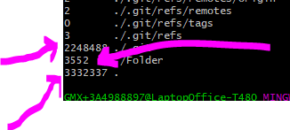

That means that “historical” is using 3.3 GB of space, and out of which ./.git is using around 2.2 GB and so the actual files may be using around 1.1 GB of data. That means if we clean this repository up, then we should be able to free up considerable space on github. (Of course, you can get the space information from Windows Explorer as well).

1. I will use the repository “historical” as an example here, but it can be done for any other repository (“Charts”, “Latest_Charts” and “pyhon”, though doing some of them would be more complicated as they have sub-directories under them, but the general flow should be similar). The sub-steps here would be to:
   1. Rename (move) that directory on the local clone (windows computer). Say move historical to historical_old. This _old directory will be used later to get the files that you want to populate the NEW and EMPLY created repository (with the same name – historical, in our case). So make sure that you do not do anything with _old unless everything is done and sanity checked. Otherwise you would have to go to the backup from the cloud to get the files and that can be messy and time consuming…
   2. delete that repository on github
   3. create (NEW) repository on github with the same name
   4. clone that newly created (empty!!!) repository on local computer and then
   5. be able to just move the files that you want the git to be populated with to the freshly created (NEW) repository clone directory, from the _old (or whatever you named it in step a.)
   6. If you now feel safe, then you can remove the _old directory that you created on local computer, to free up local space
2. So – first step – rename the “historical” directory to “historical_old”. Again – this can be done from either Windows Explorer or command line on Git bash – your choice. I will do it from Git bash this time around.   
   

Make sure that historical_old has all the historical file before moving to the next step – yes, I am being paranoid, but better safe than sorry  
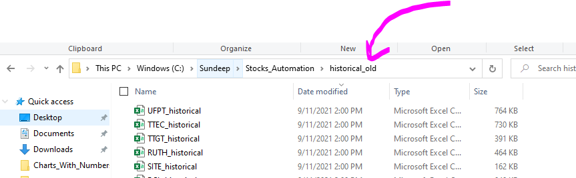

1. Now – lets delete the repository on github (steps below). You should go a read that section – then the steps that I am listing below will make more sense.

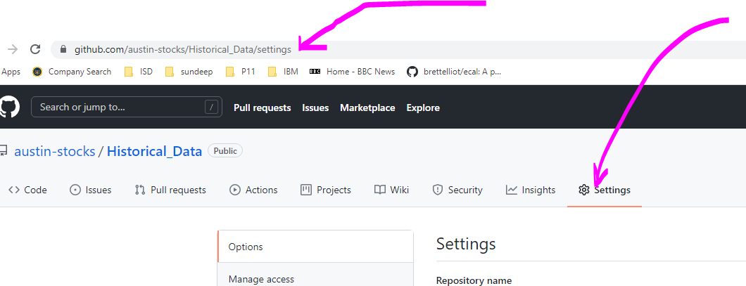

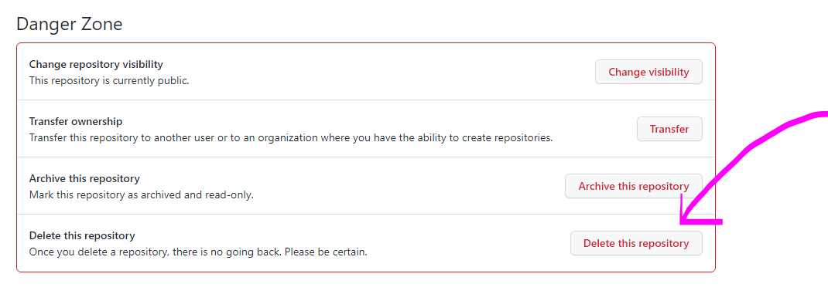

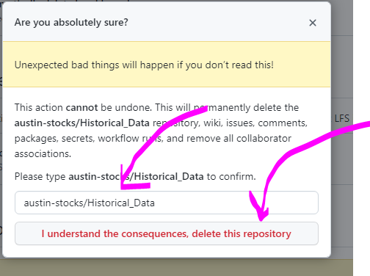

1. Now that repository is gone from austin-stocks  
     
   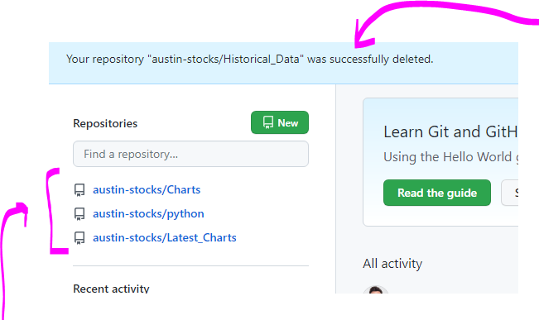
2. Now create a new / fresh repository with the same name (the steps are listed in the document below). Probably better to read those steps first, so that the subsequent steps here make more sense.



1. Creating a new repository  
     
     
   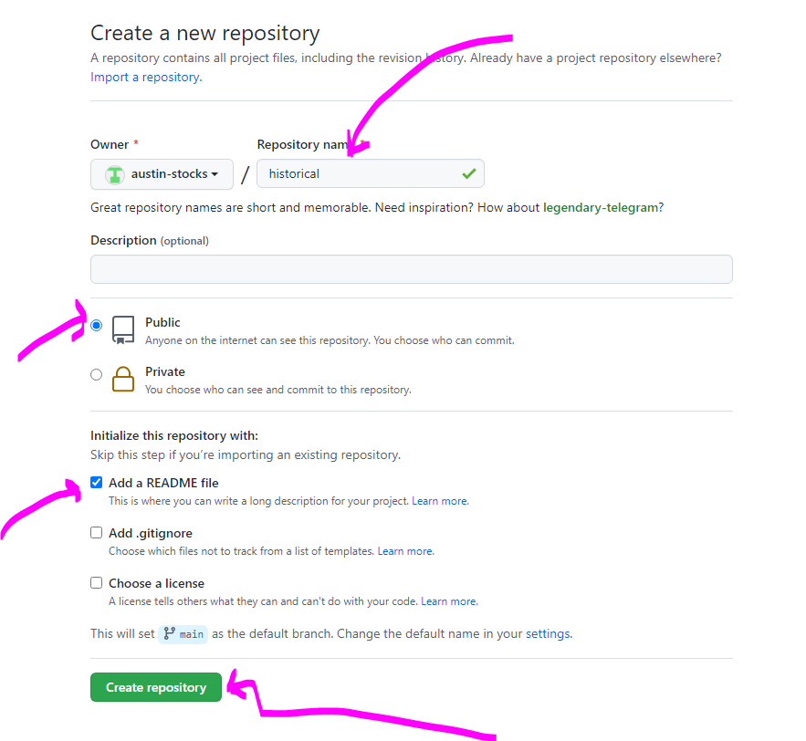
2. Repository created – now cloning that on the local computer   
     
   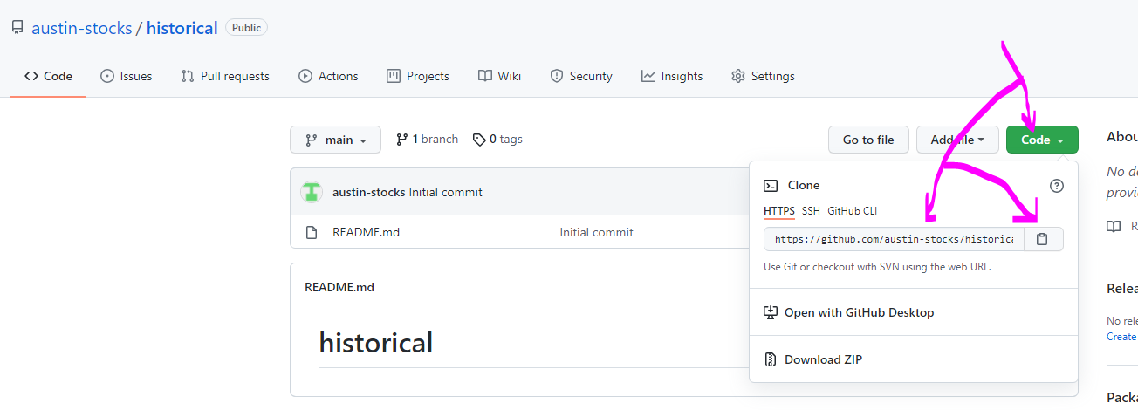

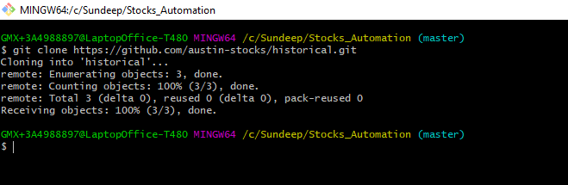

1. Now that the repository is cloned – copy/move the files from _old to the new directory and git adding and git committing and git pushing them and viloa we are done 😊  
     
   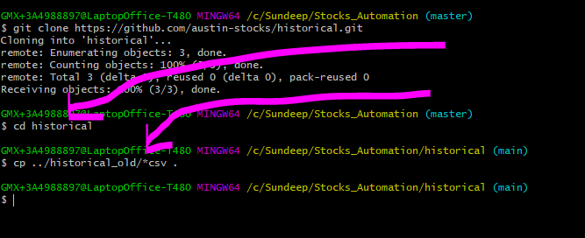

Note that I used cp here – and that can be done with windows explorer too…I could have used mv instead, but just being paranoid here to make sure that everything is still available on local computer, in case something messes up.

1. Now git add and git commit and git push  
     
   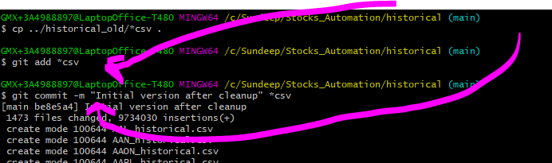

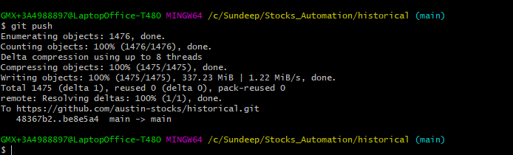

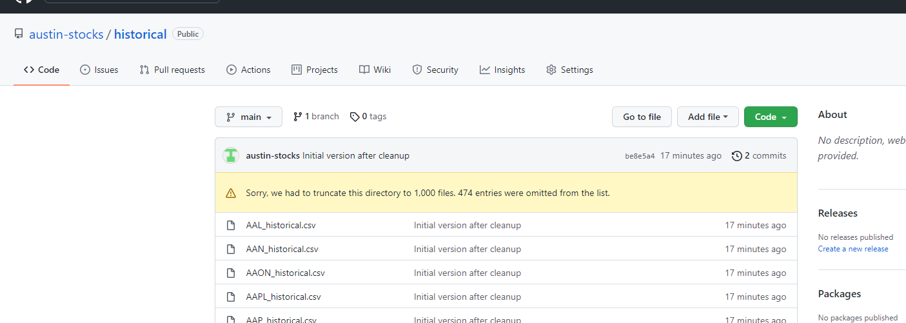

1. At this point, I would run a python script to make sure that things are working fine (in this case to make chart that reads historical, or creates a historical…I verified it and so now – I can delete historical_old directory but now before I find out how much space did I cleanup on github

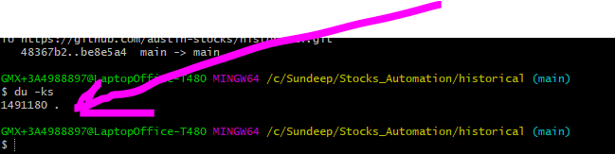

So – it seems we cleaned up around 1.5 GB of space on github….not bad.

**How to delete an existing Repository on github**

1. We are now going to delete the repository that we just created. Note : You can delete the directory on your computer and that will get rid of the the local version of the clone and that Iis all that you need to do on the local computer.
2. On the repository page, click on “**Settings”**

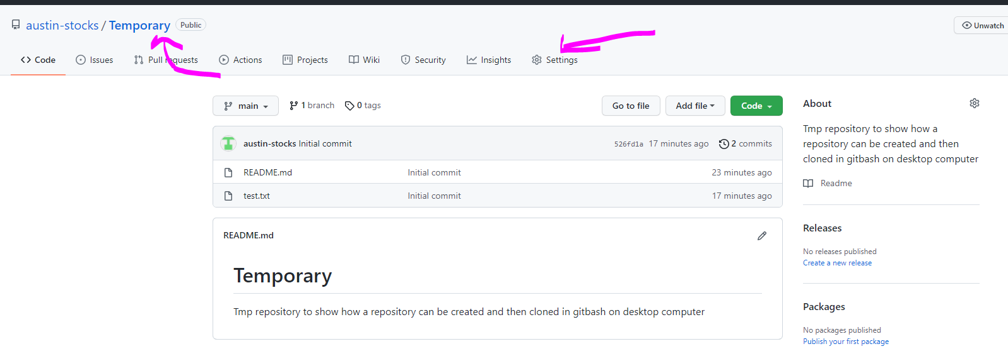

1. This will take you the setting page 😊, go all the way down in the “Danger Zone”. There we have the option to “**Delete this repository**”

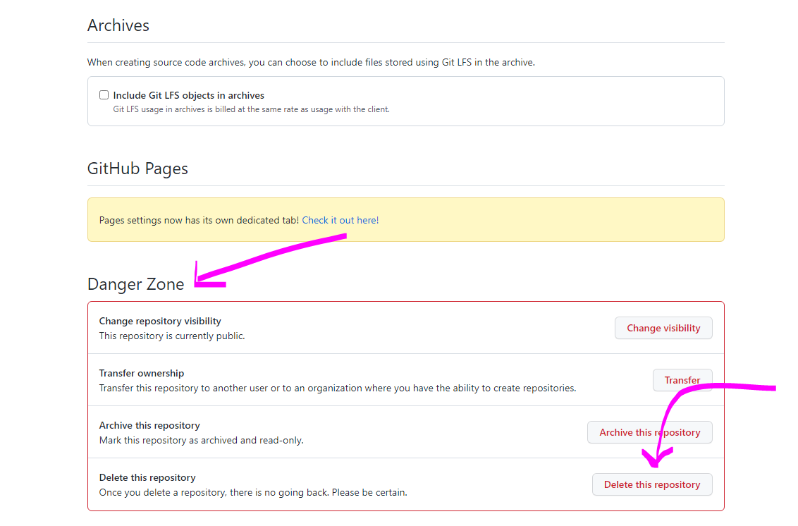

1. Since this is a pretty dangerous step (un-recoverable), so github will confirm once more

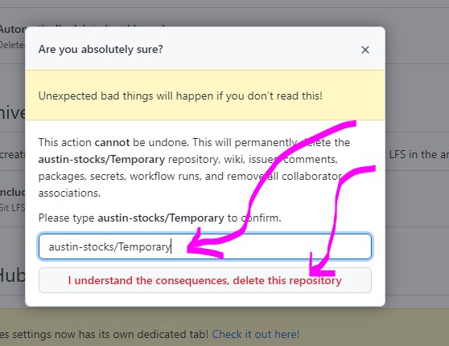

1. So, if you are really sure, then click “**I understand the consequences, delete this repository**” button and the repository will get deleted. Now we can go the the main page of austin-stocks and see that “Temporary” repository does not exist  
     
   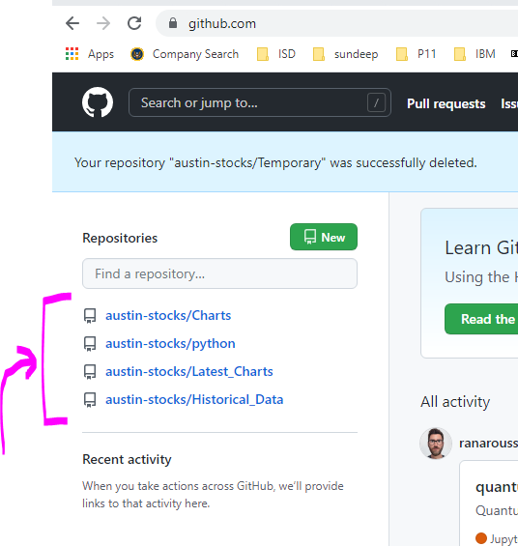
2. You can now delete “Temporary” directory on your local computer and that should be the end of any remnants of the that repository anywhere. Git bash not able to clone the repository shows that it is gone  
     
   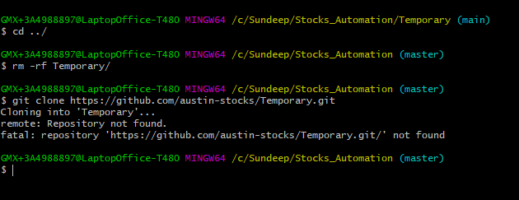

**How to create a new Repository on github and clone it on Computer**

1. To create a new repository on github, go the page where it lists the repositories for austin-stocks

<https://github.com/austin-stocks?tab=repositories>

Then click on “**New**“

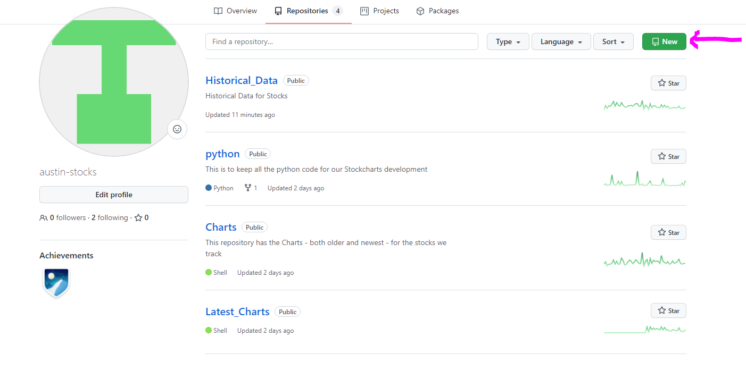

1. This takes to the window, where a new repository can be created. Fill in the name of the repository (This will be the name of the directory that will be the default name of the cloned directory on computer, so choose that with care) and Click on “Add a README file”, though it is probably not needed. If you want to fill something in the “Description”, then you can do so. Then click on “**Create Repository**”.

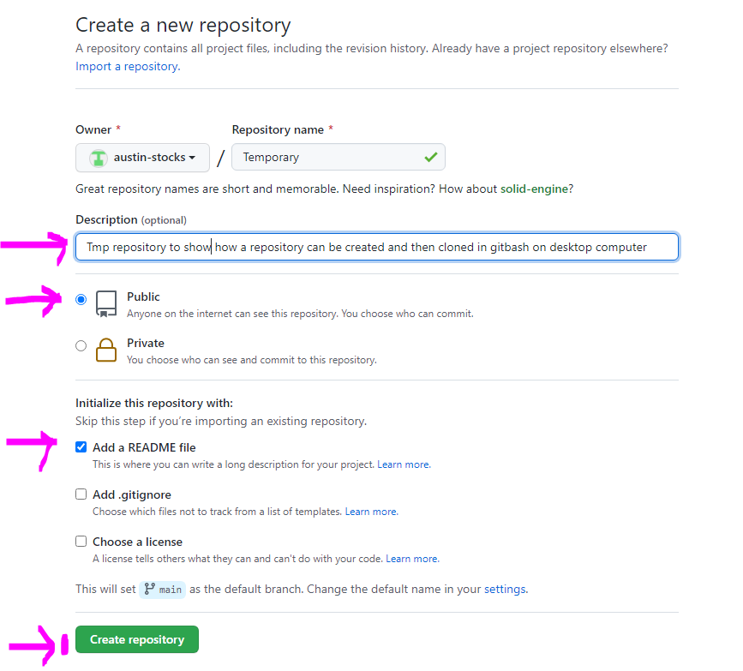

1. Once you click the repository button, the repository is created and we come to this window. Here click on the green “**Code**” button, it will give a HTTPS link to clone the repository. I think that the link can also be found by click the “gear wheel” on the right side of the “About” the repository. I did not try that, but that should work too.

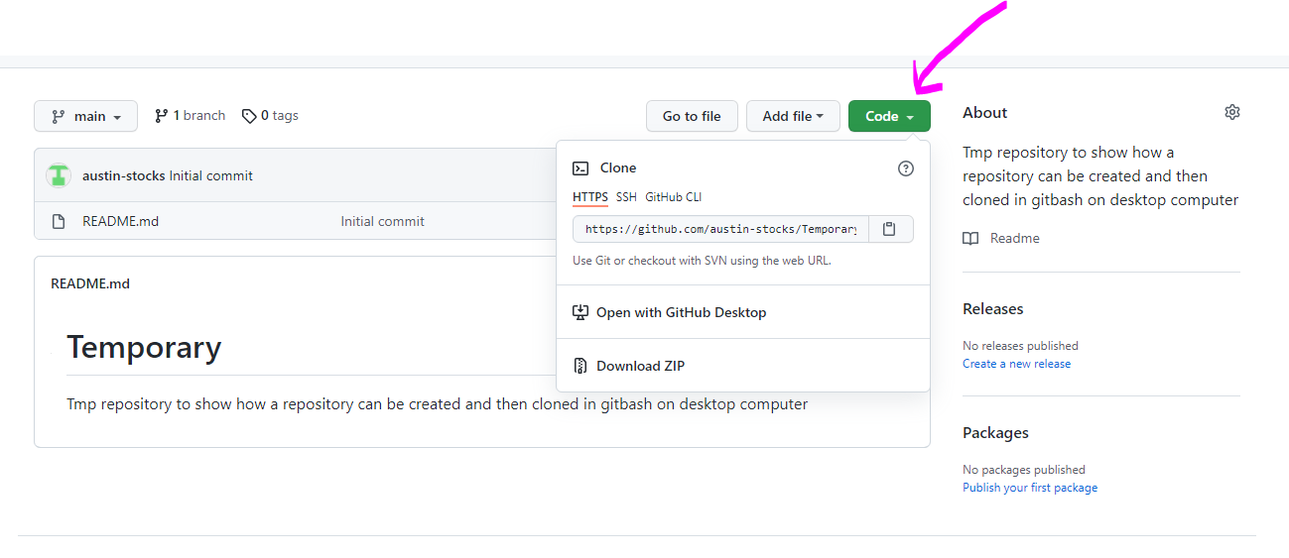

1. Now we can use that HTTPS link to clone the repository using Git bash on windows (need to make sure that we are logged in as austin-stocks (how??? – maybe later try to figure it out)) in Git bash on that computer. The link can be copied by clicking

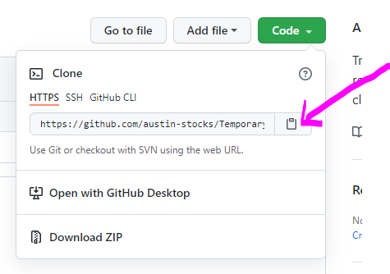

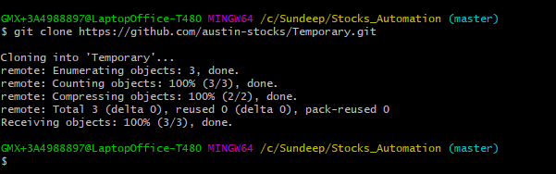

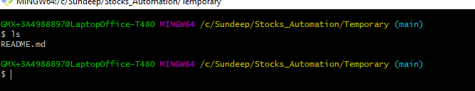

1. Now you can add files to the repository and they will appear on github

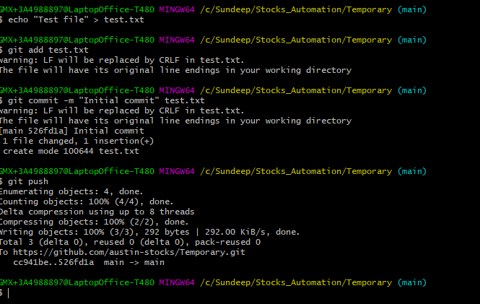

1. The file test.txt now appears on github…we are in business **voila 😊**

