**Backing Up User Files for AAII Investor Pro**

The backup directory for AAII Investor Pro User files is :

**C:\Sundeep\Stocks_Automation\User_Files\AAII_Investor_Pro_Backup**

1. The stock Investor Pro files need to be backed up, when you add some Custom field, or a new screen or view or portfolio etc.
2. Open up Stock Investor Pro Utilities by double clicking on the icon on your desktop or by selecting it from the Start menu.
3. Make sure the main Stock Investor Pro program is closed.
4. A new Stock Investor Utilities window will appear. Select Back Up User Files from this window and click on Back Up at the bottom.
5. A new window will appear prompting you to select a backup directory. Click on the icon with the three dots on the right side of this window to browse to and select the directory (folder) that you want to backup the files into.
6. Finally, click OK to back up your user files. You will be prompted when the backup is successfully completed.
7. Go to the backup directory to make sure that the dates on them have changed.
8. Do **NOT forget** to git commit those files

**Restoring User Files**

**[Select the Directory](https://www.aaii.com/files/images/articles/9212-Figure-4.jpg)**

[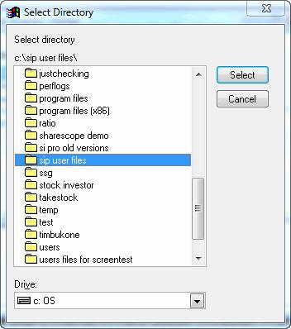](https://www.aaii.com/files/images/articles/9212-Figure-4.jpg)

To restore your user files onto your computer or to import them on a different computer, first make sure Stock Investor Pro Utilities is loaded on the system. After opening the utilities program, highlight [Restore User Files](https://www.aaii.com/stock-investor-pro/article/Backing-Up-and-Restoring-Custom-User-Files#Figure-5) and then click on Restore at the bottom of the window. Just as with backing up user files, the next window asks you to select the folder the user files are located in. If restoring files onto the same system, navigate to the folder you created.

If importing onto a new system, navigate to the folder on your removable disk drive. After you click on Select, Stock Investor Pro Utilities will notify you that a full set of user files were found and ask you to confirm whether you want to restore these files. If no user files were found, make sure to confirm that you backed up the files and selected the correct folder.

It is important to keep in mind that if you restore a set of user files, it will write over any custom user files that you already had on your current version of Stock Investor Pro. You cannot add additional custom user files onto a system.

**[Restore User Files](https://www.aaii.com/files/images/articles/9212-Figure-5.jpg)**

[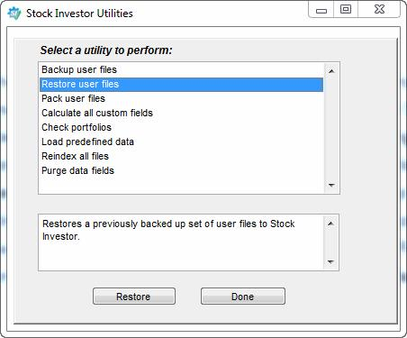](https://www.aaii.com/files/images/articles/9212-Figure-5.jpg)