**Remove Both Duplicate Rows In Excel With Helper Column**

In Excel, you can create a formula in a helper column, and then filter by this new column to filter all the duplicate values and delete them at once. Please do with following steps:

**1**. Enter this formula: **=IF(COUNTIF($A$1:$A$14,A1)=1,0,1)** into a blank cell besides your data, B1 for example, and then press **Enter** key.

**Note:** in the formula, ***$A$1:$A$14***is the original data range you want to remove the duplicates, and ***A1*** is the first cell in your data range. You can change them to your need.

**2**. Then select cell B1, and drag the fill handle down to the cells that you want to contain this formula, and you can see all the duplicate cells are displayed as the number 1, and unique cells are displayed as the number 0, see screenshot:

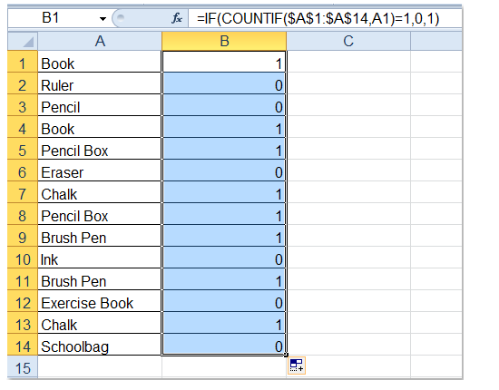

**3**. And then click **Data** > **Filter**, and a drop down list button appears in cell B1, see screenshot:

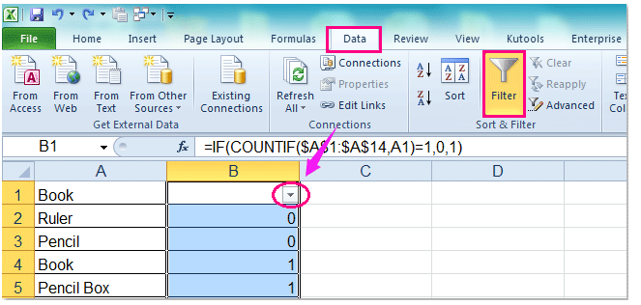

**4**. Then click the drop down list button and only check the **number 1** under the **Select All** option, see screenshot:

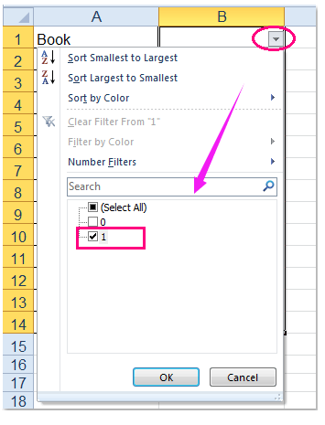

**5**. And all the duplicate values are filtered out, see screenshot:

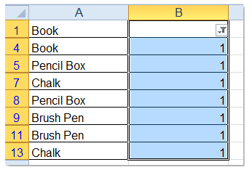

**6.** (1.)If you want to remove the values, you can just press the **Delete** key to remove all of them, and only leave the unique values as following screenshot shown:

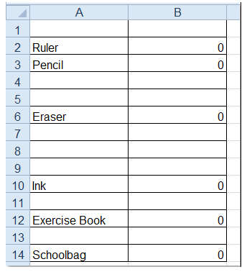

(2.) If you want to remove the entire duplicate rows, select the visible entire rows, and choose **Delete Row** from the right clicking menu, and only the unique rows are kept. See screenshots:

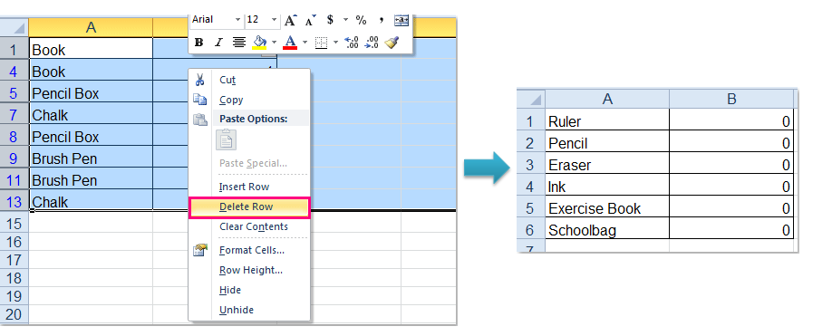

**7**. After removing the duplicate records, you can delete the contents in column B as you need.