**INDEX**

|  |  |  |
| --- | --- | --- |
| **SR.NO** | **CONTENT** | **PAGE NO.** |
| 1 | Title |  |
| 2 | Aim |  |
| 3 | Problem statement |  |
| 4 | introduction |  |
| 5 | Program Discription |  |
| 6 | Algorithm |  |
| 7 | C++ Source Code |  |
| 8 | Sample Output |  |
| 9 | Further Enhancement |  |
| 10 | Acknowledgement |  |
| 11 | Reference |  |

**PROBLEM STATEMENT**

Write a menu driven C++ program to declare a class theatre containing the following functions:-

Declare the variables as per required.

A **constructor** to initialize the data members

**void initialize () -** Function to initialize the 2-Dimentional array to zeroes.

**void displayseats() -** To display the theatre in a proper format along with the required information.

**void bookit() –** to input seat details and make changes in the array for booking a single seat and displaying the bill. Also updating the necessary data members.

**void megabook() -** to input details of the seats for booking multiple seats and make changes in the array along with displaying bill. Also updating the necessary data members.

**void sales() -** to calculate the total and display it along with number of tickets sold. The function must be protected by a pin or password.

**void cancelseat() -** to display the array and to cancel a single seat by accepting the seat details and updating the array along with the total. Also display the cashback for cancelled seat.

**The rates for the seats should be as follows :**

|  |  |  |
| --- | --- | --- |
| *Row Numbers* | *Section tag* | *Rates* |
| Row-1 to Row-3 | Royale seats | Rs. 250 |
| Row-4 to Row-6 | Gold seats | Rs. 200 |
| Row-7 to Row-9 | Silver seats | Rs. 150 |

**PROGRAM DESCRIPTION**

The following is a menu driven C++ program using Object Oriented Programming (OOPs).

**Class theatre :** To declare all the data members and member functions require for

1. storing the 2-Dimentional array
2. updating the 2-Dimentional array
3. storing Movie name
4. Storing column number and row number of the seat to be booked.
5. Storing Number of tickets booked in particular section.
6. Storing the total amount or profit earned
7. Storing admin pin

**Variables Declared in the class theatre:**

***A[100][100] :-*** To store integer values (zeroes in this case) and update it as required.

***rown :-*** To take input of the row number of the seat to be booked.

***coln :-*** To take input of the column number of the seat to be booked.

***RC :-*** To keep count of Number of Royale seats Booked.

***GC :-*** To keep count of Number of Gold seats Booked.

***SC :-*** To keep count of Number of Silver seats Booked.

***MC:-*** To keep count of Number of Mega-Book seats Booked.

***Apin :-*** To initialize the pincode for the Admin or user of the program and to show total sales for the correct pin.

***Total :-*** To store the total amount or cash earned including all section tickets (Royale , gold , silver).

***Bill :-*** To store the total amount of the recently buyed tickets and use it for displaying bill.

***mname[20] :-*** String to store the movie name of the tickets to be booked and use it for displaying theatre and in bill.

**Member Functions used in class Theatre :**

**Theatre()** :- Constructor to initialize RC,GC,SC,MC to zero.

void initialize() :- Function to initialize A[100][100] to an array of zeroes.

void displayseats() :- declares and initializes 2 variables B and C which are used in Displaying the Cinema hall properly. Contains statements which gives the user all the information needed to book the seat along with the prices making the program user friendly.

**void bookit() :-** Function displays the format in which user should enter the input and takes the input. It checks for valid input given by the user and also increases the counter for the respective section (RC/GC/LC) . Finally if the seat position is valid, it modifies the array i.e changes the “0” from the 2-Dimentional array to “1” and Displays the Bill in proper format along with the seat number, movie name, Number of tickets booked , and the total amount to be paid.

**void megabook() :-** declares 2 variables namely “start” and “end”. Used to book more than one number of tickets . First it takes input of the row number in which multiple tickets are to be booked , further it takes the input of the start column and the end column of the selected row and stores it in start and end respectively. It checks for the valid input of the user and also checks if there is a booked seat in the multiple selected seats and displays a proper error message. Further it initializes MC by the total number of seats selected . updates the total amount , and finally displays the bill which includes number of tickets booked, movie name , seat numbers , and the total amount of all the selected seats.

**void sales() :-** it calculates the grand total of all the tickets booked in one execution. It displays Number of royale seats booked, number of Gold seats booked, number of silver seats booked and the total cash earned. To access this information you need to provide the admin pin or else it displays a proper error and takes the user back to the menu.

**void cancelseat() :-** Function displays the current status of the cinema hall i.e the modified 2-Dimentional array . the boked seats are represented by “1” and available seats by “0”. Some phrases like “we serve free cancelations” in the sense of marketing point of view. Inputs the row number and column number of the seat to be cancelled and changes the booked seat back to zero. It also displays the cashback of the cancelled seat respectively. If the selected seat is 0 i.e unbooked then a proper error message is displayed.

**What’s in the main?**

Void main contains the statements of the welcome window of the output i.e all rights reserved and the statement for input of name of the movie.

It also contains the do-while code for the menu to be displayed and functions specified for each case respectively. An object of class theatre is declared to call the functions of the class using the object in the switch statement.

Algorithm

Step 1: Start

Step 2: Declare class theatre

Step 3: Declare class data members

Step 4: . declare constructor to initialize variables.

Step 5:add member functions : initialize(), displayseats() , bookit(), megabook() , sales() , cancelseat().

Step 6: write void main()

Step 7: declare an object of class theatre in main.

Step 8:write the switch statement

Step 9: in each cases under switch use function call using objects of the class.

Step 10: write default statement of the switch.

Step 11: close the main.

Step 12: end

**C++ Source code**

#include<iostream.h>

#include<stdio.h>

#include<conio.h>

#include<fstream.h>

class theatre

{

int A[100][200],rown,coln;

int RC,GC,SC,MC;

double Apin;

int total;

int bill;

public:

char mname[20];

theatre()

{

RC=GC=SC=MC=0;

}

void initialize()

{

for(int i=1;i<10;i++)

{

for(int j=1;j<15;j++)

A[i][j]=0;

}

}

void displayseats()

{

clrscr();

int B=1;

char C=1;

theatre T;

T.initialize();

cout<<"\n\t\t\t\tWELCOME TO SLOWMAPPZ CINEMAS";

cout<<endl<<"Row 1,2,3 - Royale (Rs.250) \nRow 4,5,6 - Gold(Rs.200) \nRow 7,8,9 - Silver (Rs.150)";

cout<<endl<<"\nName of the Movie - ";

puts(mname);

cout<<endl<<"\nNote- [1] - Booked seats";

cout<<"\n________________________COLUMN_________________________";

cout<<"\n___1__2__3__4__5__6__7__8__9_10__11_12_13_14___";

for(int i=1;i<10;i++)

{

cout<<endl<<B++<<C<<":";

for(int j=1;j<15;j++)

{

cout<<A[i][j]<<" ";

}

}

cout<<"\n_____________________SCREEN_IS_HERE____________________";

}

void bookit()

{

cout<<"\nEnter the row no. & column no.(Row_SPACE_column):-";

cin>>rown>>coln;

clrscr();

if((rown<1||rown>9)||(coln<1||coln>14))

{

cout<<"\nINVALId INPUT... Please check your input";

return;

}

if(A[rown][coln]==1)

{

cout<<"\n\nSeat is already taken dude!";

return;

}

if(rown==1||rown==2||rown==3)

RC++;

else if(rown==4||rown==5||rown==6)

GC++;

else if(rown==7||rown==8||rown==9)

SC++;

if(A[rown][coln]==0)

{

A[rown][coln]=1;

cout<<"\n\nseat successfully Booked bhai!! ";

cout<<"\n========================\nBill:-\nMovie Name - " <<mname;

cout<<"\nNo. of tickets - 1";

cout<<"\nSeat no- row "<<rown<<" column "<<coln;

if(rown==1||rown==2||rown==3)

bill=250;

else if(rown==4||rown==5||rown==6)

bill=200;

else if(rown==7||rown==8||rown==9)

bill=150;

cout<<"\nTotal = Rs."<<bill<<"\n========================";

}

}

void megabook()

{

int start,end;

cout<<"\n\nEnter the row number of tickets to be booked:";

cin>>rown;

if(rown<1||rown>9)

{

clrscr();

cout<<"\nINVALId INPUT... Please check your input";

}

cout<<"\nEnter the start column and End column:";

cin>>start>>end;

if((start<1||start>14)||(end<1||end>14))

{

clrscr();

cout<<"\nINVALId INPUT... Please check your input";

}

for(int j=start;j<=end;j++)

{

if(A[rown][j]==1)

{

clrscr();

cout<<"\nPlease check the input! Some seats might be already Booked!";

}

}

for(j=start;j<=end;j++)

{

MC++;

A[rown][j]=1;

}

if(rown==1||rown==2||rown==3)

{

RC+=MC;

total+=250*MC;

}

else if(rown==4||rown==5||rown==6)

{

GC+=MC;

total+=200*MC;

}

else if(rown==7||rown==8||rown==9)

{

SC+=MC;

total+=150*MC;

}

clrscr();

cout<<"\nMega-Book Succesfully !!\n\nNo. of Tickets Booked for you are:"<<MC;

cout<<"\n========================\nBill:-\nMovie Name - "<<mname;

cout<<"\nNo. of tickets - "<<MC;

cout<<"\nSeat nos- row "<<rown<<" column "<<start<<"-"<<end;

if(rown==1||rown==2||rown==3)

bill=MC*250;

else if(rown==4||rown==5||rown==6)

bill=MC*200;

else if(rown==7||rown==8||rown==9)

bill=MC*150;

cout<<"\nTotal = Rs."<<bill<<" \n========================";

}

void sales()

{

clrscr();

total=RC*250+GC*200+SC*150;

cout<<"Enter Admin PIN:-";

cin>>Apin;

if(Apin==12345)

{

clrscr();

cout<<"\nShowing sales for Movie - ";

puts(mname);

cout<<"\n\n\nNO. of tickets sold is:-";

cout<<"\nROYALE SEATS :"<<RC;

cout<<"\nGOLD SEATS :"<<GC;

cout<<"\nSILVER SEATS :"<<SC;

cout<<"\ntotal cash earned:-Rs."<<total;

}

else

cout<<"\nIncorrect pin! please try again";

}

void cancelseat()

{

clrscr();

int B=1;

char C=1;

cout<<"\n________________________COLUMN_________________________";

cout<<"\n___1__2__3__4__5__6__7__8__9_10__11_12_13_14___";

for(int i=1;i<10;i++)

{

cout<<endl<<B++<<C<<":";

for(int j=1;j<15;j++)

{

cout<<A[i][j]<<" ";

}

}

cout<<"\n_____________________SCREEN_IS_HERE____________________";

cout<<"\nWe serve free cancelations!!";

cout<<"\n\nEnter seat to be cancelled(Row_SPACE_column):";

cin>>rown>>coln;

clrscr();

if(A[rown][coln]==1)

{

A[rown][coln]=0;

cout<<"\nSeat cancelled sucessfully!";

if(rown==1|rown==2|rown==3)

{

RC--;

cout<<"\nCashback : Rs.250";

}

else if(rown==4|rown==5|rown==6)

{

GC--;

cout<<"\nCashback : Rs.200";

}

else if(rown==7|rown==8|rown==9)

{ SC--;

cout<<"\nCashback : Rs.150";

}

}

else

cout<<"\nOnly Booked seats can be cancelled!";

}

};

void main()

{

clrscr();

theatre a;

int n;

cout<<"\n[ This program is coded by Austin and Raish ] #All rights reserved#";

cout<<"\n\nEnter the Movie name:-";

gets(a.mname);

do

{

cout<<"\n\n\n1.Book my seat\n2.Ticket Cancelation\n3.Check total sales\n4.Mega-Book\n5.Exit\n\n\nEnter your choice-";

cin>>n;

switch(n)

{ case 1: a.displayseats();

a.bookit();

break;

case 2: a.cancelseat();

break;

case 3: a.sales();

break;

case 4: a.displayseats();

a.megabook();

break;

case 5:

break;

default:cout<<"\nINVALID INPUT";

}

}while(n!=5);

getch();

}

Sample Outputs:-

**Output 1:Welcome Screen**

[ This program is coded by Austin and Raish ] #All rights reserved#

Enter the Movie name:-Robot 2.0

1.Book my seat

2.Ticket Cancelation

3.Check total sales

4.Mega-Book

5.Exit

Enter your choice-5

**Output 2:Bill Output for single ticket booking**

seat successfully Booked bhai!!

========================

Bill:-

Movie Name - Robot 2.0

No. of tickets - 1

Seat no- row 3 column 4

Total = Rs.250

========================

1.Book my seat

2.Ticket Cancelation

3.Check total sales

4.Mega-Book

5.Exit

Enter your choice-5

**Output 3:Output for seat cancelation**

Seat cancelled sucessfully!

Cashback : Rs.250

1.Book my seat

2.Ticket Cancelation

3.Check total sales

4.Mega-Book

5.Exit

Enter your choice-5

**Output 4:Bill Output for Mega-Book**

Mega-Book Succesfully !!

No. of Tickets Booked for you are:6

========================

Bill:-

Movie Name - Robot 2.0

No. of tickets - 6

Seat nos- row 1 column 3-8

Total = Rs.1500

========================

1.Book my seat

2.Ticket Cancelation

3.Check total sales

4.Mega-Book

5.Exit

Enter your choice-5

**Output 5:Output for Total sales**

Showing sales for Movie - Robot 2.0

NO. of tickets sold is:-

ROYALE SEATS :1

GOLD SEATS :2

SILVER SEATS :1

total cash earned:-Rs.800

1.Book my seat

2.Ticket Cancelation

3.Check total sales

4.Mega-Book

5.Exit

Enter your choice-5

**Output 6 :Display pattern of the theatre**

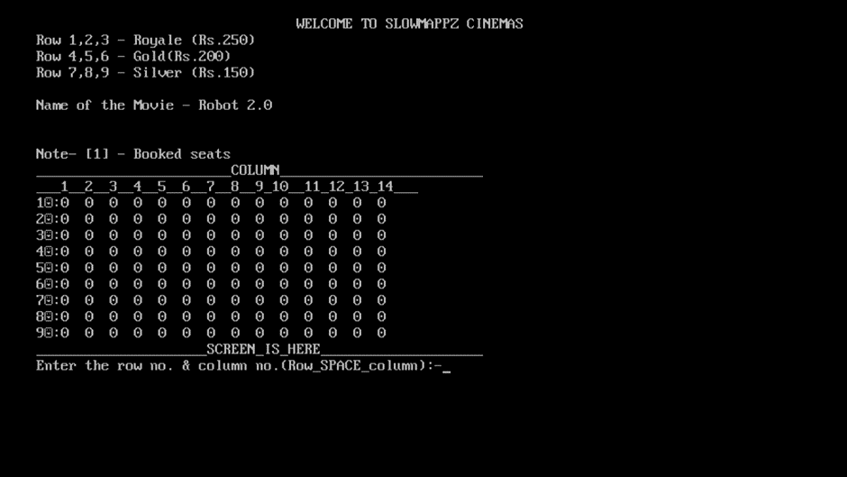

***FURTHER ENHANCEMENT***

This program can be made for practical use by including files in the program which can help in saving the stored data ( Array, Number of tickets and total profit in this case ) for more than one executions of the program.

**Reference**

Let us C

Geeksofgeek.ccom