Generic RPG

User Manual

Green Wolf, Inc., 2016

Table of Contents

1. Introduction
   1. About the developers p. 3
   2. Inspiration, Idea, and Concept p. 3
   3. Platform and Development p. 3
2. How to play
   1. Downloading the and playing game p. 4
   2. Starting Generic RPG p. 4
   3. The Map p. 5
   4. Menu Interaction p. 5
   5. Character Movement p. 5-6
   6. Entering Different Areas p. 6-7
      1. The World p. 6
      2. Towns p. 6-7
         1. Buildings
            1. Shops
            2. Arenas
            3. Inns
            4. Libraries
      3. Dungeons p. 7
         1. Bosses
         2. Loot
   7. Test Operations p. 7-8
3. Future Development p. 8
4. Open Source License and Development p. 8
5. Contact Us p. 8

**Introduction**

**About the developers**

Green Wolf, Inc., also known as Team 3, began as a small group of aspiring developers in the EECS 448 Software Engineering course at the University of Kansas. Determined to “make coding great again,” this ragtag team of students set sail on their software development career with high ambitions and endless creativity, tackling challenges such as the heavy burden of clock creation. Determined to make a name for themselves, they now venture forth to take on a new challenge: game development.

**Inspiration, Idea, and Concept**

The idea for a “generic RPG” came from the pack leader himself. Holding the title of “Scrum Master” and “Keeper of the Repo,” he assembled the team for a discussion on what could only be known as “the single greatest idea that the world has ever seen.” The objective was simply this: to create the most generic game ever made. It would be seen as a tribute to the greats that preceded it, using only the greatest elements of a standard RPG game. Generic RPG would encompass all that it means to be “generic” with overused game styles, predictable classes and stats, and art assets that could have only been done in Microsoft Paint.

**Platform and Development**

Generic RPG began its life as a simple console-based game, using 2-D arrays to represent the world around you. During this prototype phase, success was found in the implementation of the classes and the modularity of the project itself, but it was found that this primitive interface was not successfully marketable to the masses. To fix this, prototyping was done for deployment on Android devices well as PCs. First iterations of Android prototypes were developed using Android Studio and the LibGDX framework.

Though progress was steadily made using the Android Studio platform, the necessity of learning the tools and project time constraints led to the use of more familiar platforms, thus leading to the Greenfoot adaption. The Greenfoot platform uses the Java programming language to easily create a versatile and adaptable world that can easily manage the intricacies of game development. After development is complete, Greenfoot can then deploy the project to a webpage or to a standalone .jar file that can run on your PC.

**How to play**

**Downloading and playing the game**

To create your own executable file for playing the game, please be sure to download Greenfoot from the Greenfoot website as well as a Java JDK to compile and run the project contents. Once this is done, download the project contents from the Generic RPG GitHub repository and clone the repository to any local directory. Inside the newly cloned repository called GenericRPGConsole, navigate to the GenericRPG folder. From here, go to the GenericRPGGreenfoot folder. Once inside, double click the “project” file. This will open Generic RPG inside the Greenfoot platform. The game can be run directly in this environment by pressing the “Run” button or you can export the game to an executable .jar file by going to Scenario >> Share… menu option. Click on the “Application” tab and choose a location to save the file. Once this is done, hit the “Export” button. The file will then be created in the specified directory. Generic RPG can then be run by double clicking the .jar file.

**Starting Generic RPG**

The game starts by prompting the user for a character name. Enter a name for your hero and press the “OK” button. The world area will be the first item rendered by Greenfoot. Figure 1 shows the initial scene (and the world map) of Generic RPG. The screen consists of the world map on the left and a menu panel on the right. The “Act,” “Run,” and “Reset” buttons are located on the bottom right-hand side of the screen while the “Speed” slider is located on the bottom right-hand side of the screen. The “Act” button will run the program one frame at a time while the “Run” button will have the game run continuously. The “Reset” button will effectively reset the game and start again at the name prompt. Finally, the “Speed” slider will allow the user to choose how many times the “Act” method is called every second, though this option will have little effect on the play style of this game.

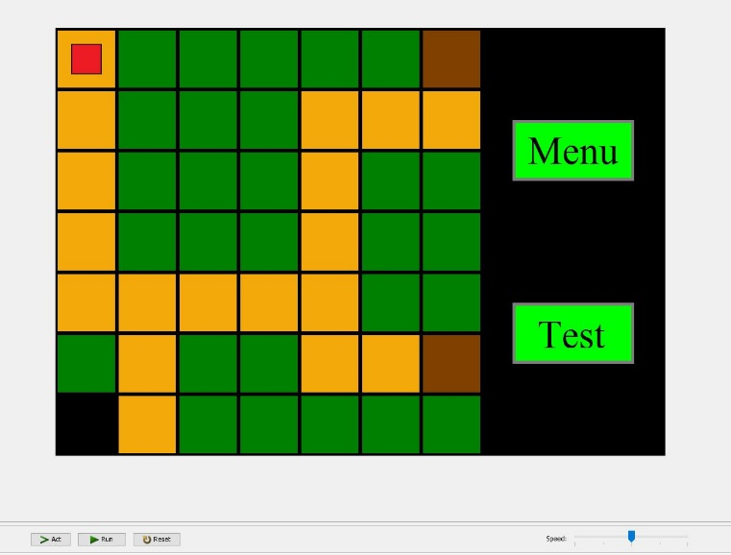

Figure 1: Starting Screen after Name Input

**The Map**

The world map shown above displays the main world of Generic RPG. This map is laid out on a 7x7 grid, serving as a graphical representation of the original map stored in a 2-D array. Each colored tile represents a different terrain feature while the small red square token represents the player’s current location. The player token will rotate while the game is running so that the player knows that the game is still running without error. The meanings of each terrain tile are detailed later in the World, Town, and Dungeon subsections.

**Menu Interaction**

The panel on the right side of the game screen displays a button for player menu as well as a button for testing (developer option). Clicking on the “Menu” button will display a window for the player options available. Figure 2 shows the player menu options available. To interact with the menu, the user will be prompted for input after the options have been displayed. The user must enter an integer value that corresponds to their desired menu choice. If the user enters a value outside of the range or enters a non-integer value, an error message will be displayed and the user will be re-prompted for input. All menu interactions in the Generic RPG game follow the same rules for interaction. Figure 3 shows an example of the error message displayed for incorrect input.

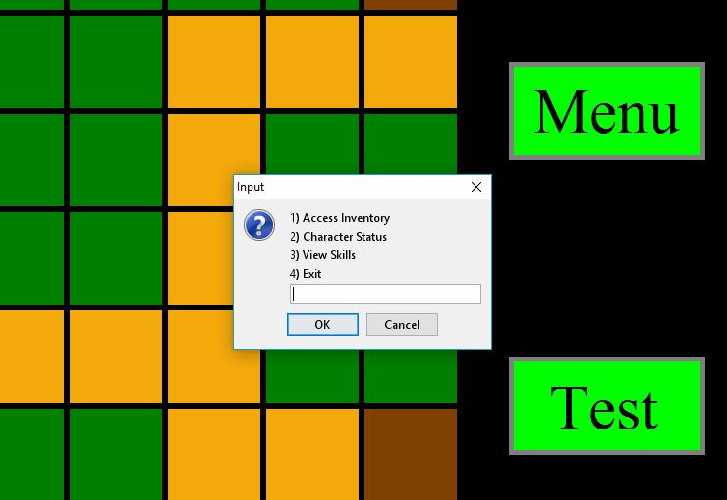 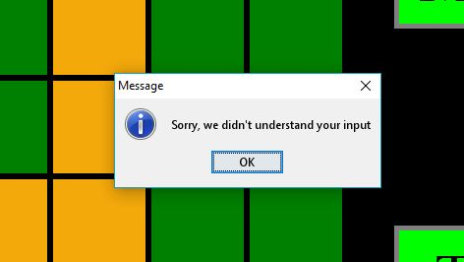

Figure 2: Player Menu Options Figure 3: Error Message for Incorrect Input

**Character Movement**

To move the character from space to space, Generic RPG used the typical “wasd“ keyboard movement configuration. The key bindings are as follows:

* W – Move Up
* A – Move Left
* S – Move Down
* D – Move Right

Pressing any of these keys will move the character in the desired direction. In this version of Generic RPG, the player can only move along the “path” tiles and will transition when an area tile is found (town, dungeon, buildings, etc.). The player will be unable to move across any other tiles except the “path” tiles, and the character will not move if the direction indicated is not an acceptable move.

**Entering Different Areas**

*The World*

The world area consists of four different possible tiles: path (gold), grass (green), town (brown), and dungeon (black). As stated in the Character Movement section, the player can only move alone the “path” tiles and will transition whenever a “town” or “dungeon” tile is reached; “grass” tiles cannot be traversed. There can exist multiple of each transition tile and each one must have its own unique destination and map. Figure 4 shows the world map with the player in the starting location.

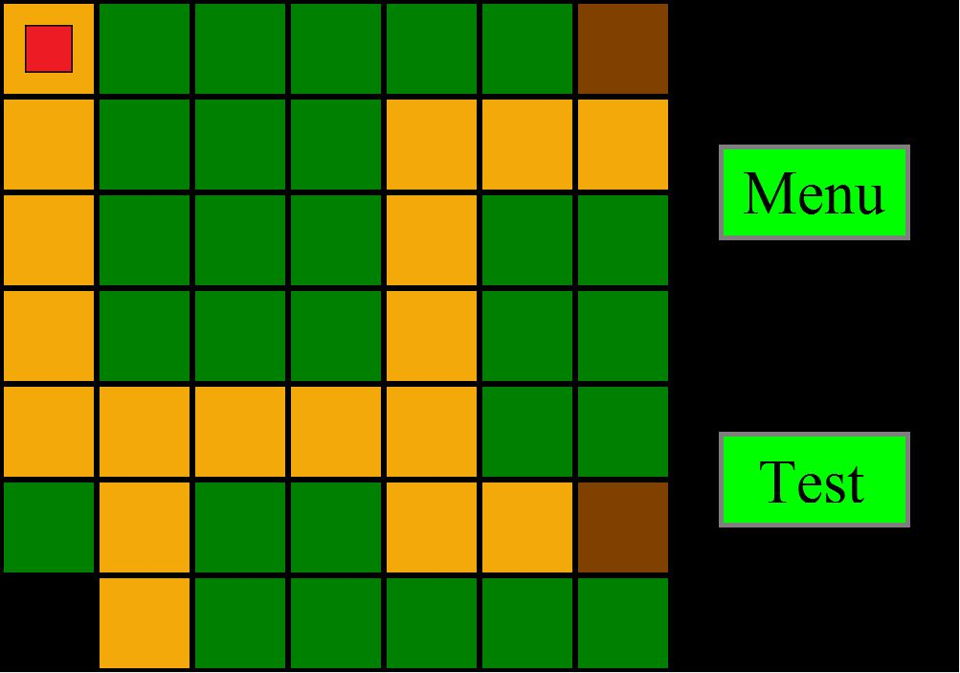

Figure 4: World Map

*Towns*

Each town area consists of four main building tiles (brown with letter): the shop, arena, inn, and library tiles. Along with these, path tiles (gold) and exit tiles (crimson) are also included. Whenever the player reaches a building tile, the player will be given a building interaction menu. See the Menu Interaction section for details on interaction with the menus. To exit the town, the player must return to the “exit” tile where they will be returned to the world map. Figure 5 and figure 6 show the maps for Villageville and Awesometown respectively. The different buildings are as follows:

**Shop**: Allows the player to buy and sell items

**Arena**: Challenges the player with a gauntlet of fighting challenges

**Inn**: Allows the player to acquire quests and rest to restore health points

**Library**: Allows the player to purchase skills and view the bestiary, a log of enemies

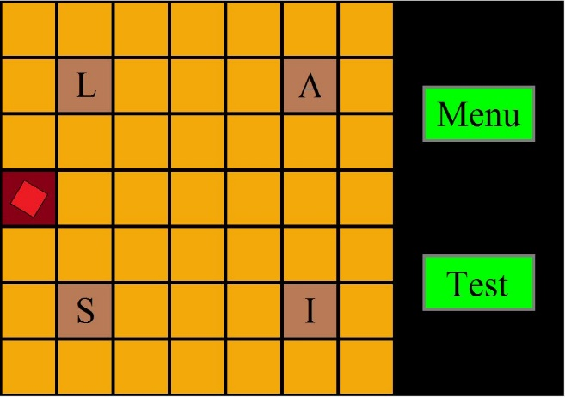 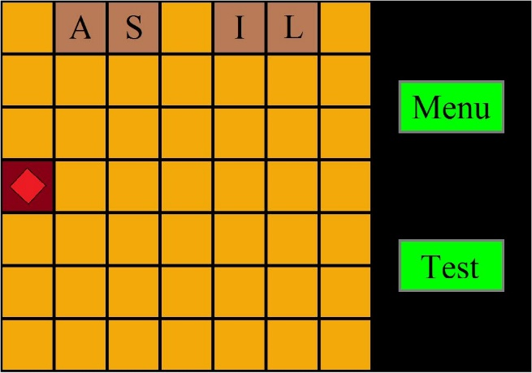

Figure 5: Villageville Map Figure 6: Awesometown Map

*Dungeons*

Each dungeon area consists of “path” tiles (gold), “wall” tiles (blue), “chest” tiles (gold with chest icon), “boss” tiles (purple), and an “exit” tile (crimson). Again, the player may only move along the “path” tiles and will be blocked by “wall” tiles. If the player reaches a “chest” tile, a chest containing a random item will be opened with the contents being added to the player’s inventory. The “boss” tiles will create an encounter between the player and a boss enemy. If the player can successfully defeat the boss, glorious loot will await them. To exit the dungeon, the player must return to the “exit” tile where they will be returned to the world map. Figure 7 shows the map for the world dungeon.

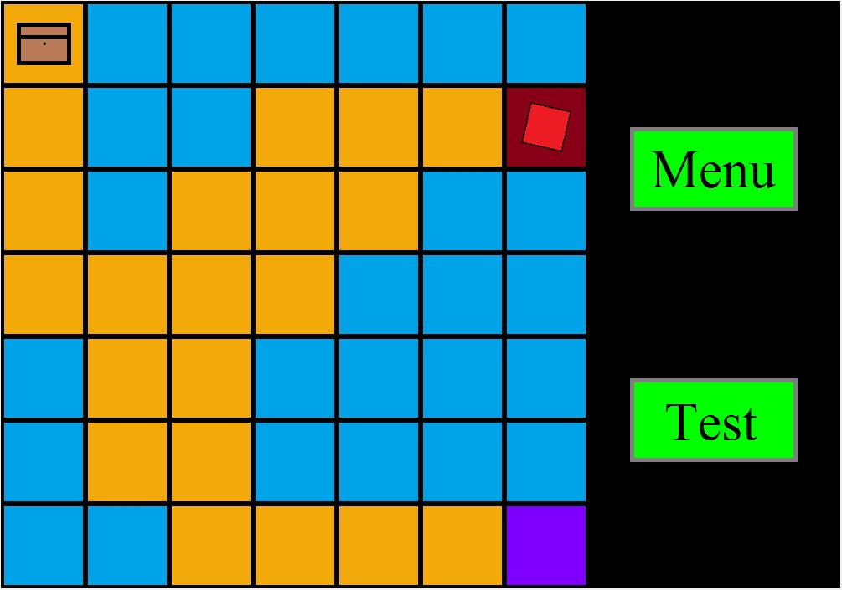

Figure 7: Dungeon Map

**Test Operations**

Generic RPG also includes a testing suite that allows the user/developer to test certain functionality of the program. These tests will test certain cases for each class and outputting whether the test passes or fails. To run these tests, press the “Test” button on the right-hand side of the screen. Once this is done, the results of the tests will be printed to a console window for viewing.

**Future Development**

As of the launch day of May 11, 2016, plans are being made to complete the Android platform port as well as compatibility with Apple devices. Website applet deployment is also being closely considered for the future. Additionally, future content will be released to update the format of the game, add story and lore, add save functionality, implement party and solo play, and to add additional enemies, bosses, items, and skills.

**Open Source License and Development**

To maintain the integrity of the generic nature of the game, Generic RPG is licensed under the GNU General Public License. Under this license, any developer that chooses to develop software of any scale for any market size using any Generic RPG open-source assets must make the developed software open-source as well. Any violation of this license agreement will result in legal action.

**Contact Us**

To contact us with any questions or concerns regarding Generic RPG, please visit the Green Wolf, Inc. website or find our developers directly wandering aimlessly around the University of Kansas campus.