Austin Bailey
EECS 560
10/17/16

Lab 6 Report
Note: The following Table was generated from a single test of a 581 Lab computer, rerun results may vary based on processing capability

Heap or BST | Operation | N | Trial Number | Time (sec)
BST | Insert | 50000 | 1 | 0.02357
BST | Insert | 50000 | 2 | 0.024467
BST | Insert | 50000 | 3 | 0.024811
BST | Insert | 50000 | 4 | 0.025345
BST | Insert | 50000 | 5 | 0.022999
BST | Insert | 50000 | Average | 0.0242384
BST | Insert | 100000 | 1 | 0.05833
BST | Insert | 100000 | 2 | 0.055432
BST | Insert | 100000 | 3 | 0.058579
BST | Insert | 100000 | 4 | 0.056718
BST | Insert | 100000 | 5 | 0.05535
BST | Insert | 100000 | Average | 0.0568818
BST | Insert | 200000 | 1 | 0.136883
BST | Insert | 200000 | 2 | 0.141891
BST | Insert | 200000 | 3 | 0.142034
BST | Insert | 200000 | 4 | 0.141209
BST | Insert | 200000 | 5 | 0.142709
BST | Insert | 200000 | Average | 0.140945
BST | Insert | 400000 | 1 | 0.33288
BST | Insert | 400000 | 2 | 0.340939
BST | Insert | 400000 | 3 | 0.343733
BST | Insert | 400000 | 4 | 0.341185
BST | Insert | 400000 | 5 | 0.353148
BST | Insert | 400000 | Average | 0.342377
Heap | Insert | 50000 | 1 | 0.001598
Heap | Insert | 50000 | 2 | 0.00159
Heap | Insert | 50000 | 3 | 0.001582
Heap | Insert | 50000 | 4 | 0.001588
Heap | Insert | 50000 | 5 | 0.001651
Heap | Insert | 50000 | Average | 0.0016018
Heap | Insert | 100000 | 1 | 0.003054
Heap | Insert | 100000 | 2 | 0.00296
Heap | Insert | 100000 | 3 | 0.002939
Heap | Insert | 100000 | 4 | 0.003042
Heap | Insert | 100000 | 5 | 0.002964
Heap | Insert | 100000 | Average | 0.0029918
Heap | Insert | 200000 | 1 | 0.005901
Heap | Insert | 200000 | 2 | 0.005902
Heap | Insert | 200000 | 3 | 0.005916
Heap | Insert | 200000 | 4 | 0.005982
Heap | Insert | 200000 | 5 | 0.005895
Heap | Insert | 200000 | Average | 0.0059192
Heap | Insert | 400000 | 1 | 0.011582
Heap | Insert | 400000 | 2 | 0.011933
Heap | Insert | 400000 | 3 | 0.01183
Heap | Insert | 400000 | 4 | 0.011943
Heap | Insert | 400000 | 5 | 0.011806
Heap | Insert | 400000 | Average | 0.0118728

The table above compares the time it takes for a BST to insert versus the amount of time it takes a heap to insert. The heaps insert time is consistently across all trials about a thirtith that of the BST. This is because when inserting in a BST the value traverses the entirity of one branch of the tree whie the Heap simply has to insert at the back of an array and upheap- a much cheaper operation, as evidenced by the speed of heap insert. Rember that in this iteration we only prefomed n/10 operations, which is the cause of the discrepancy between the above BST insert and the below BST Random. The cooresponding chart is as follows:
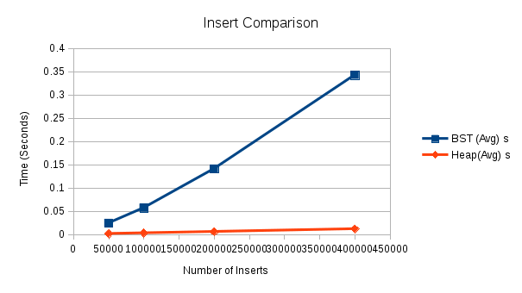

The second part of the calculation was a bit tricky – I managed to fix the problems with my heap, but not the problems with my BST (removal specifically) so I compared the mixed functions of the heap with the insert function of the BST. I hope that I am not too terribly penalized for being unable to fix the BST because I already was in the last lab. Nonetheless, here is the cooresponding table:

Heap or BST | Operation | N | Trial | Time (sec)
BST | Random | 50000 | 1 | 0.001975
BST | Random | 50000 | 2 | 0.001989
BST | Random | 50000 | 3 | 0.002047
BST | Random | 50000 | 4 | 0.002002
BST | Random | 50000 | 5 | 0.00197
BST | Random | 50000 | Average | 0.0019966
BST | Random | 100000 | 1 | 0.0046
BST | Random | 100000 | 2 | 0.004593
BST | Random | 100000 | 3 | 0.004624
BST | Random | 100000 | 4 | 0.004538
BST | Random | 100000 | 5 | 0.004652
BST | Random | 200000 | Average | 0.0045014
BST | Random | 200000 | 1 | 0.010328
BST | Random | 200000 | 2 | 0.010503
BST | Random | 200000 | 3 | 0.010349
BST | Random | 200000 | 4 | 0.009807
BST | Random | 200000 | 5 | 0.01019
BST | Random | 200000 | Average | 0.0102354
BST | Random | 400000 | 1 | 0.026059
BST | Random | 400000 | 2 | 0.024316
BST | Random | 400000 | 3 | 0.021882
BST | Random | 400000 | 4 | 0.022382
BST | Random | 400000 | 5 | 0.02353
BST | Random | 400000 | Average | 0.0236338
Heap | Random | 50000 | 1 | 0.025463
Heap | Random | 50000 | 2 | 0.025125
Heap | Random | 50000 | 3 | 0.023707
Heap | Random | 50000 | 4 | 0.024441
Heap | Random | 50000 | 5 | 0.024107
Heap | Random | 50000 | Average | 0.0245686
Heap | Ranodm | 100000 | 1 | 0.095253
Heap | Random | 100000 | 2 | 0.0925
Heap | Random | 100000 | 3 | 0.102521
Heap | Random | 100000 | 4 | 0.10361
Heap | Random | 100000 | 5 | 0.101872
Heap | Random | 100000 | Average | 0.0991512
Heap | Random | 200000 | 1 | 0.400816
Heap | Random | 200000 | 2 | 0.406793
Heap | Random | 200000 | 3 | 0.385864
Heap | Random | 200000 | 4 | 0.39567
Heap | Random | 200000 | 5 | 0.392811
Heap | Random | 200000 | Average | 0.396391
Heap | Random | 400000 | 1 | 1.62179
Heap | Random | 400000 | 2 | 1.59489
Heap | Random | 400000 | 3 | 1.60136
Heap | Random | 400000 | 4 | 1.60079
Heap | Random | 400000 | 5 | 1.57186
Heap | Random | 400000 | Average | 1.59874

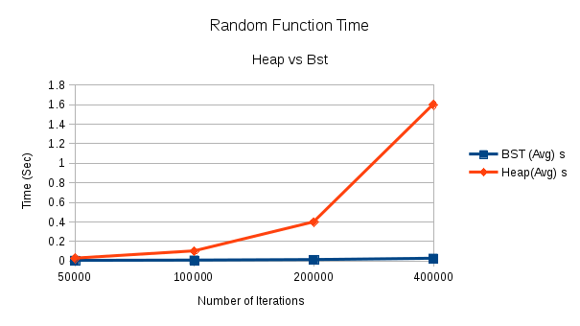
The above graph is of the averages of the times it takes to execute the functions. Obviously a direct comparison doesn’t make sense as the BST only inserted while the heap preformed four different functions randomly. The average time for the Heap is exponential because the larger the heap is, the longer the operations take, because the graph itself is larger.

