**Austin Sypolt**

**ECE 362**

**Post-Lab #6**

**Introduction:**

The objective of this lab is to teach the value of using the stack in various cases we may encounter. Through using stack manipulation, the use of the C language to use a subroutine, and visual application using the LCDs and Potentiometer.

**Lab 6.1:**

Objective/Purpose:

The objective is to properly learn how to push and pull values from the stack, and how to properly record them and their stack address.

Code:

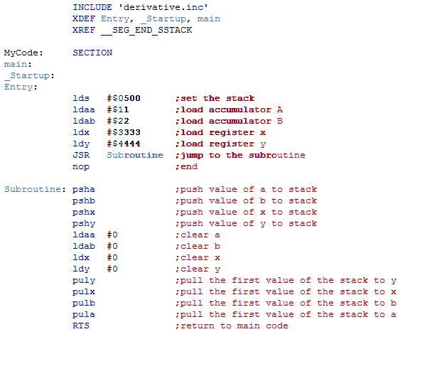

XDEF Entry

XREF __SEG_END_SSTACK

Variables: Section

var1: ds.b 1

var2: ds.b 2

var3: ds.w 1

Constants: Section

cons1: dc.b 1, 2, 3

cons2: dc.w $1111, $2222, $3333

Code: Section

Entry:

LDS #__SEG_END_SSTACK ;

LDAA #1 ;

STAA var1

nop

**Lab 6.2:**

Objective/Purpose:

The objective of this section of lab 6 was to learn how to properly interface a C language main program and a C language subroutine with our assembly language subroutine.

Code:

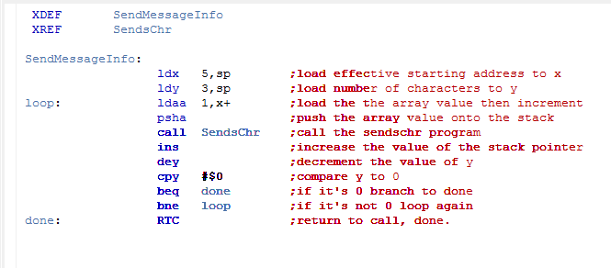

**Lab 6.3.:**

Objective/Purpose:

The purpose of this lab is to use assembly language to read values from the potentiometer and relay them to the LCD screen on the provided board.

Code:

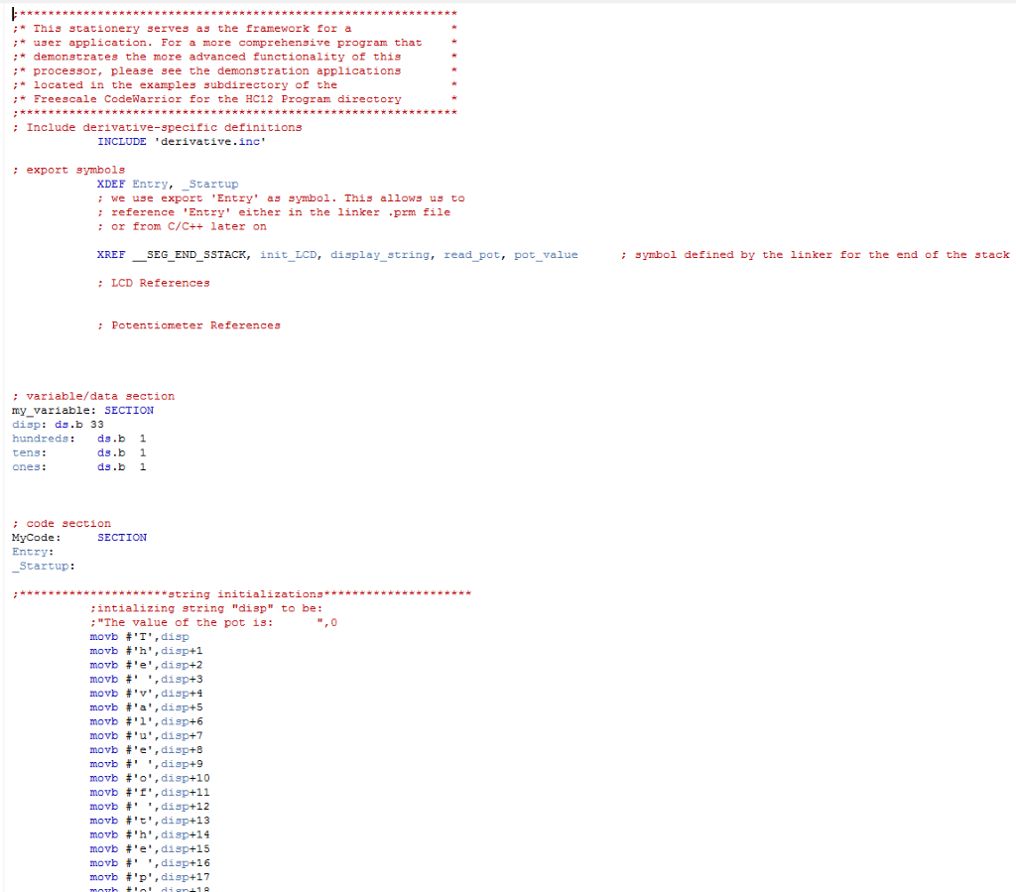

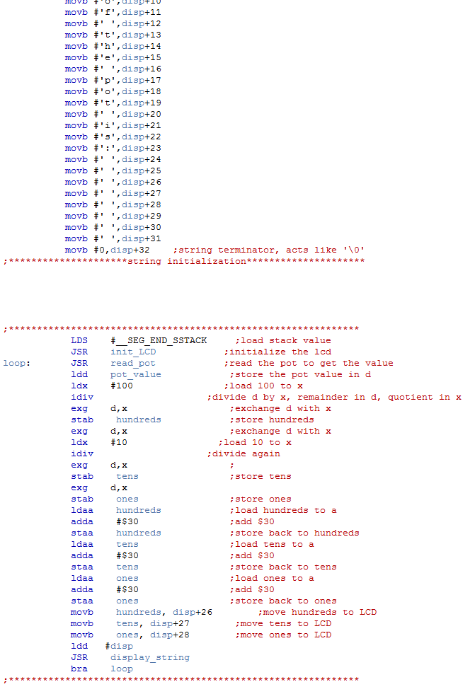

LDS #__SEG_END_SSTACK ;load stack value

JSR init_LCD ;initialize the lcd

JSR display_string ;initialize the lcd to display

loop: JSR read_pot ;read the pot to get the value

ldd pot_value ;store the pot value in d

ldx #100 ;load 100 to x

idiv ;divide d by x, remainder in d, quotient in x

exg d,x

stab hundreds ;store hundreds

exg d,x

ldx #10 ;load 10 to x

idiv ;divide again

exg d,x

stab tens ;store tens

exg d,x

stab ones ;store ones

ldaa hundreds ;load hundreds to a

adda #$30 ;add $30

staa hundreds ;store back to hundreds

ldaa tens ;load tens to a

adda #$30 ;add $30

staa tens ;store back to tens

ldaa ones ;load ones to a

adda #$30 ;add $30

staa ones ;store back to ones

movb hundreds, disp+26 ;move hundreds to LCD

movb tens, disp+27 ;move tens to LCD

movb ones, disp+28 ;move ones to LCD

JSR display_string

bra loop

**Conclusion:**

Ultimately, we learned how to properly use the stack in our HCS12 circuit boards as well as being able to properly implement a c program into our code and use it in our assembly subroutine. Finally, we learned how to use our LCD and potentiometer such that our potentiometer would display a value on the LCD that increased with rotation of the potentiometer. In learning all this new great stuff about assembly we will be able to go about our lives in a happier fashion. Additionally, although many obstacles were encountered in the process of lab 6 through ruthless and relentless debugging we were able to come out on top of the machines once again, and learn some fun new knowledge I can’t wait to share at my next family get together.