**Austin Sypolt**

**ECE 362**

**Post-Lab #4**

**Introduction:**

In this lab we will work on conditional branches, stacks, subroutines, loops and arrays. We will make applications of all of these throughout the lab for development and use of them for future labs.

**Lab 4.1.1:**

Objective/Purpose:

The objective of the first section is to matchup the LEDs to the sequence given.

Explanation: The values of sequence are ran through with a loop

Results: Results in appropriate LEDs lighting up dependent on where in the sequence the index is.

Code:

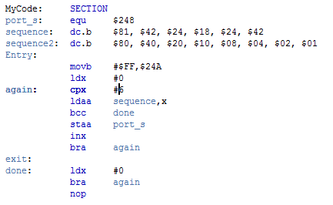

**Lab 4.1.2:**

Objective/Purpose:

The purpose is to add code so that there are 2 output depending on the state of a dipswitch.

Explanation: If port t is 0 then sequence 1 is ran through and if port t is 1 then sequence 2 is ran through.

Results: Depending on the position of the dipswitch the appropriate sequence will run, and will continue to run through each respective sequence where it left off.

Code:

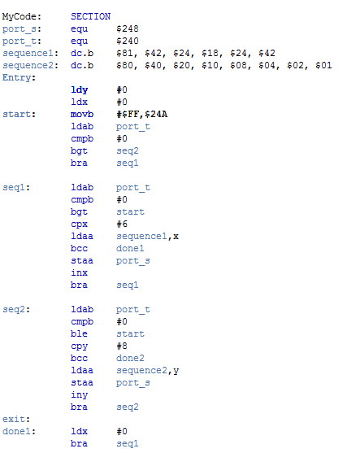

**Lab 4.2:**

Objective/Purpose:

The objective is to make a program to determine the index of a number in a look-up table.

Explanation: The value is loaded and compared to first index variable, depending on match or no match they will branch differently, at the end it will increment this value. If there is a match it will swap x and d and then swap a and b and then branch to the end of the code as a match was found. If there is no match the value $FF is loaded into accumulator a.

Code:

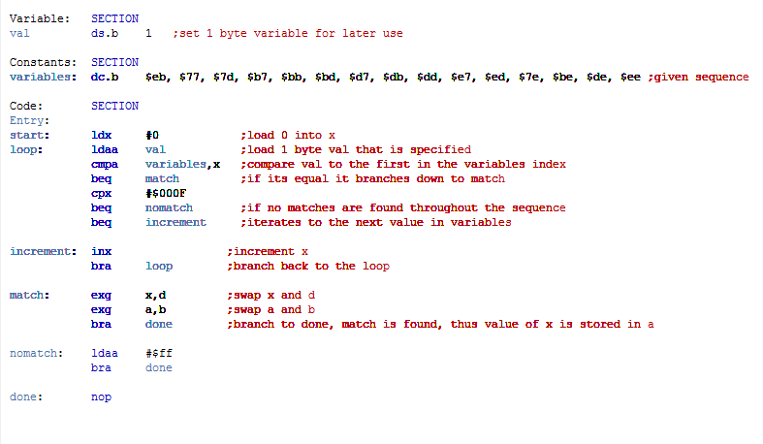

**Lab 4.3:**

Objective/Purpose:

Purpose is to use assembly to turn the stepper motor.

Explanation: The address of the stepper motor will be associated with a starting value at 1E. 0 will be loaded into b and the first value in the variable value. Y will be loaded with 30000 which is the value of our delay length. The delay will have a 30000 delay between each process so that the stepper will properly output, otherwise not all actions may take place due to them occurring too quickly together.

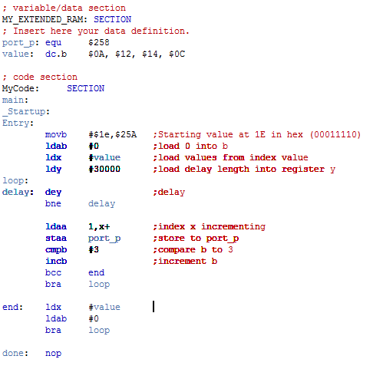

**Lab 4.4:**

Objective/Purpose:

Purpose is to use assembly to turn the stepper motor but with the delay being read in from a file instead of directly in the code.

Explanation:

The same general actions occur as in the last program however here the delay is read in from an attached file. The references had to be set up in order for the file to be properly read and written from.

Code:

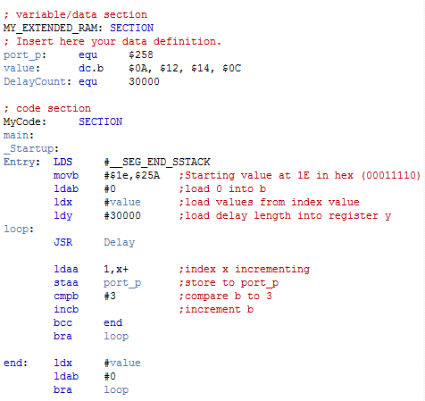

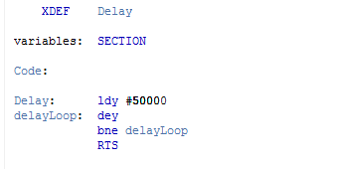

**Conclusion:**

In this lab we worked on the reading a sequence into our LEDs as well as adding a delay to our LEDs to get them to properly display on our board in loop. Additionally we learned to turn the stepper motor and the various applications of the delay function to get a real function out of programming in assembly.