**Austin Sypolt**

**ECE 362**

**Post-Lab #5**

**Introduction:**

In this lab we will learn how to use logic and bit instructions to change LEDs as well as learning the application of a hex keypad and further lessons in utilizing the stepper motor on our HSC12 boards.

**Lab 5.1.1: Logic Instructions**

Objective/Purpose: Clears bit 6 of VAR_1 and stores it back into VAR_1. Then sets bit 4 of VAR_1 and stores it in VAR_1. Then using the AND instruction it will wait for bit 1 (switch 2) of the dipswitches to go low then send VAR_1 to the LEDs. Finally testing for switch 2 to wait until it goes high after going low.

Explanation:

Code:

XDEF Entry

XREF __SEG_END_SSTACK

Variables: Section

var1: ds.b 1

Constants: Section

port_s: equ $248

Code: Section

main:

_Startup:

Entry:

Movb #$FF, $24a

Adda var1

anda #%10111111

oraa #%00000100

nop

Variables: Section

var1: ds.b 1

Constants: Section

port_s: equ $248

port_t: equ $240

Code: Section

main:

_Startup:

Entry:

Movb #$FF, $24a

loop: ldaa port_t

anda #%00000100

bne loop

loop1: ldaa port_t

anda #%00000100

beq loop1

staa port_s

nop

**Lab 5.1.2: Bit Instructions**

Objective/Purpose:

Use BSET and BCLR to initialize and turn off LEDs/DDR in port S.

Explanation:

Code:

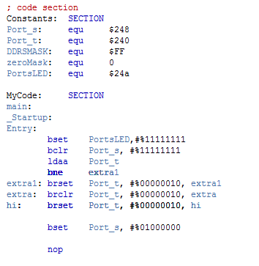

**Lab 5.2: Hex Keypad**

Objective/Purpose:

Initializing Port U so that the upper 4 bits are outputs and the lower 4 are inputs. Then the value pressed on the hex keypad should be read in to the right bits and then oscillate with output pressed on the hex keypad.

Explanation:

Code:

**Lab 5.3: Stepper Motor**

Objective/Purpose:

Use BSET and BCLR to initialize and turn off LEDs/DDR in port S.

Explanation:

Code:

 XDEF DelayFast, DelaySlow, Entry, _Startup, main

            XREF Delay, DelayS, __SEG_END_SSTACK      ; symbol defined by the linker for the end of the stack

Constants:    Section

sequence    dc.b    0, $0a, $12, $14, $0c

port_p     equ     $258

port_t     equ     $240

DelayFast   dc.w    15000

DelaySlow   dc.w    60000

; code section

MyCode:     SECTION

main:

_Startup:

Entry:

        LDS    #__SEG_END_SSTACK

        movb   #$1e, $25a

        ldx    #0

again:  brset    port_t, #%00000100, h

        brclr    port_t, #%00000100, l

    h:  JSR    Delay

        bra    check

    l:  JSR    DelayS

        bra    check

check:  brset port_t, #%00000001, dcheck

        brclr port_t, #%00000010, check

        bra     ccw

dcheck: brset    port_t, #%00000010, check

        bra     cw

ccw:    ldaa     sequence,x

        staa     port_p

        dex

        cpx    #0000

        beq    reset1

        bra    again

reset1: ldx    #4

        bra    again

cw:     ldaa   sequence,x

        staa   port_p

        inx

        cpx    #0005

        beq    reset2

        bra    again

reset2: ldx    #1

        bra    again

        Nop

    XDEF    Delay

    XREF    DelayFast

Delay:     ldy    DelayFast

    go:    dey

           bne    go

           RTS

    XDEF    DelayS

    XREF    DelaySlow

DelayS:    ldy    DelaySlow

    go:    dey

           bne    go

           RTS

**Conclusion:**