Admin

Edit Profile

Manage Job

**Use Case Diagram (Admin)**

**Use Case Diagram**

Manage

Company

Compose

Message

Manage Listing

View Jobseeker

info

Get Notification

Update Job

Manage Company details

**Use Case Diagram**

**(**

**Company**

**)**

Company

Manage

batches

View batch requirement

Search job

Apply For Job

**Use Case Diagram**

**)**

**Jobseeker**

**(**

Jobseeker

View Job Alert

View Job Plan

View Company

Info

Cancel

Registration

Post Comment

Give feedback

Login

Is

Valid??

Manage Category Profile

Get

Notification

Logout

**Activity Diagram (Admin)**

NO

Yes

Manage Job

Manage

Company

Mange

Listing

View Jobseeker

Info

Manage Canditate Application

Login

Is

Valid?

Update Job

Logout

**ActivityDiagram (Compny)**

NO

Yes

Manage

Company

Compose

Message

View Inbox

Give Feedback

Login

Is

Valid?

Edit Profile

View Job

Alert

Logout

**Activity Diagram**

**)**

**(**

**Jobseeker**

NO

Yes

View Job

View

Company

Cancel

Registration

Apply For

Job

Give Feedback

Post

Comment

**Sequence Diagram (Jobseeker)**

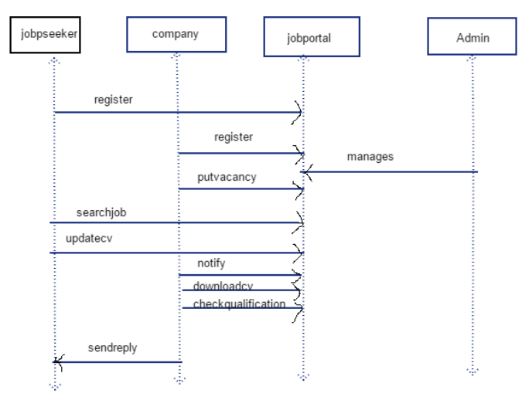

ADMIN

COMPANY

JOB SEEKER

MANAGE

MANAGE

JOB

POST

VIEW

GIVE

SEE

FEEDBACK

1

1

m

m

m

m

m

m

m

m

m

m