Heroes Of Pymoli

Purchase Data Analysis

Below are three trends that are apparent when analyzing the in-game purchase dataset of ‘Heroes of Pymoli’:

1. (GENDER) While the game is player primarily by Male users (84.03%), the average price per in-game purchases are higher for Female & “Other / Non-Disclosed gender” users

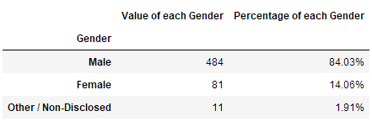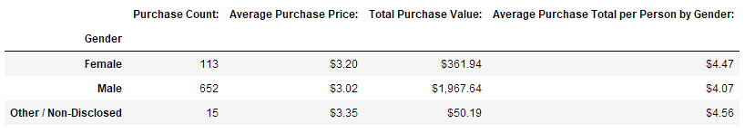

1. (AGE) The 20 to 24 year-old age bracket has the most users, most purchases and highest total purchase value compared to all other age brackets. The age group with the highest purchase totals per person are 35 to 39 year old users, who also spend the most on average per purchase made.

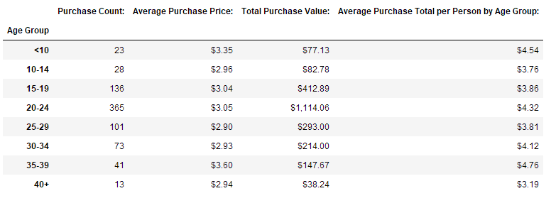

1. (ITEM PURCHASES) The most purchased item in the game is “Final Critic”, which has been purchased 13 time and has earned the most revenue as well, at $59.99 of profit.

