Pymaceuticals Analysis

Below are three trends that are apparent when analyzing the performance of the Pymaceuticals' drugs on the mice.

1. By some simple analysis, we can tell that the study was well setup with its controllables. Statistically there were even splits with male and female mice, as well as having almost an even number of mice being tested by each drug.

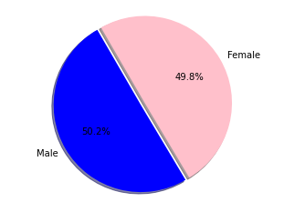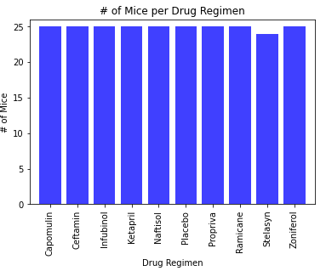

1. For one particular mouse, that was on the Capomulin treatment for its tumor, its tumor size significantly decreased over the period of 20 days from over 44mm^3 to around 30mm^3, which means that the drug is showing some positive results.

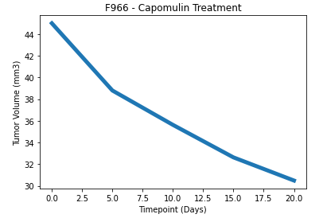

1. There was a positive linear correlation between average tumor volume and average weight of the mouse. As each increased in size or weight, so did the other.

