SafeSpace UG — Platform Overview & Walkthrough

About This Document
This document provides a comprehensive visual walkthrough of the SafeSpace UG platform — a digital ecosystem purpose-built to support the University of Ghana’s commitment to addressing sexual harassment and misconduct within its community. It is intended for university leadership, policy teams, institutional reviewers, and external evaluators who wish to understand the platform’s purpose, design philosophy, and user experience without requiring technical background.
Every section includes annotated screenshots and detailed explanations of what each interface achieves, why it was designed the way it was, and how it contributes to the broader institutional mission of safety, fairness, confidentiality, and accountability.

1. Platform Vision & Purpose
Sexual harassment and misconduct in academic institutions demand a response that is simultaneously compassionate and procedurally rigorous. The University of Ghana’s 2017 Policy on Sexual Harassment and Misconduct established clear definitions, reporting structures, investigation timelines, and disciplinary frameworks. However, translating a written policy into lived institutional practice requires more than awareness campaigns and printed guidelines.
SafeSpace UG exists to bridge that gap.
The platform digitises the full lifecycle of the university’s harassment response framework — from the moment a community member first learns about their rights, through the act of filing a report, to the structured investigation and resolution process managed by the institution’s designated committee. Rather than consolidating all of these responsibilities into a single application, SafeSpace UG intentionally separates them into distinct, purpose-built portals, each designed around the emotional and procedural needs of its specific audience.
The platform is organised into four interconnected applications:
- The Public Awareness Platform — An open educational resource that helps community members understand what constitutes harassment, what their rights are, and how the reporting process works, before they ever need to use it.
- The Reporting Portal — A secure, guided intake system where individuals can file formal or informal complaints, with full support for anonymous submission.
- The Participation Portal — A private, role-based workspace where complainants, respondents, and witnesses can track their involvement in active cases, view deadlines, attend hearings, and access support resources.
- The Committee Dashboard — An administrative operations centre where designated committee members coordinate investigations, manage hearings, enforce institutional deadlines, and maintain a transparent record of all actions taken.
This separation is deliberate. A person seeking to understand their rights should never be confronted with administrative complexity. A respondent should never have access to a complainant’s private correspondence. A committee member should have full operational visibility without compromising the confidentiality of individual participants. Each application serves its audience with clarity and care.

2. The Public Awareness Platform

Purpose & Philosophy
The Public Awareness Platform is the front door of the SafeSpace UG ecosystem. It exists for a simple but critically important reason: people cannot exercise rights they do not understand.
Before any reporting takes place, before any investigation begins, there must be a space where students, faculty, and staff can learn — without pressure, without login requirements, and without any record of their visit — what sexual harassment means under university policy, what protections exist for those who come forward, and what the institutional process looks like from beginning to end.
This platform is entirely public. No account is needed. No personal information is collected. The design philosophy is rooted in accessibility and reassurance: warm colours, clear typography, intuitive navigation, and language that transforms dense legal text into something a first-year student can understand on their first read.

Homepage — The First Impression
The homepage was crafted to balance institutional authority with human warmth. Rather than opening with legal definitions or bureaucratic language, it welcomes visitors with clear messaging about the university’s commitment to a safe community. As the user scrolls, the page progressively introduces key concepts through smooth, gentle animations that reveal content at a natural reading pace.
The visual hierarchy is intentional. The most important message — that help is available and reporting is safe — appears immediately. Supporting information about definitions, rights, and procedures unfolds naturally as the user continues exploring. This scroll-based revelation prevents information overload and allows users to absorb difficult subject matter at their own pace.
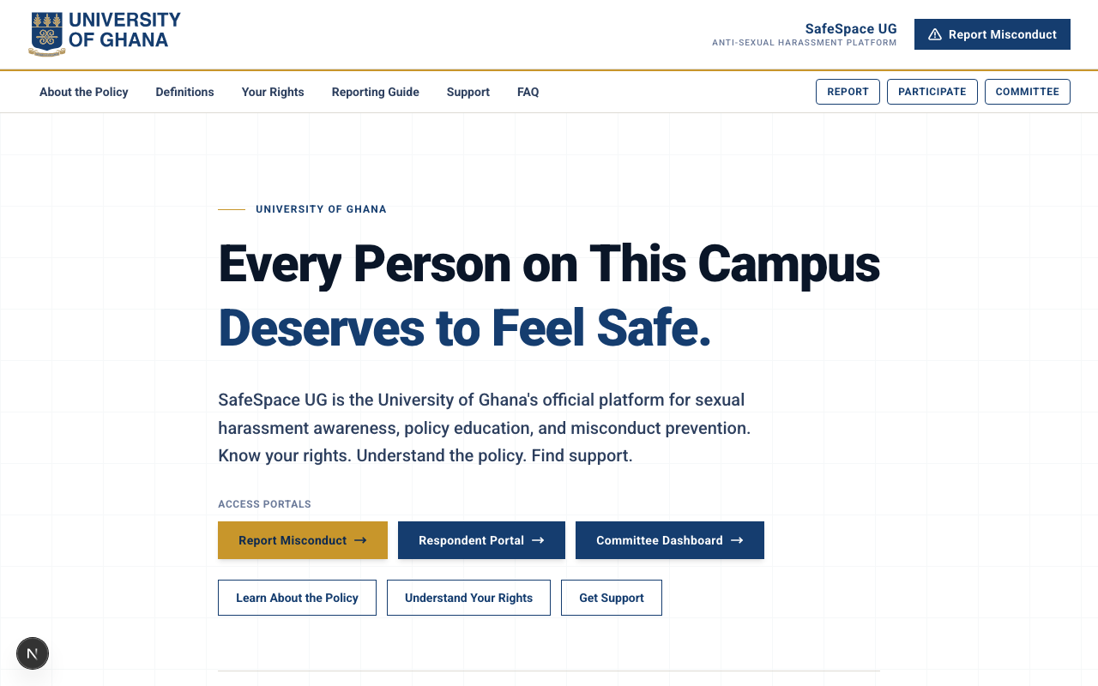
Homepage - Top
The opening section establishes trust and institutional commitment. The design avoids clinical or legalistic tones, instead using approachable language and visual warmth to signal that this is a safe space for learning.
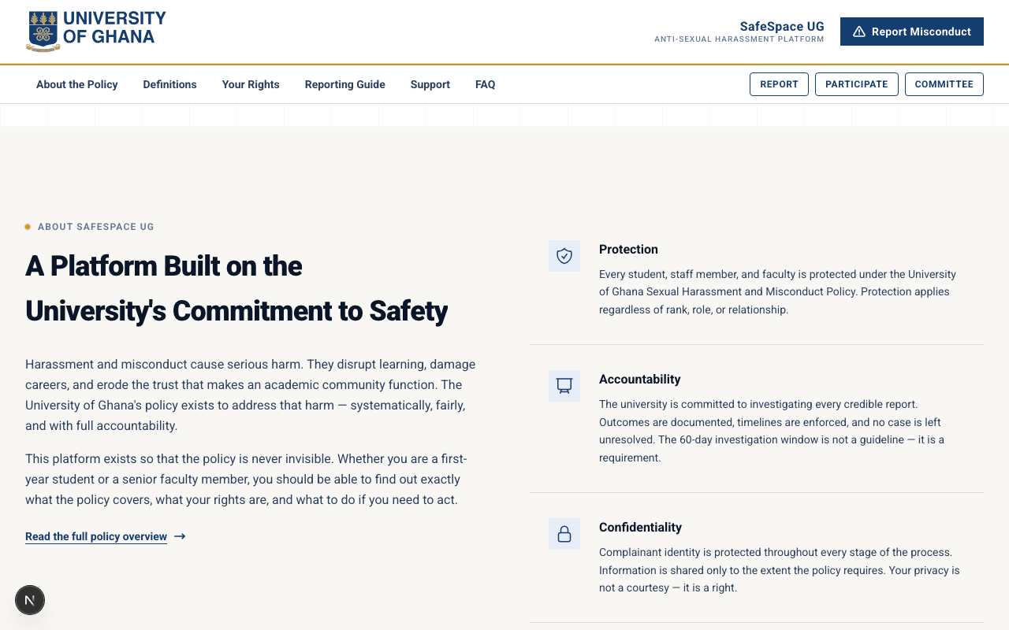
Homepage - Scroll Section 1
As the user scrolls, additional sections reveal key information about definitions, rights, and available support. Each section is visually distinct, helping users locate exactly the information they need without feeling overwhelmed by a wall of text.
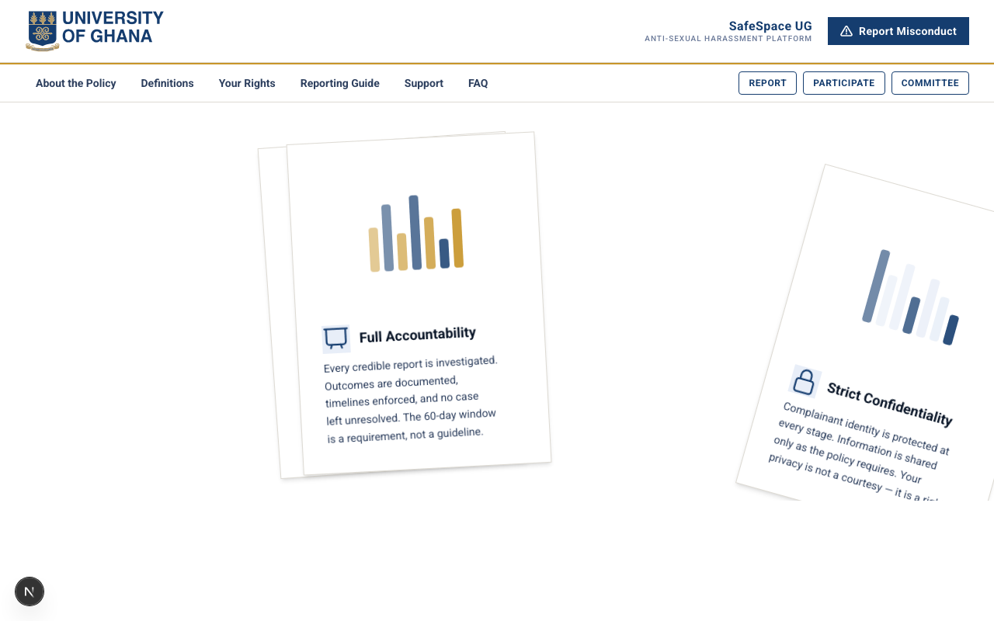
Homepage - Scroll Section 2
Further down the page, the platform introduces the reporting pathway and what to expect from the institutional process. This proactive explanation helps reduce the fear and uncertainty that often prevents individuals from coming forward.
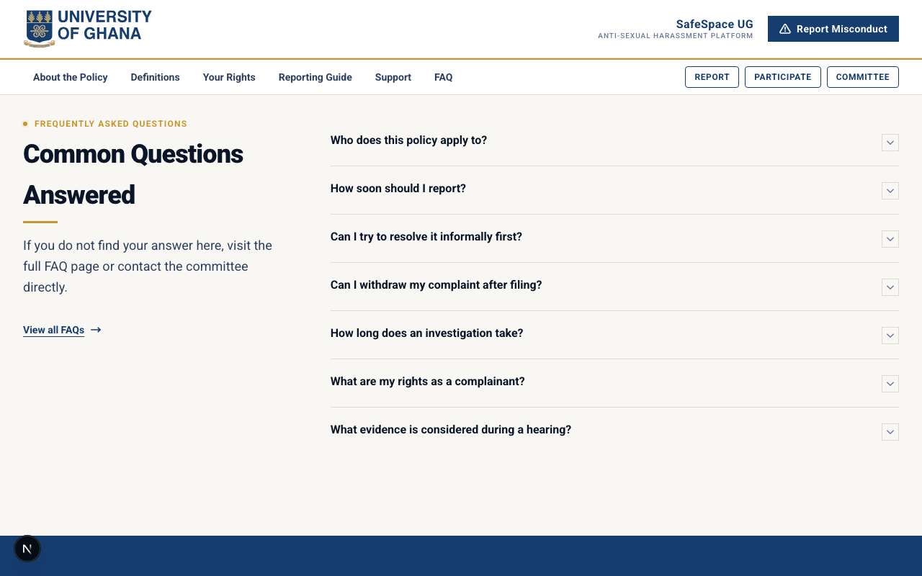
Homepage - Bottom
The lower sections of the homepage provide quick-access links to detailed resources, support services, and the reporting portal itself. The call-to-action is always visible but never aggressive — reflecting the platform’s trauma-informed design approach.

Policy Summary — Making Legal Language Accessible
The University of Ghana’s 2017 policy document is comprehensive but dense. The Policy Summary page exists to translate that document into clear, readable language that any member of the university community can understand. Key definitions, prohibited behaviours, and institutional responsibilities are presented in structured sections with plain-language explanations.
This page answers the question every potential reporter asks first: “Does what happened to me count?” By providing clear, accessible definitions alongside real-world examples, the platform removes ambiguity and empowers individuals to make informed decisions about their next steps.
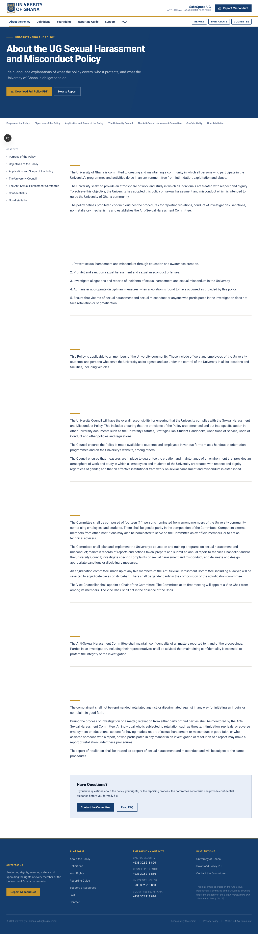
About Policy

Reporting Guide & Rights — Demystifying the Process
One of the greatest barriers to reporting harassment is fear of the unknown. The Reporting Guide addresses this directly by walking users through the entire institutional process step by step — from initial complaint submission through the 60-day investigation window, to the final resolution. Each stage is explained in plain language with clear timelines.
The Your Rights page complements this by explicitly outlining the protections afforded to every participant in the process: the right to representation, protection against retaliation, the right to be informed of progress, and the right to appeal outcomes. These pages work together to transform what might feel like an intimidating bureaucratic process into something transparent and navigable.
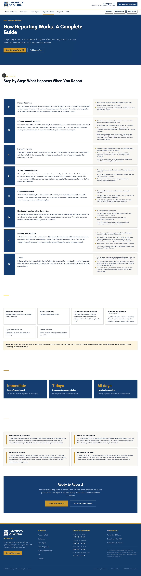
Reporting Guide
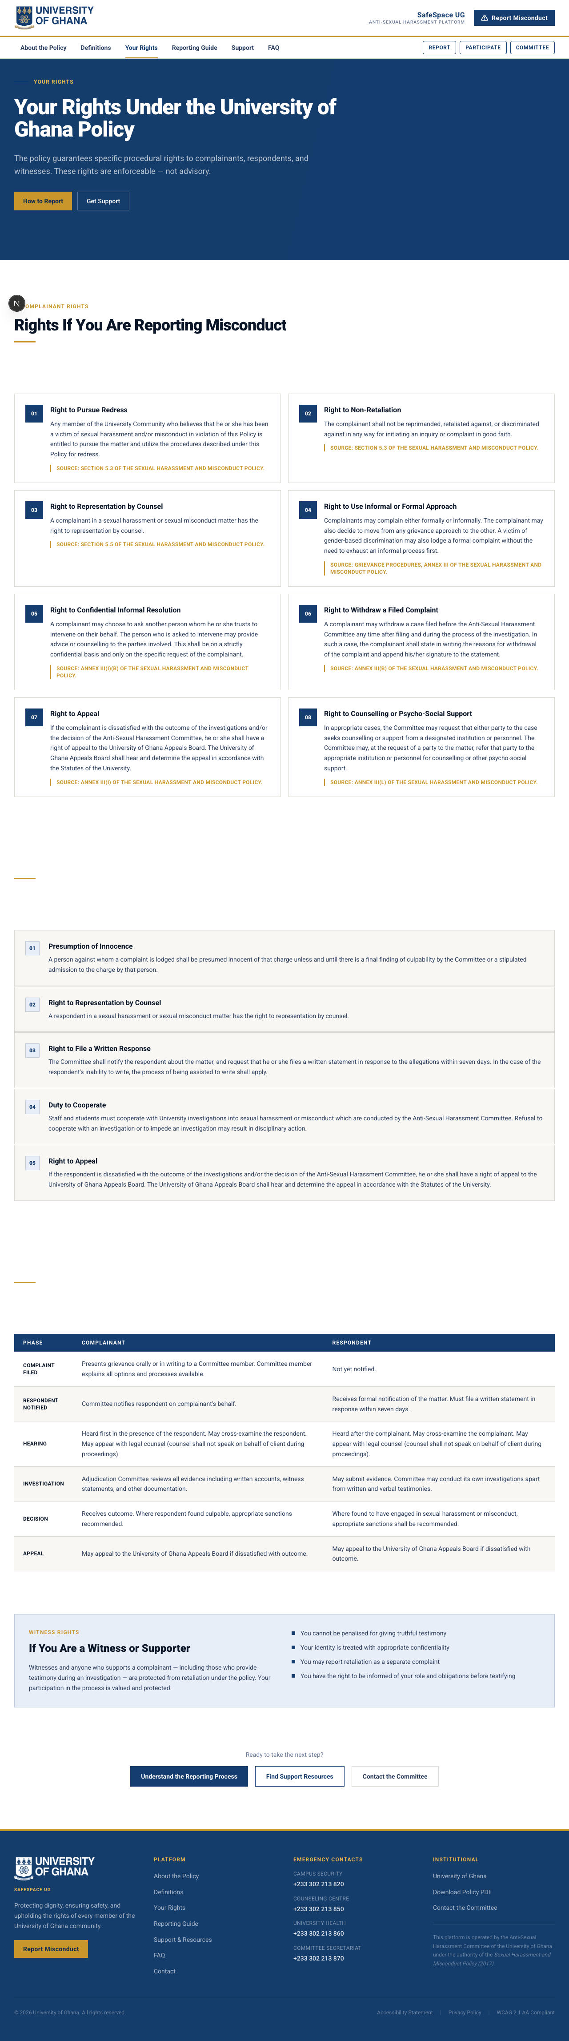
Your Rights

Definitions, FAQ & Support Resources — Comprehensive Knowledge Base
The Definitions page provides a structured glossary of key terms used throughout the policy and the platform. For individuals encountering institutional language around harassment for the first time, this resource ensures that terminology never becomes a barrier to understanding.
The FAQ page anticipates the questions that community members most commonly ask — about confidentiality, about what happens after a report is filed, about whether anonymous reports are taken seriously, and about what support is available during the process.
The Support Resources page connects users to counselling services, legal aid, peer support networks, and emergency contacts. This page recognises that the platform is not a replacement for human support — it is a bridge to it.
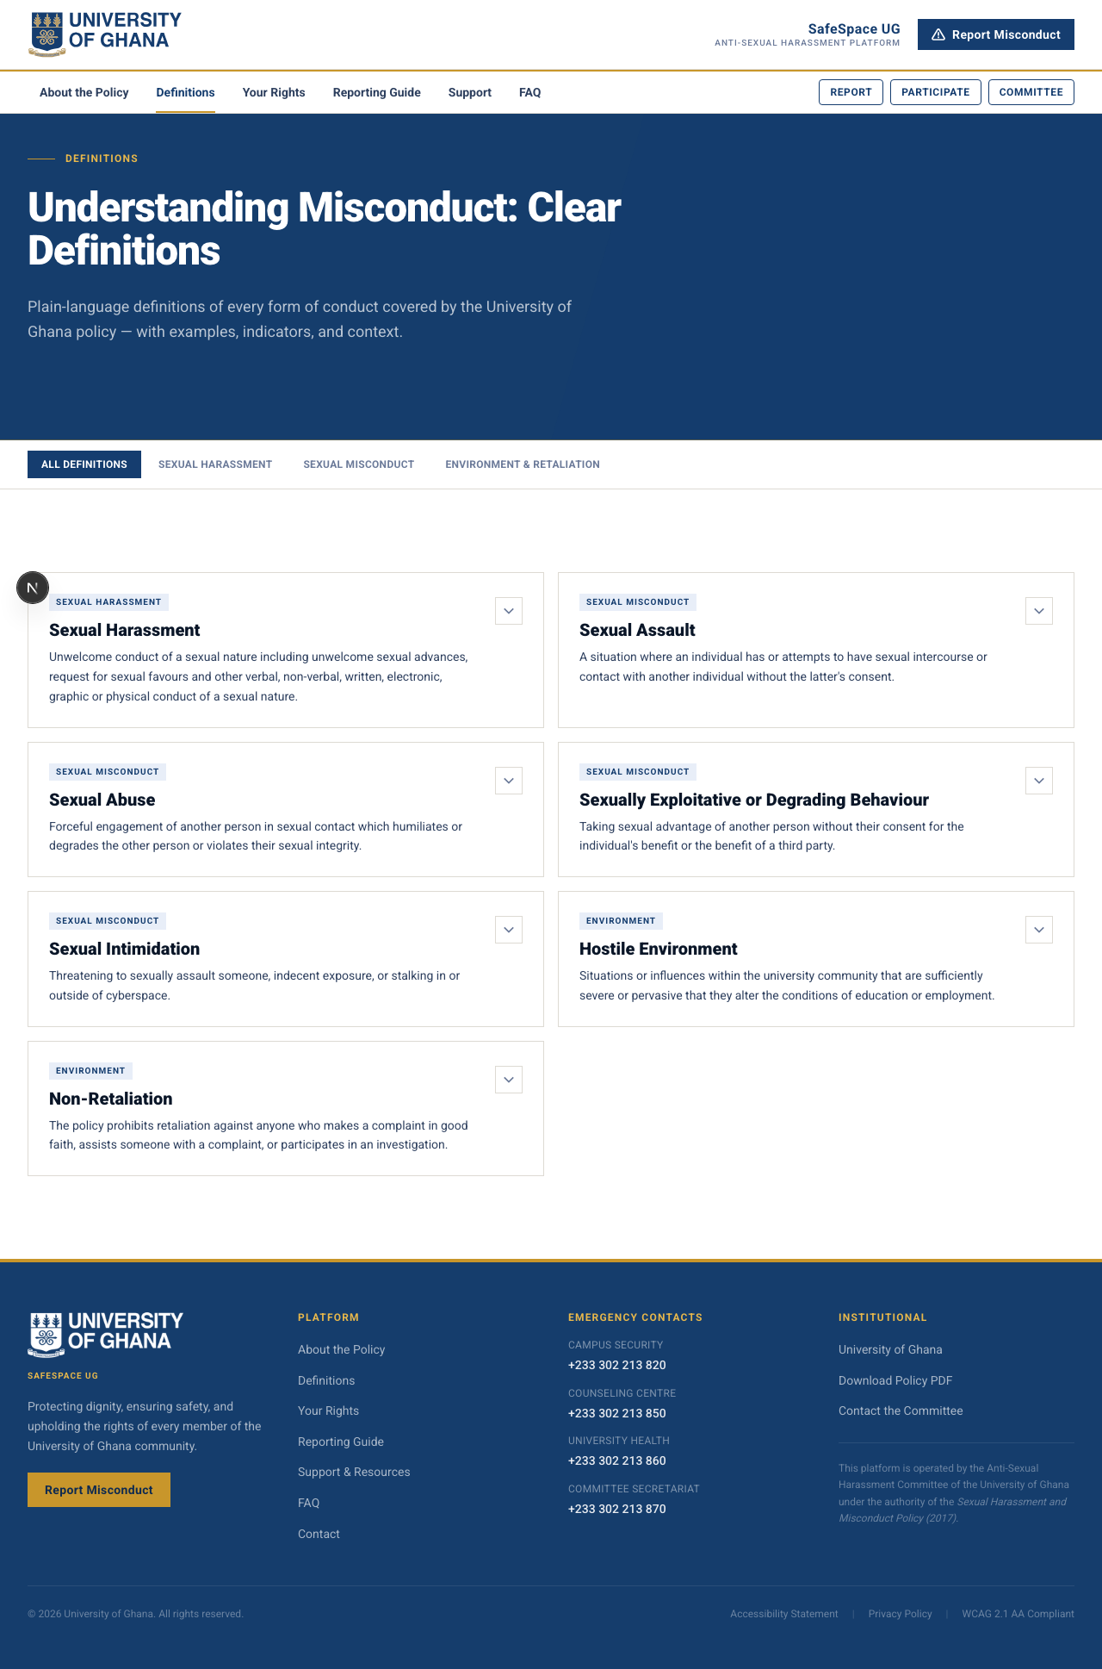
Definitions
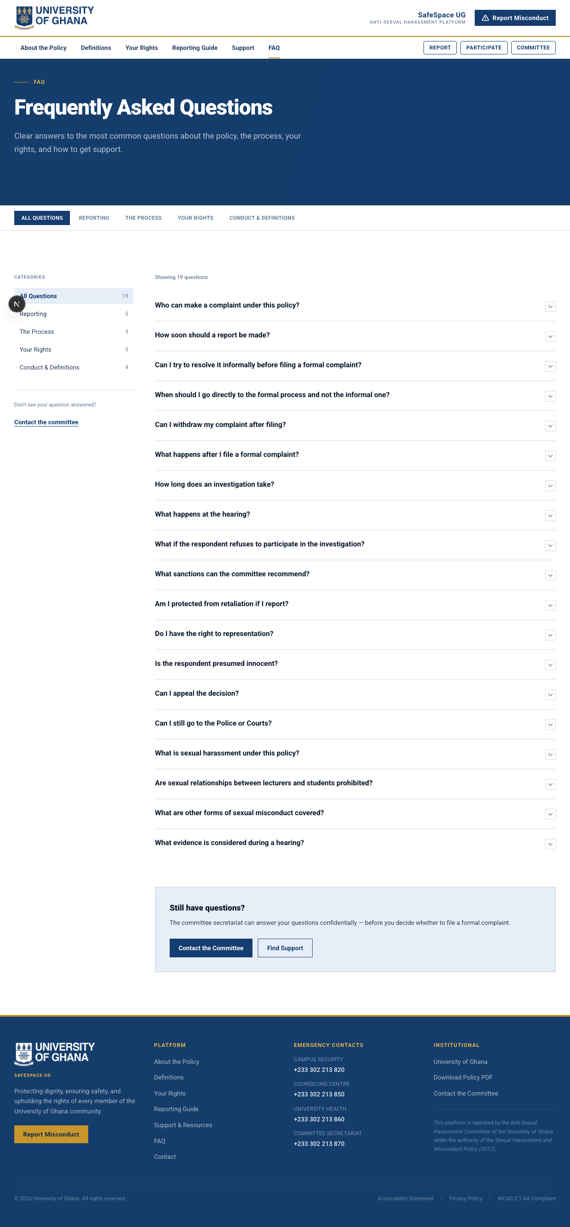
FAQ
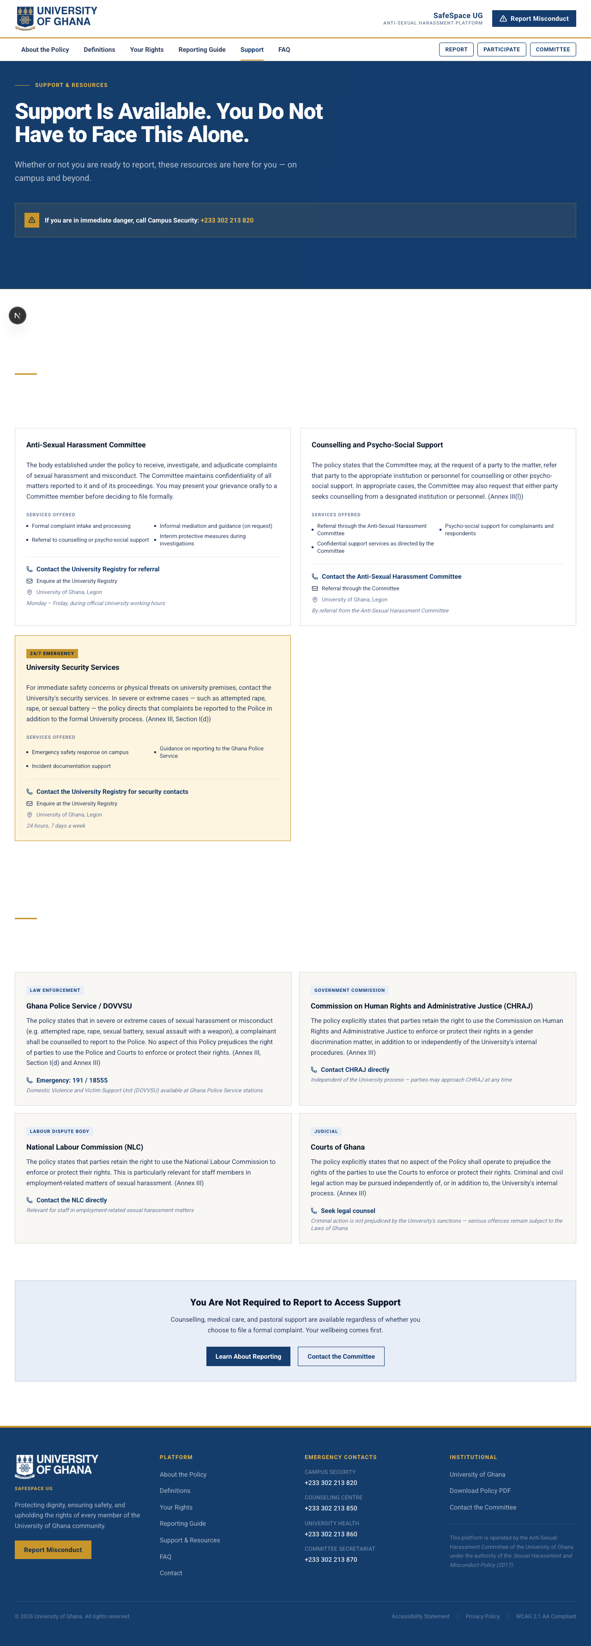
Support Resources
The Public Awareness Platform succeeds in its core mission: it makes institutional policy feel human. The design is warm without being casual, informative without being overwhelming, and reassuring without making promises. It respects the emotional state of someone who may be visiting during one of the most difficult moments of their life.

3. The Reporting Portal

Purpose & Philosophy
The Reporting Portal is where awareness transitions into action. This is the application that handles the formal intake of complaints — the moment when a community member decides to come forward and initiate the institutional response process.
The design of this portal is guided by a single principle: the act of reporting should never feel more difficult than the experience being reported. Every element of the interface — from the language used in form labels to the order in which questions are presented — has been considered through the lens of someone who may be experiencing fear, shame, confusion, or urgency.

The Intake Experience
The reporting process is structured as a guided flow rather than a single overwhelming form. Users are walked through their submission step by step, beginning with the type of report they wish to file (formal or informal), then progressing through the details of the incident, identification of involved parties, and the option to upload supporting evidence.
Critically, the portal provides full support for anonymous submission. When a user chooses to report anonymously, their identity is not linked to the submission in any way. Instead, a secure Case Reference Number is generated that allows them to track the status of their report without ever revealing who they are. This feature exists because the university recognises that some individuals are not yet ready to identify themselves — but their experiences still deserve to be heard and addressed.
The interface is deliberately calm and uncluttered. There are no distracting elements, no unnecessary graphics, and no pressure to complete the form in a single session. The design communicates patience: take your time, we are here when you are ready.
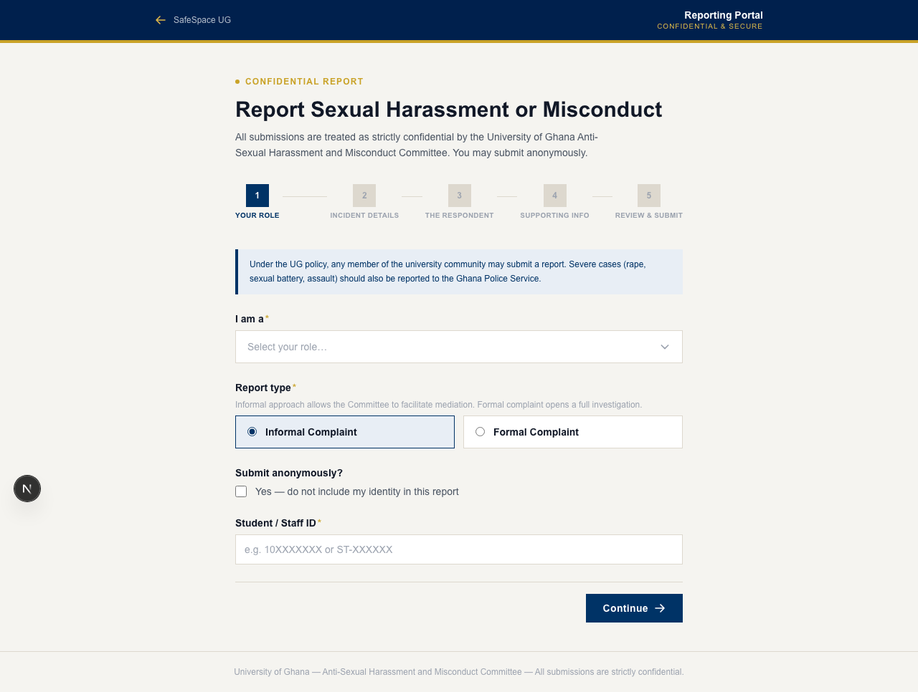
Reporting Home
It is worth noting that the institutional response process formally begins once a report is successfully submitted. Under the university’s policy framework, the designated committee must acknowledge receipt and notify relevant parties within defined timeframes. The platform tracks these deadlines automatically, ensuring that no report falls through administrative gaps.

4. Identity & Access — How Users Are Verified

Purpose & Philosophy
SafeSpace UG handles deeply sensitive matters — allegations of misconduct, personal testimony, evidence submissions, and institutional decisions that can affect careers, academic standing, and lives. For this reason, the platform does not allow open public registration. There is no “Sign Up” button that anyone on the internet can click to create an account.
This is an intentional and fundamental design decision rooted in institutional integrity.

Why Access Is Institutionally Governed
The platform is designed to operate within the University of Ghana’s existing identity ecosystem. Every student, faculty member, and staff member at the university already possesses institutional credentials — a university ID number, an institutional email address, and a verified role within the university community. SafeSpace UG leverages this existing identity infrastructure rather than creating a parallel one.
This approach serves several critical purposes:
Preventing Impersonation. In a system that handles misconduct allegations, it is essential that every participant is who they claim to be. By tying access to verified institutional identities, the platform eliminates the risk of external actors creating fraudulent accounts to file false reports, interfere with ongoing cases, or access sensitive information.
Ensuring Accountability. Every action taken within the platform — from filing a complaint to rendering a committee decision — is attributable to a verified member of the university community. This accountability is foundational to the integrity of the process.
Preserving Confidentiality. By restricting access to verified university members, the platform ensures that sensitive case information is only accessible to individuals with a legitimate institutional relationship to the matter at hand.
Supporting Institutional Governance. The university’s harassment policy designates specific roles and responsibilities — committee members, investigators, designated support personnel. The authentication system ensures that only individuals properly assigned to these roles can access the corresponding administrative functions.
In a production deployment, the authentication system would integrate directly with the university’s official identity management infrastructure, ensuring seamless verification against current enrolment and employment records. Users do not create new accounts — they access the platform using their existing institutional credentials.

The Login Experience
The authentication interface is clean and purposeful. Users identify themselves using their university ID or institutional email address along with a personal passcode. The interface provides clear pathways for password recovery, ensuring that access barriers are minimal for legitimate users while remaining robust against unauthorised access.
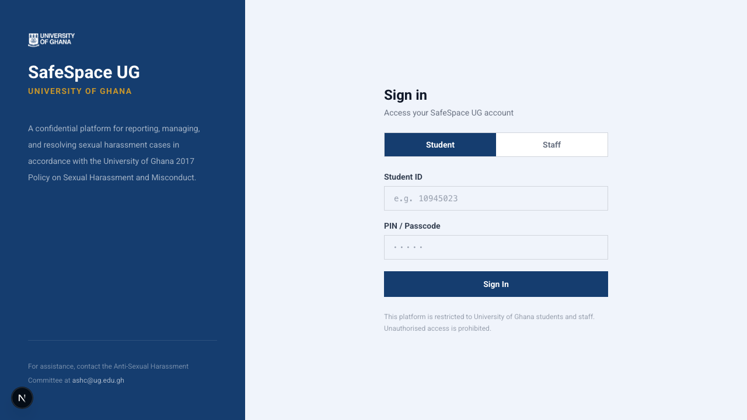
Auth Login
The registration view exists to support the initial onboarding of verified users into the platform — not as an open public registration form. Access is always tied to institutional identity verification.
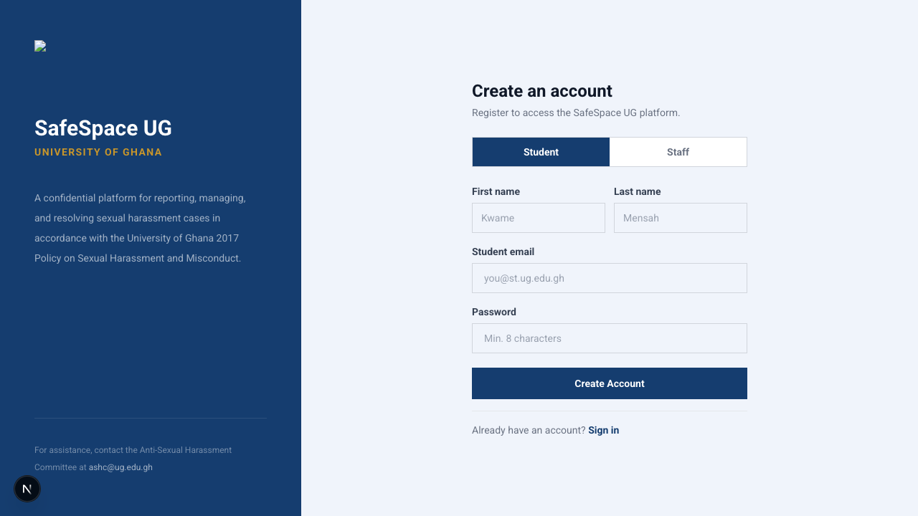
Auth Register
The password recovery flow provides a straightforward pathway for users who need to regain access to their accounts, ensuring that temporary credential issues never prevent someone from participating in time-sensitive case activities.
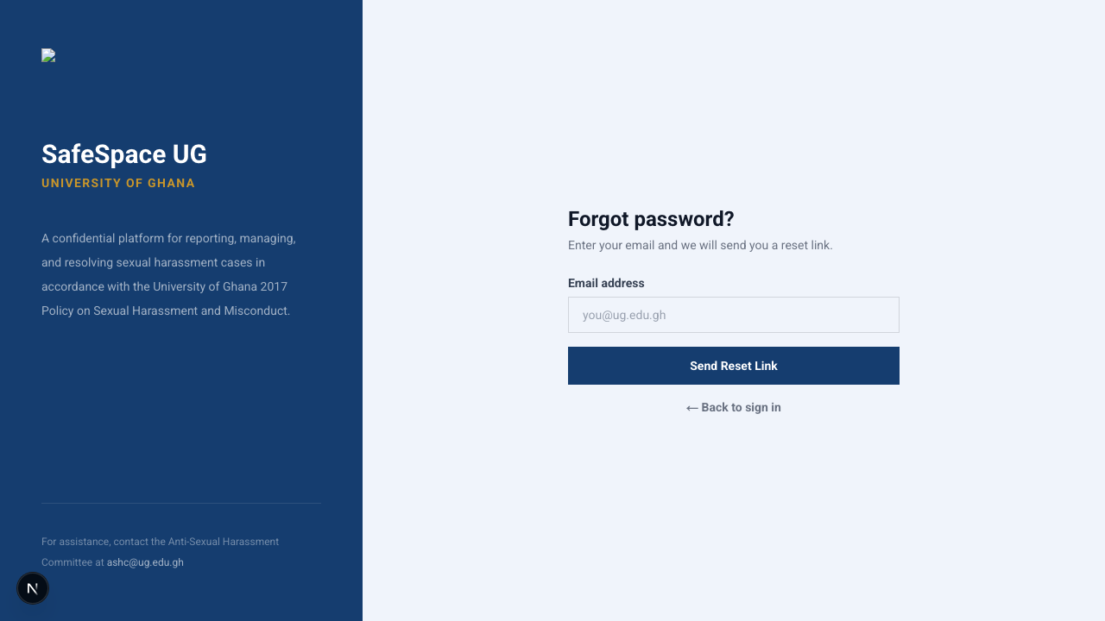
Auth Forgot Password

5. The Participation Portal

Purpose & Philosophy
The Participation Portal is perhaps the most emotionally significant application in the SafeSpace UG ecosystem. This is where individuals who are directly involved in an active case — whether as a complainant, a respondent, or a witness — come to manage their participation in the institutional process.
The design challenge here is profound: how do you create an interface that serves people on opposite sides of an allegation with equal fairness, clarity, and respect?
The answer lies in role-based visibility. Every user who logs into the Participation Portal sees only the information that is relevant to their specific role in their specific case. A complainant sees their own submissions, their hearing schedule, and their correspondence with the committee. A respondent sees the allegations made against them, the deadline for their formal response, and their own hearing schedule. A witness sees only the specific matter they have been asked to contribute to.
No participant can see another participant’s private information, communications, or case materials. This strict separation protects everyone involved and ensures that the platform itself cannot become a vector for intimidation, harassment, or unfair advantage.

The Dashboard — A Calm Centre in a Difficult Process
When a participant first logs into the portal, the dashboard is intentionally designed to avoid overwhelming them. If they have no active cases linked to their identity, the interface is entirely neutral — calm, informative, and uncluttered. If they are involved in one or more active cases, the dashboard provides a clear, immediate summary of what requires their attention.
This design reflects a trauma-informed approach to interface design. During emotionally difficult situations, cognitive overload is a real risk. The dashboard prioritises clarity over density, showing only the most essential information: active cases, upcoming deadlines, and pending actions. Everything else is accessible through clearly labelled navigation, available when the user is ready to explore it.
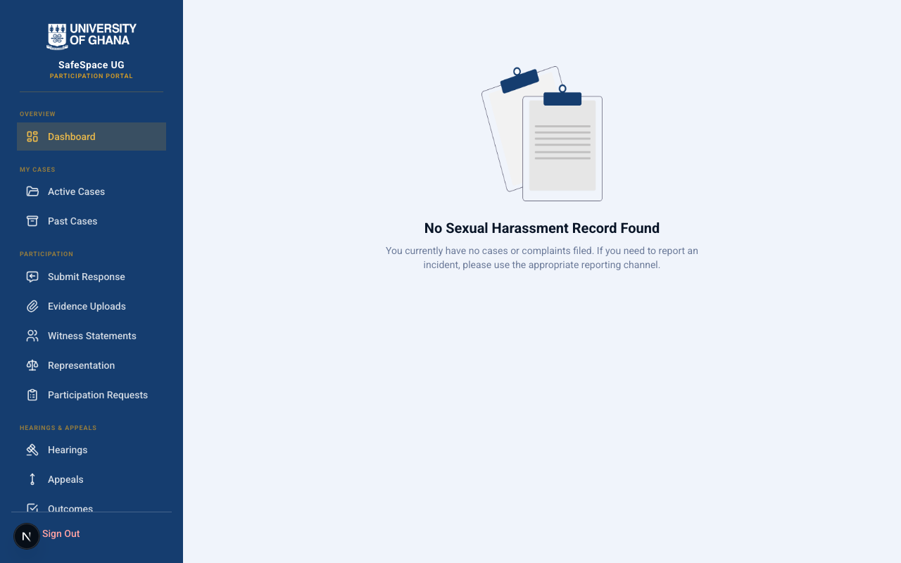
Participation Portal Dashboard - Logged In (Student)

Navigating Case Involvement
The portal provides structured access to every aspect of a participant’s involvement in the institutional process. Each section is designed to answer specific questions that participants commonly have during an ongoing case.

Cases — “What matters involve me?”
The Cases view provides a comprehensive overview of all cases in which the user has an assigned role. Each case displays its current status, key dates, and the user’s specific role. This transparency helps participants understand exactly where things stand without needing to contact the committee for updates.
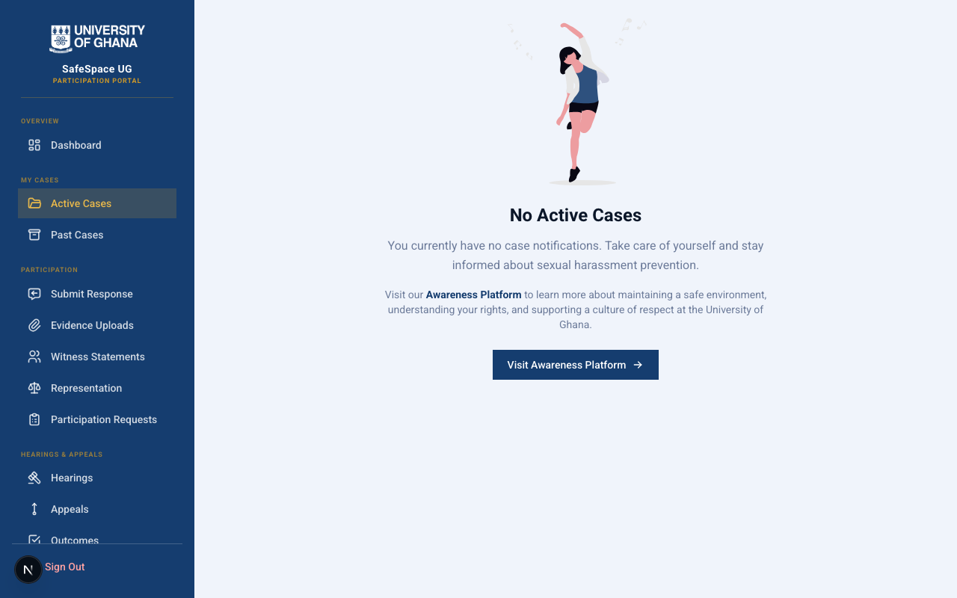
Cases

Deadlines & Timeline — “When do I need to act?”
One of the most anxiety-inducing aspects of any institutional process is uncertainty about timelines. The Deadlines view addresses this directly by presenting all relevant deadlines in a clear, visual format. The 60-day investigation timeline mandated by university policy is prominently displayed, along with any specific response deadlines assigned to the participant.
The Timeline view provides a chronological record of all significant events in the case — when the complaint was filed, when notifications were sent, when hearings were scheduled, and when decisions were rendered. This transparency helps participants feel informed and reduces the anxiety that comes from not knowing what is happening with their case.
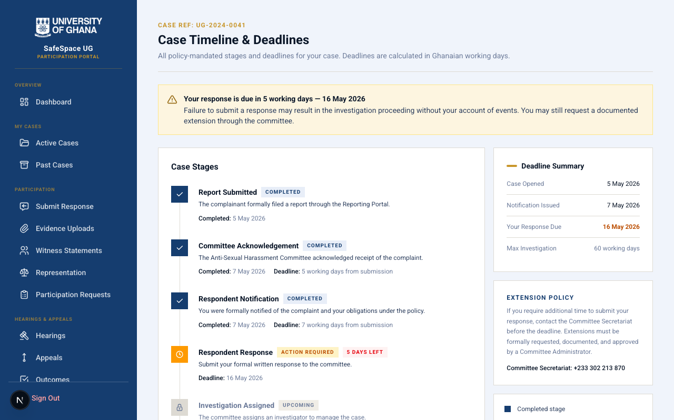
Deadlines
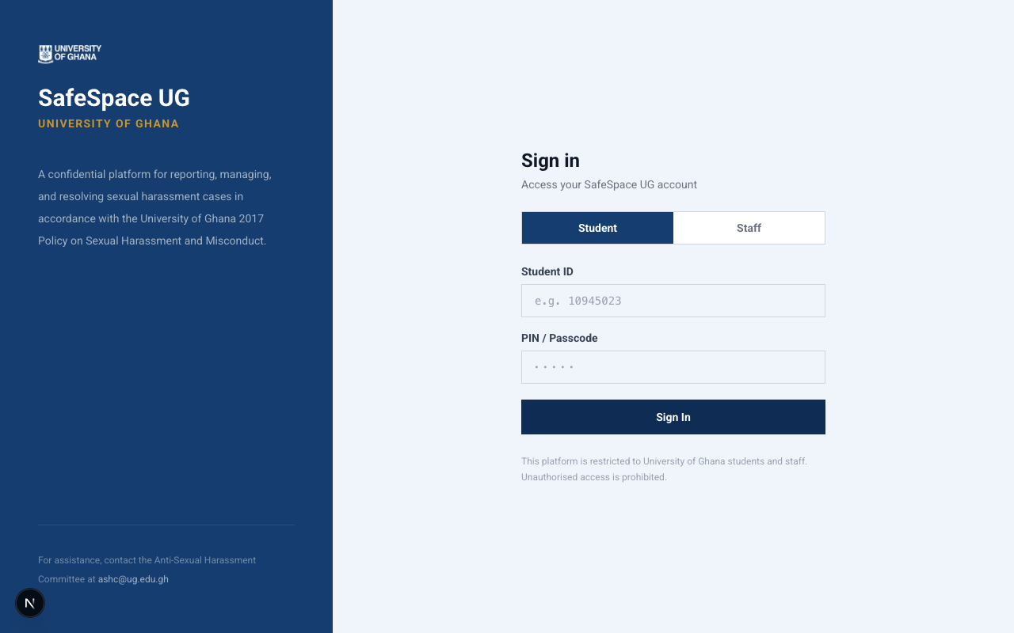
Timeline

Communications & Notifications — “Is anyone trying to reach me?”
All formal correspondence between the committee and individual participants flows through the platform’s secure communication system. This ensures that important messages are never lost in email spam folders, that all communications are properly documented, and that participants can reference past correspondence at any time.
The Notifications section provides alerts about case updates, upcoming deadlines, and required actions, ensuring that participants are never caught off guard by procedural developments.

Communications

Notifications

Hearings & Outcomes — “What happens next?”
The Hearings view shows all scheduled hearing sessions, including dates, expected duration, and any preparation materials the participant should review. The Outcomes view, accessible after a decision has been rendered, presents the formal resolution of the case in clear language.
These views work together to demystify the most daunting part of the process. By providing clear information about what to expect at a hearing and what the possible outcomes are, the platform helps reduce the fear and uncertainty that often accompanies formal proceedings.
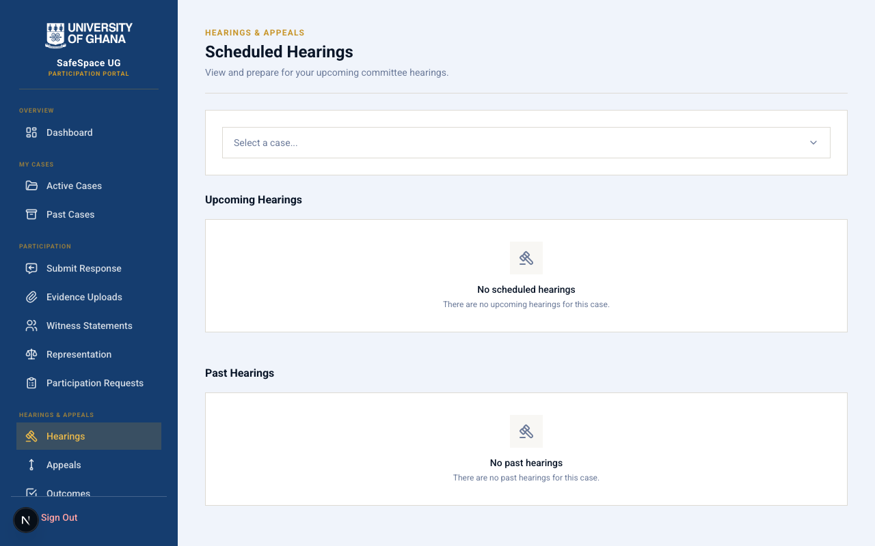
Hearings
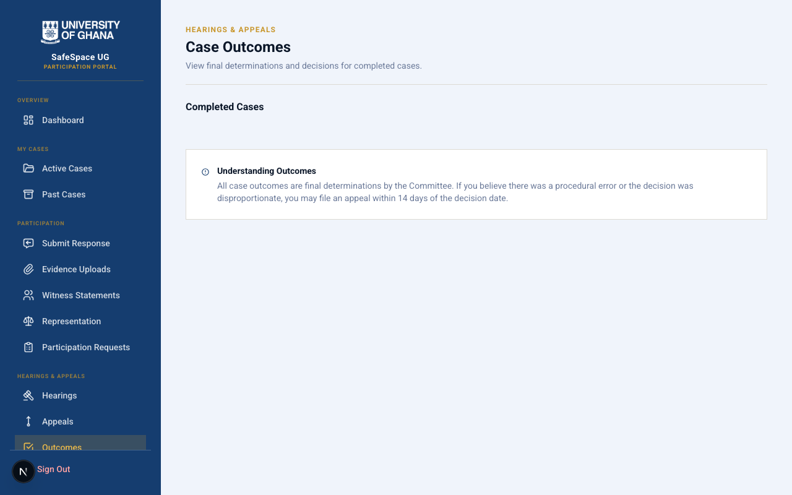
Outcomes

Appeals — “What if I disagree with the outcome?”
The university’s policy provides for an appeal process, and the platform makes this right clearly accessible. The Appeals section explains the grounds for appeal, the timeline for filing, and the process that follows. If a participant chooses to appeal, the submission flow is guided and supportive, mirroring the care taken in the original reporting process.
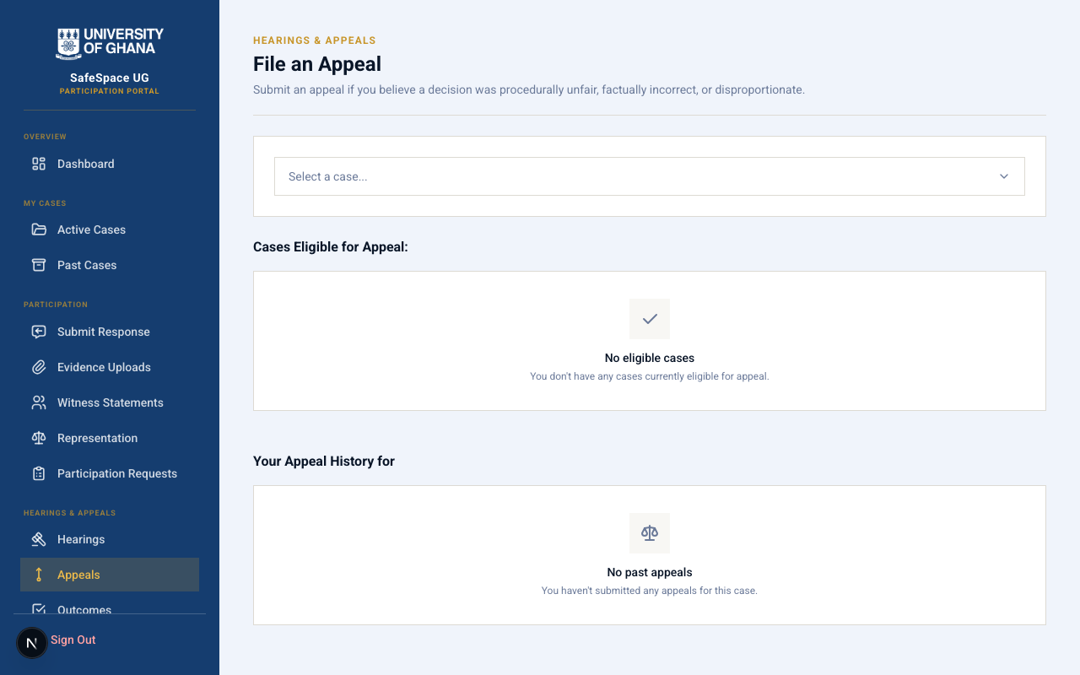
Appeals

Rights, Resources & Participation Details — “Where can I get help?”
Even within a structured institutional process, participants need ongoing access to information about their rights and available support services. The Rights page reiterates the protections afforded to all participants. The Resources page connects users to counselling, legal aid, and peer support. The Participation Details page provides a comprehensive overview of the user’s involvement across all active matters.
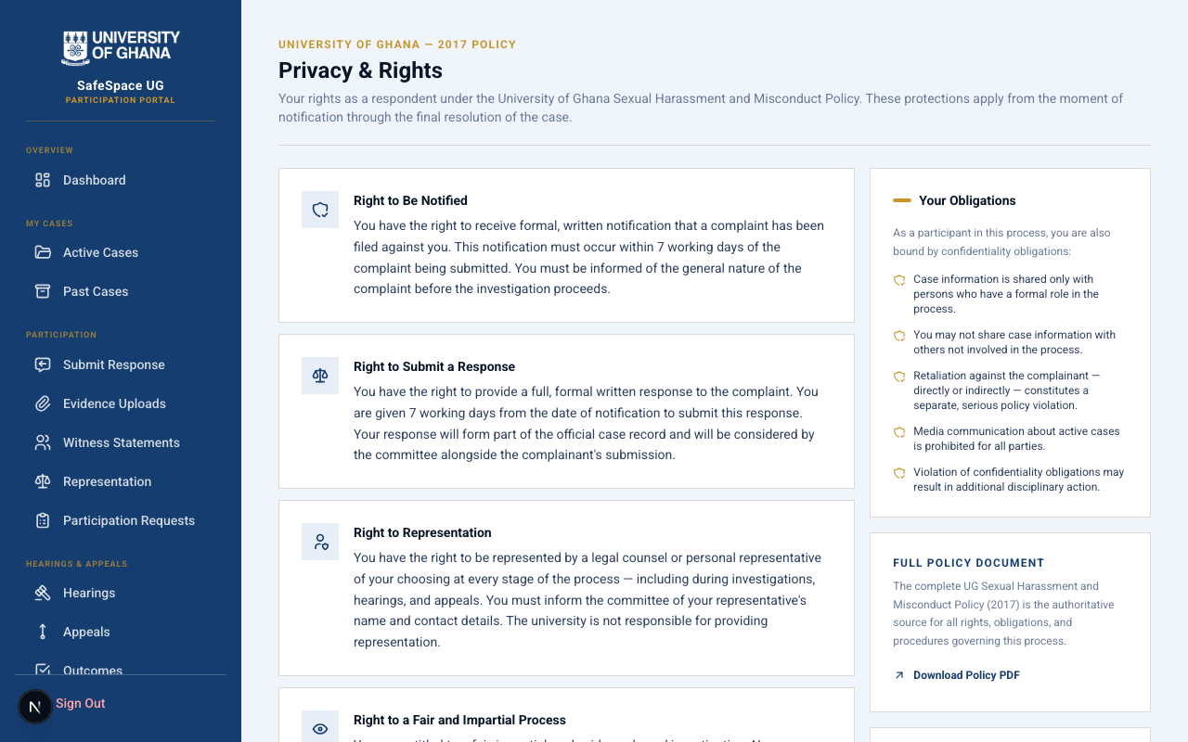
Rights
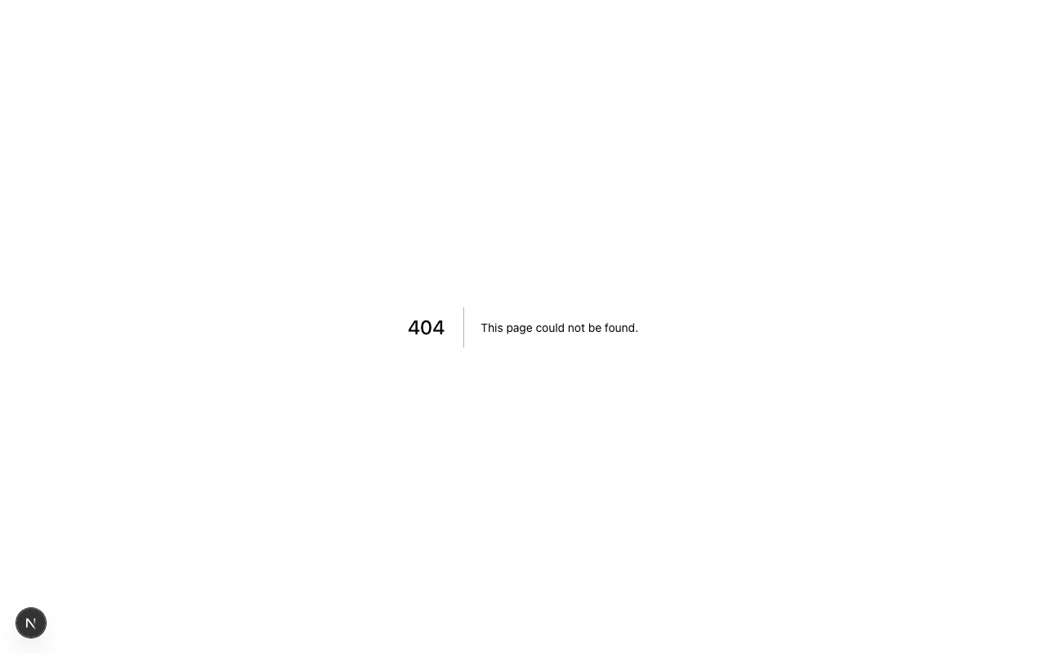
Resources

Participation Details

Account — Personal Profile & Security
The Account section allows participants to manage their personal information and security settings. This includes the ability to update contact information and manage access credentials, ensuring that participants maintain control over their own platform presence.
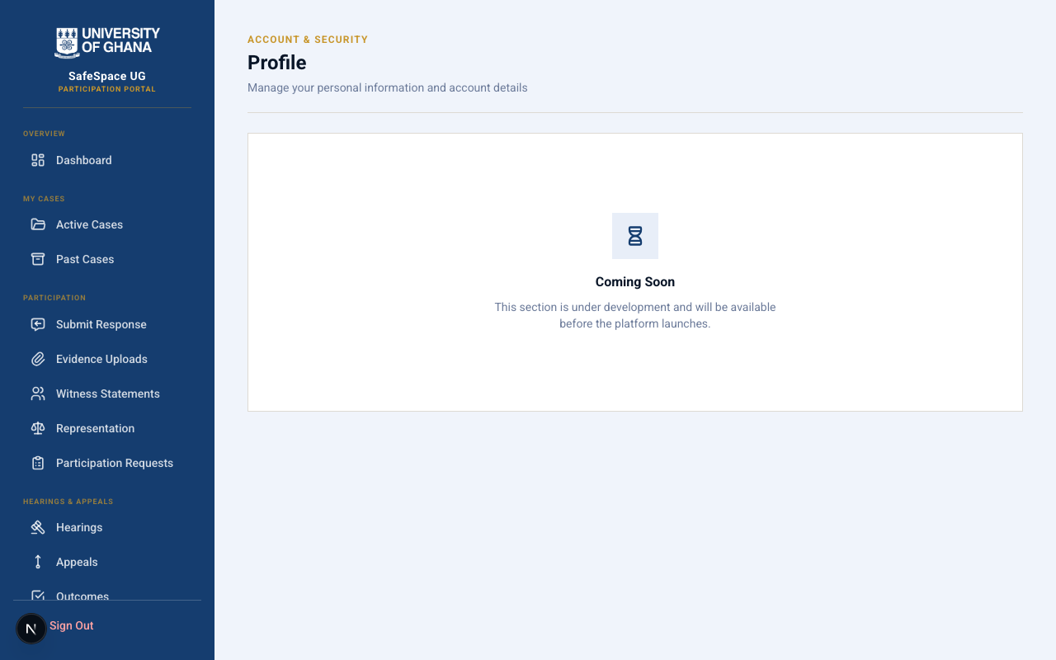
Account Profile

6. The Committee Dashboard

Purpose & Philosophy
The Committee Dashboard is the operational nerve centre of the SafeSpace UG ecosystem. While the other portals are designed around emotional safety and user accessibility, the Committee Dashboard is designed around institutional accountability, operational efficiency, and procedural rigour.
This is where designated committee members — appointed by the university to oversee the harassment response process — coordinate investigations, manage case workflows, enforce policy-mandated deadlines, schedule and conduct hearings, record formal decisions, and maintain a comprehensive audit trail of every action taken.
The interface is intentionally more data-oriented than the public-facing portals. Committee members are trained professionals who need rapid access to operational information: how many active cases require attention, which deadlines are approaching, which complaints have not yet been acknowledged, and which hearings need to be scheduled. The design prioritises operational clarity and efficiency while maintaining the gravity appropriate to the subject matter.

The Committee Home — Operational Overview
Upon logging in, committee members are presented with a dashboard that provides an immediate snapshot of the current operational state. Active case counts, pending actions, approaching deadlines, and recent activity are all visible at a glance. This allows committee members to quickly assess their priorities and direct their attention where it is most urgently needed.
Deadline enforcement is a core feature of this dashboard. The university’s policy mandates specific timeframes for every stage of the process — acknowledgement of complaints, notification of respondents, completion of investigations, and delivery of decisions. The dashboard visually flags items that are approaching their deadlines and highlights items that have exceeded them, ensuring that institutional obligations are met consistently.
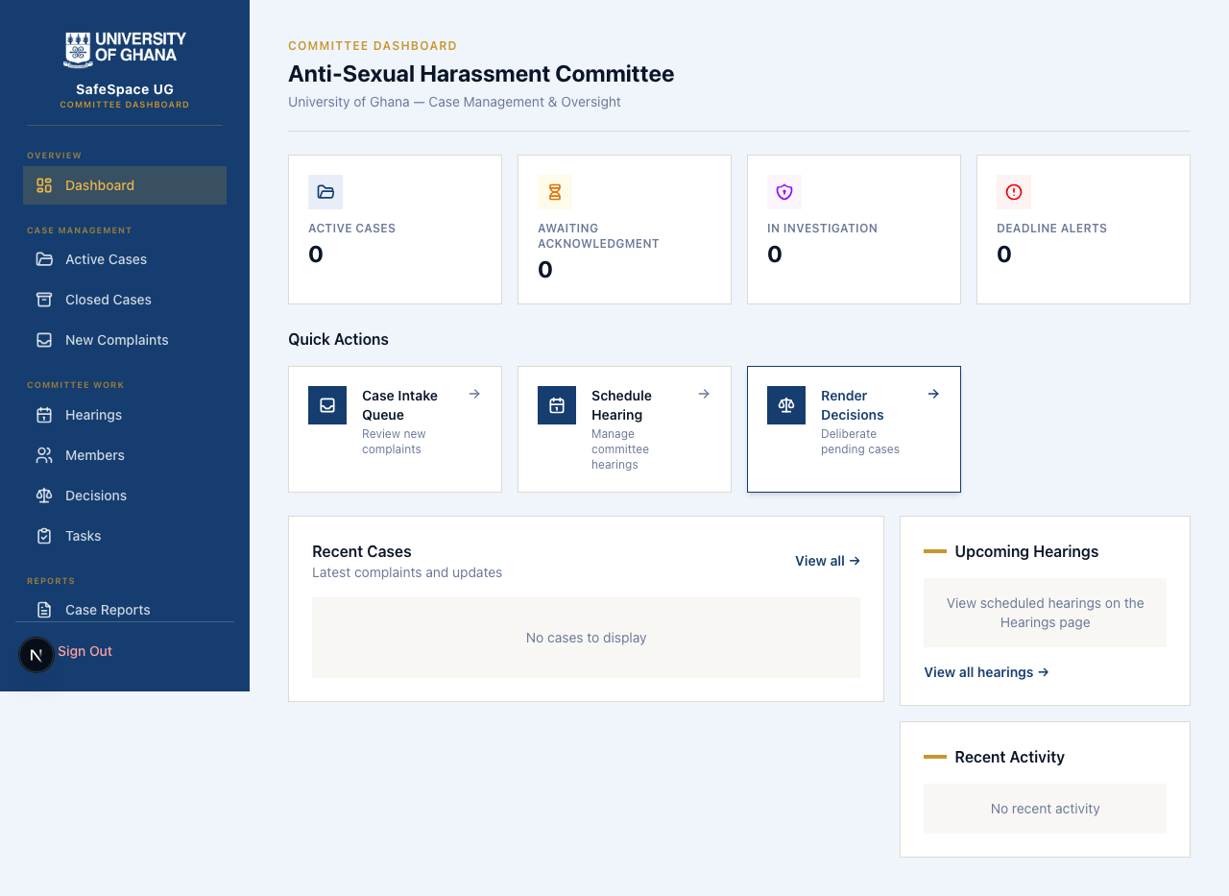
Committee Dashboard - Logged In (Staff)

Detailed Administrative Views
The Committee Dashboard provides comprehensive views for every aspect of the institutional response process:

Dashboard — At-a-Glance Metrics
The main dashboard aggregates key operational metrics into a clear, scannable overview. Committee members can immediately see the volume and status of cases, complaints, and tasks across the entire system. This view supports both day-to-day operational management and longer-term strategic oversight.
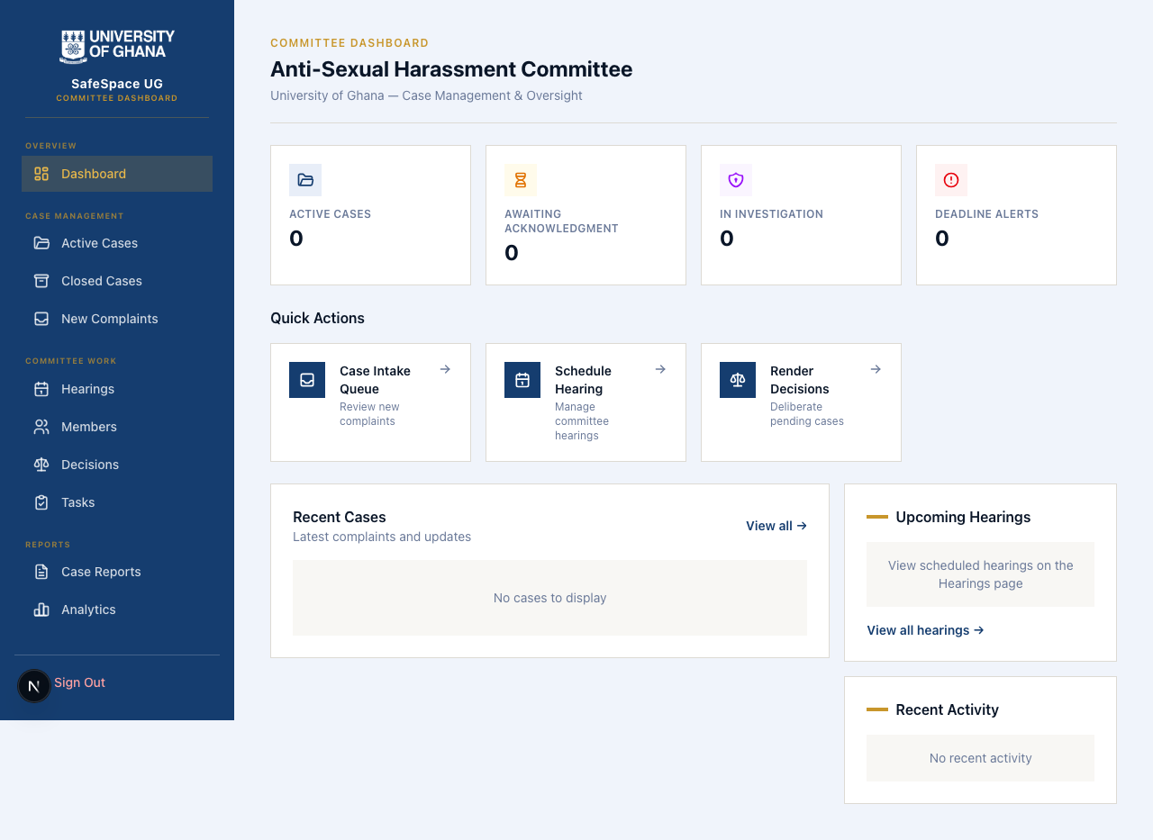
Dashboard Overview

Case Management — Active & Closed
The Cases section is the primary workspace for managing ongoing investigations. Committee members can view all active cases, review their current status, access associated documentation, and track progress against institutional timelines. The Closed Cases view provides a searchable archive of resolved matters, supporting institutional record-keeping and pattern analysis.
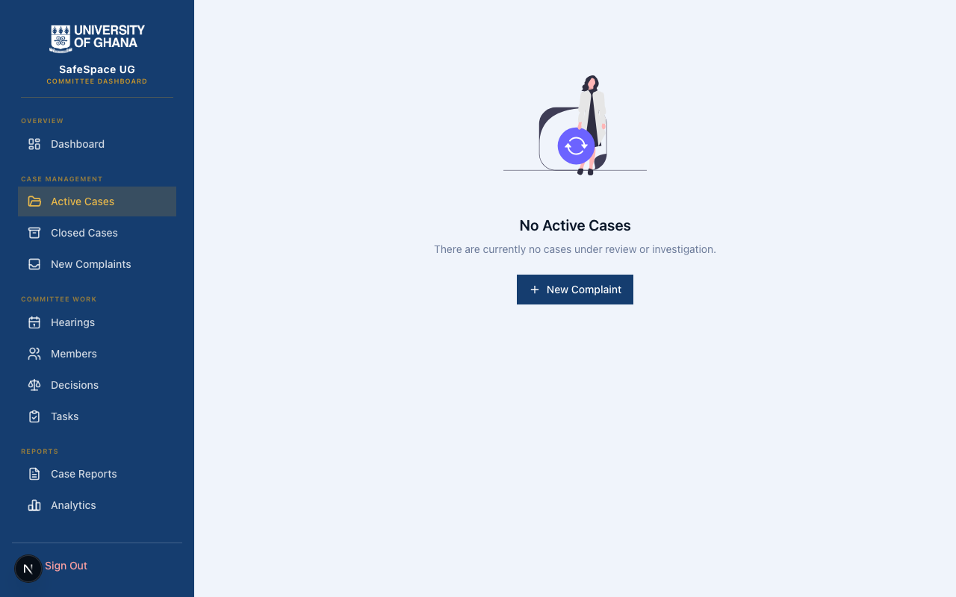
Cases
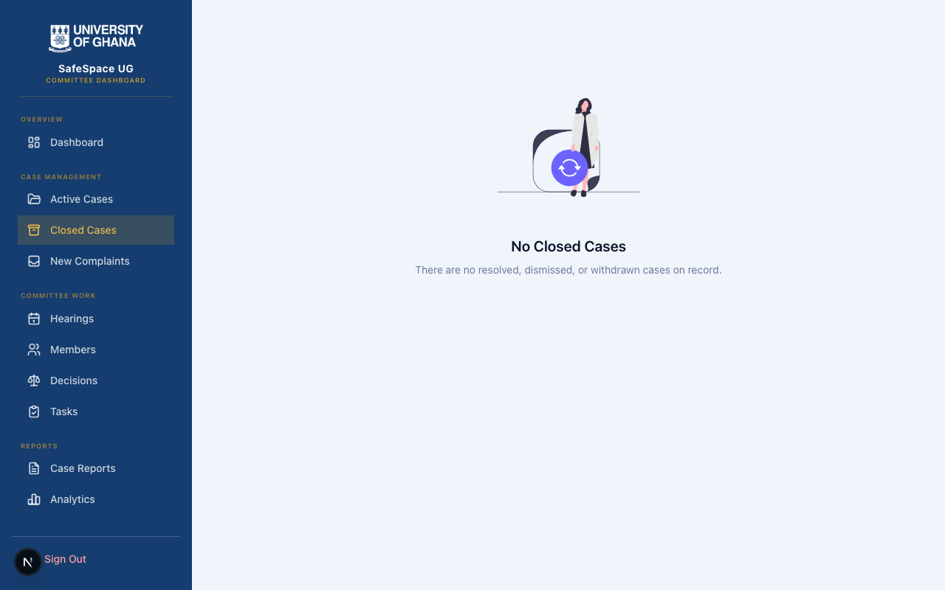
Closed Cases

Complaints — Intake & Assignment
The Complaints section surfaces all incoming reports that have been submitted through the Reporting Portal but have not yet been assigned to an investigator or formally acknowledged. This is the first point of institutional response, and the interface ensures that no complaint goes unnoticed or unaddressed.
The New Complaints view provides a streamlined intake workflow where committee members can review submission details, assess the nature and urgency of the complaint, and initiate the formal case creation process.
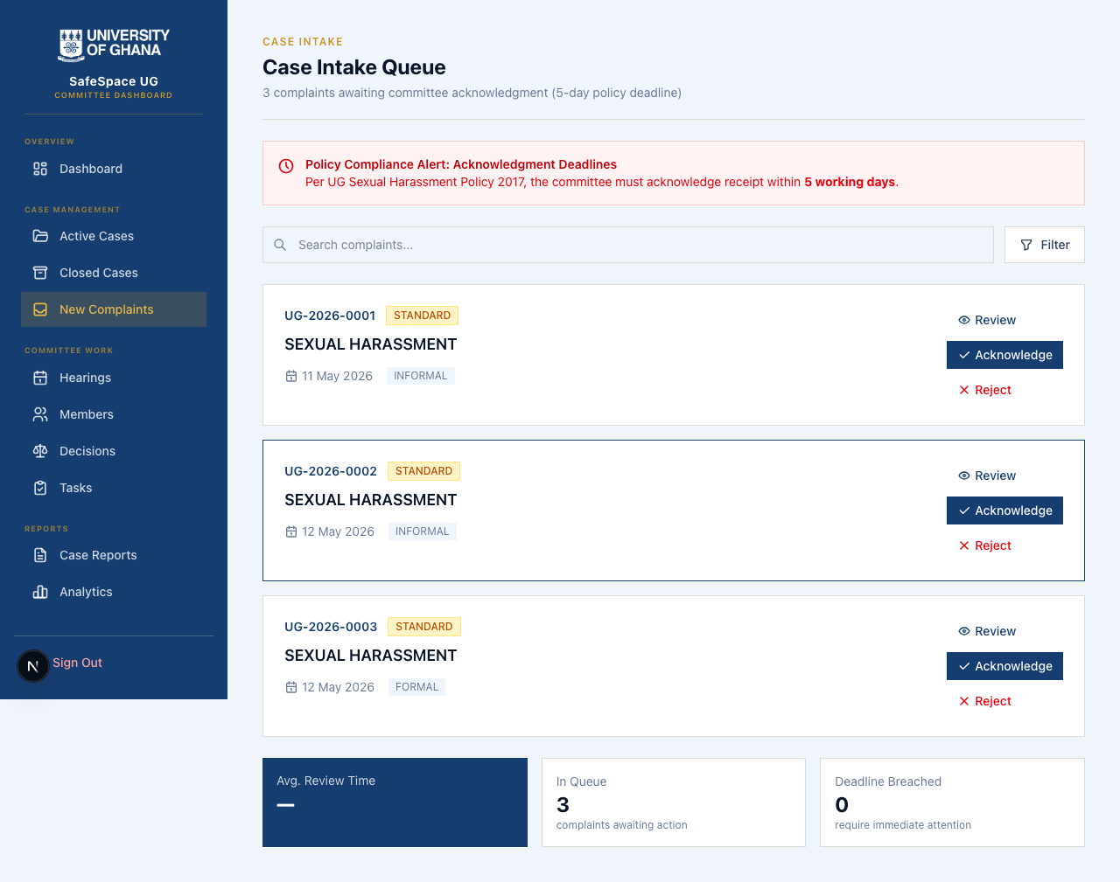
Complaints List
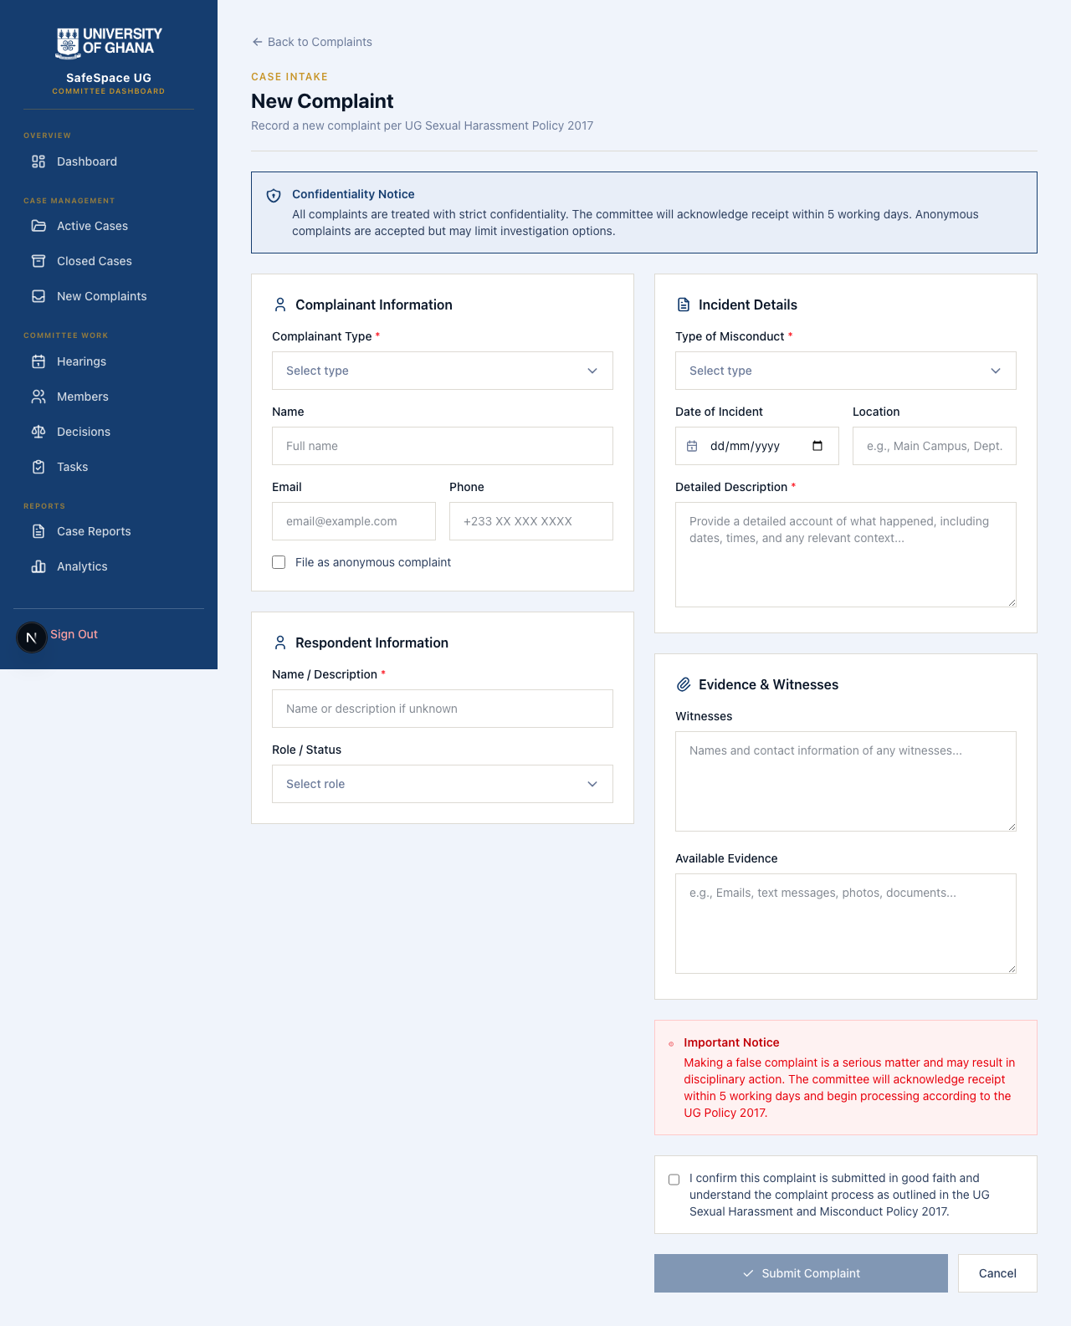
New Complaints

Hearings — Scheduling & Preparation
The Hearings section supports the formal hearing process mandated by university policy. Committee members can view all scheduled hearings, create new hearing sessions, assign participants, and manage hearing logistics. The scheduling interface helps coordinate the complex logistics of bringing together committee members, complainants, respondents, and witnesses within policy-mandated timeframes.
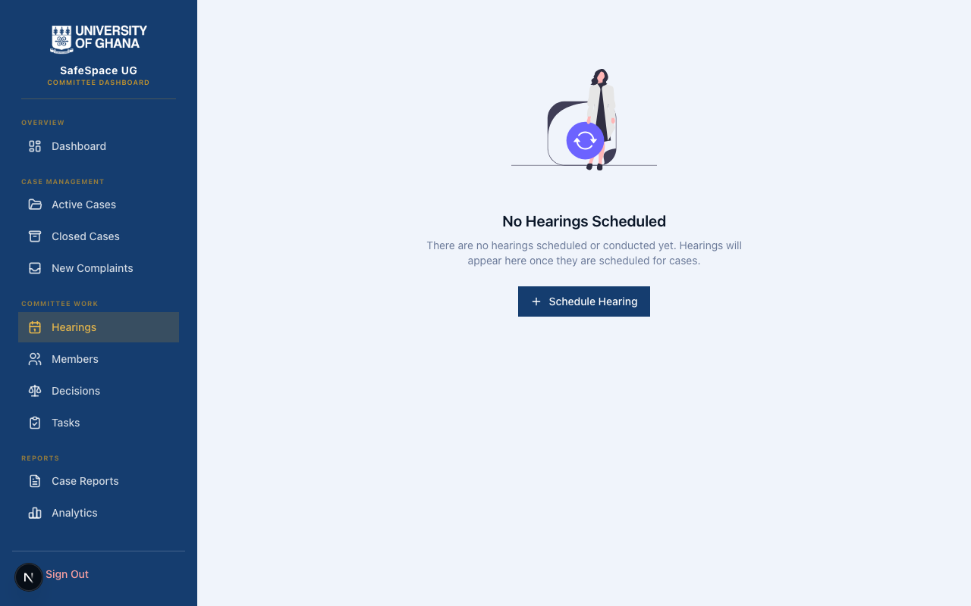
Hearings List
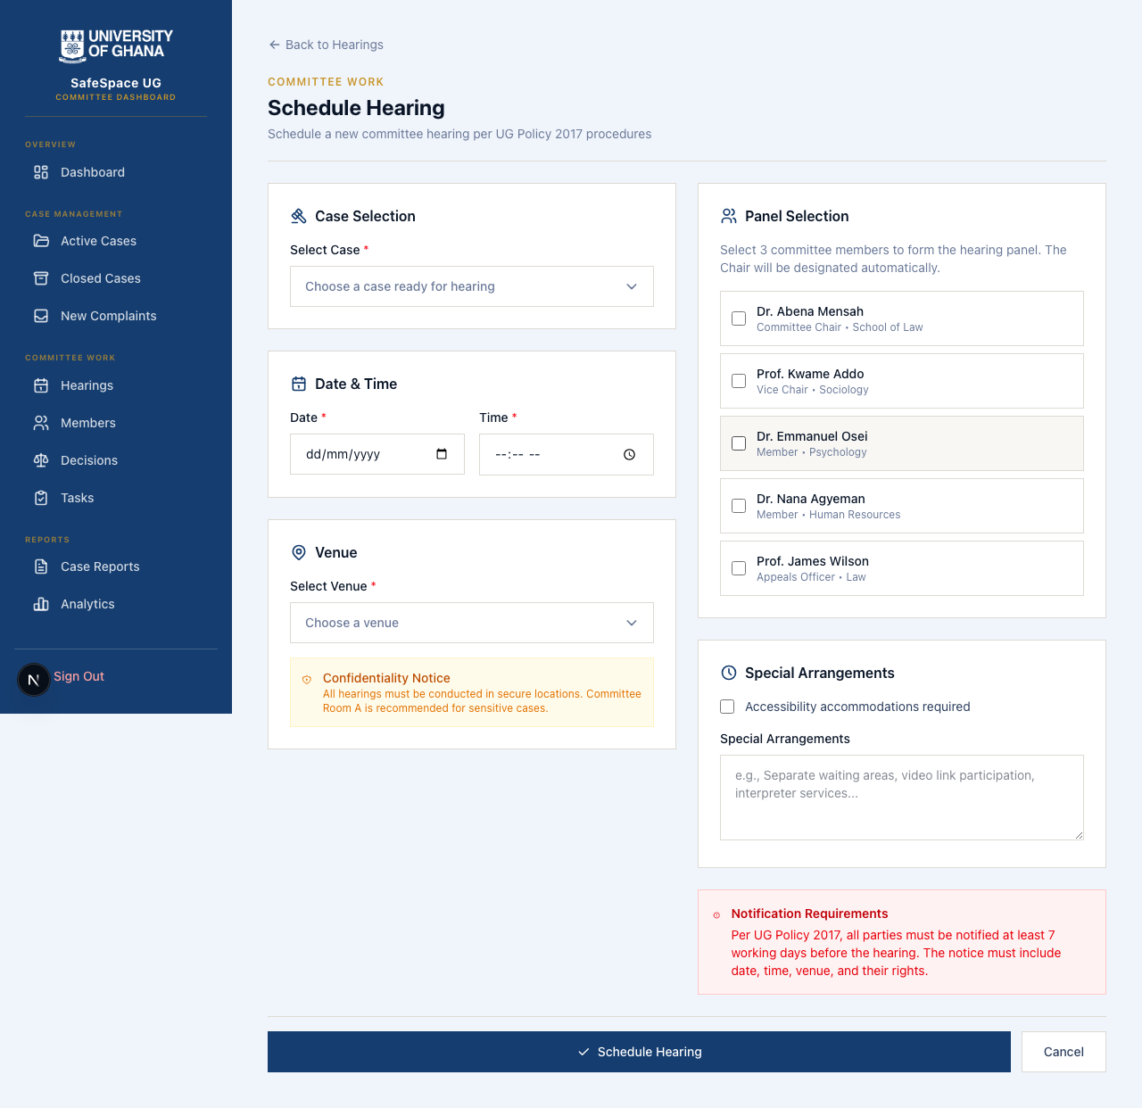
Schedule Hearings

Decisions — Recording Formal Outcomes
The Decisions section is where formal resolutions are documented. After investigations are complete and hearings have been conducted, committee members record their findings, recommendations, and decisions in a structured format that becomes part of the permanent institutional record.
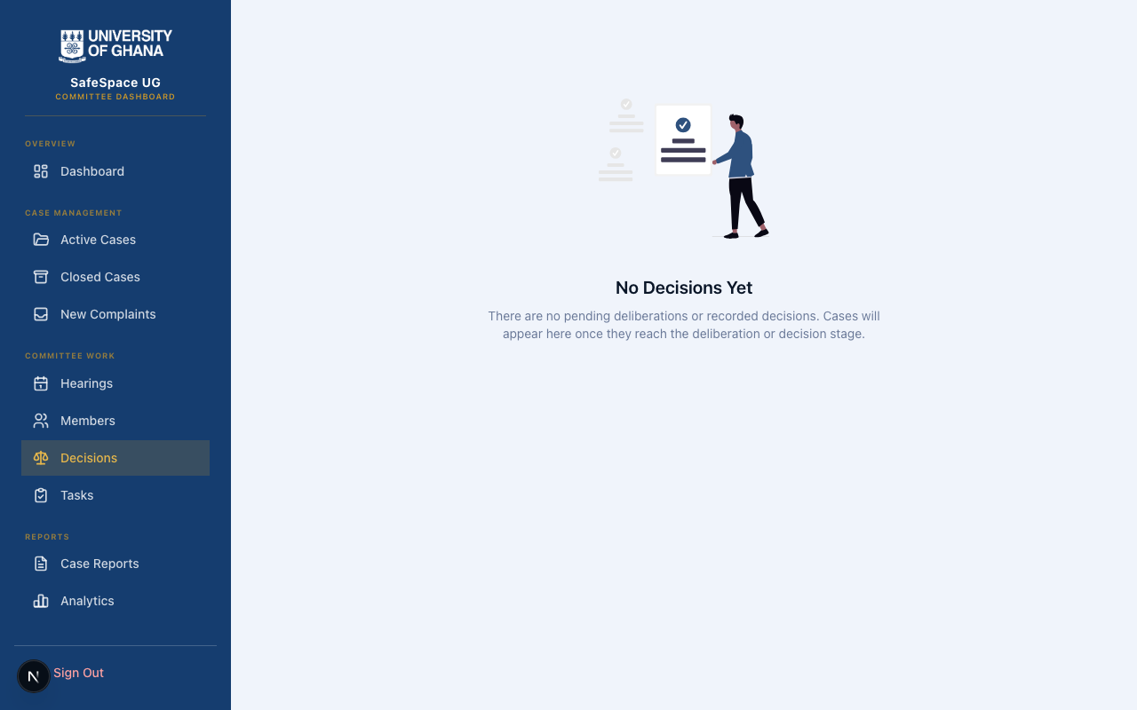
Decisions

Task Management — Internal Coordination
The Tasks section supports the internal operational coordination of the committee. Tasks can be created, assigned to specific committee members, tracked against deadlines, and marked as complete. This ensures that the administrative work of managing investigations — document reviews, evidence assessments, procedural follow-ups — is systematically tracked and distributed.
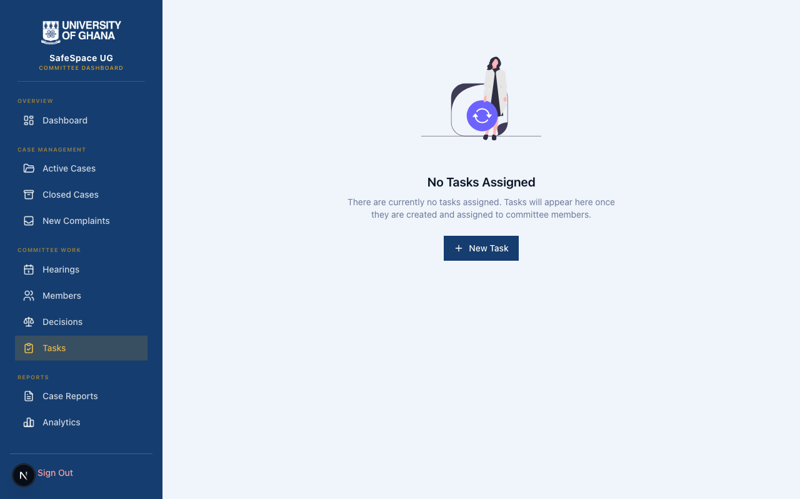
Tasks List
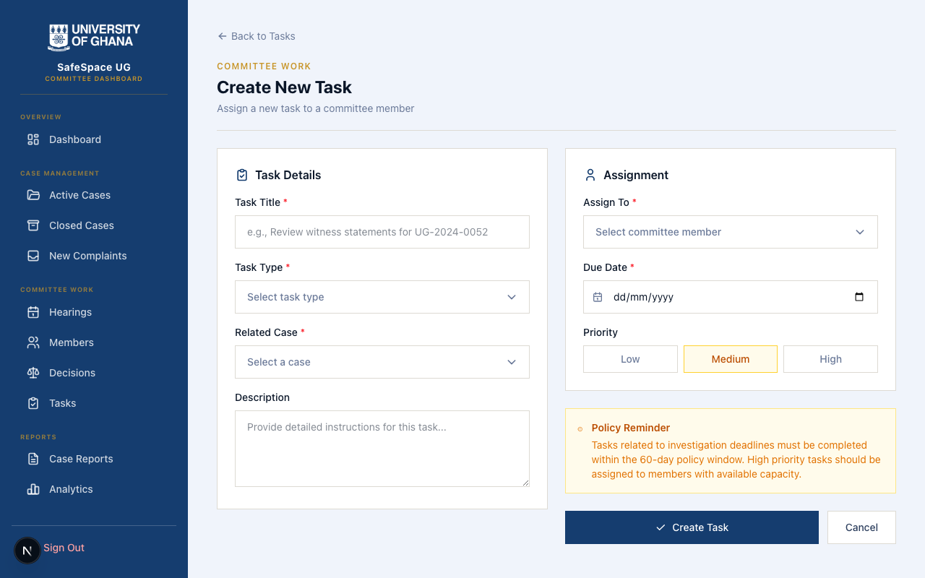
New Task

Reports & Analytics — Institutional Transparency
The Reports and Analytics sections provide aggregated, anonymised data about platform activity and case outcomes. These views support the institutional obligation to monitor patterns, assess the effectiveness of the response process, and report to university leadership on the state of harassment prevention and response.
This data is presented in a way that preserves individual confidentiality while providing meaningful institutional insight. Trend analysis, case volume tracking, resolution timelines, and outcome distributions help the university understand whether its response mechanisms are working effectively and where improvements may be needed.
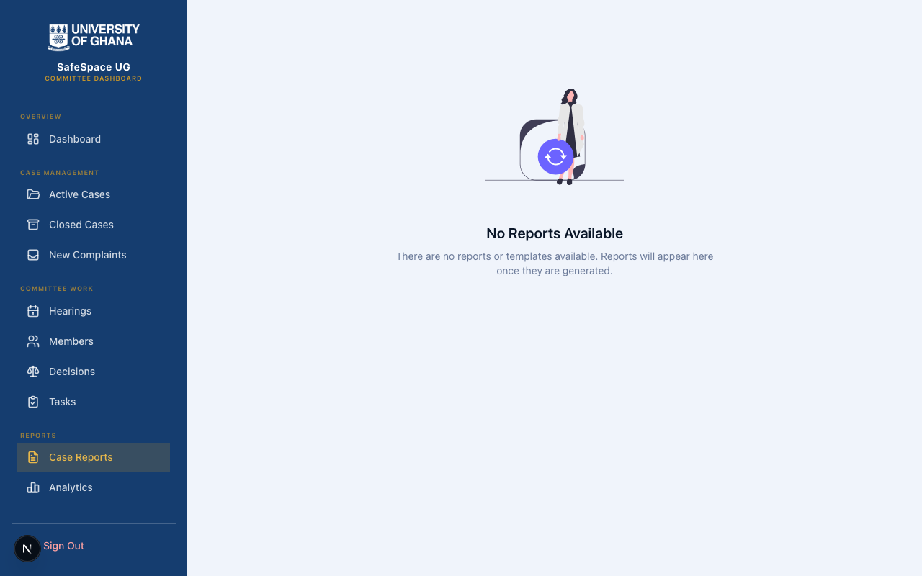
Reports
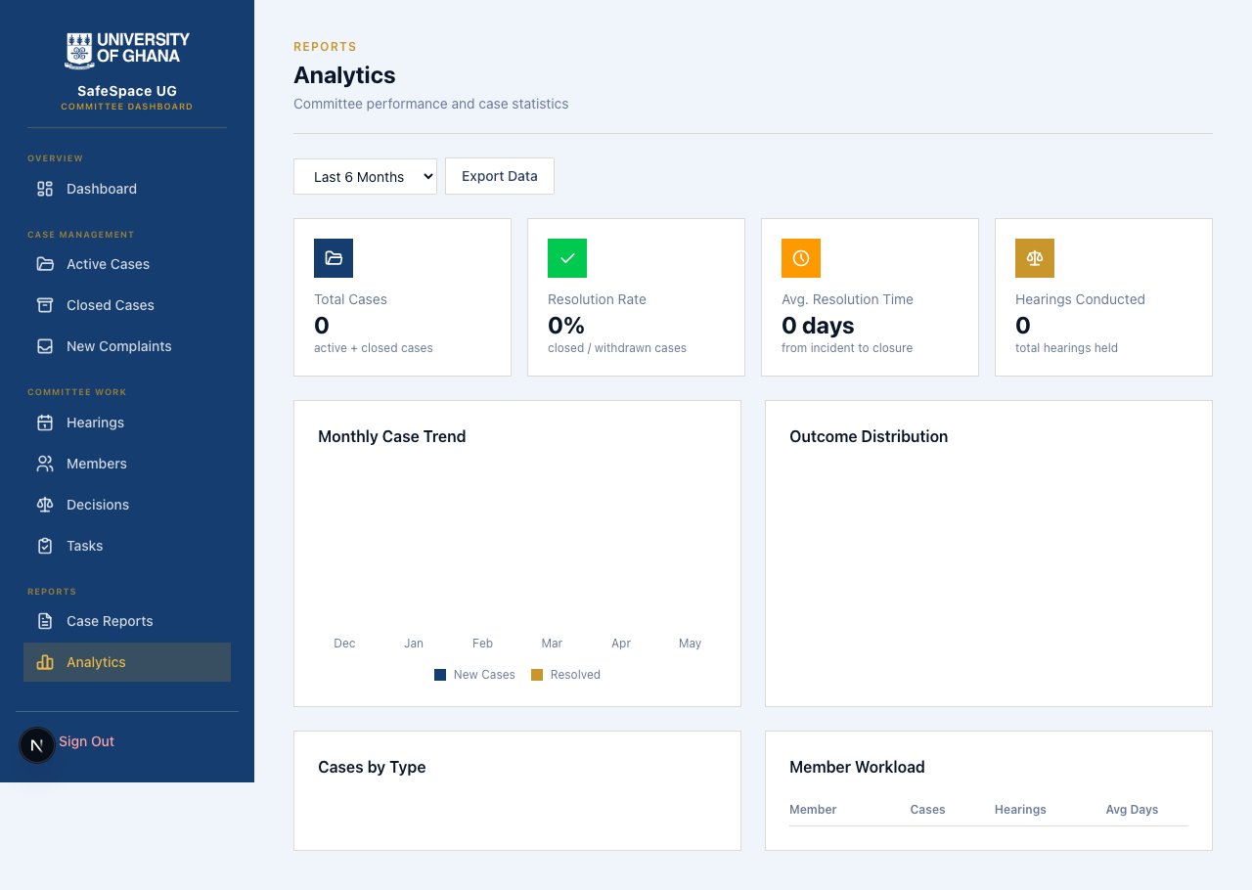
Analytics

Member Management & Settings — Administrative Control
The Members section allows authorised administrators to manage the committee’s composition — adding new members, reviewing current assignments, and ensuring that the committee roster reflects current institutional appointments. The Settings section provides configuration options for platform operations.
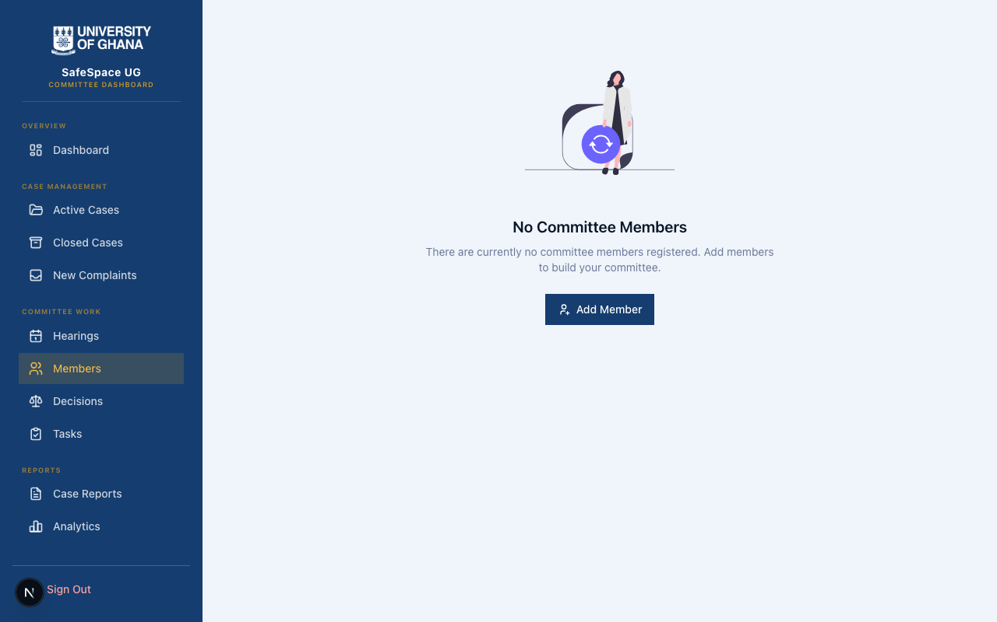
Members
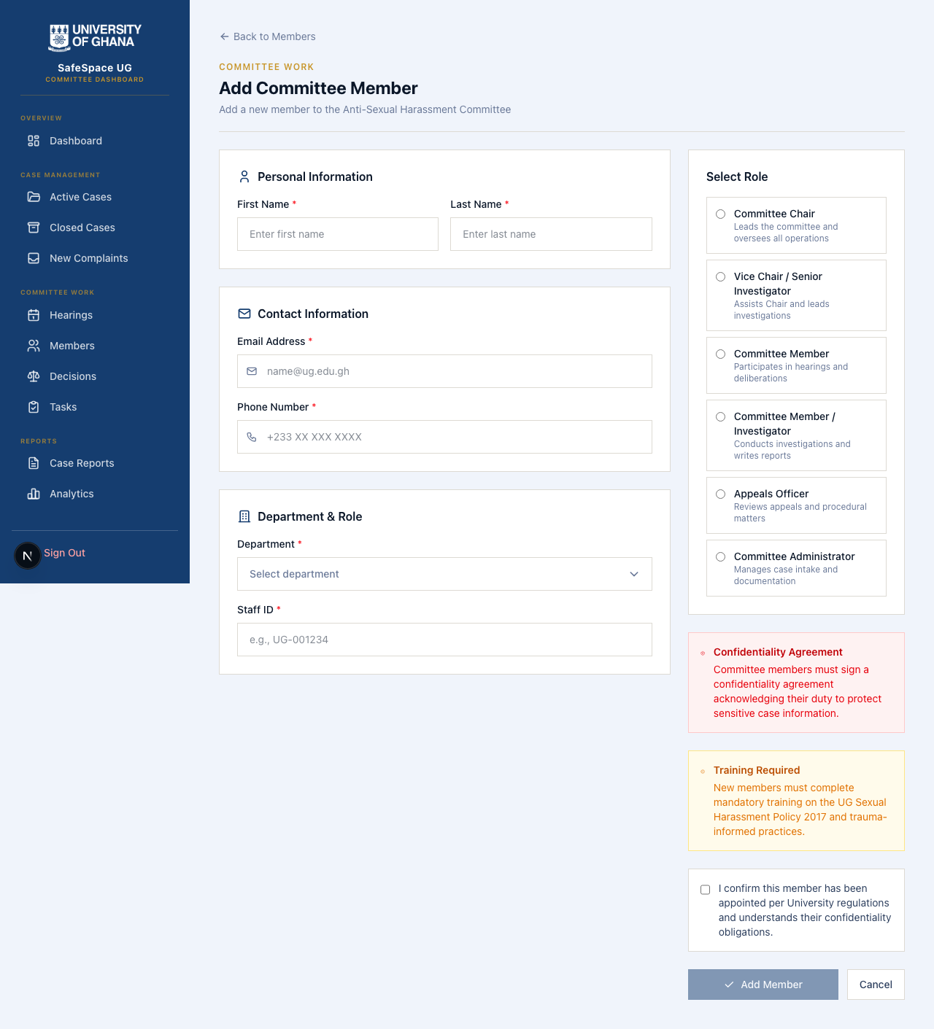
Add Member
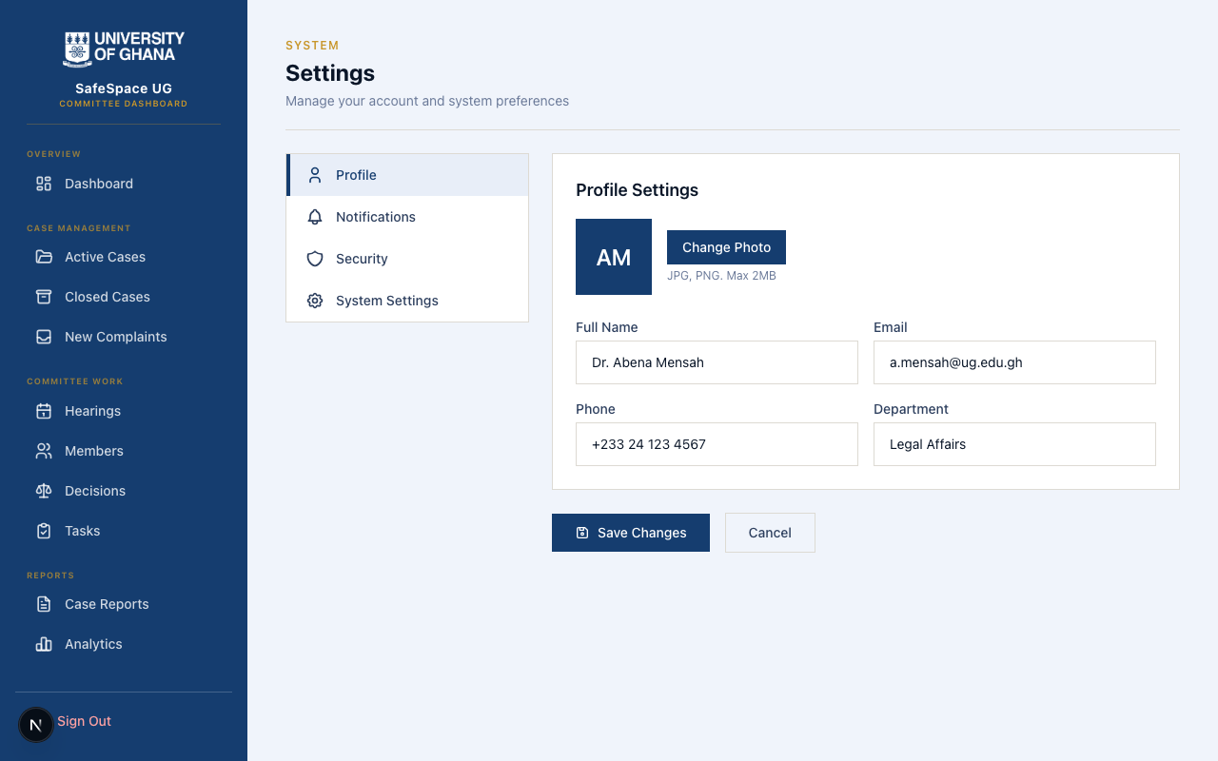
Settings

7. Access Control & Participant Privacy
SafeSpace UG implements a carefully layered access model that reflects the distinct roles defined in the university’s policy framework:
Community Members & Visitors can access the Public Awareness Platform freely, without any account or identification. They can also submit reports through the Reporting Portal — including anonymously — ensuring that the barrier to reporting is as low as possible.
Complainants, Respondents & Witnesses access the Participation Portal using their verified university credentials. Once authenticated, they can only see information directly relevant to cases in which they have an assigned role. A respondent cannot see a complainant’s private communications. A witness cannot access hearing outcomes for cases they were not involved in. This strict role-based visibility protects all participants and maintains the integrity of the process.
Committee Members access the administrative Dashboard using their staff credentials and designated committee role. They have the operational visibility needed to manage cases effectively, but their actions are fully logged and auditable, ensuring that administrative power is exercised transparently and responsibly.

8. Evidence & Document Handling
When participants upload evidence or supporting documents through the platform — whether during the initial reporting process or later during case participation — those files are stored securely using encrypted, access-controlled storage. Documents are never publicly accessible. Access is granted only to authorised participants for limited timeframes, and every access event is recorded.
The platform handles this complexity invisibly. From the user’s perspective, uploading a file is as simple as selecting it from their device. The security measures that protect that file from the moment of upload are entirely behind the scenes, requiring no technical knowledge from the user.

9. Confidentiality & Safety Measures
The platform implements comprehensive confidentiality protections throughout every layer of the system:
- Personal information is carefully controlled, with access limited strictly to those with a legitimate need to know within the context of a specific case.
- Anonymous submissions are genuinely anonymous — no identifying information is associated with the report in the platform’s records.
- Communications between participants and the committee are conducted through the platform’s secure messaging system, creating a documented record while preventing unauthorised access.
- All administrative actions taken by committee members are permanently recorded, creating an audit trail that supports institutional accountability and protects against procedural irregularities.

10. Institutional Readiness
SafeSpace UG has been designed for real-world institutional deployment. The platform’s multi-application architecture provides natural security boundaries between different user groups. The consistent visual design across all applications creates a unified institutional identity while respecting the distinct needs of each audience.
The system is built to scale with the university’s needs, supporting concurrent users across all portals while maintaining the responsiveness and reliability that a sensitive reporting platform demands. The unified aesthetic — consistent colours, typography, and interaction patterns across all applications — ensures that users feel they are engaging with a single, cohesive institutional service regardless of which portal they are using.

11. Summary & Institutional Value
SafeSpace UG represents the University of Ghana’s commitment to translating policy into practice. The platform transforms the complex frameworks of the 2017 Sexual Harassment and Misconduct Policy into an accessible, navigable, and humane digital experience that serves every member of the university community.
For students, faculty, and staff seeking to understand their rights, the Public Awareness Platform provides clear, accessible education without requiring any personal information.
For individuals who experience harassment, the Reporting Portal offers a guided, supportive submission process that respects their pace, protects their identity if they choose anonymity, and ensures their report receives prompt institutional attention.
For all participants in the resolution process, the Participation Portal provides transparency, timeline visibility, and secure communication that reduces anxiety and supports informed participation.
For the institution itself, the Committee Dashboard ensures that investigations are conducted within mandated timeframes, decisions are properly documented, and the entire process maintains the auditability and accountability that institutional governance demands.
Together, these four applications form a comprehensive ecosystem that makes the university’s harassment response framework not just a policy on paper, but a living, operational system that serves its community with care, rigour, and respect.
SafeSpace UG — Because every member of the university community deserves to feel safe.

