I pulled all the aggregate data on the number of detentions for each state. Here are some initial findings.

* The states with the most detentions are California, Texas, Arizona, Florida, and Georgia.
* The states with the highest propensity to hand over a detainee to ICE are: Washington, Oregon, Delaware, Idaho, Virginia.
  + If you limit to only places with >30,000 detentions over the period (i.e., those in the top 15 detaining states) the highest proportion are: Virginia (69.3%), Arizona (66.6%), Colorado (65.1%), New Jersey (64.3%), and North Carolina (62.5%).
* High-detention states do not necessarily match up with traditional red-blue state dichotomies, suggesting that there is local-level nuance to the issue, and as such sheriff jurisdictions may be a good level to attack.
* There are few states with a high level of total detainees and a low percentage of handoff to ICE. Tennessee is the state with the lowest total handoff that has more than 20,000 total detentions over the time period.
* The vast majority of states demonstrate a similar pattern of detentions over the period for the data. (The total data period varied across states, but is generally about 2003 to November 2015.) Detentions in a state rise from 2007 to about 2010 or 2011, when they begin tapering off through 2015. Here is a representative chart of this change, from Florida.

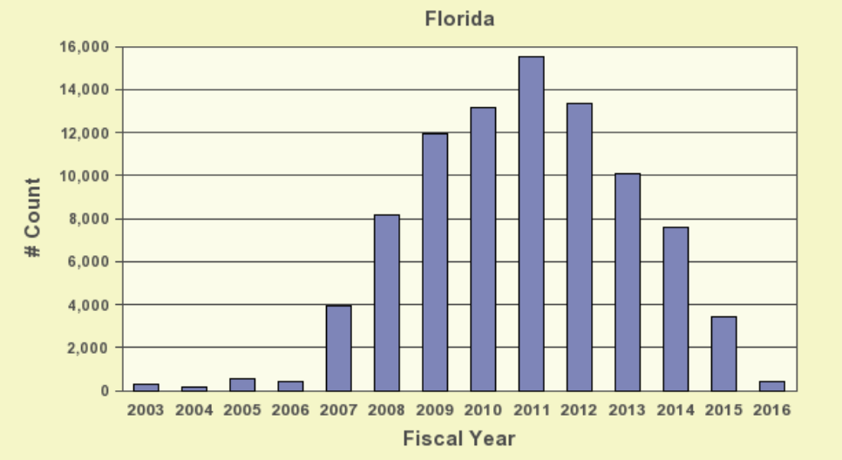

* A spreadsheet is attached, but here is a graphical version of the highlights.

