# CS 5153/5053 Network Security, Spring 2023

## Project 2: Buffer Overflow Attack

## Report

### **Student:** Austin Tyler Conn

Link to Source Code <https://github.com/austinc3030/buffer_m11809075>

## Host Environment Used

Operating System: macOS Ventura 13.0.1

Hardware: Apple M1 Mac Mini (ARM Architecture)

Hypervisor: UTM

## Additional Notes

Due to the current state of virtualization on M1 Macs (ARM based), the pre-built virtualbox image provided by SEED Labs was not used. Instead, the instructions to build the virtual machine for the lab provided by SEED Labs were followed and used for the project.

## Virtual Machine Environment Used

Operating System: Ubuntu Desktop 22.03.2



gcc:

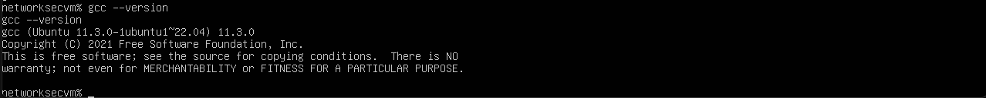

Caveats:

1. Due to differences between 32/64-bit assembly, the `gcc-multilib` package is required. 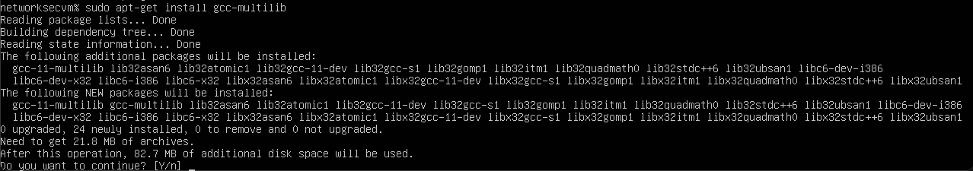
   1. Further, when compiling c code in this environment, the gcc flag `-m32` is required to instruct gcc to compile for a 32-bit architecture.
2. The gdb plugin Python Exploit Development Assistance for GDB (PEDA) is installed on this virtual machine for ease of use in gdb

## How do you perform the attack in your VM

1. Disable address space randomization



1. Compile *stack.c* with the flags:
   1. `-m32` instructs gcc to compile for 32-bit architectures
   2. `-z execstack` make the stack executable
   3. `-fno-stack-protector` disabled Stack-Guard Protection Scheme

***Note:*** *it is assumed here that the steps in the sections below, “How do you find the value of ebp” and “How do you decide the content of badfile” have been completed previously*

1. Make the *stack* program a root-owned Set-UID program

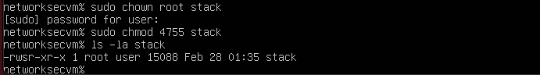

1. Run *exploit.py* to generate *badfile*

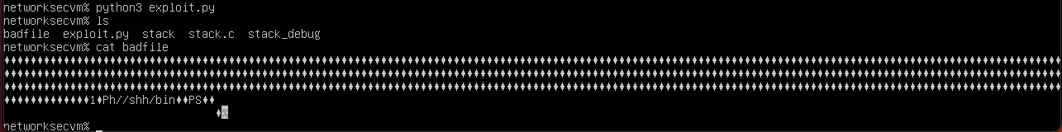

1. Run *stack*

## How do you find the value of ebp

1. Compile *stack.c* with the flags:
   1. `-m32` instructs gcc to compile for 32-bit architectures
   2. `-g` debug flag
   3. `-z execstack` make the stack executable
   4. `-fno-stack-protector` disabled Stack-Guard Protection Scheme

1. Create a temporary, blank file *badfile* (failure to do so leads to a segmentation fault)

1. Run *stack_debug* with *gdb*

1. Set a breakpoint on the *bof* function



1. Continue execution of the program

1. Obtain the value of *ebp*  
   

*ebp* = **0xffffd858**

## How do you decide the content of badfile

1. Complete the steps in the section above, “How do you find the value of ebp” as the *ebp* value found will be used in the calculations for the construction of the badfile
2. In addition to the value of *ebp*, the address where *buffer* starts is required



*buffer* starts at **0xffffd7ce**

1. The return address *ebp* is after the starting address of *buffer*, therefore, we can overflow the buffer such that the content at that return address will be an address we want to return to. To determine where this address should be stored, we must determine the difference between the return address (*ebp*) and the start address of *buffer*



* 1. This means that 138 bytes after the start of *buffer*, the next byte will be the beginning of the return address we want to alter. Thus, our offset will be 142, meaning the address we want to return will be stored 142 bytes into the content of badfile

1. Since we are placing our shellcode at the end of the badfile, and we do not want to return exactly where the program would normally return, we need to add some padding to the address we store so that the return lands at least in the NOP bytes of our payload. This can be an arbitrary number greater than 4 such that this number lies within the content of the badfile. I chose 96 such that:
   1. *ebp*+offset+96 = 0xFFFFD858 + 0x60 = 0xFFFFD8B8
2. The address determined in step 5a needs to be stored at the offset in the badfile

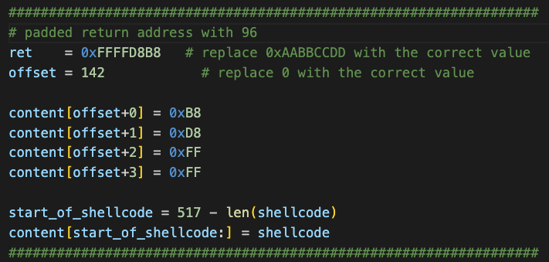

## Whether your attack is successful

1. When running *stack* with the generated *badfile* alongside, the exploit works correctly. We can verify we have a root shell by running `whoami` which returns *root*

