**Steps to download and configure Instant Client and ADWC/ATP wallet in MAC.**

1. Download Oracle Instant Client from the following link:

<https://www.oracle.com/technetwork/topics/intel-macsoft-096467.html>

1. Go to your terminal, navigate to the folder where the zip files are installed and unzip the files to root directory by typing the following command:

**Unzip <<package name.zip>> -d ~**

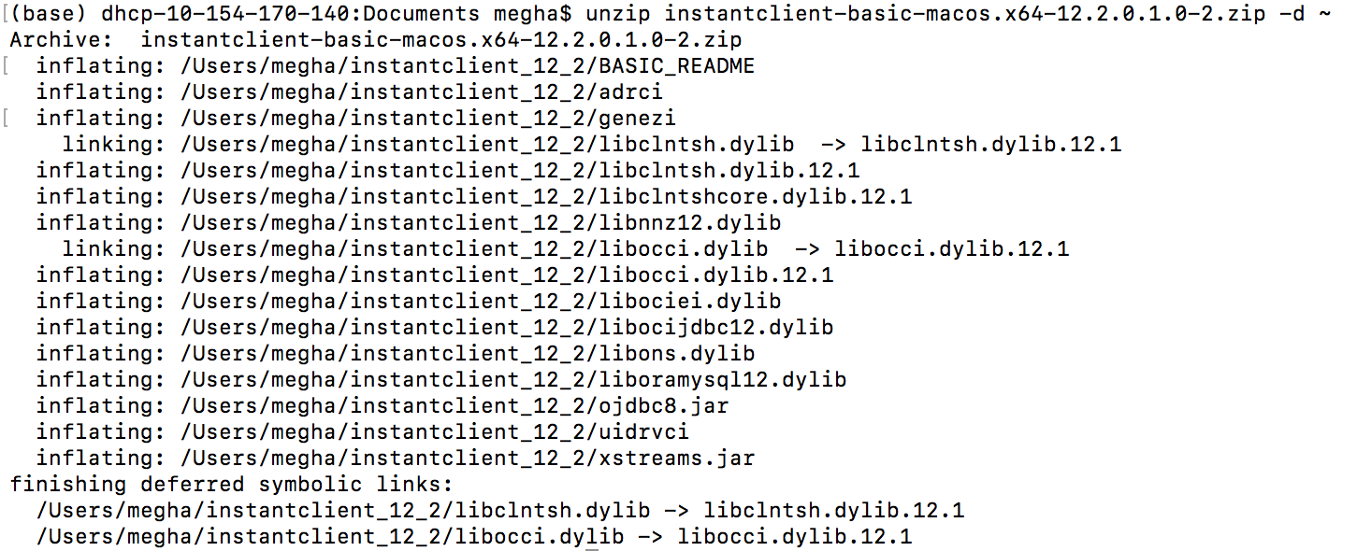

It will create a folder called “instantclient_12_2” in your home directory. Go to your home directory “cd ~” and type “ls” to check if the folder exist.



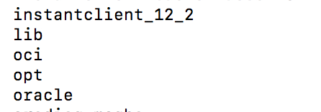

1. If you have several oracle packages to unzip, make sure to unzip the same way mentioned in step 2. All the packages will be unzipped in the same folder “instantclient_12_2”.

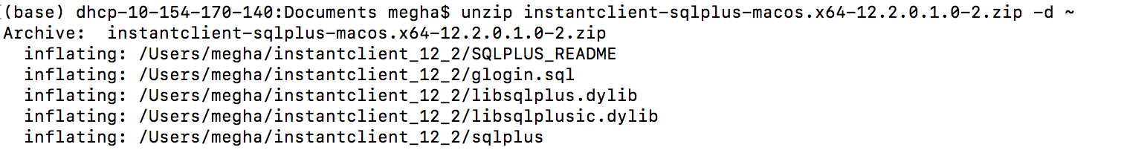

1. Navigate to home directory and make sure you have the desired files in instantclient_12_2.

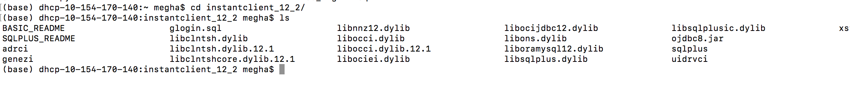

Type “**pwd**” in terminal to get your present working directory and copy paste the path.



1. Open up your bash_profile file by typing the following command:

**vim ~/.bash_profile**

1. Make sure that you are in the insert mode (press i) and type the following lines:

**export PATH="<<copy pasted path>>:$PATH"**

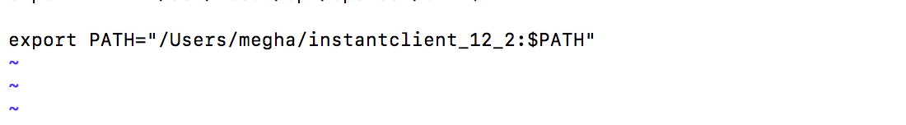

Save and quit the file by pressing escape and typing “!wq”.

1. Run the following command on terminal :

**“source ~/.bash_profile”**

1. Create a folder in instantclient_12_2 named “network”. Create another folder inside “network” as “admin”.

Type the following command inside instantclient_12_2 folder:

**“mkdir –p network/admin”**



1. Unzip the wallet that you have downloaded from Autonomous Data Warehouse Cloud Service or Autonomous Transaction Processing in the admin folder.

Type the following command in the folder where you have your wallet zip file:

**unzip <<Wallet name>>.zip -d ~/instantclient_12_2/network/admin/**

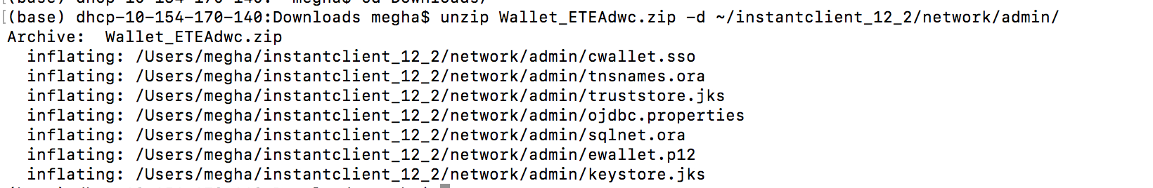

1. Now we will set TNS_ADMIN environment variable.

Open the bash_profile by entering following command on terminal :

**vim ~/.bash_profile**

Type the following command:

**export ORACLE_HOME=/Users/megha/instantclient_12_2**

**export TNS_ADMIN=/Users/megha/instantclient_12_2/network/admin/**

**export LD_LIBRARY_PATH=$ORACLE_HOME**

Your file should have following parameters:

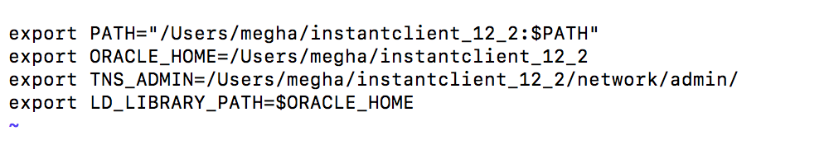

Save and close the file.

1. Type the following command in terminal :

**“Source ~/.bash_profile”**

1. Now connect to your ADWC instance through sqlplus.

**Sqlplus <<username>>@<<service_name>>.**

