Lab Activity 2
IT325 Machine Learning | Performing EDA for the PIT Dataset
Type | Laboratory Activity
Topic Focus | Exploratory data analysis for text classification datasets
Time Allotment | 1 laboratory meeting
PIT Connection | Students generate EDA outputs that will support preprocessing and model selection
Mode | Individual hands on work

Learning Outcomes
1. Load and inspect a text classification dataset using Python.
2. Detects missing values, duplicates, class imbalance, and basic text characteristics.
3. Present and interpret simple EDA visualizations.
Task Overview
Students will implement the EDA plan prepared in Lecture Activity 1. The output of this task will become part of the PIT notebook and may also be used in the final presentation.
Laboratory Tasks
1. Load the dataset in pandas and display the first few rows.
2. Show the dataset shape, column names, and data types.
3. Check for missing values and duplicate rows.
4. Show the distribution of the target variable.
5. Create at least five EDA visualizations relevant to the dataset.
7. In a Text Cell Write three to five observations based on the analysis.
Minimum Required Outputs
1. A Jupyter Notebook or Colab notebook with complete code
2. At least two visuals such as class distribution or text length distribution
3. A short interpretation paragraph written in clear academic language
Submission Reminder
The notebook should be organized and readable. Use meaningful section titles such as dataset overview, data quality checks, class distribution, text characteristics, and interpretation.
Simple Scoring Guide
Use the checklist below to evaluate the submitted work for this activity.

Criteria | Description | Points
Correct Execution | Notebook runs and shows the required EDA steps. | 10
Visual Outputs | At least two relevant visuals are included. | 10
Interpretation | Observations are clear and connected to the dataset. | 5

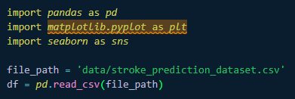
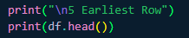
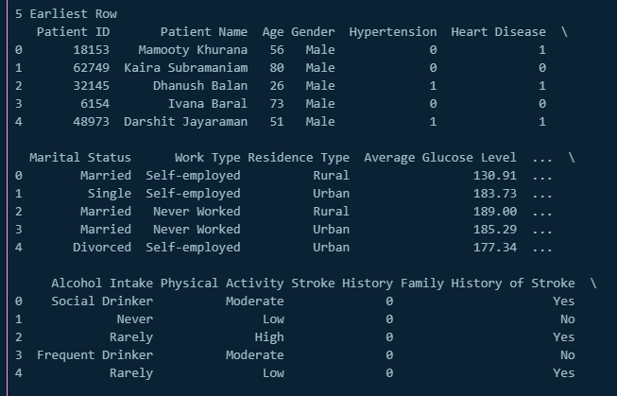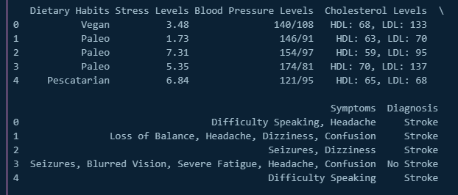
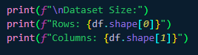
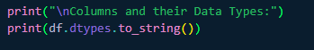
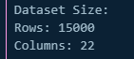
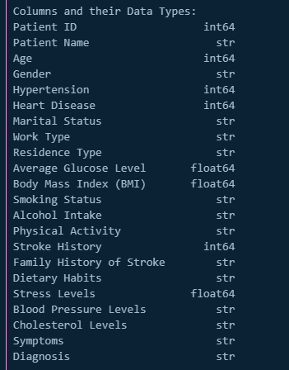

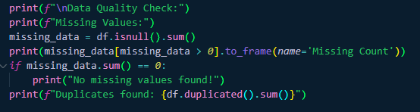
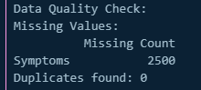
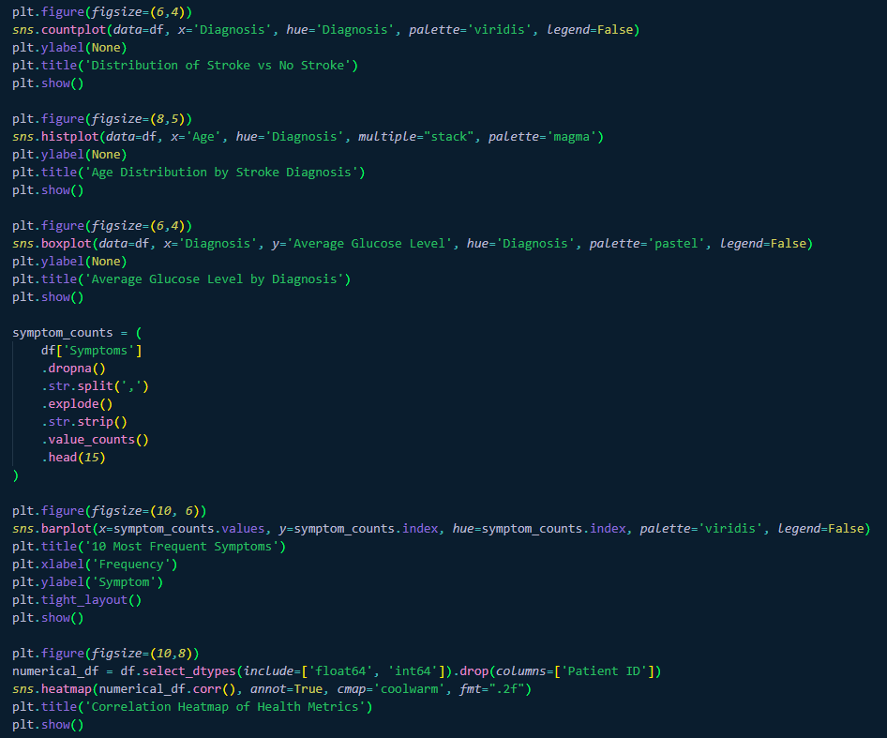
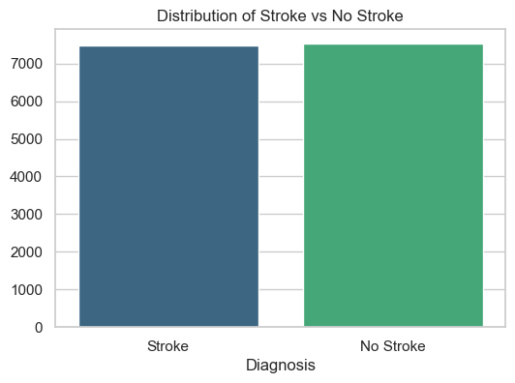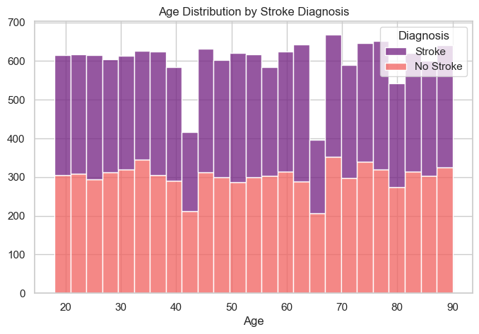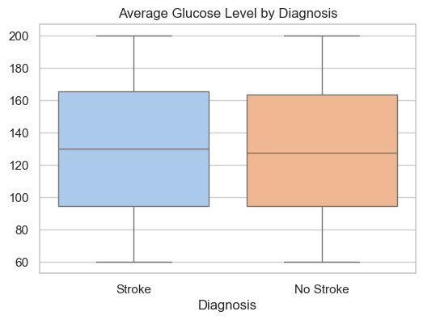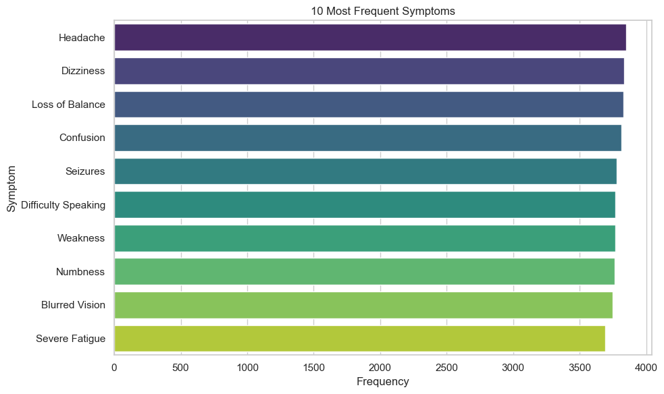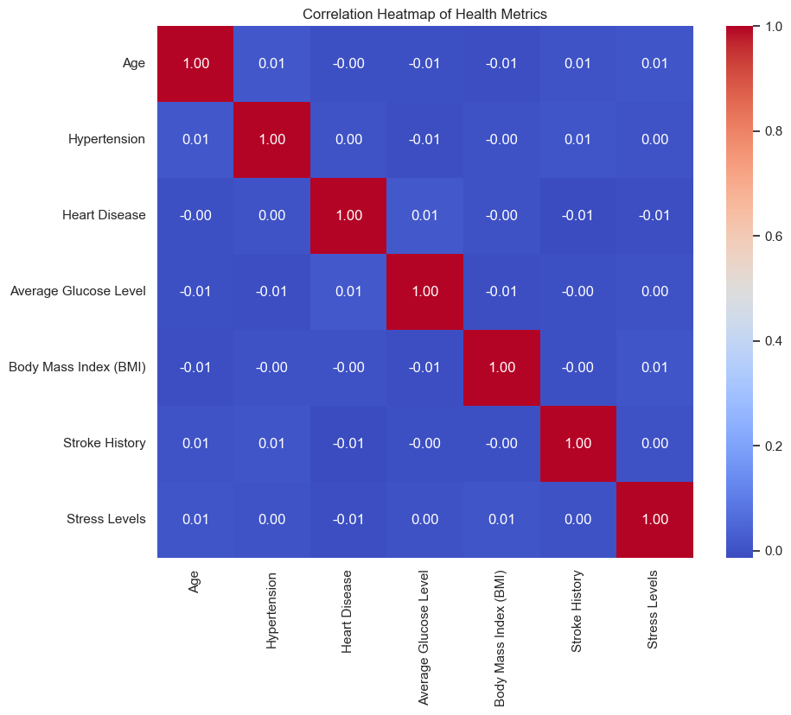

The Stroke Prediction data analysis reveals a balanced dataset of 15,000 records. Key insights include a significant increase in stroke frequency among older populations (ages 60-90) and a high prevalence of neurological symptoms such as 'Difficulty Speaking' and 'Confusion.' .Metrics like Glucose and BMI showed overlapping distributions between classes, suggesting that predictive modeling will require a holistic analysis of multiple health factors rather than relying on a single clinical metric.

