Lab Activity 3
IT325 Machine Learning | Training and Comparing Five Models
Type | Laboratory Activity
Topic Focus | Model comparison for text classification
Time Allotment | 1 laboratory meeting
PIT Connection | Students produce a formal comparison of candidate models for their dataset
Mode | Individual hands on work

Learning Outcomes
1. Transform text data into numerical features using a suitable vectorization method.
2. Train at least five classification models using the same dataset split.
3. Evaluate models using the same metrics and identify strong candidates for tuning.
Required Workflow
1. Prepare features and target variables.
2. Split the dataset into training and testing sets.
3. Train five models using the same prepared data.
4. Evaluate each model using accuracy, precision, recall, F1 score, and confusion matrix.
5. Summarize results in one comparison table.
Note: Use exactly the same dataset split and evaluation approach for all models so that the comparison remains fair and meaningful.
Choose any 3 of the Models Discussed
1. Linear Regression
2. Logistic Regression
3. K Nearest Neighbors
4. Decision Tree
5. Random Forest
6. Naive Bayes

Required Write Up
1. Present one comparison table for the five models.
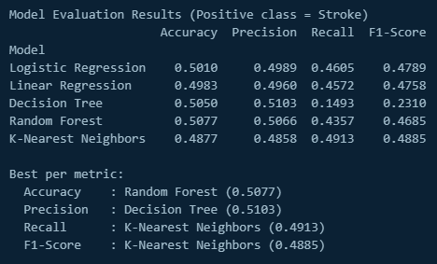

2. State which two models will move to the tuning stage.
Random Forest and Nearest Neighbors

3. Write one paragraph explaining the basis for your selection.
Since we our dataset is related to medical cases, KNN is naturally one of the best models that is moving to the tuning stage as it has the highest recall and f1-score. As I said in the previous activity, giving a false negative is fatal in situations like this, that’s why recall is the most important thing here. The second model is the Random Forest, it has the highest accuracy and also have strong precision. We are now using structured data with TF-IDF text features, Random Forest becomes valuable as it is robust, resistant to overfitting and strong suited for tabular datasets.

Simple Scoring Guide
Use the checklist below to evaluate the submitted work for this activity.

Criteria | Description | Points
Model Implementation | Five models are trained correctly. | 10
Evaluation | Required metrics and comparison table are complete. | 10
Selection Rationale | Top models are chosen with sound justification. | 5

