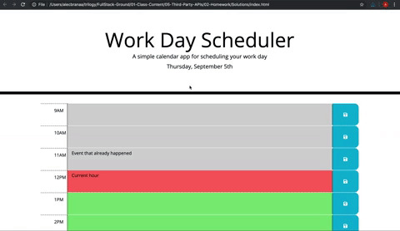

Looks like a fixed header/jumbotron with a big table under that. The table scrolls with the page. Its basically just 3 columns, with the hours in the first column, <p> in the middle and save icons in the third. The color is based on the time of day.

