Austin Fouch
CMPS 366 OPL
10/18/2017
Manual
Bug Report
1) Serialization bug: At the execution of the program, the user will be prompted to load a serialized game. If the user chooses to load a game, they will be prompted to enter the name of the file they wish to load. After a filename is inputted, the program will read the file using streams, parsing the file line by line and word by word. The bug occurs when reading the layout of the board from the file. While reading the left side of the board, the program uses the logic below while it is reading the left side of the board:
// tileStr is a word of format "X-X", where X is a digit between 0-9
int leftPips = tileStr[0] - 48;
int rightPips = tileStr[2] - 48;
Tile temp(leftPips, rightPips);
if(temp == tempEng)
{
board.set_engine(tempEng);
break;
}
board.push_left(temp);

The above highlighted line will push the tile "temp" back onto the left side of the board, a vector of type Tile. But because the function is pushing back, the left side of the board will be read in correctly, but stored backwards. An example of the bug is illustrated below:
When reading the line below (the engine is highlighted):
Layout:
L 5-4 4-6 6-6 6-0 0-0 0-3 3-3 3-6 6-1 1-2 2-3 3-1 1-4 R
The loading portion of the function will store the board as such:
Layout:
L 6-0 6-6 4-6 5-4 0-0 0-3 3-3 3-6 6-1 1-2 2-3 3-1 1-4 R
The board now has a leftmost tile 6-0 instead of the intended 5-4. Becuase the program does not contain functionality to reverse the the vector leftSide of type tile, the loading function stores the vector in reverse order.

Feature Report
Features note implemented:
1.After the boneyard has emptied out, the pass that consititutes the last tile drawn from the boneyard counts towards the back-to-back passes required to end the round. This will only occur if the player who draws the last tile in the boneyard does not play the tile, therefore passing.

Description of data structures/classes:
Tile class:
Simple class used to hold data and functionality of the tiles used in the program.
Board class:
Holds the data of the board during the program.
Data structueres:
Engine: a tile object.
LeftSide: a vector of tiles representing the left side of the board.
RightSide: a vector of tiles representing the right side of the board.
BoardView class:
Implements functionality to display a board to the console is proper format.
Boneyard class:
Holds the stock of tiles for which the players of the game draw from.
Data structures:
Tiles: a vector of type tiles.
Hand class:
Acts as a vector of tiles. Each Player object contains a hand which holds their tiles.
Data structures:
Tiles: vector of type tiles.
Player class:
Implements functionality for the players of the game to interact with the board, playing tiles, and drawing from the boneyard.
Data structures:
Hand: an object of type Hand.
Human class:
Inherits from the Player class.
Computer class:
Inherits from the Player class.
Turn class:
Contains data that represents a turn in a round. Each turn object has a boolean variable for determining if the last turn was passed, a tile object containing the tile played in the turn, and a string that holds the side of the board the turn was played on.
Round class:
Acts as the actual game. Each round object contains functionality to run a round of Longana to completetion.
Data structures:
Boneyard: a boneyard object.
Board: a board object.
LastTurn: a turn object representing the last turn played.
Tournament class:
Contains functionality to run a tournament of Longana. Also contains functionality to serialize a current game and functionality to load a saved game state.
Data structures:
Players: a vector of pointers of type Player to hold the players of the tournament.

Log:
09/08/2017 (1 hour, 10 min)
Implemented the Tile class. Created a copy constructor Tile::Tile(const int&, const int&) and a void Tile::swap_pips() function that swaps the values of the leftPips and rightPips of a tile. (20 min)
Implemented the Hand class. Created a copy constructor Hand::Hand(const vector<Tile> &t) and a void Hand::push_back(const Tile&) function that gives member data access to Hand.tiles.push_back(tile). (10 min)
Partially implemented the Board class. Created the functions void Board::push_left(const Tile&) and void Board::push_right(const Tile&) to give push_back() functionality to Board member stacks, stack<Tile> leftSide and stack<Tile> rightSide. (30 min)
Partially implemented the Player class. Created the functions void Player::push_back(const Tile &t) which calls the Player's hand function, void Hand::push_back(t). (10 min)
09/10/2017 (1 hour, 45 min)
Implemented a vector<Tile> Round::create_tiles() function which returns a vector<Tile> of all the tiles in a 6-6 set, first element being a 6-6 tile and the last being a 0-0 tile. This was done by defining MAX_PIP_SIZE and MIN_PIP_SIZE and for-loops. (1 hour)
Implemented a void Round::distribute_tiles(vector<Tile> &tileList) function that calls std::random_shuffle() on the input vector and uses NUM_PLAYERS and MAX_HAND_SIZE in order to distribute the shuffled vector to a player's hand. Initally used a deque<Tile> instead of vector<Tile> becuase I thought a vector elements could nto be accessed with a back() or front() function. (45 min)
09/13/2017 (1 hour)
Implemented the Boneyard class which acts as a stack<Tile>. It contains functions Tile Boneyard::pop(), void Boneyard::push(const Tile &t), bool Boneyard::empty() and Tile& Boneyard::top() in order to give complete access to Boneyard.tiles member variable of type stack<Tile>. (30 min)
Implemented further functionality for the void Round::distribute_tiles(vector<Tile> &tileList) to not only distribute the inital vector<Tile> tileList created by void Round::create_tiles() to the player's hands but also the boneyard. (30 min)
09/15/2017 (10 min)
Cleaned up copy constructors for each class. I was passing variables to be copied as parameters instead of passing objets of the same class to be copied. (10 min)
09/19/2016 (1 hour 45 min)
Boneyard class now uses a vector instead of a stack to store tiles. Overloaded ostream operator using vector.begin() and vector.end() to iterate over the vector instead of index accessing. (45 min)
Implemented iterator access for the Hand and Player classes so that the Round class can iterate over a player's hand. This feature is currently used when searching for a round's engine, but I may move this functionality to exist inside of the Player class instead of the Round class. (30 min)
Redesigned the random shuffling done in Round::distribute_tiles() so that a new RNG seed is used each time the program is executed. (30 min)
09/25/2016 (1 hour 30 minutes)
Within my main.cpp, I was creating a vector<Player> and pushing a human object and a computer object back into the vector. This vector would then get passed into round.run() by reference and the round class would manipulate the players in the vector during the round's runtime. But because player is an abstract class, making vector<Player> a container of an abstact class, whenever the round class called play() on the elements in the vector<Player>, Player::play() would be called instead of the desired Human::play() or Computer::play(). In order to allow the round class to call play() on elements of a vector of players, I instead chose to create a vector of unique_ptr<Player> to store players in a container to be passed by reference and manipulated in the round class.

09/26/2017 (1 hour 30 minutes)
Worked on Round::find_engine() so that the function sets Round->current_player as it loops over the players vector looking for the rounds engine. If no engine is found in the players hands, then the boneyard is popped and players draw until a player draws the valid round engine. (1 hour)
Implemented logic in Round::run() and Round::find_engine() that handles toggling between player 1 and 2 in a 2 player game. Obviously not scalable, but using it for this project. (30 min)
09/30/2017 (3 hours 30 minutes)
Created a Turn class which exists just to hold the last turns data: tile played, side played, and if the turn was passed or not. The Player::play() (and thus Human::play() and Computer::play()) now return an object of type Turn. (1 hour)
Completed displaying of a board class. Used ostringstreams to create streams for display of double tiles on the first and third lines, and non double tiles on the second line. (2 hours)
Fixed Board::display_board() so that if the engine is empty (-1-,-1 tile) then the board prints out as (empty). (30 minutes)
10/02/2017 (2 hours)
Implemented user interface for the human player each turn. Also implemented the human playing of the tile, although no validation is done yet.
Logic for validating human turns is finished. They can always play on the left side of the board if their tile can be played their. If they have a double tile, they can play it on either side if it can be played. Finally, if the last turn was passed, they can play a normal tile on either side if it can be played.
10/03/2017 (3 hours)
Implemented the help functionality for the human player. The human can now request help, and the program will out the most optimal tile, according to the algorithm it uses. This output will consist of a tile and a side. Example: 1-1 on L. (3 hours)
10/07/2017 (4 hours)
Using the help function algorithm, the computer player’s logic for playing a tile has been implemented. This algorithm works as follows: Check the engine. If the engine is empty, a tile of -1 - -1, then the engine must be in the hand. Find the engine in the hand and play it to the engine. If the engine is not empty, so not equal to a tile of -1–1, then check the last turn played, and determine which side is available for play. Play the most optimal tile given the available sides, keeping into account that a tile needs to be a legal tile for that side. Find the most optimal tile. The most optimal tile is found with the following logic: For each tile in the player’s hand, sum the tile’s pips. The tile with the highest sum of pips has the priority for being played. This logic was used because a player wins a round, they receive an addition to their score equal to the sum of all of the tiles’ pips in the loser’s hand. By trying to play the tile with the highest pip sum first, the player reduces the overall pip sum of their hand, reducing the amount of points awarded to their opponent in the event that they lose the round. (4 hours).
10/10/2017 (1 hour)
Implemented the tournament class. This class creates a round based on the current round number and runs the round. After each round is run, the program checks to see if either of the player’s scores are greater than that of the tournament score, which is set by user input at the start of the program. (1 hour)
10/12/2017 (4 hours)
Implemented serialization of the current game at the beginning of each player’s turn. This means that before a player is given the choice of what to do with their turn, they must select yes or no to serializing and exiting the current game. (1 hour)
Implemented loading a serialized game from a text file, using the format described in the Longana project description. (3 hours)
How to run:
Execute the file “exe’ in the bin directory.
The program was compiled in a Linux terminal with the command:
$ g++ -std=c++14 *cpp -o exe
Screen shots:
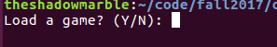
Load a game state:

Get game state filename:
Set tournament score:
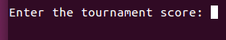

Serialize current game:
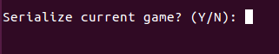

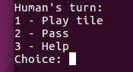
Human choice menu:

Human tile choice:
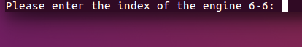

Human side choice:
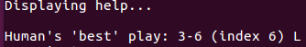
Human help display:

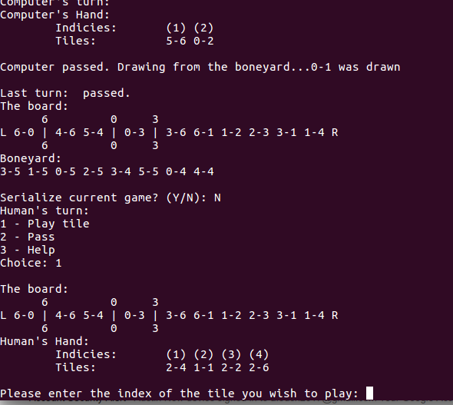
All components:

