Austin Fouch
CMPS 366 OPL
12/05/2017
Manual
Bug Report
1) Clicking the board buttons during the computer’s turn: During the exectuion of the Round activity, the user (human player) must click the “Start Round” button in order to finish the current player’s turn and begin the next player’s turn. If the current player is the computer and the user clicks the “L” or “R” buttons on the board, the last tile the human player played will be duplicated on the side it was played. This bug occurs because each tile in the human’s hand is an ImageButton. When a tile is clicked in the human’s hand, an OnClickListener is set for the “L” and “R” buttons on the board. When either of these buttons are clicked, the tile the user clicked is checked for legality, and if it is a legal play, the tile is played. So, if the “L” or “R” button is clicked during the computer’s turn, the last tile the human clicked, which will be the last tile they played successfully, will be duplicated on the same side it was placed.
In order to fix this bug, the “L” and “R” buttons could simply be set to disabled when the current player is the computer.

Feature Report
Features added:
1. Images for tiles. Each tile an associated .png file which is displayed on the tile’s button when the round is drawn.
Features not implemented:
1. Serialization – both loading and saving game states.

Description of data structures/classes:
Tile class:
Simple class used to hold data and functionality of the tiles used in the program.
Board class:
Holds the data of the board during the program.
Data structueres:
Engine: a tile object.
LeftSide: a vector of tiles representing the left side of the board.
RightSide: a vector of tiles representing the right side of the board.
BoardView class:
Implements functionality to draw the left side, right side, and engine of the board based on an the passed model. Each tile in the model is drawn as an ImageView, excluding the engine, which is drawn as an ImageButton.
Boneyard class:
Holds the stock of tiles for which the players of the game draw from.
Data structures:
Tiles: a vector of type tiles.
BoneyardView class:
Implements functionality to draw the boneyard layout based on the passed model. Each tile in the model is drawn as an ImageView.
Hand class:
Acts as a vector of tiles. Each Player object contains a hand which holds their tiles.
Data structures:
Tiles: vector of type tiles.
HandView class:
Implements functionality to draw the hand layout based on an the passed model. If player passed is a computer, the tiles are drawn as ImageView. If the player passed is a human, the tiles are drawn as an ImageButton.
Player class:
Implements functionality for the players of the game to interact with the board, playing tiles, and drawing from the boneyard.
Data structures:
Hand: an object of type Hand.
Human class:
Inherits from the Player class.
Computer class:
Inherits from the Player class.
Turn class:
Contains data that represents a turn in a round. Each turn object has a boolean variable for determining if the last turn was passed, a tile object containing the tile played in the turn, and a string that holds the side of the board the turn was played on.
Round class:
Acts as the actual game. Each round object contains functionality to run a round of Longana to completetion.
Data structures:
Boneyard: a boneyard object.
Board: a board object.
LastTurn: a turn object representing the last turn played.
Tournament class:
Contains functionality to run a tournament of Longana. Also contains functionality to serialize a current game and functionality to load a saved game state.
Data structures:
Players: a vector of pointers of type Player to hold the players of the tournament.
MainActivity class:
Acts as the “main” function for the program. The program initial starts in this Activity, where the user is displayed two buttons, “New Game” or “Load Game”.
NewGame class:
Navigated to from MainActivity upon clicking the “New Game” button, this Activity contains a simple EditText field for entering a tournament score and a “Start Game” button.

Log:
10/31/2017 (2 hours, 25 minutes)
Implemented a simple MainActivity that contains a “New Game” button and “Load Game” button. This activity also contains an EditText field for entering a numerical value. The intention of this activity is that when “New Game” is clicked, the value in the EditText field will be interpreted as the tournament score for the game, and a new game is started. The “Load Game” button will begin the loading portion of the serialization process. (2 hours)
Implemented the Tile class. Created a default constructor and generated a copy constructor as well as getters and setters for the leftPip and rightPip member variables. (20 min)

Created a swapPips member function in the tile class for swapping the pips of the tile. (5 min)

11/02/2017 (1 hour)
Implemented the Hand class. Created a default constructor and generated a copy constructor as well as getters and setters for the tiles member variable, a List object containing tile objects. (10 min)

Added addTile, removeTile, and searchFor member functions to the Hand class. These functions behave exactly as their name implies. (30 min)

Implemented the Board class. Created a default constructor and generated a copy constructor as well as getters and setters for the leftSide, rightSide, and engine member variables. Both leftSide and rightSide are List objects containing tile objects and engine is a tile object. (20 min)

11/03/2017 (3 hours, 20 minutes)
Partially implemented the Player class. Created a default constructor and generated a copy constructor as well as getters and setters for the score and hand member variable. Hand is a hand object and score is an integer. Implemented the abstract function play, which currently returns void. (20 min)

Implemented a Turn class. Created a default constructor and generated a copy constructor as well as getters and setters for the tilePlayed, wasPassed, and sidePlayed member variables. TilePlayed represents the tile played in the turn, wasPassed is true if the turn was passed or false otherwise, and sidePlayed will be “L” if the turn was played on the left side of the board, “R” if the turn was played on the right side of the board, “E” if the turn was played on the engine, or “” on initialization. (1 hour)

Added a boolean function legalTurn to the Player class as a member function. LegalTurn takes in a turn object representing the turn being attempted, a board object where the turn is being attempted upon, and a second turn object representing the last turn in the round. This function will return true if the attempted turn is legal based on the board and last turn, or false otherwise. (2 hours)

11/05/2017
Implemented a Boneyard class that acts as an abstracted away List<Tile> data structure. (30 min)

Implemented a round class with member variables Turn lastTurn, List<Player> players, List<Int> playerScores, Board board, Boneyard Boneyard

Implemented a createTiles function which creates all of the Tile objects for the function which returns a List<Tile> of all the tiles in a 6-6 set, first element being a 6-6 tile and the last being a 0-0 tile. This was done by defining MAX_PIP_SIZE and MIN_PIP_SIZE and for-loops. (1 hour)
Implemented adistributeTiles() function that calls Collections.shuffle() on the input List and uses NUM_PLAYERS and MAX_HAND_SIZE in order to distribute the shuffled List to a player's hand. (45 min)
11/06/2017 (30 min)
Implemented further functionality for thedistributeTile() to not only distribute the inital List<Tile> tileList created by createTiles() to the player's hands but also the boneyard. (30 min)

11/09/2017 (1 hour 45 min)
Redesigned the random shuffling done in distributeTiles so that a new RNG seed is used each time the program is executed. (30 min)
11/10/2017 (1 hour 30 minutes)
Worked on findEngine() so that the function sets the currentPlayer as it loops over the players List looking for the rounds engine. If no engine is found in the players hands, then the boneyard is popped and players draw until a player draws the valid round engine. (1 hour)
Implemented logic in Round.runRound() and Round.findEngine() that handles toggling between player 1 and 2 in a 2 player game. Obviously not scalable, but using it for this project. (30 min)
11/12/2017 (3 hours 30 minutes)
Created a Turn class which exists just to hold the last turns data: tile played, side played, and if the turn was passed or not. The Player.play() (and thus Human.play() and Computer.play()) now return an object of type Turn. (1 hour)
Completed displaying of a board class in the Round activity. Used seperate linear layouts for left and right side, placed buttons L and R on the left and right side, set the engine in its own layout as an ImageButton. All of these layouts are placed in a horizontal scroll view in case the board gets large. (2 hours)
Created Computer and Human hand layouts with horizontal scrolling. (30 minutes)
11/14/2017 (2 hours)
Implemented a NewGame activity that simply has an EditText field for inputting an integer and a Start Game button for moving to the Tournament Activity. (30 min)
Implemented a Tournament activity that displays the current round, the tournament score, the human score, and the computer score. This activity can be entered from the NewGame activity as well as the Round activity. (1 hour 30 min)
11/15/2017 (4 hours)
Logic for validating human turns is finished. They can always play on the left side of the board if their tile can be played their. If they have a double tile, they can play it on either side if it can be played. Finally, if the last turn was passed, they can play a normal tile on either side if it can be played. This was done by setting onclick listeners in the human hand for each ImageButton present. Once one of these buttons is clicked, the Board buttons become enabled and the user can select a side to attempt to play the Tile they clicked. (4 hours)
11/16/2017 (3 hours)
Implemented the help functionality for the human player. The human can now request help via the help button in the Round activity. The function called is the help function, which will return a Turn objet that holds details on the best turn available for the human. (3 hours)
11/17/2017 (4 hours)
Using the help function algorithm, the computer player’s logic for playing a tile has been implemented. This algorithm works as follows: Check the engine. If the engine is empty, a tile of -1 - -1, then the engine must be in the hand. Find the engine in the hand and play it to the engine. If the engine is not empty, so not equal to a tile of -1–1, then check the last turn played, and determine which side is available for play. Play the most optimal tile given the available sides, keeping into account that a tile needs to be a legal tile for that side. Find the most optimal tile. The most optimal tile is found with the following logic: For each tile in the player’s hand, sum the tile’s pips. The tile with the highest sum of pips has the priority for being played. This logic was used because a player wins a round, they receive an addition to their score equal to the sum of all of the tiles’ pips in the loser’s hand. By trying to play the tile with the highest pip sum first, the player reduces the overall pip sum of their hand, reducing the amount of points awarded to their opponent in the event that they lose the round. (4 hours).
How to run:
Program must be built and run in Android Studio
Screen shots:
Initial Screen:
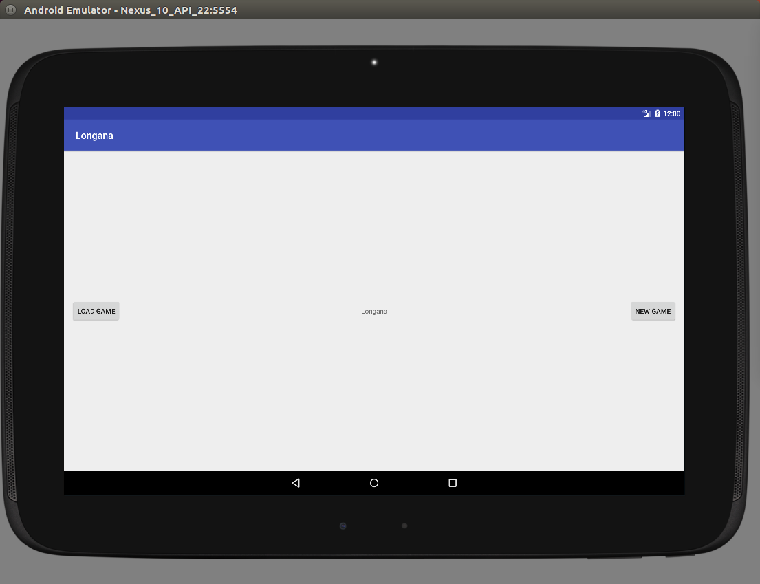
Set tournament score:
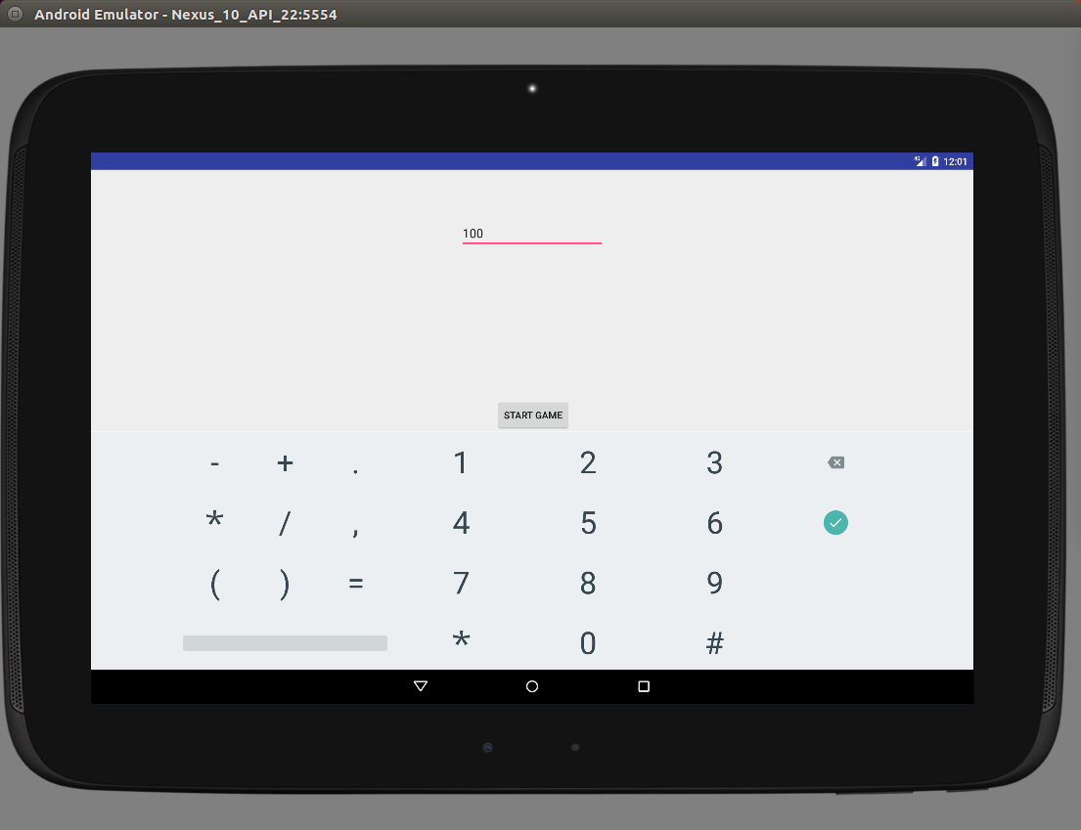

Tournament Display:
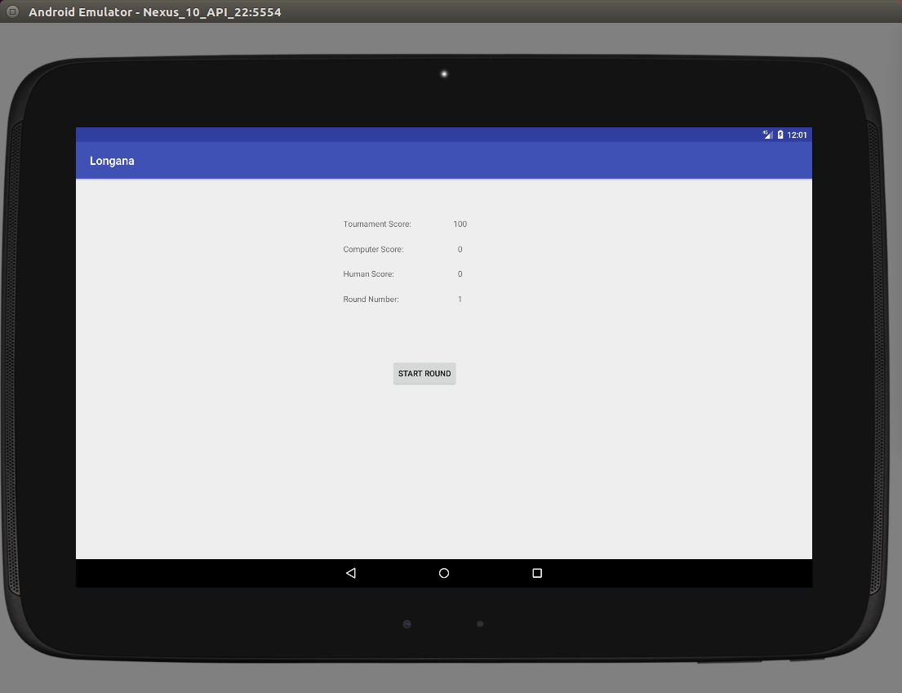

Human help display:
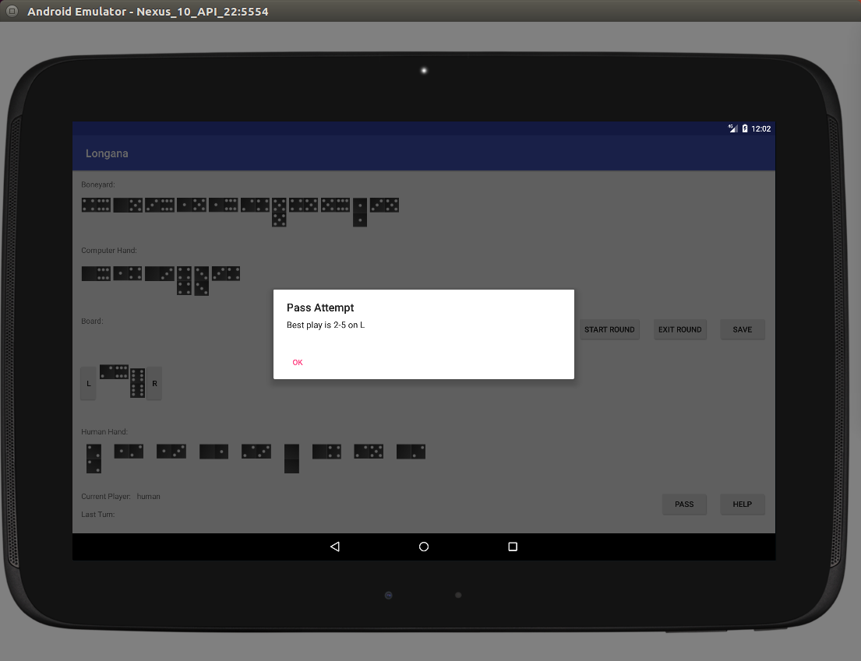

Computer Strat:
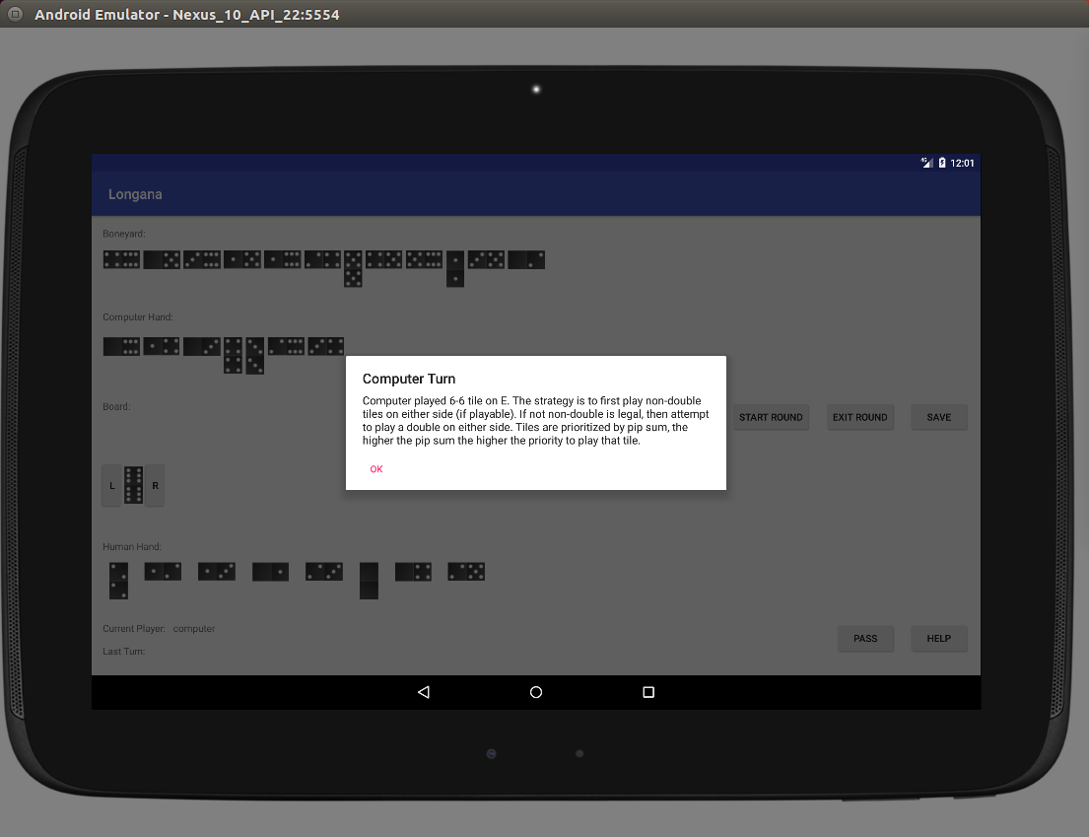

Round win:
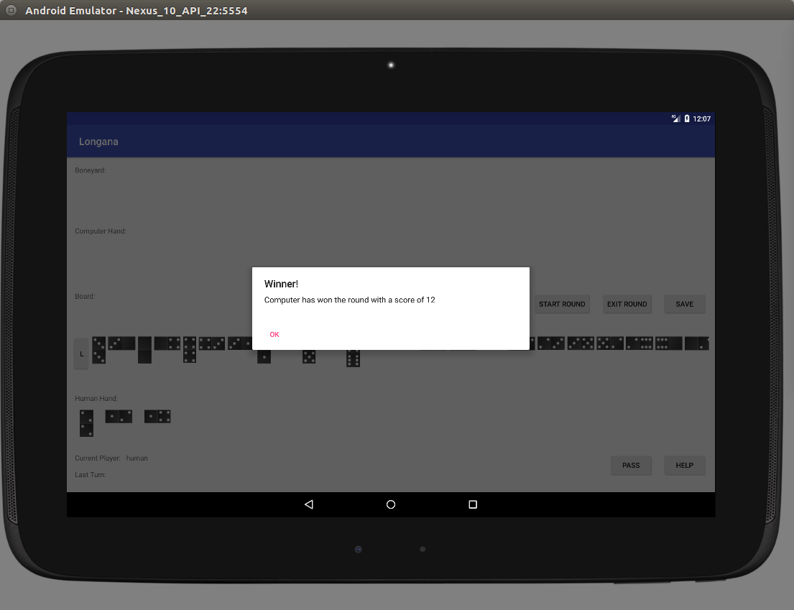

Tournament Win:
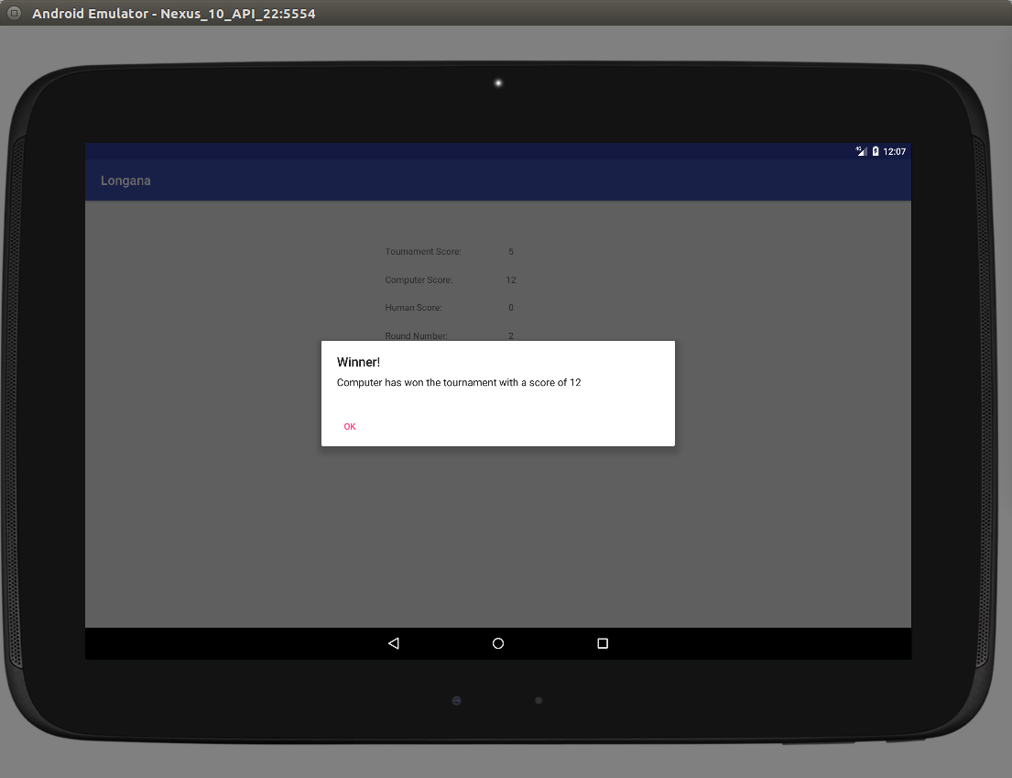

All components:
