Controls Lab 1

Austin Glaser

Jay Greco

0.0.1 Step Response

We examine the step response of the system shown below:

$$G=\frac{K}{s^{2}+2ζω_{0}s+{ω_{0}}^{2}}$$ with the following parameter values:

$$K=1 \\ ζ=1.25 \\ ω_{0}=2$$

To this, we apply a simple proportional controller with parameter Kp.

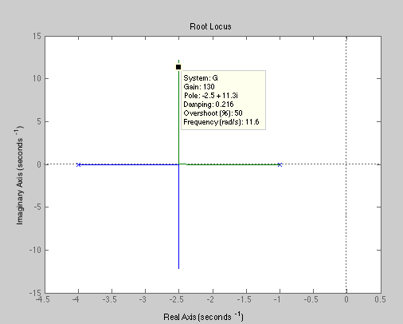Examining the step response of the system using Matlab’s rlocus() function, we see that a Kp of 2.5 is the highest we can go while maintaining zero overshoot, and a Kp of 130 gives us 50% overshoot (see figures 1 and 2 below).

Figure 2

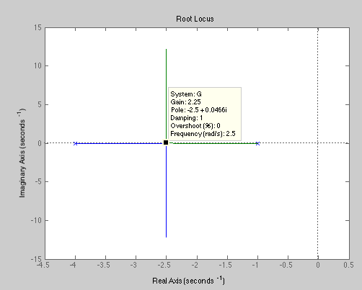We then simulated the systems in labview, and exported this data into Matlab where we created plots of the time response. From these, it’s immediately obvious that a higher Kp will produce a quicker rise time, but increase the controlled system’s overshoot. It’s less immediately obvious from the graphs, but calculating the settling time to within 2% of the final value (not the commanded value) we see that the higher Kp also produces a shorter settling time (1.47 seconds for Kp=130, as opposed to 2.33 seconds for Kp=2.5). Interestingly, our system never reaches within 2% of the setpoint of 10 (we will later find that adding an integral or proportional term will resolve this problem).

Figure 1

Physically, this is an extremely simple model of our

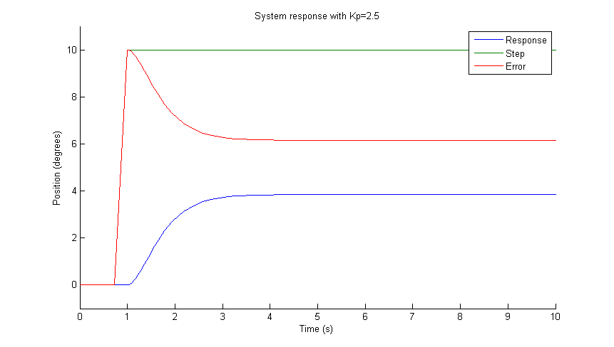

Figure

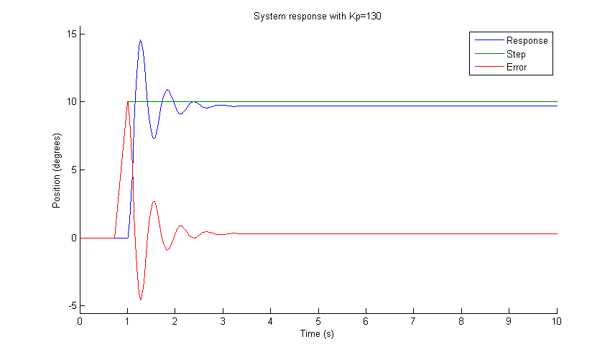

Figure

It’s clear from these plots that a higher gain will give us a faster rise time, and a lower steady-state error – though this never goes to zero.

