Plots are found using Yale’s polynomial as initial guess. I

Physical order: 120

Input parameters 🡪 [ 5, 0.65 , 65]

If marks 3 lines for the present order and 105 lines for all orders.

Note: It seems to be picking the lines correctly. The three first plot illustrate that.

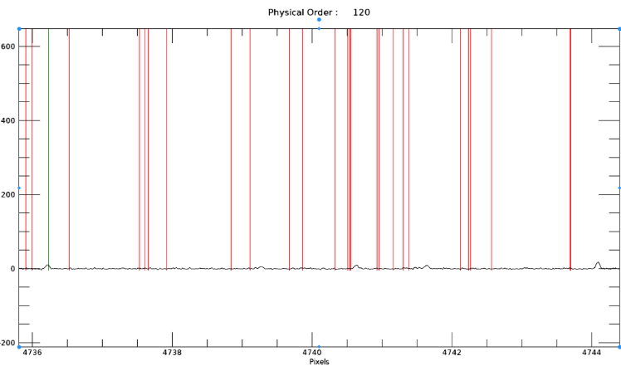

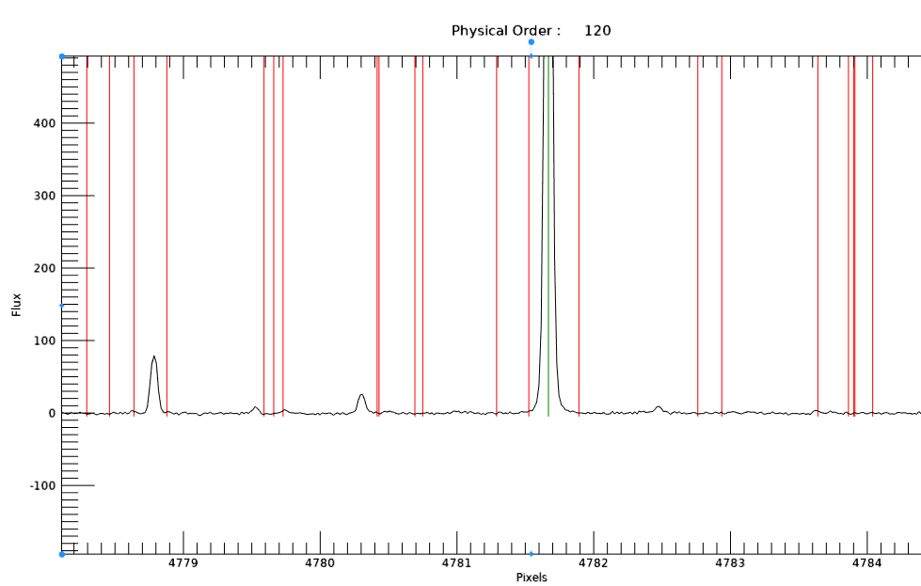

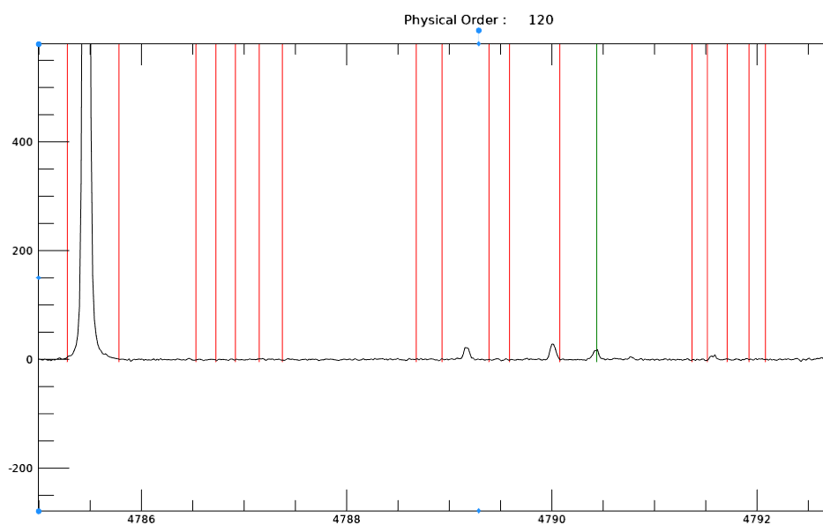

However, it is still missing lots of “obvious peaks”. Some of these obvious peaks don’t even have a line nearby to be considered therefore I feel like it doesn’t matter how well we tune in the inputs since those pixels are not even considered in the first place.

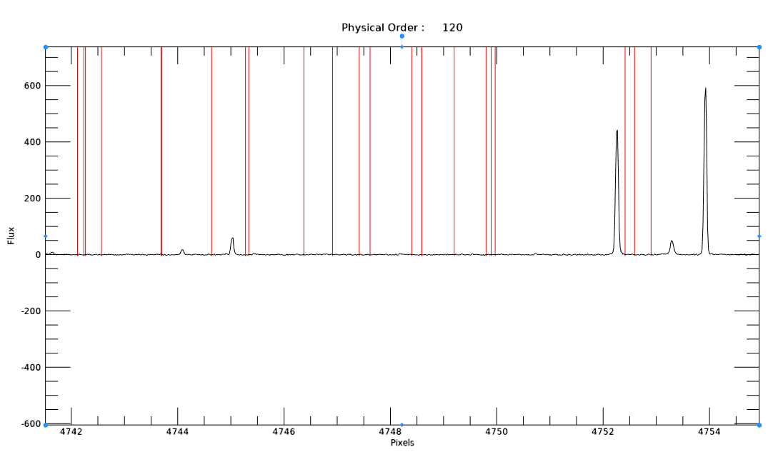

If for the same order I change the inputs to [2, 0.65, 3 ] then 13 lines are marked for the present order and a total of 552 are being found. However, we again find that these new lines been marked in comparison with the ones for the previous inputs seem to be picking noise.

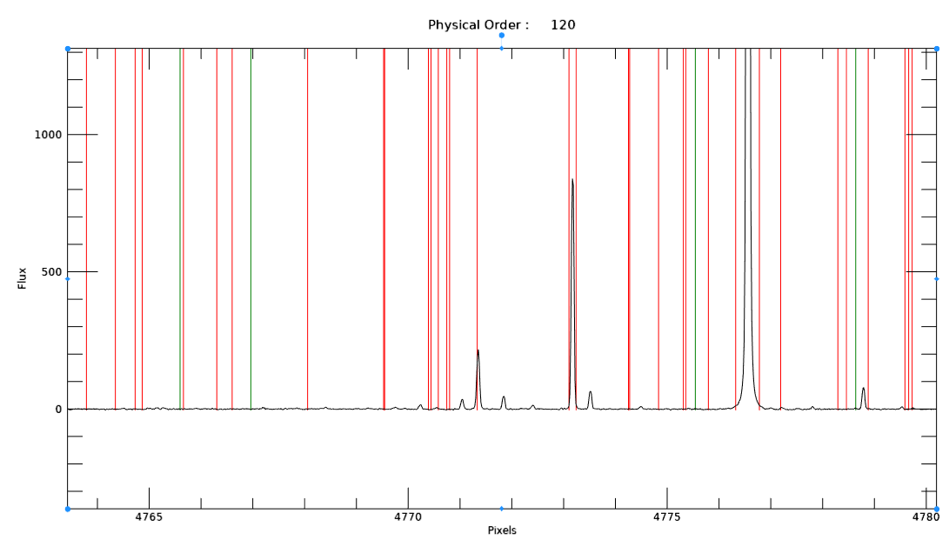

This got me thinking that maybe the initial guess (Yale’s polynomial) although it seems to work for very few lines, it is not completely correct even for the physical orders from 65 to 123. Initially I naively modified the thid.wvc structure which contains yale’s initial polynomial. I did not change the coefficients, but I had to change the number of pixels and # of orders as seen the illustration bellow. (The meaning of each elements in thid.wvc are in the excel sheet I sent you previously.)

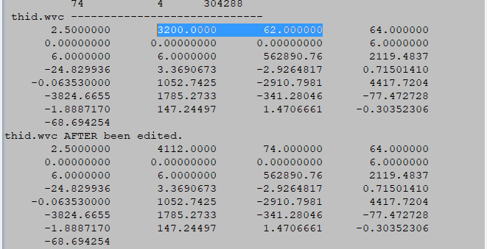

Now if I changed the #of pixels considering that the mapping is been done based on the marked lines and pixels then the polynomial is not going to pick up the correct peaks. In conclusion, I believe that the polynomial we got from Yale was specifically from a spectrum captured with 3200 pixels but now we are dealing with 4112 pixels therefore the used polynomial can not be used. Am I making sense?

I was trying to use Walter’s wavelength solution for the slicer mode as our initial guess, but he is marking the lines order by order meaning that he has 74 wavelength solutions. I cannot use one out of the 74 solutions because I will be falling in a similar problem than before. I am thinking to plot all 74 solutions and use Marquart to fit them all under one polynomial, what do you think ?