HW_Group #1_Austin Halvorsen

Pedram Jahangiry

Sep 15 2020

# Problems

## Question 1

### (i)

v1 <- seq(1,17,4)  
  
v1

[1] 1 5 9 13 17

### (ii)

## Question 2

### (i)

[,1] [,2] [,3] [,4] [,5]  
[1,] 20 21 22 23 24  
[2,] 25 26 27 28 29  
[3,] 30 31 32 33 34  
[4,] 35 36 37 38 39

A B C D E  
[1,] 20 21 22 23 24  
[2,] 25 26 27 28 29  
[3,] 30 31 32 33 34  
[4,] 35 36 37 38 39

### (ii)

# Extracting Columns B & D  
  
B <- A[c(2,4),c("B","D")]

### (iii)

# Transpose Matrix B  
  
t(B)

## [,1] [,2]  
## B 26 36  
## D 28 38

### (iv)

# Inverse of Matrix B  
  
B_inverse <- solve(B)

### (v)

B %*% B_inverse

## [,1] [,2]  
## [1,] 1 0  
## [2,] 0 1

## Question 3

### (i)

df <- data.frame(mtcars)  
head(df,10)

## mpg cyl disp hp drat wt qsec vs am gear carb  
## Mazda RX4 21.0 6 160.0 110 3.90 2.620 16.46 0 1 4 4  
## Mazda RX4 Wag 21.0 6 160.0 110 3.90 2.875 17.02 0 1 4 4  
## Datsun 710 22.8 4 108.0 93 3.85 2.320 18.61 1 1 4 1  
## Hornet 4 Drive 21.4 6 258.0 110 3.08 3.215 19.44 1 0 3 1  
## Hornet Sportabout 18.7 8 360.0 175 3.15 3.440 17.02 0 0 3 2  
## Valiant 18.1 6 225.0 105 2.76 3.460 20.22 1 0 3 1  
## Duster 360 14.3 8 360.0 245 3.21 3.570 15.84 0 0 3 4  
## Merc 240D 24.4 4 146.7 62 3.69 3.190 20.00 1 0 4 2  
## Merc 230 22.8 4 140.8 95 3.92 3.150 22.90 1 0 4 2  
## Merc 280 19.2 6 167.6 123 3.92 3.440 18.30 1 0 4 4

### (ii)

library(dplyr)

##   
## Attaching package: 'dplyr'

## The following objects are masked from 'package:stats':  
##   
## filter, lag

## The following objects are masked from 'package:base':  
##   
## intersect, setdiff, setequal, union

df1 <- df %>%   
 select(c(cyl, hp, wt, vs, am, gear, mpg)) %>%   
 filter(cyl == 4) %>%   
 head(5)

### (iii)

df1 %>%   
 mutate(gpm = round((1/df1$mpg),3)) %>%   
 head(5)

## cyl hp wt vs am gear mpg gpm  
## 1 4 93 2.320 1 1 4 22.8 0.044  
## 2 4 62 3.190 1 0 4 24.4 0.041  
## 3 4 95 3.150 1 0 4 22.8 0.044  
## 4 4 66 2.200 1 1 4 32.4 0.031  
## 5 4 52 1.615 1 1 4 30.4 0.033

### (iv)

str(df1)

## 'data.frame': 5 obs. of 7 variables:  
## $ cyl : num 4 4 4 4 4  
## $ hp : num 93 62 95 66 52  
## $ wt : num 2.32 3.19 3.15 2.2 1.61  
## $ vs : num 1 1 1 1 1  
## $ am : num 1 0 0 1 1  
## $ gear: num 4 4 4 4 4  
## $ mpg : num 22.8 24.4 22.8 32.4 30.4

### (v)

# Computer Exercises

## C1 Use the data in wage1 for this exercise.

### (i)

This is my answer to section (i)

# Including r output within some text

for example I calculated the average number of cars as:

avg_speed <- mean(cars$speed)  
avg_speed

## [1] 15.4

from the R output above, we see that the average speed is equal to 15.4.

Or you could directly do some in-line calculations. Here is the average speed: 15.4.

We can also insert plots from R in Rmarkdown:

hist(wage2$wage, col="red")

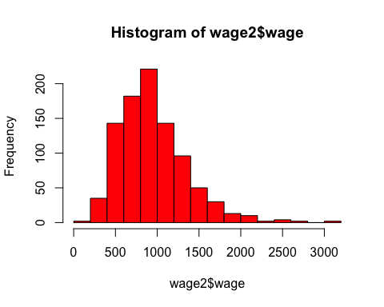

How to write mathematical formulas in **Rmarkdown**:

1. Writing in-line formulas using one dollar sign: $y=β_{0}+β_{1}x_{1}+...+β_{k}x_{k}+u$
2. Writing centered and stand alone formulas using 2 dollar signs:

$$y=β_{0}+β_{1}x_{1}+...+β_{k}x_{k}+u$$

$$P(X|Y)$$

$log(salary)$

$P(X≤6)$

$f(x)=3x^{2}−2x^{3}$ then $0≤x≤1$