# Macintosh HD:Users:AH:Documents:CS:383ECE:Lab3:Plots:plot1.pngA

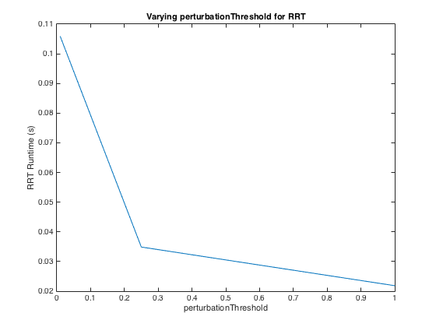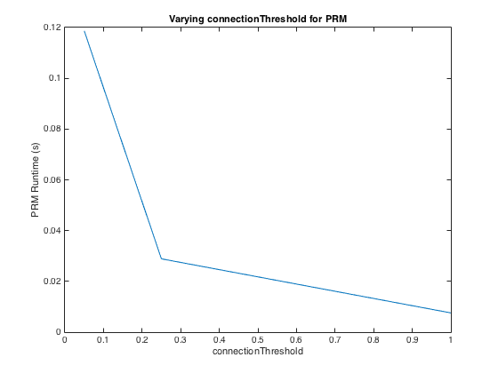

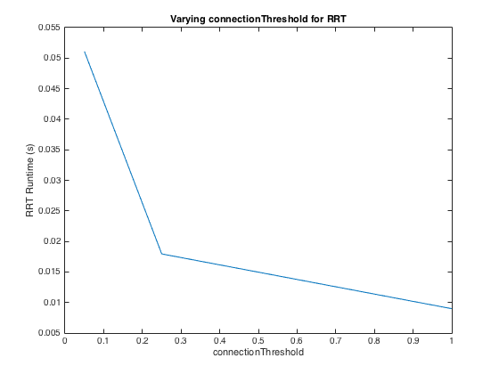

Decreasing the radius of the obstacle meant that there were more feasible paths to the goal, so it decreased the time it took to find a solution.

The PRM tends to have a faster runtime than the RRT, but the RRT tends to provide smoother and more efficient curves.

A smaller knn makes the PRM faster since it doesn't have to check as many nodes, but makes the solution path less optimal. A smaller connectionThreshold makes the PRM slower but makes the solution path more optimal. Similarly, a smaller perturbationThreshold makes the RRT slower but makes the solution path more optimal.

Due to the random sampling of the planner, there is quite a bit of variability between runs, where the largest runtimes are around 200-300% more than the smallest runtimes.

High quality values for the PRM are 10 for knn or .15 for connectionThreshold and for the RRT are .15 for connectionThreshold and .5 for perturbationThreshold.

# B

Optimizing probabilistic random roadmap planner that does not converge to optimal path:

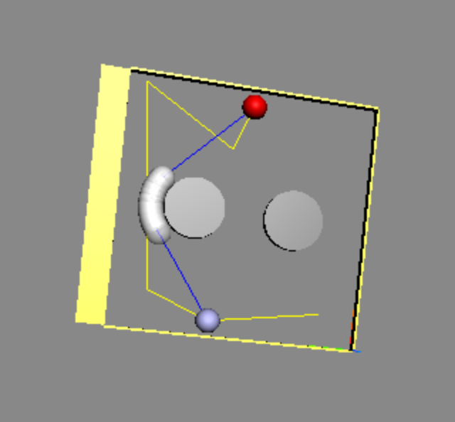

Random-restart + shortcutting RRT that does converge toward an optimal path:

