LX2: The Photoelectric Effect

Austin Irvine

Rony Singh

October 31, 2017

Tuesdays from 12PM – 2PM

Objective

The objective of this lab was to measure the voltage of different light sources on a detector through various shaded lenses and at specific nano-ampere readings. The equations used in this lab involved velocity, wavelength, kinetic energy, charge, and Plank’s constant. The equations directly dealt with how photon and electron interaction, also known as the photoelectric effect. An incandescent light, laser, mercury light, red filter, green filter, blue filter, and a photoelectric (PE) device were used in the development of this experiment.

Setup

-Basic Physics-

The theories involved in this lab heavily involved the use of Plank’s constant. The photoelectric effect was established by Albert Einstein and supported through experimentation by Robert Millikan.

To summarize, the photoelectric effect can be explained by a photon striking a sheet of metal and exciting an electron. When the electron is given enough energy, it flies from the surface of the metal. The energy needed for this much excitement is measured by the kinetic energy and voltage. The energy of the electron will not be as great as the electron or the work taken to eject an electron. KE is kinetic energy, h is plank’s constant, c is the speed of light, W is work, and λ is wavelength of the light.



Following that equation, the voltage is thrown into the equation. Voltage, V, resembles the maximum kinetic energy and energy to stop electrons from moving to a positive collector. The stands for the voltage related to work to tear the electron from the metal.



This equation is the same as the one above, just with everything reordered in terms of voltage. The, e, resembles the charge of the electron.



If the equation is solved for Plank’s constant, we get the equation below.

The instrumental error was for the most part negligible inside of this lab experiment.

-SETUP-

The setup for this experiment involved moving a different light sources close-to and away-from a PE detector.

The first experiment performed used the mercury light and a blue filter. The filter was placed over the PE detector lens. After placing filter, the machines were powered on and the detector was zeroed. After doing this, we moved the light away from the PE till the PE read 12 nano amps. We then adjusted the voltage on the detector till it reached 10 nano amps. We then recorded the voltage from a voltmeter. Subsequently, we did five more of the measurements moving down by two nano amps each time except moving down one nano amp on the last measurement of one nano amp.

The only difference in the second experiment was that a green filter was used instead of a blue filter to cover the PE detector.

The third experiment was run exactly like the first two experiments except with an incandescent light source and a red filter. The light also had to heat-up and be situated at a higher level due to being a short light.

The last experiment was the same as the three prior except that it used a laser light source. The laser was also diffused by placing a generic piece of scotch tape in front of it. For this experiment, there were no filters placed in front of the PE detector.

Sources of error from this experiment could likely come from several sources which are listed below. The sources of error ranged from poor electrical wiring, to the light sources not being as strong as they once were, to changes in height creating inaccurate results.

I believe the largest source of error was from height of the light sources. This caused the largest amount of error and inaccuracy because changing the height even the slightest amount made a significant effect on the readings. Additionally some of the lights had greater spreads of light at further distances, which at times left the light source uncentered on the detector. Moving the light further from the source at a certain height lead the light not being centered.

Sample Calculations

**-Part 1A: Plots and Linest-**

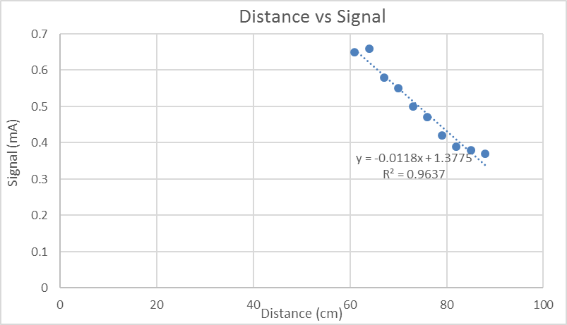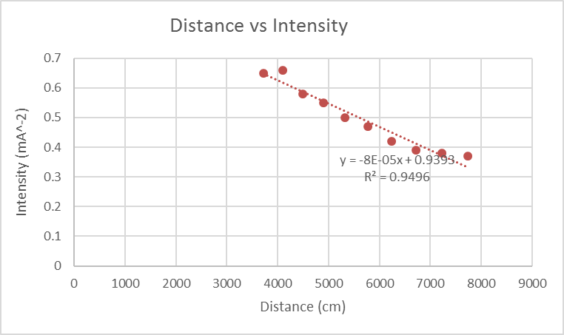

*Linest Calculations*

**Plot 1:** Distance vs. Signal Amplitude || **Linest = 0.006**

**Plot 2:** Distance vs. Intensity || **Linest = 0.00008**

**Equation:** Relating Signal and Intensity: **y =** -8E-05**x** + 0.9393

**-Part 1B: Malus’s Law Comparison-**

|  |  |  |
| --- | --- | --- |
| **Part 1 b** | | |
| **Radians** | **Actual** | **I=I0cos^2(theta)** |
| 0 | 0.55 | 0.57 |
| 0.349066 | 0.51 | 0.503322666 |
| 0.698132 | 0.41 | 0.334489731 |
| 1.047198 | 0.24 | 0.1425 |
| 1.396263 | 0.04 | 0.017187603 |
| 1.745329 | 0.02 | 0.017187603 |
| 2.094395 | 0.19 | 0.1425 |
| 2.443461 | 0.41 | 0.334489731 |
| 2.792527 | 0.53 | 0.503322666 |
| 3.141593 | 0.57 | 0.57 |

**-Part 2: Microwave Double-Slit Error Propagation-**

*Single Slit Diffraction Equation;*

**-Distance and Intensity-**

*Single Slit Diffraction Equation:*

*Single Slit Diffraction Equation Solved For ‘a,’ slit width:*

1. First we found the average values for: d = distance to detector, , and then n which is the current maximum signal found.
2. After finding the average values, plug them into the equation. For example:
   1. = 2.65 cm

Partial Derivatives:

d = slit distance, = maxima angle, = wavelength of microwave, n = which maxima found

**|** **|**

Error Propagation

=

= 2.65 cm

= 2.32 cm

= 0.81 cm

Uncertainties

*Note: Instrumental Error is .5 mm.

= = = 0.20 cm

= = = 0.18 cm

= = = 0.06 cm

Lamda

**-Part 3: Simple Interferometer Comparison-**

|  |
| --- |
| **Successive Diffs. 2** |
| 1 |
| 1.4 |
| 1.9 |
| 1.4 |
| 1.3 |
| 1.6 |
| 1.4 |
| 1.4 |
| 1.5 |
| 1.2 |
| **Average** |
| 1.41 |

The **average wavelength is 2.82** for part three compared to…

In part 2, we had **about 2.65, 2.32, and 2.45**.

Results

Below are the results for double-slit experiment for microwaves.

**-Wavelength of Microwaves-**

Table 1: Lambda Values

|  |  |  |  |
| --- | --- | --- | --- |
| **Values** | **Experimental** | **Total Error** | **Actual** |
| Lambda 1 | 2.65 | 0.20 |  |
| Lambda 2 | 2.32 | 0.18 |  |
| Lambda 3 | 2.45 | 0.06 |  |

**- Discussion –**

The values contrived from part one, two, and three of this experiment were generally what we would expect. When the lambda values were plugged into a general equation solving for 10.525 GHz as the frequency, with the speed of light as the velocity, the answers were very close, not perfect, but close. Most of the answers were close to each other, and quite frankly, they made sense. The value for the first maxima in part 2 was almost exactly correct with the error. As we moved to the other maximums, the answer began to differentiate. I would say that our answers, for the most part, were correct. The error created in our experiment was not a major issue.

The answers in part 3 were also extremely close to what we’d expect for the wavelength of a microwave. We were barely off the mark for the average wavelength.

**Questions**

**1.** The detector was measuring the current and strength of the signal from the microwave emitter. This helped solve for the connection between intensity and signal strength which helped us find the wavelength of the microwave.

**2.** The results from Malus’s law were very close to the actual results we found. Some of the measurements had some major differences, but they seemed to be outliers from the majority of our data.

**3.** The distance is half-lambda because of the angle we had the detector compared to the emitter.

**- Discussion of Uncertainty -**

The error values we calculated seemed to be fairly accurate, but I think there were some points in which the error values diminished and did not correlate with the data. On the latter two maximums in part two, the error values did not seem to match up as well as the first maxima. Likely the largest source of error came from the measuring device that we were using on the stand apparatus. While the device was sturdy, the actual number and lines were at times hard to read and the separation in the center of the measuring device created some points of disassociation in our data. Other sources of possible error sources could have been the emitter and detector not being exactly level or the technology being old. I would take more measurements, buy higher quality laser measuring devices, and use a digital signal detector to avoid age depreciation and friction of a gauge.

**-Concluding Statement of Results -**

In conclusion, the use of Malus’s law, the basic wavelength equation, and the Fraunhofer equation for diffraction played heavy role in the calculations in this experiment. Maximas were measured to find the true wavelength of a microwave, and the results showed a fair amount of success. This experiment was very similar to lab ten, but I thought it was twice as important to perform this experiment that that one. Not being able to see the wave and making clear arguments about the wavelengths felt like a valuable experience.