Activity 7

Products(**productID**, Barcode, name, expiration date, price, tax rate, quantity, supplier, manufactured date)

Customers(**customerID**, **purchaseID**, name, address, phone, payment info)

Purchase(**purchaseID**, **customerID**, **productID**, date/time, quality, price, tax, total cost)

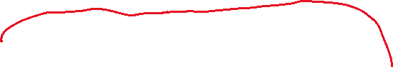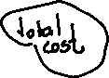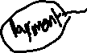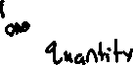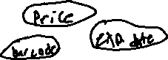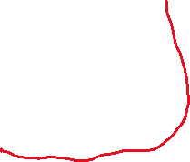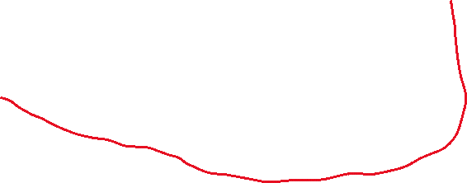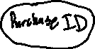

INSERT INFO Customers(CostumerID, Name, Phone, Address)

VALUES

(2, ‘Newkirk’, ‘ ‘, ‘Auburn, AL’),

(3, ‘Adam Smith’, ‘256-444-4444’, ‘USA’),

(4, ‘Eve’, ‘ ’, ‘Eden’)

CREATE TABLE Products (

ProductID INTEGER not null PRIMARY key,

Name TEXT,

Price FLOAT,

TaxRate FLOAT,

);

INSERT INFO Products

VALUES

(1, ‘Apple’, 0.99, 100, 0.09),

(2, ‘Orange’, 0.99, 100, 0.09),

(3, ‘iPhone X’, 0.99, 100, 1000.09),