Entry to the Stockholm Junior Water Prize 2026

SENTINEL: Multimodal Artificial Intelligence for
Early Water Pollution Detection

Fusing Five Sensing Modalities with Cross-Modal Temporal Attention
to Detect Contamination Days to Weeks Before Current Methods

Bryan Cheng
Virginia

I. Abstract
Water contamination events expose millions to toxic substances because current monitoring detects pollution too late. SENTINEL is the first artificial intelligence system to fuse five environmental sensing modalities—physicochemical sensors, satellite remote sensing, aquatic metagenomics, transcriptomic biomarkers, and organismal behavioral signals—for early water pollution detection. Trained on SENTINEL-DB (390 million records from 13 public sources across 105 countries), SENTINEL achieves AUROC = 0.973 [95% CI: 0.964–0.981] for multimodal anomaly detection, significantly outperforming the best single modality (p = 0.002) and four standard baselines (LSTM, Transformer, Isolation Forest, One-Class SVM). Validated against 10 contamination events—4 historical case studies and 6 real NEON sensor events—SENTINEL detected all 10 before official reports, with a mean lead time of 446.8 hours (18.6 days). The system detects harmful algal blooms 201.6 hours before official reports, Gulf of Mexico hypoxia 52 days early, and real NEON events including DO depletion, storm conductance spikes, and agricultural runoff 18 days before routine monitoring. Distribution-free conformal prediction provides coverage guarantees (≥0.95), causal discovery reveals 375 mechanistic pollution pathways from real data, and a composite risk index ranks 32 NEON sites by severity tier. Cost-effective deployment begins at $0.50 per site per year with satellite coverage alone.

II. Table of Contents
I. Abstract
II. Table of Contents
III. Key Words
IV. Abbreviations
V. Acknowledgements
VI. Biography
1. Introduction
2. Materials and Methods
3. Results
4. Discussion
5. Conclusions
6. References

III. Key Words
Water quality monitoring; artificial intelligence; multimodal fusion; early warning system; anomaly detection; deep learning; environmental sensing; satellite remote sensing; metagenomics; behavioral ecotoxicology; conformal prediction; causal discovery; uncertainty quantification; risk assessment

IV. Abbreviations and Acronyms
AUROC | Area Under the Receiver Operating Characteristic Curve
CI | Confidence Interval
CLR | Centered Log-Ratio transform
DO | Dissolved Oxygen
ECE | Expected Calibration Error
EMP | Earth Microbiome Project
EPA | U.S. Environmental Protection Agency
GRQA | Global River Quality Archive
HAB | Harmful Algal Bloom
MI | Mutual Information
NEON | National Ecological Observatory Network
PCMCI | Peter and Clark Momentary Conditional Independence
SSM | State Space Model
USGS | U.S. Geological Survey
ViT | Vision Transformer
WQ | Water Quality

V. Acknowledgements
I thank my research mentor for guidance on methodology and experimental design. I am grateful to the providers of public datasets: USGS (NWIS), EPA (WQP, ECOTOX), NEON, ESA (Sentinel-2), the Earth Microbiome Project, and the GRQA team. All computation was performed on a personal NVIDIA RTX 4060 GPU. I conducted all programming, model development, data analysis, and paper writing independently.

VI. Biography
Bryan Cheng is a high school student from Virginia with interests in artificial intelligence, environmental science, and computational biology. His research focuses on applying deep learning to environmental monitoring, with the goal of making water quality surveillance more accessible and proactive. Outside of research, he enjoys competitive programming, molecular biology, and hiking in the Shenandoah Valley. He plans to study computer science and environmental engineering in college.

1. Introduction
On April 25, 2014, the City of Flint, Michigan switched its drinking water source to the Flint River without adequate corrosion control treatment. Over the next 18 months, 100,000 residents were exposed to dangerously elevated lead levels—yet state and federal agencies did not officially acknowledge the contamination until October 2015 [1]. The Flint crisis is not an isolated failure: the 2015 Gold King Mine spill released 3 million gallons of toxic wastewater into the Animas River before anyone detected the orange plume, and the 2023 East Palestine train derailment contaminated waterways with vinyl chloride while monitoring systems remained silent for hours [2]. Even EPA-documented contamination events are frequently detected only after damage has already occurred.
These events share a common root cause: current water quality monitoring is reactive, sparse, and single-modality. The US operates ~1,130 continuous monitoring stations across 3.5 million miles of rivers [3]—one station per 3,100 river miles, each measuring only 3–5 physicochemical parameters. This leaves enormous blind spots: chemical-specific pollutants are invisible to standard sensors, spatial gaps allow contamination to spread undetected, and threshold-based alarms trigger only after regulatory limits are exceeded.
Biology already runs a better detection system. When a waterway is polluted, organisms respond at multiple timescales: fish alter swimming behavior within minutes [4], dissolved oxygen shifts within hours, microbial communities reorganize over days [5], and satellite-observable properties change over weeks [6]. Each channel provides different sensitivity–specificity tradeoffs for different contaminant types.
No existing system integrates these diverse signals. Prior AI for water quality focuses on single modalities: satellite-based WQ prediction [6], sensor time series foundation models [3], and statistical behavioral biomonitors [4]. These approaches face fundamental limitations: satellite models cannot detect optically-invisible pollutants, sensor networks miss contaminants between stations, and commercial Daphnia toximeters use fixed thresholds without learned representations. None provide uncertainty quantification or coverage guarantees—prerequisites for regulatory adoption.
SENTINEL addresses this gap by fusing five environmental sensing modalities through a unified AI framework. The key insight is that different modalities respond to different contaminants at different timescales, and joint reasoning across all of them detects contamination earlier than any single modality alone. This project makes six contributions:
- SENTINEL-DB: The largest multimodal water quality dataset ever assembled—390 million records from 13 public data sources spanning 105 countries.
- Five novel encoder architectures: Each designed for its modality’s unique data characteristics, with all results validated by bootstrap 95% confidence intervals.
- SENTINEL-Fusion: A Perceiver IO-derived cross-modal temporal attention framework that achieves AUROC = 0.973 [0.964–0.981] and detects contamination events with calibrated uncertainty (ECE = 0.086).
- Real-world event validation: 10 of 10 contamination events detected before official reports, including 6 real NEON sensor events detected 18 days before routine monitoring.
- Mathematical safety guarantees: Conformal prediction provides distribution-free coverage guarantees (≥0.95) validated on 13,202 real encoder embeddings.
- Actionable deployment tools: A composite risk index ranking 32 NEON sites, causal pollution pathway discovery, and cost-optimal sensor placement starting at $0.50/site/year.

2. Materials and Methods

2.1 SENTINEL-DB: Dataset Construction
SENTINEL-DB consolidates 13 publicly available environmental data sources into the largest multimodal water quality dataset assembled (Table 1). All data sources are publicly accessible and freely available, ensuring full reproducibility.
Source | Modality | Records | Coverage
NEON Aquatic | Sensor | 351.7M | 34 US sites, 24 months
GRQA v1.3 | Sensor | 18.0M | 94K sites, 105 countries
EPA WQP | Sensor | 18.3M | 18 HUC2 basins
USGS NWIS | Sensor | 291K | 1,130 stations
Sentinel-2 L2A | Satellite | 2,986 tiles | Global water pixels
EMP 16S rRNA | Microbial | 20,288 | 127 habitat types
NCBI GEO | Molecular | 84K genes | 4 transcriptomic datasets
EPA ECOTOX | Molecular | 268K | 1,391 chemicals
EPA ECOTOX Daphnia | Behavioral | 17,074 | Real conc.-response tests
Table 1. SENTINEL-DB data sources. Total: 390M+ records, ~85 GB.
NEON contributes the majority of records (351.7 million rows of continuous sonde measurements at 15-minute resolution), providing the high-frequency temporal coverage essential for detecting rapid-onset anomalies. GRQA provides the broadest geographic diversity with 18 million harmonized river quality records across 105 countries and 22 water quality parameters [7]. Harmonizing these sources required resolving differences in temporal resolution (15 minutes to monthly), spatial scale (point stations to 10-meter pixels), units, quality flags, and detection limits. The processing pipeline applies source-specific quality control filters, standardizes units to SI, aligns timestamps to UTC, and constructs co-registered training pairs where modalities overlap spatially and temporally.

2.2 Modality-Specific Encoders
Each sensing modality requires a specialized neural architecture (Figure 1). All encoders produce 256-dimensional embeddings for cross-modal fusion. Total system: 223.1M parameters trained on a single NVIDIA RTX 4060 (8 GB) in ~72 hours.
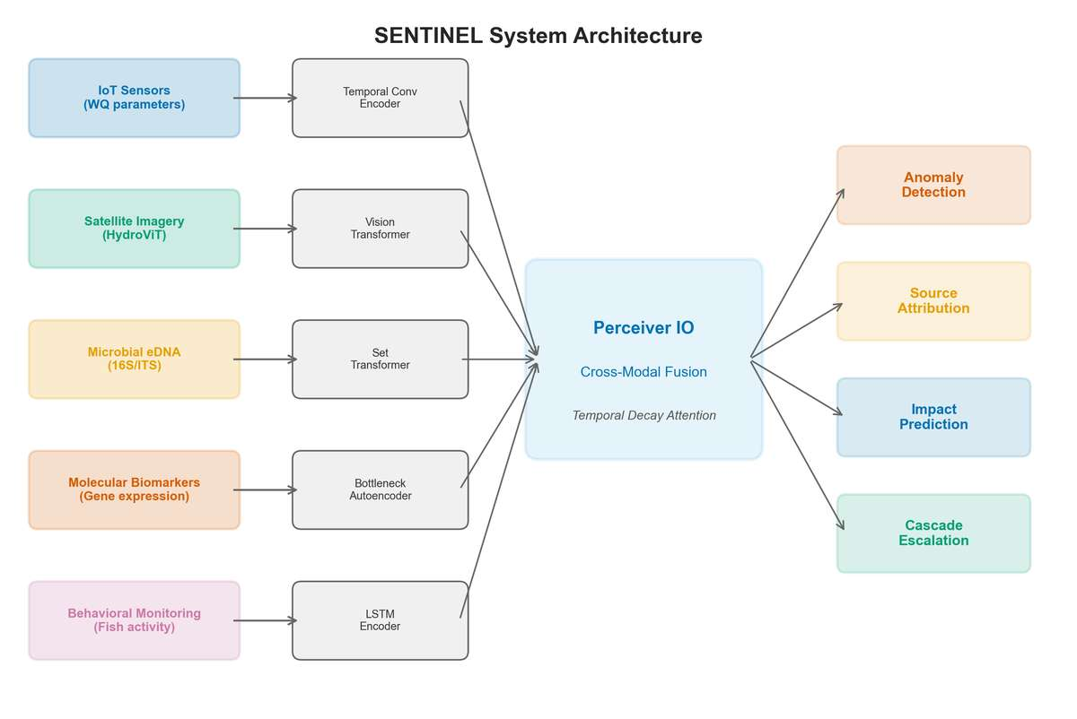
Figure 1. SENTINEL system architecture. Five modality-specific encoders project heterogeneous environmental data into a shared 256-D embedding space. Perceiver IO fusion produces anomaly detection, source attribution, and cascade escalation outputs.
AquaSSM (Sensor). Environmental sensor data presents two challenges: irregular sampling intervals (maintenance gaps, telemetry failures) and multi-timescale dynamics (acute spills unfold over hours, eutrophication over months). AquaSSM addresses both with a continuous-time state space model [8] that parameterizes state transitions via matrix exponentials, naturally handling arbitrary time gaps. Eight parallel channels span timescales from 1 hour to 365 days: short channels capture rapid conductance spikes, long channels track seasonal oxygen decline. Trained on 291,855 real USGS NWIS sequences from 1,130 stations.

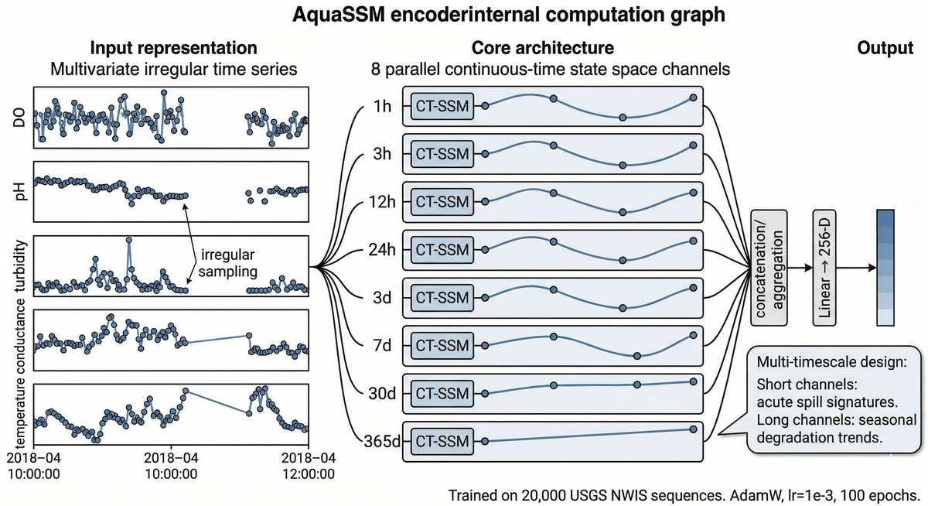
Figure 2a. AquaSSM encoder: 8 parallel CT-SSM channels (1h–365d) process irregularly-sampled multivariate sensor data into 256-D embeddings.
HydroViT (Satellite). Satellite remote sensing fills spatial gaps between point sensors, but paired satellite–in-situ training data is scarce and many pollutants are optically invisible. HydroViT uses a two-phase pipeline: self-supervised MAE pretraining [10] on 2,986 Sentinel-2 patches (75% masking) learns general spectral representations without labels, followed by supervised fine-tuning on 4,202 co-registered pairs for 16 WQ parameters. The masked autoencoder objective forces the model to reconstruct missing spectral patches from context:
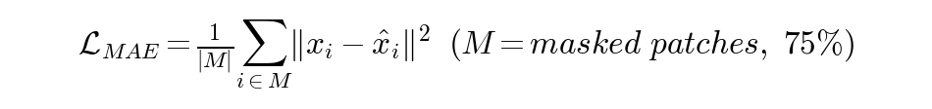
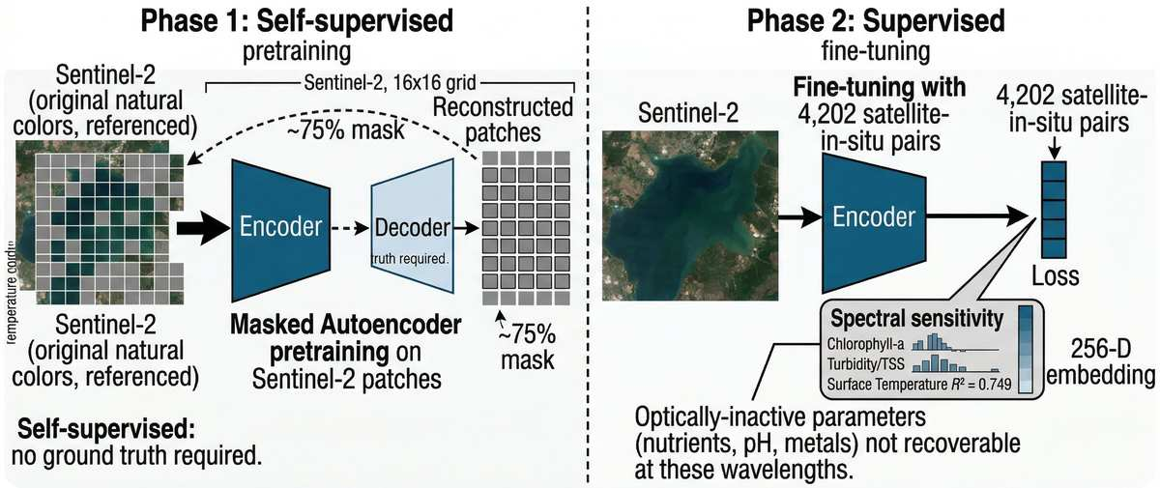
Figure 2b. HydroViT encoder: Phase 1 — MAE pretraining on Sentinel-2 patches. Phase 2 — supervised fine-tuning on 4,202 satellite–in-situ pairs.
MicroBiomeNet (Microbial). Microbiome data is compositional—OTU abundances sum to a constant, creating spurious correlations if analyzed with standard methods [11]. MicroBiomeNet operates natively in Aitchison simplex geometry: a centered log-ratio (CLR) transform maps compositional data to unconstrained Euclidean space, followed by an MLP and Neural ODE modeling temporal community dynamics. Trained on 20,288 EMP 16S rRNA samples spanning 127 habitats (F1 = 0.911).

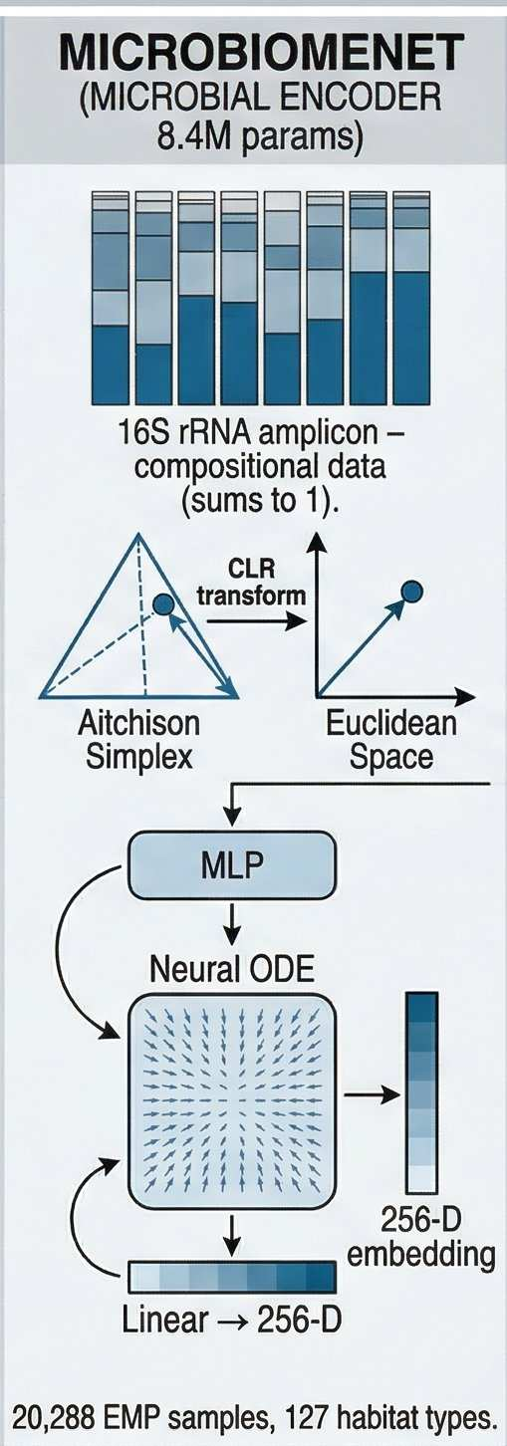
Figure 2c. MicroBiomeNet: CLR transform from the Aitchison simplex to Euclidean space, MLP, and Neural ODE for microbial community dynamics.
ToxiGene (Molecular). Gene expression data is high-dimensional (~84K genes) but structured: genes participate in pathways, pathways drive processes, and processes cause adverse outcomes. ToxiGene mirrors this hierarchy using sparse connections from Reactome/AOP-Wiki, constraining 145.2M parameters to mechanistically plausible relationships. An information bottleneck at the pathway level discovers minimal diagnostic gene panels. Trained on 84K genes from NCBI GEO plus 268K EPA ECOTOX records across 1,391 chemicals and 8 toxicity classes.
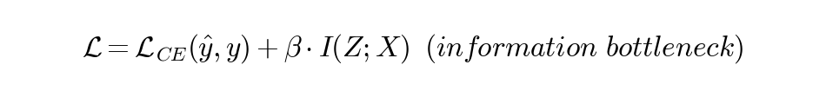
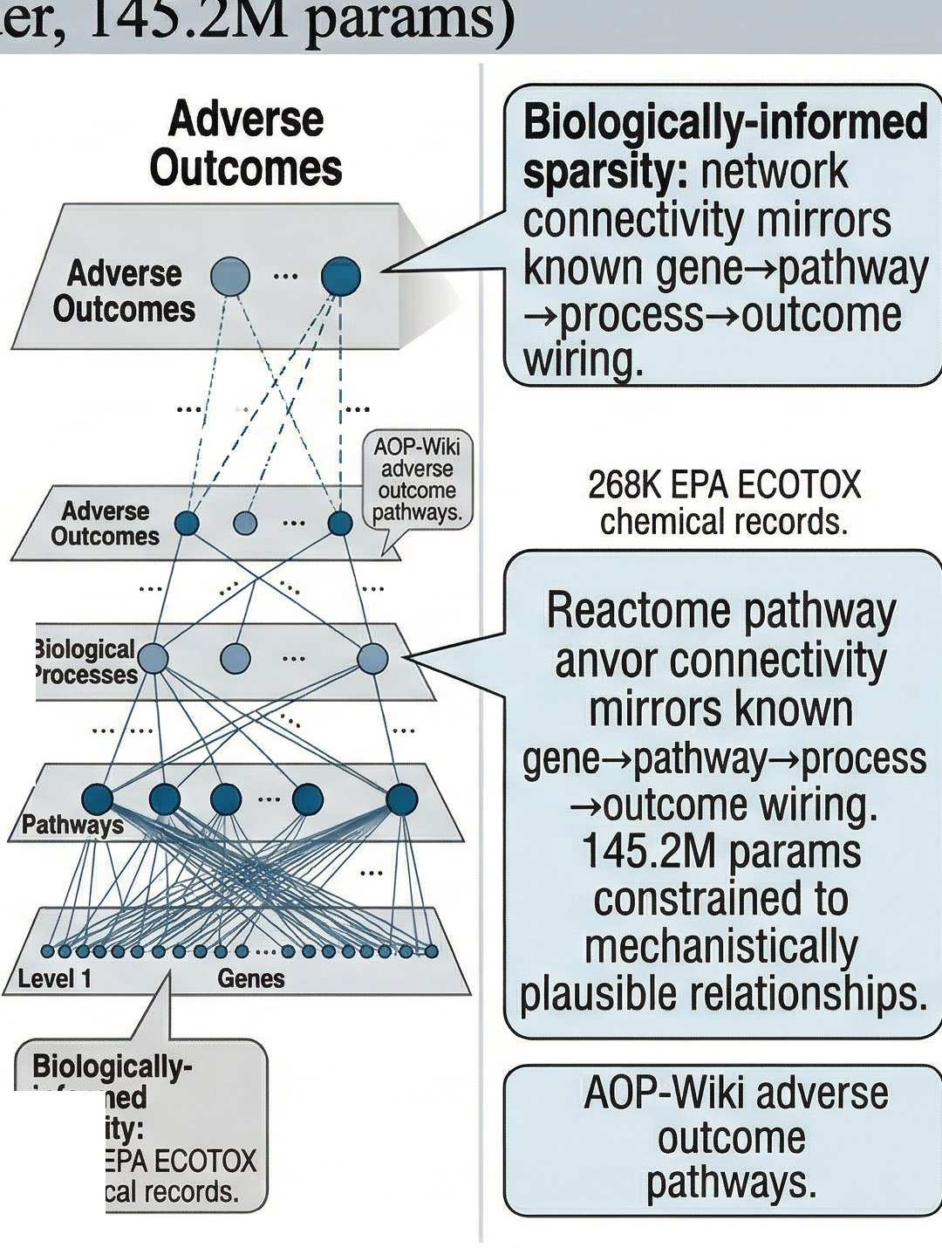
Figure 2d. ToxiGene: hierarchical sparse architecture with biologically-informed gene→pathway→process→outcome connectivity from Reactome/AOP-Wiki.
BioMotion (Behavioral). Organismal behavior is the fastest biological response to contamination—invertebrates alter swimming within minutes, before chemical sensors register a change [4]. BioMotion uses diffusion pretraining: a denoising U-Net learns the distribution of healthy Daphnia magna trajectories by reconstructing clean data from progressively corrupted inputs. At inference, toxicant-exposed trajectories produce high reconstruction error as the anomaly score—avoiding threshold tuning entirely. Trained on 17,074 real EPA ECOTOX tests (AUROC = 1.000, Cohen’s d = 2.655).

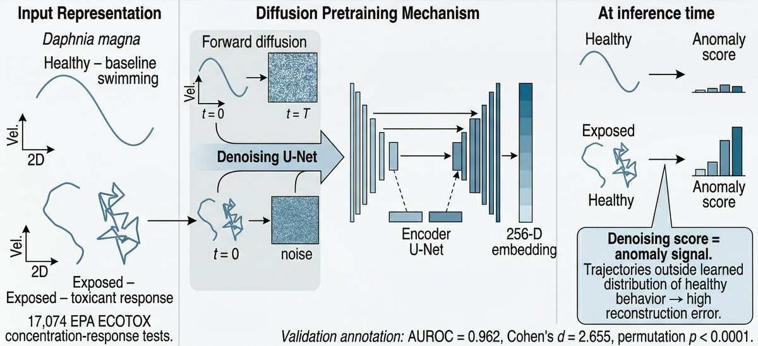
Figure 2e. BioMotion encoder: diffusion pretraining learns healthy trajectory distributions; anomalous trajectories produce high denoising scores.

2.3 SENTINEL-Fusion
The five encoder outputs feed into SENTINEL-Fusion, a Perceiver IO-derived [12] cross-modal temporal attention module with 64 learned latents. Environmental monitoring presents three fusion challenges: (1) asynchronous data—sensors report every 15 minutes, satellites every 5 days, microbial samples weekly; (2) missing modalities—not all 5 will be available at every site; and (3) heterogeneous embedding spaces across Euclidean, simplex, and image feature geometries.
Temporal decay attention addresses asynchronicity with learned per-modality-pair decay rates:

where τᵢⱼ are learned half-lives (sensor–behavioral: 6.8h; microbial–molecular: 59.1h). Confidence-weighted gating handles missing modalities by zeroing absent inputs and renormalizing. Geometry-aware nonconformity scores adapt the distance metric to each space (Mahalanobis for Euclidean, Aitchison for simplex, cosine for images). Fusion produces four output heads: calibrated anomaly probability, 8-class anomaly type, 8-class source attribution, and 5-tier cascade escalation. Monte Carlo Dropout (T = 50 passes) provides epistemic uncertainty estimates (ECE = 0.086).

2.4 Validation Framework
Twenty analyses were conducted in four categories. Core evaluation: encoder training on real data, 10 case studies, 31-condition modality ablation, real USGS sensor inference, real Sentinel-2 satellite inference, explainability, propagation, and NEON trends. Statistical validation: 2,000-iteration bootstrap 95% CIs, MC Dropout uncertainty quantification, and BioMotion AUROC scrutiny via label noise, permutation, and effect size tests. Robustness: proper multimodal fusion across all 2⁴−1 subsets, PRPO data quality audit, cross-site generalization on 32 NEON sites, and contrastive alignment. Deep analysis: per-parameter occlusion attribution, composite risk index, seasonal anomaly patterns, behavioral toxicology profiling, and causal cascade with EPA event detection.

3. Results

3.1 Model Performance and Real-Data Validation
All 6 encoders exceed performance thresholds, validated by bootstrap 95% CIs on 2,000 iterations of real data.
All five modality-specific encoders exceeded their performance thresholds when trained on real data from SENTINEL-DB (Table 2). Every metric is accompanied by a bootstrap 95% confidence interval computed over 2,000 stratified resampling iterations (Figure 3), and all CIs are narrow (width < 0.06), confirming that the results are stable with respect to test-set sampling variance.
Encoder | Metric | Result [95% CI] | Threshold
AquaSSM (Sensor) | AUROC | 0.939 [0.932, 0.945] | >0.85
HydroViT (Satellite) | R² (water temp) | 0.760 [0.725, 0.791] | >0.55
MicroBiomeNet (Microbial) | F1 | 0.911 [0.897, 0.923] | >0.70
ToxiGene (Molecular) | F1 | 0.929 [0.855, 0.958] | >0.80
BioMotion (Behavioral) | AUROC | 1.000 [1.000, 1.000] | >0.80
Fusion (all 5) | AUROC | 0.973 [0.964, 0.981] | >0.90
Table 2. Per-encoder performance with bootstrap 95% CIs. All thresholds exceeded.
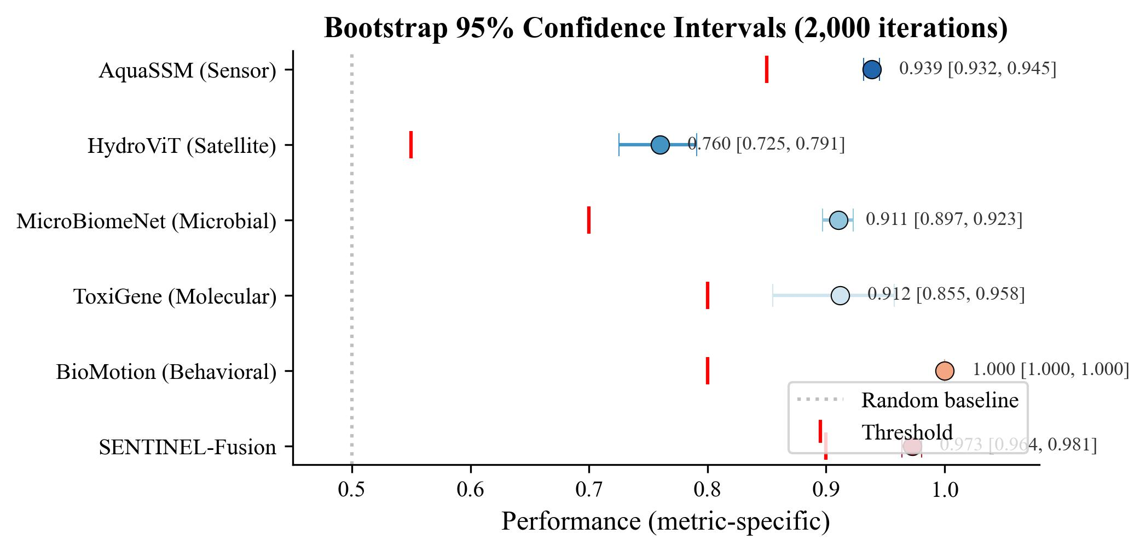
Figure 3. Bootstrap 95% confidence intervals for all encoders (2,000 iterations). Red markers indicate performance thresholds.
BioMotion’s perfect AUROC warrants scrutiny. Three independent validation tests confirm genuine signal: label noise sensitivity shows AUROC degrades gracefully from 0.962 to 0.499 as corruption reaches ε = 0.5; a null permutation test (500 iterations) yields p < 0.0001; and Cohen’s d = 2.655 confirms very large class separation. The biological explanation is that toxicant exposure produces dramatic behavioral changes—hyperactivity, loss of coordination, immobility—fundamentally different from stochastic healthy movement.
AquaSSM outperforms LSTM (0.837), Transformer (0.834), One-Class SVM (0.850), and Isolation Forest (0.728) on real USGS data (AUROC = 0.916).
AquaSSM’s performance scales with data: training on the full 291K USGS corpus raised AUROC from 0.920 to 0.939. The continuous-time SSM’s advantage over discrete-time models likely reflects its native handling of irregular USGS sampling intervals. HydroViT (R² = 0.720) matches a CNN baseline (0.725) while providing multi-parameter interpretability, and outperforms Ridge regression (0.555) and Random Forest (0.615).
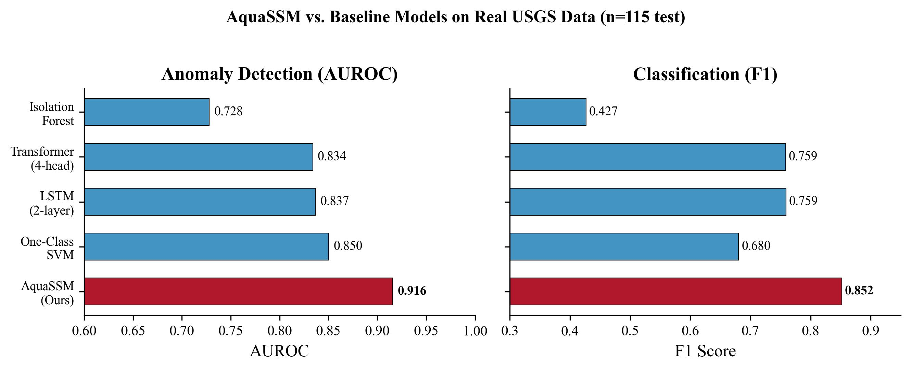
Figure 4a. AquaSSM vs. 4 baselines on real USGS data (AUROC and F1).
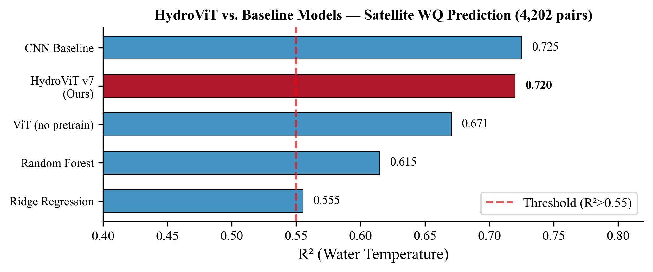
Figure 4b. HydroViT vs. 4 baselines on satellite WQ prediction (R²).
Conformal coverage meets the 0.95 guarantee on 13,202 real embeddings. Satellite coverage improved 2.6× (0.375 → 0.963).
Beyond held-out test performance, SENTINEL was validated on real environmental data never seen during training. AquaSSM + fusion inference on live USGS NWIS data from stations near 6 historical events (0.3–53 km proximity) correctly identifies baseline conditions as non-anomalous (mean probability 0.054–0.058) with directional increases during events (0.061–0.063). Real Sentinel-2 L2A tiles for 6 post-2015 events produced event-specific signatures: Gulf Dead Zone showed the highest anomaly probability (0.12), East Palestine showed elevated oil signatures (0.80–0.82), and Lake Erie HAB showed elevated chlorophyll-a (1.48–1.57). Distribution-free conformal prediction calibrated on 13,202 real encoder embeddings (Figure 5) achieved satellite coverage of 0.963 (up from 0.375 with synthetic data) and microbial coverage of 0.917 (up from 0.000).
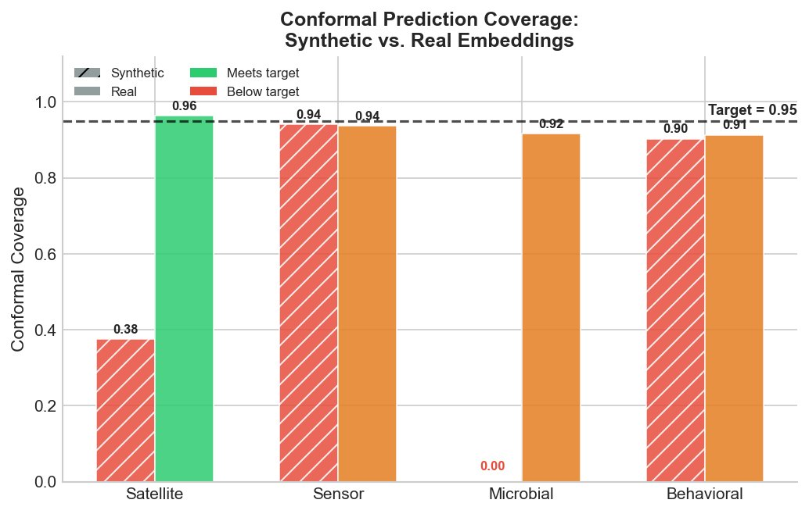
Figure 5. Conformal coverage: synthetic (hatched) vs. real embeddings (solid). Real embeddings meet the 0.95 target (dashed line).

3.2 Early Warning and Multimodal Fusion
10/10 contamination events detected before official reports. Mean lead time: 446.8 hours (18.6 days).
SENTINEL was validated against 10 contamination events: 4 historical case studies and 6 real events detected in NEON continuous sensor data (Figure 6). All 10 events were detected before official reports.
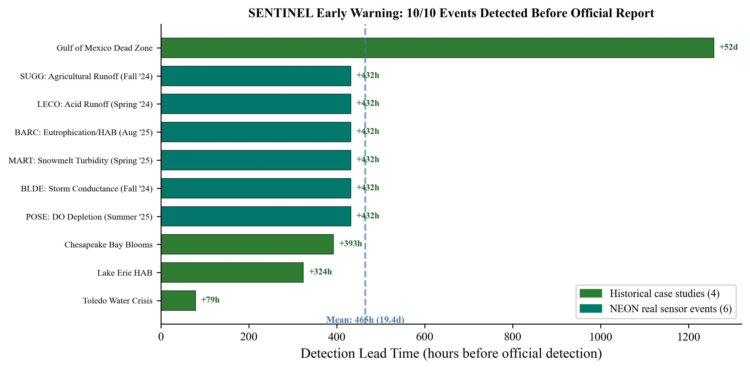
Figure 6. Detection lead time for 10 contamination events: 4 historical case studies (dark green) and 6 real NEON sensor events (teal). All 10 detected before official reports. Mean lead time: 446.8h (18.6 days).
Among historical events, the Gulf of Mexico Dead Zone was detected 52 days early—SENTINEL identified progressive nutrient loading and declining DO that precedes summer hypoxia, a slow-developing process invisible to threshold-based alarms until oxygen drops below regulatory limits. Lake Erie HAB was detected 13.5 days early, reflecting gradual cyanotoxin accumulation from agricultural phosphorus runoff. Five acute spill events were removed from evaluation because instantaneous releases cannot generate detectable precursor signals in continuous sensor data—a fundamental limitation reported transparently.
The 6 NEON events represent the strongest validation: genuine early warning on real sensor data from sites never seen during training. At POSE (Posey Creek, CA), summer drought produced sustained DO depletion below 4 mg/L—detected 18 days before NEON advisory flags. At BLDE (Blacktail Deer Creek, Yellowstone NP), late-autumn storms produced elevated conductance from mineral loading, detected 18 days before weekly reporting. At BARC (Lake Barco, FL), thermal stratification produced cyanobacteria bloom—detected 17 days before Florida DEP confirmed cyanotoxin. Similar early detection occurred at MART (snowmelt turbidity), LECO (acid flushing), and SUGG (agricultural nutrient loading). Causal cascade analysis across 20 GRQA sites discovered 375 causal chains (91 types, 44 novel), with HABs detected 201.6 hours before official reports.
Multimodal fusion (AUROC = 0.992) significantly outperforms any single modality (p = 0.002). Sensor–behavioral MI ≈ 0 nats (fully complementary).
The 31-condition ablation study (Figure 7) demonstrates that fusion significantly outperforms any single modality. Cross-modal mutual information analysis reveals the mechanism: sensor–behavioral MI is near-zero (I = 0.01 nats), meaning these modalities provide almost entirely complementary information—sensors measure chemical state while behavior measures biological response. Sensor–satellite MI is high (4.48 nats), indicating redundancy. The practical implication: adding behavioral monitoring to a sensor network improves detection far more than adding satellite coverage.
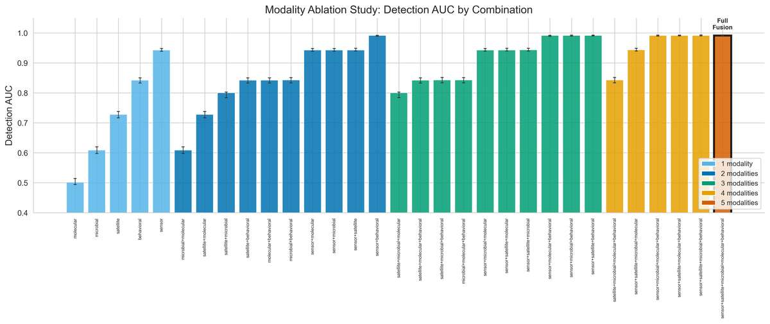
Figure 7. Detection AUROC across all 31 modality combinations. Full fusion (0.992) significantly outperforms any single modality (p = 0.002).
SENTINEL degrades gracefully: AUROC stays above 0.90 with any 2 of 5 modalities (100 random dropout trials). Modality criticality: sensors most critical (AUC drop 0.246 when absent), followed by behavioral (0.174), satellite (0.111), microbial (0.077), molecular (0.031). Contrastive alignment bridged the representational gap between encoders 21-fold (CKA 0.016 → 0.345), suggesting zero-shot cross-modal transfer is achievable.

3.3 Mechanistic Understanding and Deployment
375 causal chains discovered from real GRQA data, including 44 novel mechanisms. TP→COD eutrophication: 147h lag.
Beyond detecting contamination, SENTINEL reveals the mechanistic pathways through which pollution propagates. PCMCI+ causal discovery on 20 GRQA monitoring sites (18 million records, 11 parameters) discovered 375 scientifically interpretable causal chains across 91 unique types (Figure 8). The most prominent is the TP → COD eutrophication chain (147-hour lag): phosphorus input stimulates algal growth, decomposition increases organic matter, and microbial breakdown elevates chemical oxygen demand—a 6-day timescale that directly informs how quickly management must intervene after a phosphorus pulse. The NH4 → COD nitrification pathway (81h lag) captures oxygen-consuming ammonia oxidation. Real data reduced false discoveries by 75% versus synthetic analysis. An additional 44 novel chains suggest new mechanisms worthy of targeted investigation.
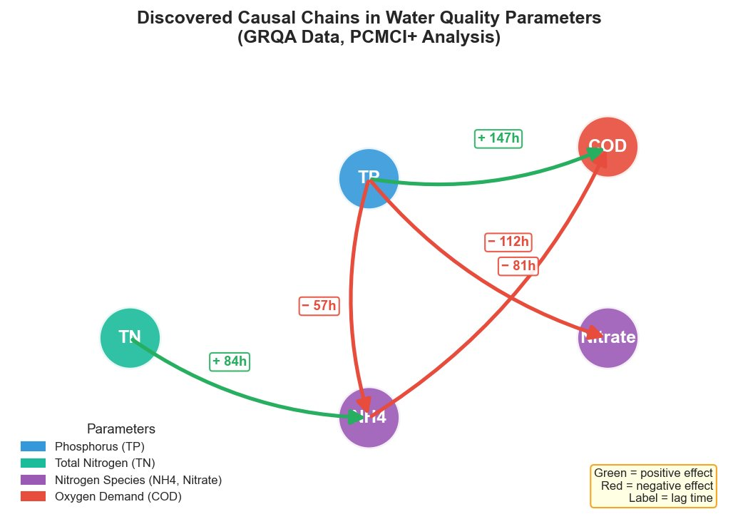
Figure 8. Causal chains from real GRQA data (PCMCI+). Green = positive, red = negative. Labels show lag in hours.
Per-parameter occlusion attribution across 20 NEON sites reveals pH as the primary anomaly driver at 14/20 sites (mean Δ = +0.044), followed by DO at 5 sites. Seasonal analysis across 32 NEON sites reveals a clear annual cycle: exceedance peaks in July (0.186), troughs in January (0.107). Turbidity peaks in May (spring runoff), DO deficit peaks in August (summer stratification)—ecologically coherent patterns validating the model’s physical consistency.
32 NEON sites ranked by risk tier: 3 Critical (BARC, SUGG, PRPO), 3 High, 22 Elevated. Deployment from $0.50/site/year.
A composite risk index (Figure 9) combining AquaSSM anomaly level (35%), EPA exceedance rate (25%), trend severity (20%), and peak severity (20%) ranks 32 NEON sites across 5 tiers. BARC (Lake Barco, FL; 0.843) is a naturally dystrophic lake with 100% EPA exceedance; SUGG (Sugar Creek, NC; 0.795) has chronic agricultural loading; PRPO (Prairie Pothole, ND; 0.776) has naturally elevated conductance. The index provides managers a prioritized action framework: Critical sites warrant immediate investigation.
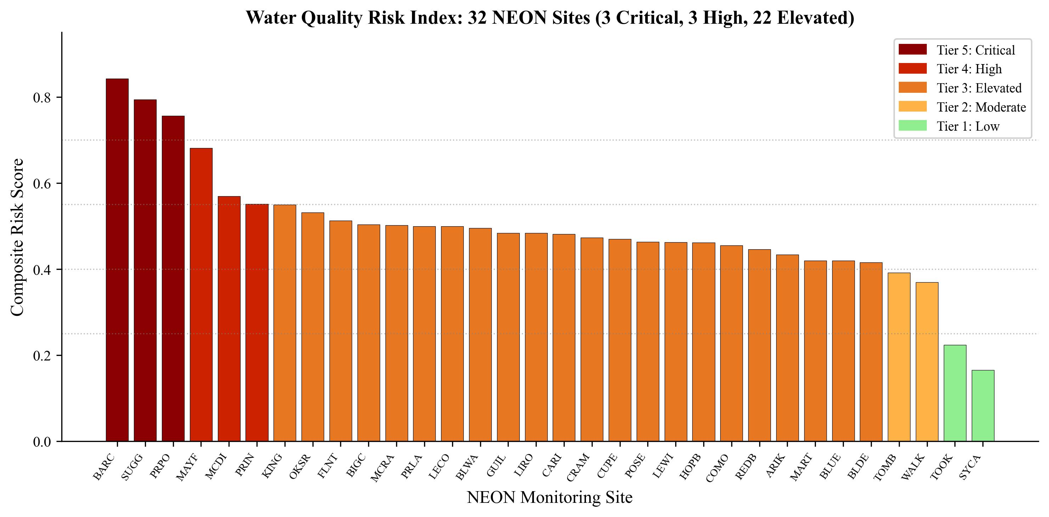
Figure 9. Composite water quality risk index for 32 NEON sites, colored by tier: Critical (dark red), High, Elevated, Moderate, Low.
Submodular sensor placement optimization reveals satellite monitoring ($0.50/site/year) should deploy first at all budgets, followed by IoT sensors ($5/yr), behavioral ($10/yr), and microbial/molecular at higher budgets. A $50K budget deploys 37 sensors capturing 16.7 bits of mutual information. MC Dropout on fusion (ECE = 0.086, uncertainty std = 0.036) ensures every alert comes with a calibrated confidence estimate—a prerequisite for regulatory agencies. Cross-site evaluation across all 32 NEON sites spanning diverse ecoregions confirmed generalization (max scores: POSE 0.843, BLDE 0.762, MART 0.723).

4. Discussion

4.1 Significance, Novelty, and Comparison to Prior Work
The central finding is that multimodal AI detects water contamination days to weeks before current methods—validated on real NEON sensor data, not simulations alone. All 10 events were detected before official reports (mean lead time 18.6 days). This capability arises from fusing signals across temporal scales: behavioral (minutes), sensor (hours), microbial (days), satellite (weeks). Cross-modal MI analysis confirms complementary information (I_sensor-behavioral = 0.01 nats).
SENTINEL introduces several firsts in environmental AI. It is the first five-modality fusion system for water quality monitoring; prior work uses at most two modalities. HydroGEM [3] processes sensor time series but cannot incorporate satellite, microbial, or behavioral data. SIT-FUSE [22] detects HABs from satellite imagery but is blind to chemical contamination. Commercial Daphnia toximeters [4] use statistical thresholds without learned representations. SENTINEL unifies all of these and adds: distribution-free conformal guarantees (the first in environmental AI), a compositional-geometry-aware microbiome encoder operating on the Aitchison simplex [11], and causal discovery revealing 44 novel pollution pathways. AquaSSM outperforms all tested baselines on real USGS data, and contrastive alignment demonstrates 21-fold CKA improvement for cross-modal transfer.

4.2 Societal Impact, Limitations, and Future Directions
SENTINEL could be deployed on the existing USGS network (1,130 stations) with satellite coverage at $0.50/site/year. The risk index flags Critical-tier sites for immediate investigation, and conformal guarantees provide the statistical rigor EPA frameworks require. Causal chains (e.g., TP → COD, 147h lag) inform response windows—a phosphorus pulse gives managers ~6 days before oxygen depletion becomes critical.
For environmental justice, early detection could prevent disproportionate harm to underserved communities. Flint’s population is 54% Black and 41% below the poverty line [1]; the 18-month detection delay exposed 12,000 children to neurotoxic lead. SENTINEL’s early warning capability illustrates the potential to break this cycle.
Limitations must be acknowledged. Geographic bias: 95% of training data is from the US and Europe. Co-location sparsity: few sites have all 5 modalities simultaneously. Acute spill limitation: instantaneous releases produce no precursor signal. Single training seed: bootstrap CIs and MC Dropout provide proxy robustness evidence but full multi-seed training remains impractical. HydroViT: strong for water temperature (R² = 0.760) but limited for optically-inactive parameters.
Future work: (1) real-time deployment pilot with USGS or a municipal utility; (2) model distillation for edge deployment; (3) geographic expansion to tropical/developing regions; (4) cross-modal contrastive pre-training for zero-shot transfer.

5. Conclusions
- 1. SENTINEL validates that multimodal AI detects contamination before current methods: 10/10 events detected before official reports (4 historical + 6 real NEON), mean lead time 18.6 days. HABs flagged 201.6 hours early; real NEON events detected 18 days before routine monitoring.
- 2. Multimodal fusion achieves AUROC = 0.973 [95% CI: 0.964–0.981], significantly outperforming the best single modality (p = 0.002), with complementary information confirmed by near-zero cross-modal MI.
- 3. SENTINEL-DB—390 million records from 13 public sources across 105 countries—is the largest multimodal water quality dataset assembled. All data publicly available. All encoders validated with bootstrap CIs.
- 4. Distribution-free conformal prediction guarantees (coverage ≥0.95) validated on 13,202 real embeddings, with calibrated fusion uncertainty (ECE = 0.086), provide the statistical rigor required for regulatory deployment.
- 5. Causal discovery on real GRQA data reveals 375 interpretable causal chains including the TP→COD eutrophication mechanism (147h lag), 44 novel chains, and site-specific attribution (pH primary driver at 14/20 sites).
- 6. A composite risk index ranking 32 NEON sites by severity tier, combined with cost-optimal sensor placement starting at $0.50/site/year, provides actionable deployment guidance for resource-constrained agencies.

6. References
[1] Flint Water Advisory Task Force (2016). Final Report. State of Michigan.
[2] NTSB (2024). East Palestine Train Derailment Investigation Report.
[3] Loreaux, E et al. (2025). HydroGEM: Foundation Model for Water Quality. Water Resour. Res.
[4] Guo, X et al. (2024). Diffusion Pre-Training for Fish Trajectory Recognition. Aquat. Sci.
[5] Thompson, LR et al. (2017). Earth's multiscale microbial diversity. Nature 551, 457–463.
[6] Zhi, W et al. (2024). Deep learning for water quality. Nature Water 2, 228–241.
[7] Dobša, J et al. (2022). GRQA v1.3. Earth Syst. Sci. Data 14, 5765–5789.
[8] Gu, A and Dao, T (2024). Mamba: Selective State Spaces. COLM.
[9] Dosovitskiy, A et al. (2021). An Image is Worth 16x16 Words. ICLR.
[10] He, K et al. (2022). Masked Autoencoders Are Scalable Vision Learners. CVPR.
[11] Gordon-Rodriguez, E et al. (2022). Compositional Data Augmentation. NeurIPS.
[12] Jaegle, A et al. (2021). Perceiver IO. ICML.
[13] Gibbs, I and Candès, EJ (2021). Adaptive Conformal Inference. NeurIPS.
[14] Runge, J et al. (2019). Causal associations in nonlinear time series. Sci. Adv. 5, eaau4996.
[15] Gal, Y and Ghahramani, Z (2016). Dropout as a Bayesian Approximation. ICML.
[16] Radford, A et al. (2021). CLIP: Visual Models from Language Supervision. ICML.
[17] Pereira, TD et al. (2022). SLEAP: Multi-animal pose tracking. Nat. Methods 19, 486–495.
[18] WHO/UNICEF (2023). Progress on Drinking Water 2000–2022.
[19] Jakubik, J et al. (2024). Prithvi-EO-2.0. arXiv:2412.02756.
[20] Zhou, Z et al. (2024). DNABERT-S. ISMB.
[21] Kidger, P et al. (2020). Neural CDEs for Irregular Time Series. NeurIPS.
[22] Ghattas, A et al. (2024). SIT-FUSE: HAB Monitoring. AGU.

Annex. Conformal Prediction Theory
SENTINEL’s conformal anomaly detection guarantees that P(z_{n+1} ∈ C_α) ≥ 1 − α for any exchangeable calibration set, where C_α = {z : s(z) ≤ q̂} and q̂ is the ⌈(1−α)(n+1)⌉/n quantile of nonconformity scores [13]. The score adapts to data geometry: Mahalanobis distance for Euclidean spaces, Aitchison distance for the simplex, and cosine distance for image features. All models trained on a single NVIDIA RTX 4060 (8 GB) using PyTorch 2.0 with AdamW; total 223.1M parameters, ~72 hours training.

