Install Python 3

<https://www.python.org/downloads/>

Check to make sure latest update of pip

pip3 install –-upgrade pip

Install Virtual Environment

<https://virtualenv.pypa.io/en/latest/installation/>

pip3 install virtualenv

Install and Create Virtual Envionrment Wrapper

<https://virtualenvwrapper.readthedocs.io/en/latest/>

pip3 install virtualenvwrapper

export WORKON_HOME=~/Envs

mkdir -p $WORKON_HOME

source /usr/local/bin/virtualenvwrapper.sh

mkvirtualenv burgerForm

Install Django 2.1 7

<https://www.djangoproject.com/download/>

pip3 install Django==2.1.7

**Django Burger Form Project**

<https://docs.djangoproject.com/en/2.1/intro/tutorial01/>

Work on virtual environment

workon djangoBurger

To deactivate virtual environment

deactivate

Make a directory

mkdir djangoBurger

Start a django project inside djangoBurger

django-admin startproject burgerSite

Run server at <http://127.0.0.1:8000/>

python3 manage.py runserver

(Ctrl + C to exit from terminal)

Start an application

python3 manage.py startapp burgerForm

Create burgerForm/ticketView.py and edit burgerSite/urls.py and burgerForm/urls.py

Set up database in burgerSite/settings.py

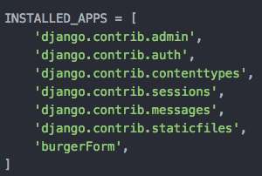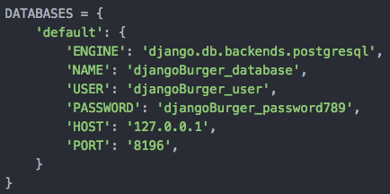

Migrate changes

python3 manage.py migrate

If ModuleNotFoundError: No module named ‘psycopg2’

pip3 install psycopg2

Rerun migrate

Create burgerForm/models.py

Make migrations and migrate

python3 manage.py makemigrations

python3 manage.py migrate

Create a superuser

python3 manage.py createsuperuser

Edit burgerFrom/admin.py