1. **Right Triangle Star Pattern** 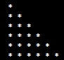
2. **Left Triangle Star Pattern** 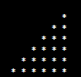
3. **Pyramid Star Pattern** 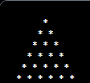
4. **Diamond Shape Pattern** 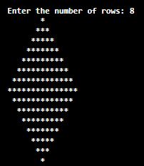
5. **Downward Triangle Star Pattern** 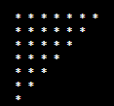
6. **Mirrored Right Triangle Star Pattern** 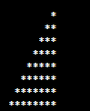
7. **Reverse Pyramid Star Pattern** 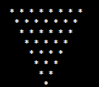
8. **Right Down Mirror Star Pattern** 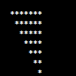
9. **Right Pascal's Triangle** 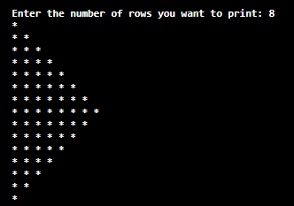
10. **Left Pascal's Triangle** 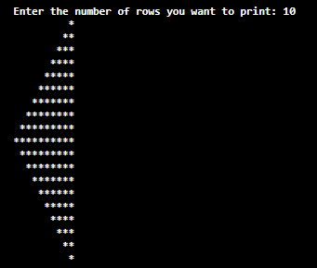
11. **Sandglass Star Pattern** 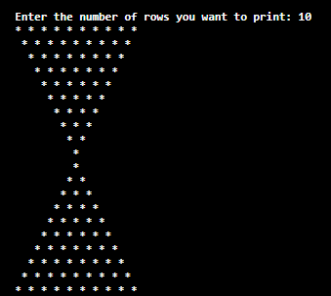
12. **Alphabet Star Pattern** 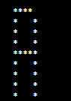
13. **Triangle Star Pattern** 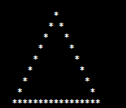
14. **Down Triangle Pattern** 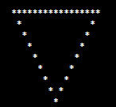
15. **Diamond Star Pattern**   
    