San Jose State University

Department of Electrical Engineering

EE104, Fall 2021, Pham

Laboratory Assignment #7

# Objectives

This lab introduces you the art of integration a few tools that you are already familiar to provide a business solution that you can use in the real life application using FFT.

# Grading

Refer to the section **Python Programming** for grading criteria.

# Bibliography

Refer to lecture notes for sample programs.

# Requirements

## 1 - FFT/IFFT Audio Signal Processing – Noise Cancelling Application

Write you own code to generate the waveforms or use your own audio recording device such as your smart phone or computer to record and generate a WAV file that has at least 3 tones with different frequencies.

Optional: You can also leverage the following websites for tone generation or write your own Python code to generate the tones:

* <https://www.audiocheck.net/audiofrequencysignalgenerator_index.php>
* <https://www.wavtones.com/functiongenerator.php>

Write a Python program to show the signals in the frequency domain. Filter out one or more frequencies as you wish and convert back to the time domain.

## 2 - Heart Rate Analysis – Time Domain Measurements – Biotechnology

Download a WAV file from the heartbeat sound bank website <https://www.kaggle.com/kinguistics/heartbeat-sounds> by selecting a wave file that shows at the minimum 30 beats in the preview waveform. Using WAV to CSV conversion tool and write a Python program to plot the heart rate signal and find the time-domain measurements for that WAV file. See a sample below.

Note: CSV data has to be normalized to 0.xxx format. For example, if your converted data is 95, then normalize by dividing the number by 1000 to get 0.095.

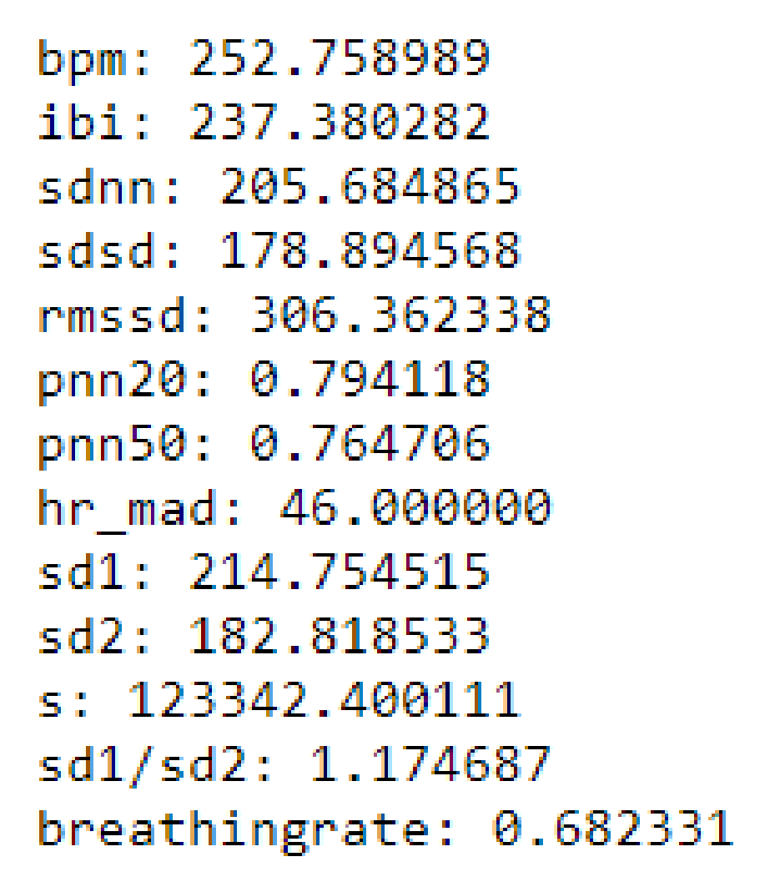

## 3 – Game Development – Red Alert

Leverage the base code from chapter Red Alert, and implement your own Hacks and Tweaks for any 3 of the options below: Change the Actor, A Need for Speed, Try Again or Shuffling.

# Python Programming

#### Lab Submission

|  |  |  |
| --- | --- | --- |
| **Program or Requirement** | **Use Case** | **Earned Score / Max Score** |
| Demonstration Video | You must submit a demonstration video or your score for this lab will be zero |  |
| README file and Documentation on GitHub | This is a brief user guide so that the user can install the proper python packages and knows how to execute your program. The README file can contain sample screenshots with explanation.  You will practice how to use GitHub. | _____ / 10 |
| FFT/IFFT Audio Signal Processing – Noise Cancelling Application | Acoustic noise-cancelling headsets | _____ / 30 |
| Heart Rate Analysis – Time Domain Measurements | Hospital clinical vital measurement instrument | _____ / 30 |
| Game Development – Red Alert | Entertaining Industry, Education | _____ / 30 |
|  | **TOTAL** | **100%** |

That’s all for this lab. Hopefully you found it useful and increase your interest in the Python world! See you in the next lab.

# Laboratory Hand-In Requirements

Once you have completed a working design, prepare for the submission process. You are required to demonstrate a working design. You are also required to submit an archive of your project in the form of a ZIP file. Use 7-Zip option to create the ZIP file. Name the archive lab#_yourlastname_yourfirstname.zip. Refer to Lab 1 for detail instructions.

You will submit your zip file to the instructor through Canvas by the due date and time. You will also submit the same to Github so that you can run the Google Colab directly from Github. If the class will be on campus, then you will expect to demonstrate in the classroom. If we ever have to go back to an online mode, turn in your archive to Canvas along with a narrated video capturing the screen of your computer running your program demonstration. If your program is not completely functional by the due date, you should demonstrate and turn in what you have accomplished to receive partial credit. See the syllabus for the late penalty guideline