DI.FM

A Digital Imported Radio App for Windows 8

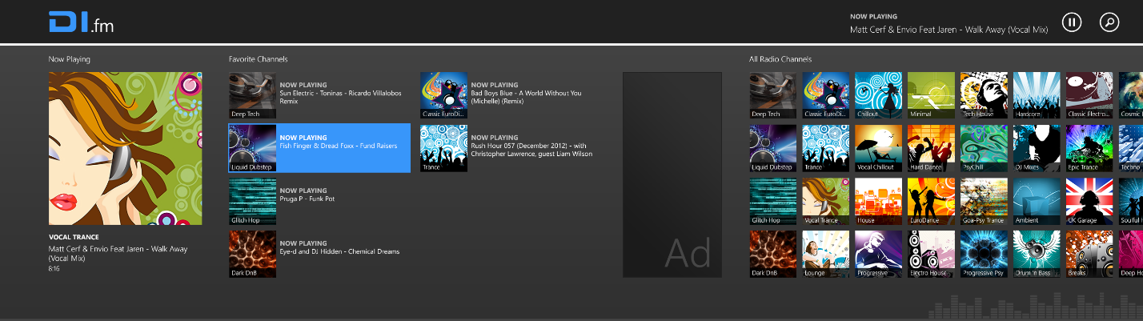

# Overview

To take advantage of this template’s design, use the Styles gallery on the Home tab. You can format your headings by using heading styles, or highlight important text using other styles, like Emphasis and Intense Quote. These styles come in formatted to look great and work together to help communicate your ideas.

# Features

## Roaming Settings File

All users will have a cloud-enabled object save. Favorites, Play time (on each channel, total), and user settings should be saved to the cloud via the integrated ‘Roaming Profile/Save’ functionality in Windows 8.

This covers a few scenario where this is being used.

1. Any channel marked as a 'favorite' will be saved to the roaming profile.
2. More..

## Windows 8 Exclusive Integration

## Search

## Share

## Play-To Contracts

## Semantic Zoom

Support for semantically zooming on the Main View of DI.FM.

# Application Layout & Pages

Main View  
Users start in DI.FM on the Main View. This view is distributed into a few sections 'Now Playing', 'Favorite Channels', and 'All Radio Channels'.

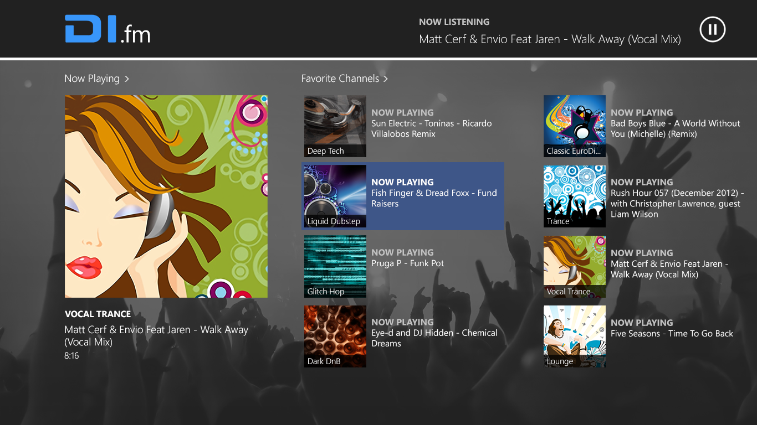  
  
Now Playing showcases whatever is the currently playing channel in DI.FM. When no channel is currently active, then this should show the most recently played channel.

Favorite Channels lists out all of the channels the user has designated as a 'favorite'. Limited to displaying 3 items on the Main View.

All Radio Channels provides a Grid list of all of the Radio Channels currently available.

## Channel View

A page used to show a selected channel and all important information related to each channel.  
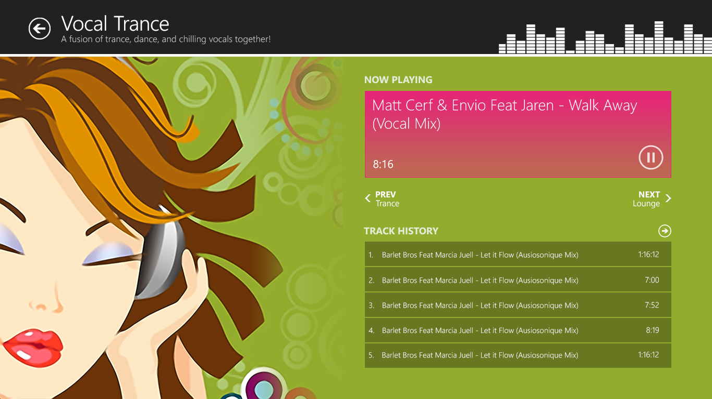  
  
Now Playing showcases the currently playing song, and a Play/Pause button.

Prev/Next Buttons provide the user the ability to view other channels near Vocal Trance, this is alphabetically determined currently, but may evolve into a more dynamic/smarter system.

Track History is a section that simply lists the previous tracks that have played on this Channel, with the Arrow in the top Right of this section being clickable to load 5 even older tracks (6, 7, 8, 9 and 10).

Snap View  
At any given time the user should be able to load a Snap View of DI.FM. This is simple a constrained view of the Channel and Main View, but should not limit functionality.  
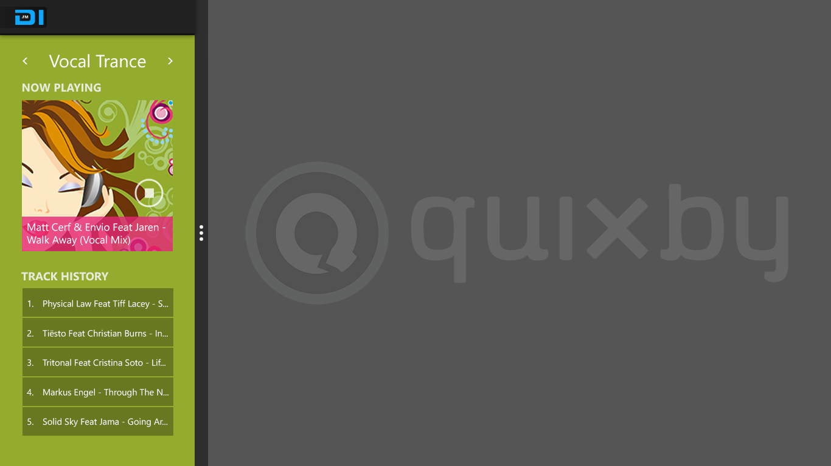

# Other…

Information not available yet.

# References

http://msdn.microsoft.com/en-us/windows/apps/hh852650.aspx