After examining data related to math / reading schools at a variety of schools, we can draw some interesting conclusions.

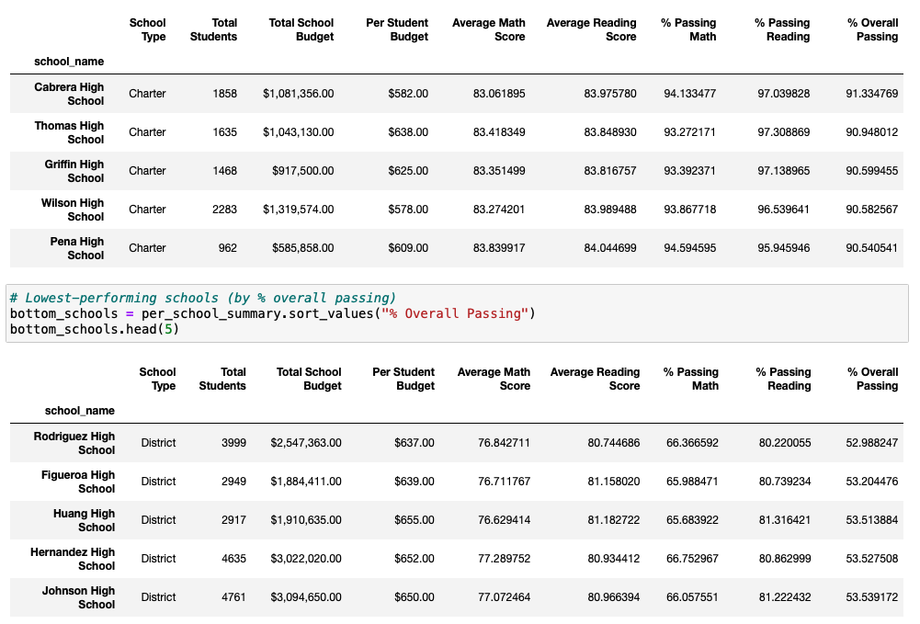When sorting the table of schools by the highest and lowest overall passing percentages, as seen below, we notice that the five highest-performing schools all fall into the “Charter” type while the five lowest-performing schools are categorized as “District.”

The district schools tend to have a higher overall budget than charter schools, but they also contain more total students which may impact the scores being achieved. Perhaps charter schools attract a niche sample of the population, while the larger overall sample attending district schools provides a more accurate representation of the general public.

The tables below show that higher per student spending does not correlate to improved math/reading scores, and instead a small/medium sized school seems to be the key.

We also see a wide gap between charter and district schools as mentioned before, with over 90% of charter students passing both math and reading and only 54% of district students doing so.

An interesting tidbit of information relates to average test scores by grade. As seen in the table below, average scores tend to stay the same as students progress from 9th to 12th grade. Whether or not this is due to the types of students each school is attracting or the performance of the school itself, it is helpful to know that scores stay relatively steady between grades when comparing other variables.

