Talking Drawing Analysis Software

Case 1: Comparing Talking Drawing Prompts against a word list

1. Create a text file with all important words that need to be scanned for
   1. Make sure there is some method of demarcation between words that the program can understand. The software current accepts commas, line breaks, and a host of special characters to delimit words.
   2. Example:
   3. 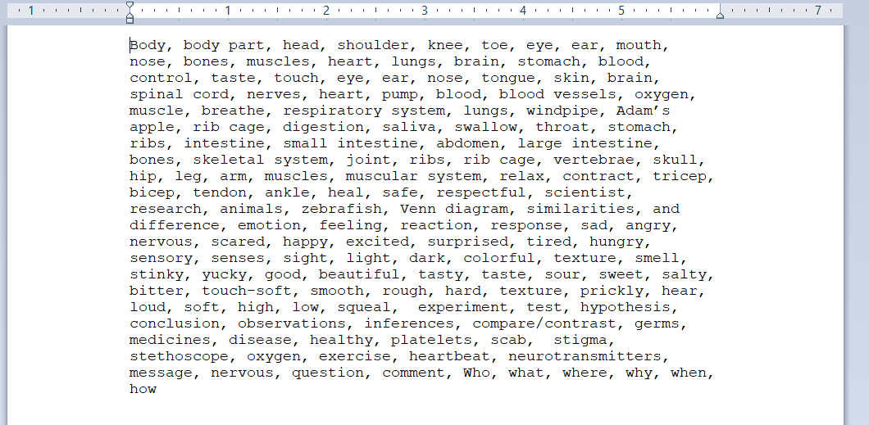
2. Save the file as a .txt file
   1. The software **CANNOT** interpret pdf/.docx files, as they have a proprietary encoding format.
   2. Example:

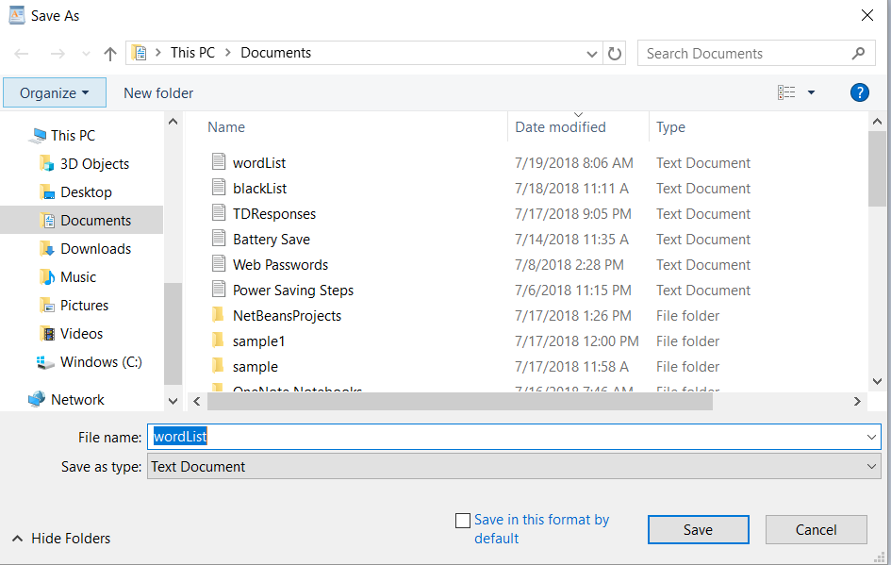

1. If the Talking Drawing Responses are current in a spreadsheet, copy the column of Talking Drawing Responses that you wish to analyze and paste them into an empty excel column. Then**, delete any cells that have text that you don’t want to analyze**. For example, in the case below, you should delete the header “Pre Translated Text” and “Prompt: How does my body show my feelings”
   1. Example:
   2. 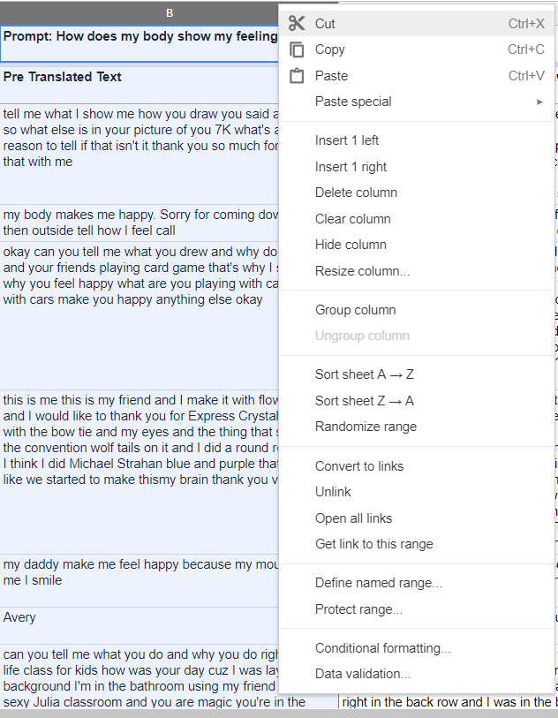
   3. 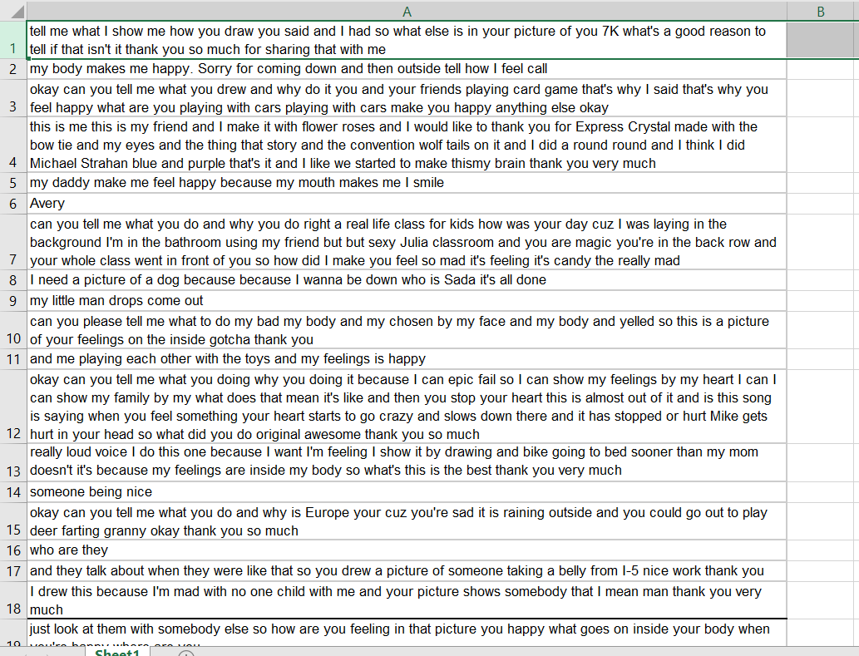
2. If the Talking Drawing Responses are currently in a different format, either paste them into an empty text file one by one, **making sure to press enter between each prompt**, or paste them into an Excel column one by one.
   1. Example A:
   2. 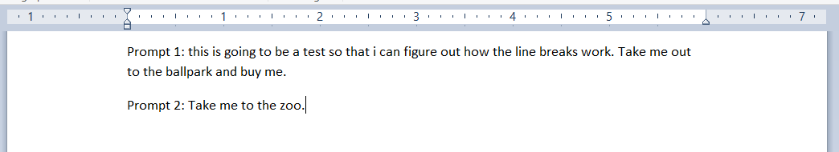
   3. Example B:
   4. 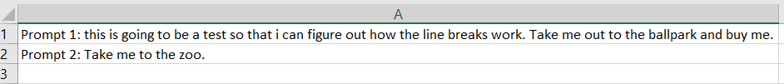
3. If you are working with a text file, simply **save it as a .txt file**. If you are working with an Excel file, **save it as a .csv file**
   1. Example A:
      1. 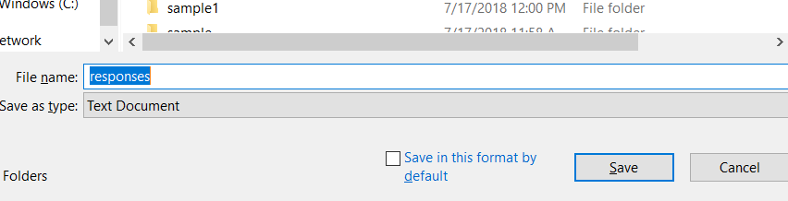
   2. Example B:
   3. 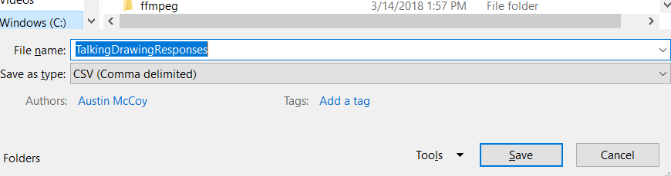
4. Now, open the Talking Drawing Software
   1. 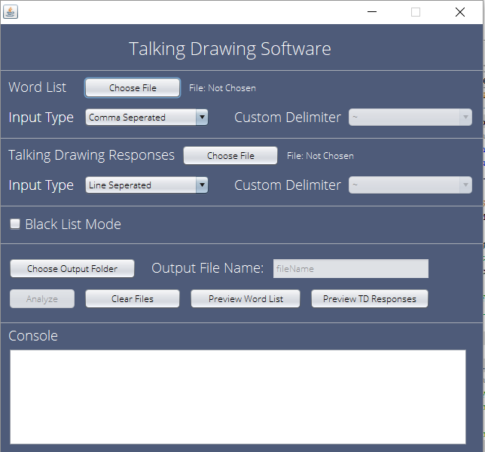
5. Click “Choose File” next to the label that says “Word List” and choose your text file
   1. 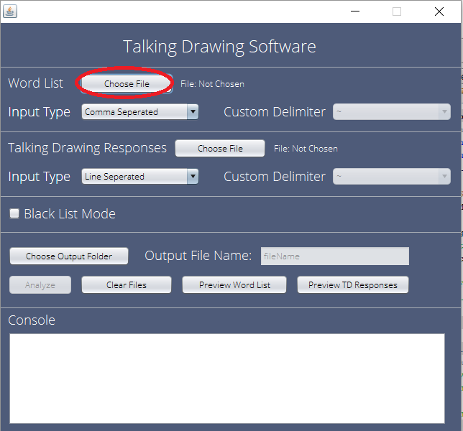
   2. 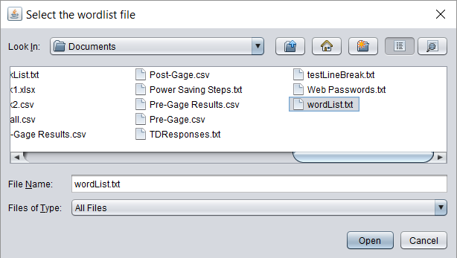
6. Now, select the delimiter you’re using for the Word List. This is likely “Comma Separated” or “Line Separated”
   1. 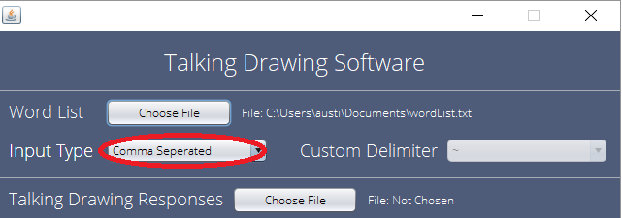
7. Next, hit “Choose File” next to the label “Talking Drawing Responses” and choose your Talking Drawing Response text or csv file.
   1. 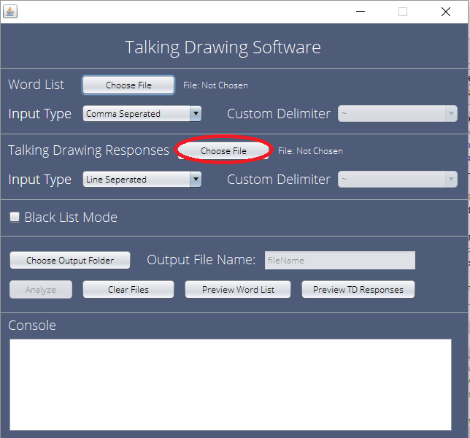
   2. 
8. Now, select the delimiter you’re using for the Talking Drawing Response List. This is likely “Comma Separated” or “Line Separated”. **Note: If you used a .CSV file, it is actually Line Seperated**
   1. 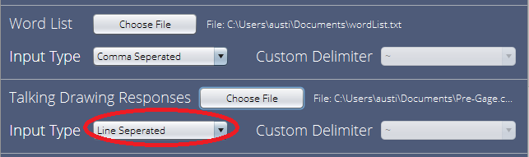
9. Now, skip past the “Black List Mode” checkbox and hit “Choose Output Folder” and choose the folder you want the results to go to
   1. 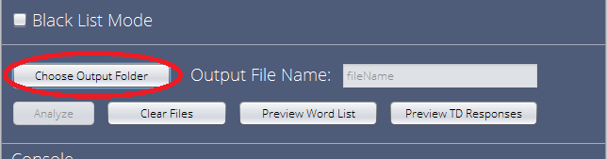
   2. 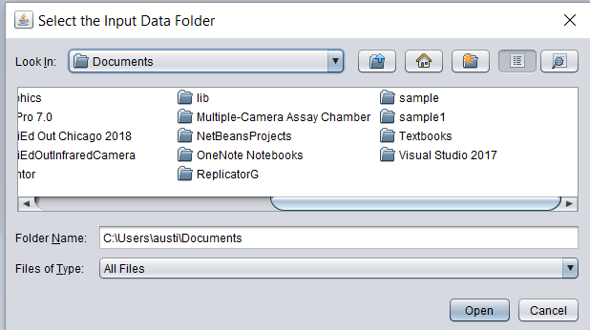
10. Now, name your file in the “Output File Name” text box
    1. 
11. If you want to make sure it is correctly understanding your word list, hit “Preview Word List” and the words will appear in the Console Box if everything is okay.
    1. 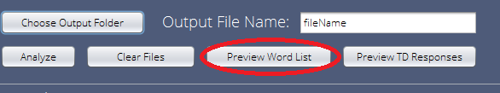
    2. 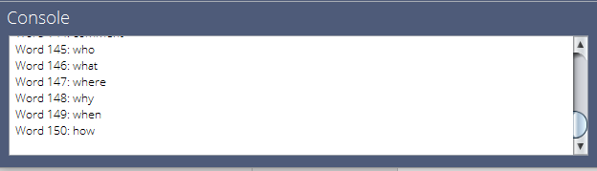
12. If you want to make sure it is correctly understanding your Talking Drawing Response list, hit “Preview TD Responses” and the words will appear in the Console Box if everything is okay.
    1. 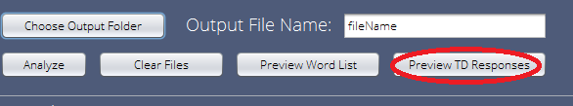
    2. 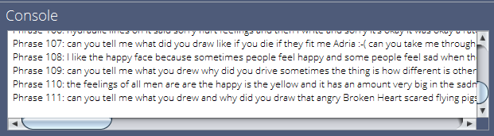
13. Hit “Analyze” and the button will turn grey. Wait until it is normal again, and the results file will be wherever you told it to save to.
    1. 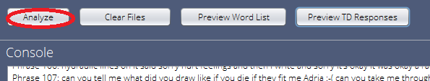
14. Hit “Clear Files” to analyze another set of prompts.
    1. 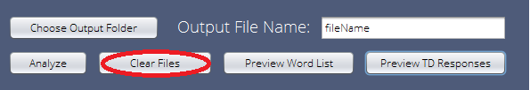

Case 2: Obtaining a frequency list of all non-ubiquitous words

1. Create a text file with all the words you want to exclude. This includes conjunctions, prepositions, articles, etc.
   1. Make sure there is some method of demarcation between words that the program can understand. The software current accepts commas, line breaks, and a host of special characters to delimit words.
   2. Example:
   3. 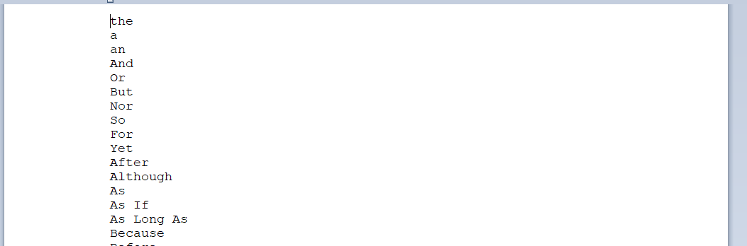
2. Save the file as a .txt file
   1. The software **CANNOT** interpret pdf/.docx files, as they have a proprietary encoding format.
   2. Example:



1. If the Talking Drawing Responses are current in a spreadsheet, copy the column of Talking Drawing Responses that you wish to analyze and paste them into an empty excel column. Then**, delete any cells that have text that you don’t want to analyze**. For example, in the case below, you should delete the header “Pre Translated Text” and “Prompt: How does my body show my feelings”
   1. Example:
   2. 
   3. 
2. If the Talking Drawing Responses are currently in a different format, either paste them into an empty text file one by one, **making sure to press enter between each prompt**, or paste them into an Excel column one by one.
   1. Example A:
   2. 
   3. Example B:
   4. 
3. If you are working with a text file, simply **save it as a .txt file**. If you are working with an Excel file, **save it as a .csv file**
   1. Example A:
      1. 
   2. Example B:
   3. 
4. Now, open the Talking Drawing Software
   1. 
5. Click “Choose File” next to the label that says “Word List” and choose your text file
   1. 
   2. 
6. Now, select the delimiter you’re using for the Word List. This is likely “Comma Separated” or “Line Separated”
   1. 
7. Next, hit “Choose File” next to the label “Talking Drawing Responses” and choose your Talking Drawing Response text or csv file.
   1. 
   2. 
8. Now, select the delimiter you’re using for the Talking Drawing Response List. This is likely “Comma Separated” or “Line Separated”. **Note: If you used a .CSV file, it is actually Line Seperated**
   1. 
9. **Check the box that says “Black List Mode”**
   1. 
10. Hit “Choose Output Folder” and choose the folder you want the results to go to
    1. 
    2. 
11. Now, name your file in the “Output File Name” text box
    1. 
12. If you want to make sure it is correctly understanding your word list, hit “Preview Word List” and the words will appear in the Console Box if everything is okay.
    1. 
    2. 
13. If you want to make sure it is correctly understanding your Talking Drawing Response list, hit “Preview TD Responses” and the words will appear in the Console Box if everything is okay.
    1. 
    2. 
14. Hit “Analyze” and the button will turn grey. Wait until it is normal again, and the results file will be wherever you told it to save to.
    1. 
15. Hit “Clear Files” to analyze another set of prompts.
    1. 

The results will now appear where you saved them:

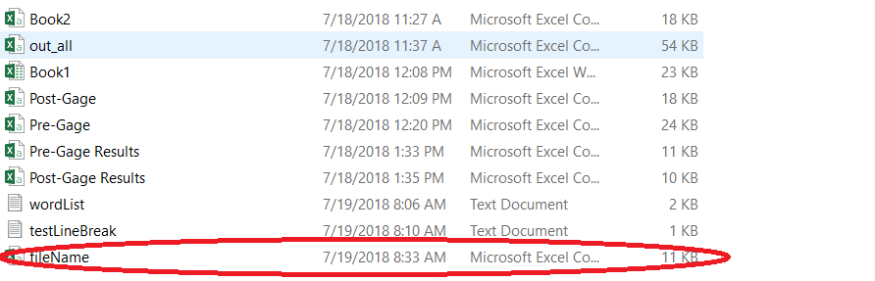

Open in Excel/Google Sheets/Sheets to view it:

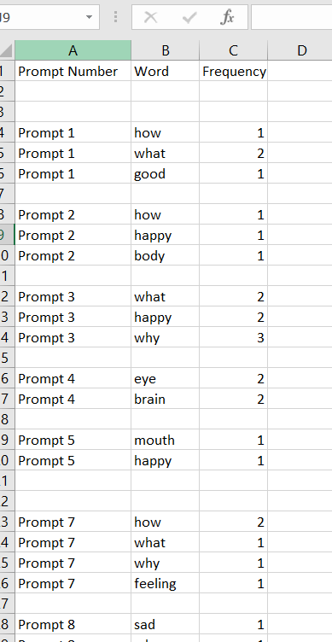

Individual results are at the top and cumulative results are at the bottom