Configuring ETT using AMIs

# Introduction

The document explains the process on how to use ONC provided AMIs to install and configure ETT to have and independent instance from the ONC hosted instance.

**Note:** The ETT AMIs is currently available as private images. The reason for them being private is because the AMIs were created using an older version of Ubuntu Linux (12.x) and Amazon does not allow creation of public AMIs for the older operating systems. So in order to access the AMIs, the organization would have to provide their AWS account id so that ONC team can authorize the organization to access and use the AMIs.

# ETT Deployment Architecture and Instances

The diagram below shows a high level overview of the ETT deployment architecture

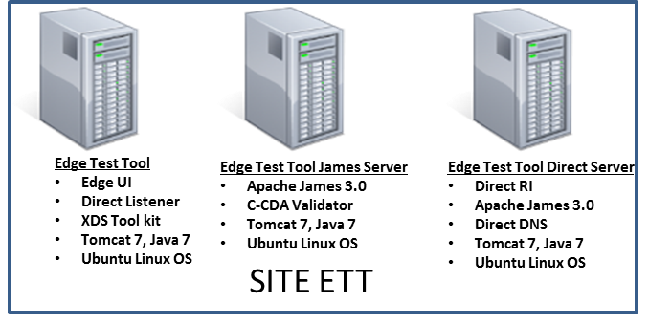

ETT architecture requires these three instances and three registered domains for running all the components: we will refer to these three domains as edgedomain, jamesdomain, directdomain. The provided instances are functional with these pre-configured parameters for the above three domains: ttpedgedev.sitenv.org, ttpdsdev.sitenv.org, ttpds2dev.sitenv.org. After instantiating you will have to follow the outlined steps to point these settings to your own domains with corresponding certificates.

Please note that in addition to pointing DNS A records for the corresponding domain names to these servers, since edgedomain and directdomain also run their own name servers (due to the fact that the certificates need to be published in the DNS for direct) - you may have to add glue records for these two domains as well pointing to the corresponding ips.

**Configuring ETT UI Instance**

ETT is packaged as springboot jar application. All the parameters to the ETT UI can be configured in these two files: [/opt/ttp/application.properties](https://github.com/siteadmin/ett/blob/resources/installation-resources/application.properties)and */opt/ttp/smtptestcases.json* by replacing all the occurrences of the preconfigured ttp to your domain settings. The application.properties is used by the application during the startup to reference the validator, toolkit, james, direct components. The json file is used by the user interface to display the endpoints.

**Configuring ETT Direct Instance**

The Direct instance is used as a Sending HISP for SMTP message tracking test cases. The instance is configured with an address bound certificate to this domain ttpds2dev.sitenv.org. Configuring the instance involves creating your domain using the UI for the direct web application which may need accessing the application through the ip address till all the name services are configured fully: (<http://directserver-ip:8081/config-ui>). To access the application, tomcat needs to be started in this instance:

cd /opt/tomcat7/bin

sudo ./startup.sh

cd /opt/direct/DirectDNSServices/DirectDNSServer/bin

sudo ./DirectDNSServer start

cd /opt/direct/apache-james-3.0-beta4/bin

sudo ./james start

The instructions to create a domain and import your certificate are available [here](https://github.com/meaningfuluse/mu2/blob/master/transport/direct-hello-world.md).

* credentials: admin/adm1nD1r3ct. Update the trust anchors and certificates for your directserver domain.
* After you complete the above steps successfully, you should be able to view their certs by querying the DNS

$ dig directserver CERT

In addition, follow the instructions from the above guide to create a user called *hisptesting@jamesdomain* in the directserver James - this is the account from which ETT communicates to the Receiving HISP test cases. If you are using address bound certificate for this domain, you may need to create a certificate and upload that as well to the DirectDNS using the above web application.

**Configuring ETT James Instance**

The ETT James instance is preconfigured with users and mailboxes for the ttpds.sitenv.org domain. You will have to create your corresponding domain and create these users using the provided script: [addusers.sh](https://github.com/siteadmin/ett/blob/resources/installation-resources/james/addusers.sh) and populate the corresponding mailboxes using the contents [here](https://github.com/siteadmin/ett/tree/resources/installation-resources/james/mailbox-testmessages).

**Configuring the certificate settings**

**Direct certificate settings for your domain**

The /opt/certificates folder contains the certificates used by the ETT direct.

1. good/aia folders with appropriate certificates for your domain for the [Direct Send component](https://ttpedge.sitenv.org/ttp/#/direct/send). Populate the good folder with the security cert (PKCS#12) for edgedomain. Use the same certs for the next step in creating the edgeserver domain which publishes the certs to DNS. If you want to update the downloadable URLs shown in the in the [ETT direct page](https://ttpedge.sitenv.org/ttp/#/direct), you have to update the /opt/ttp/direct_certificates_links.json correspondingly.
2. Also these certs need to be published to the DNS by following the the instructions [here](https://github.com/meaningfuluse/mu2/blob/master/transport/direct-hello-world.md) (similar to the Directserver configuration above, except that we will not configure the James SMTP component).

* Create the domain for edgeserver. http://edgeserver-ip:8081/config-ui credentials: admin/adm1nD1r3ct Update the trust anchors and certificates for your edgeserver domain.

3 . After you complete the above steps successfully, you should be able to view their certs in the DNS

$ dig edgeserver CERT

**XDS toolkit Mutual-TLS**

These certificates are used by the mutual TLS for XDR testcases: /opt/certificates/xdr files: keystore, keystore.p12, key.pem, cert.pem.

**Optional: SSL configuration for HTTPS**

SSL can be enabled through apache and/or springboot combination. Pls update /opt/ttp/application.properties, /opt/certificates/private and/or /etc/apache2 conf files.

**Startup**

Edge server: Name services

cd /opt/tomcat7/bin

sudo ./startup.sh

cd /opt/direct/DirectDNSServices/DirectDNSServer/bin

sudo ./DirectDNSServer start

James server:

cd /opt/james/bin

sudo ./james start

This server also runs the ccda-validator:

cd /opt/tomcat7/bin

sudo ./startup.sh

Direct services:

cd /opt/tomcat7/bin

sudo ./startup.sh

cd /opt/direct/DirectDNSServices/DirectDNSServer/bin

sudo ./DirectDNSServer start

cd /opt/direct/apache-james-3.0-beta4/bin

sudo ./james start

**Maintenance notes**

1. Please remove /opt/ttp/ccda_objectives.txt to reflect the refresh github resources periodically.
2. Please avail these logs for troubleshooting ett - /opt/ttp/logs/catalina.out @edgeserver

toolkit - /opt/tomcat7/logs/catalina.out @edgeserver

DNS issues for edgeserver - /opt/tomcat7/logs/catalina.out @edgeserver

james issues - /opt/james/logs @jamesserver

validator - /opt/tomcat7/logs/catalina.out @jamesserver

1. The toolkit may need periodic updates; more info can be found [here](https://github.com/usnistgov/iheos-toolkit2) Also the ccda validator updates are available [here](https://github.com/siteadmin/referenceccdavalidator/releases) and the technical Support [here](https://groups.google.com/d/forum/edge-test-tool) or [edge-testing-tool@googlegroups.com](mailto:edge-testing-tool@googlegroups.com)