CDA3103 – Computer Logic and Organization
Project Description

1. Introduction

In this project, you are asked to write the core part of a mini processor simulator called MySPIM using C language on a Unix or a PC platform. Your MySPIM will demonstrate some functions of MIPS processor as well as the principle of the datapath and the control signals of MIPS processor. The MySPIM simulator should read in a file containing MIPS machine codes (in the format specified below) and simulate what the MIPS does cycle-by-cycle. You are required to implement the MySPIM with a single-cycle datapath. You are asked to fill in the body of several functions in a given file.

2. Specification of the simulator
2.1. Instructions to be simulated

The 14 instructions listed in Appendix A, Figure 1 are to be simulated. Please refer to the tables in Chapter 4 of the textbook (or the relevant powerpoint slides) for the machine codes of these instructions. Note that you are NOT required to treat situations leading to exception, interrupt, or change in the status register.

2.2. Registers to be handled

MySPIM should handle the 32 general purpose registers.

2.3. Memory usage

- The size of memory of MySPIM is 64kB (Address 0x0000 to 0xFFFF).
- The system assumes that all program starts at memory location 0x4000.
- All instructions are word-aligned in the memory, i.e., the addresses of all instructions are multiple of 4.
- The simulator (and the MIPS processor itself) treats the memory as one segment. (The division of memory into text, data, and stack segments is only done by the compiler/assembler.)
- At the start of the program, all memory are initialized to zero, except those specified in the “-asc” file, as shown in the provided codes.
- The memory is in big-endian byte order.
- The memory is in the following format: e.g. Store a 32-bit number 0xaabbccdd in memory address 0x0 – 0x3.

 | Mem[0]
Address | 0x0 | 0x1 | 0x2 | 0x3
Content | aa | bb | cc | dd

2.4. Conditions that the MySPIM should halt

If one of the following situations is encountered, the global flag Halt is set to 1, and hence the simulation halts.
- An illegal instruction is encountered.
- Jumping to an address that is not word-aligned (being multiple of 4).
- The address of lw or sw is not word-aligned.
- Accessing data or jump to address that is beyond the memory.
Note: The instructions beyond the list of instructions in Figure 1 are illegal.

2.5. Format of the input machine code file

MySPIM takes hexadecimal formatted machine codes, with filename xxx.asc, as input. An example of .asc file is shown below. Text after “#” on any line is treated as comments.

20010000 # addi $1, $0, 0
200200c8 # addi $2, $0, 200
10220003 # beq $1, $2, 3
00000020 # delay slot
20210001 # addi $1, $1, 1
00000020 # no operation

The simulation ends when an illegal instruction, such as 0x00000000, is encountered.

2.6. Note on branch addressing

The branch offset in MIPS, and hence in MySPIM, is relative to the next instruction, i.e. (PC+4). For example,

Assembly Code

beq $1, $2, label
beq $3, $4, label
label: beq $5, $6, label
Machine Codes

4 | 1 | 2 | 0x0001

4 | 3 | 4 | 0x0000

4 | 5 | 6 | 0xffff
Opcode Rs Rt offset
6 bits 5 bits 5 bits 16 bits

3. Resources
3.1. Files provided

Please download the following files from the WebCourses:

spimcore.c
spimcore.h
project.c

These files contain the main program and the other supporting functions of the simulator. The code should be self-explanatory. You are required to fill in the functions in project.c. You may also introduce new functions, but do not modify any other part of the files. Otherwise, your program may not be properly marked. You are not allowed to modify spimcore.c and spimcore.h. All your works should be placed in project.c only.

The details are described in Section 4 below.

4. The functions to be filled in

The project is divided into 2 parts. In the first part, you are required to fill in a function (ALU(…)) in project.c that simulates the operations of an ALU.

- ALU(…)
  - Implement the operations on input parameters A and B according to ALUControl.
  - Output the result (Z) to ALUresult.
  - Assign Zero to 1 if the result is zero; otherwise, assign 0.
  - The following table shows the operations of the ALU.
ALU Control | Meaning
000 | Z = A + B
001 | Z = A – B
010 | if A < B, Z = 1; otherwise, Z = 0
011 | if A < B, Z = 1; otherwise, Z = 0 (A and B are unsigned integers)
100 | Z = A AND B
101 | Z = A OR B
110 | Shift left B by 16 bits
111 | Z = NOT A

In the second part, you are required to fill in 9 functions in project.c. Each function simulates the operations of a section of the datapath. Figure 2 in the appendix below shows the datapath and the sections of the datapath you need to simulate.

In spimcore.c, the function Step() is the core function of the MySPIM. This function invokes the 9 functions that you are required to implement to simulate the signals and data passing between the components of the datapath. Read Step() thoroughly in order to understand the signals and data passing, and implement the 9 functions.
The following shows the specifications of the 9 functions:
- instruction_fetch(…)
  - Fetch the instruction addressed by PC from Mem and write it to instruction.
  - Return 1 if a halt condition occurs; otherwise, return 0.
- instruction_partition(…)
  - Partition instruction into several parts (op, r1, r2, r3, funct, offset, jsec).
  - Read line 41 to 47 of spimcore.c for more information.
(I included lines 41-47 in italics below -Austin)
unsigned op, // instruction [31-26]
r1, // instruction [25-21]
r2, // instruction [20-16]
r3, // instruction [15-11]
funct, // instruction [5-0]
offset, // instruction [15-0]
jsec; // instruction [25-0]
- instruction_decode(…)
  - Decode the instruction using the opcode (op).
  - Assign the values of the control signals to the variables in the structure controls (See spimcore.h file).
The meanings of the values of the control signals:
For MemRead, MemWrite or RegWrite, the value 1 means that enabled, 0 means that disabled, 2 means “don’t care”.
For RegDst, Jump, Branch, MemtoReg or ALUSrc, the value 0 or 1 indicates the selected path of the multiplexer; 2 means “don’t care”.
The following table shows the meaning of the values of ALUOp.

Value (Binary) | Meaning
000 | ALU will do addition or “don’t care”
001 | ALU will do subtraction
010 | ALU will do “set less than” operation
011 | ALU will do “set less than unsigned” operation
100 | ALU will do “AND” operation
101 | ALU will do “OR” operation
110 | ALU will shift left extended_value by 16 bits
111 | The instruction is an R-type instruction

- Return 1 if a halt condition occurs; otherwise, return 0.
  - read_register(…)
- Read the registers addressed by r1 and r2 from Reg, and write the read values to data1 and data2 respectively.
  - sign_extend(…)
- Assign the sign-extended value of offset to extended_value.
  - ALU_operations(…)
- Apply ALU operations on data1, and data2 or extended_value (determined by ALUSrc).
- The operation performed is based on ALUOp and funct.
- Apply the function ALU(…).
- Output the result to ALUresult.
- Return 1 if a halt condition occurs; otherwise, return 0.
  - rw_memory(…)
- Base on the value of MemWrite or MemRead to determine memory write operation or memory read operation.
- Read the content of the memory location addressed by ALUresult to memdata.
- Write the value of data2 to the memory location addressed by ALUresult.
- Return 1 if a halt condition occurs; otherwise, return 0.
  - write_register(…)
- Write the data (ALUresult or memdata) to a register (Reg) addressed by r2 or r3.
  - PC_update(…)
    - Update the program counter (PC).

The file spimcore.h is the header file which contains the definition of a structure storing the control signals and the prototypes of the above 10 functions. The functions may contain some parameters. Read spimcore.h for more information.

Hint: Some instructions may try to write to the register $zero and we assume that they are valid.
However, your simulator should always keep the value of $zero equal to 0.

NOTE: You should not do any “print” operation in project.c. Otherwise, the operation will disturb the marking process and you will be penalized.

5. Operation of the spimcore

For your convenience, here is how you could do it in UNIX environment. First compile:

$ gcc -o spimcore spimcore.c project.c

After compilation, to use MySPIM, you would type the following command in UNIX:

$ ./spimcore <filename>.asc

The command prompt

cmd:

should appear. spimcore works like a simple debugger with the following commands:
r | Dump registers contents
m | Dump memory contents (in Hexadecimal format)
s[n] | Step n instructions (simulate the next n instruction). If n is not typed, 1 is assumed
c | Continue (carry on the simulation until the program halts (with illegal instruction))
H | Check if the program has halted
d | ads1 ads2 Hexadecimal dump from address ads1 to ads2
I | Inquire memory size
P | Print the input file
g | Display all control signals
X, X, q, Q | Quit

6. Submission Guideline

Make sure that your program can be compiled and works properly.
Submit project.c online through WebCourses.

You are only required to submit project.c. No additional report to summarize your work is required. Therefore, you should provide detailed explanation & comments in your project.c file for any partial credit.

You are allowed to work in a group of 3. Groups will be formed on webcourses.

Appendix A

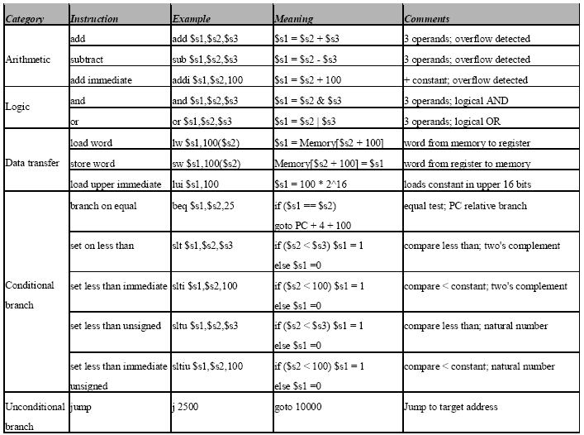

Figure 1: Instructions to be implemented in this project.

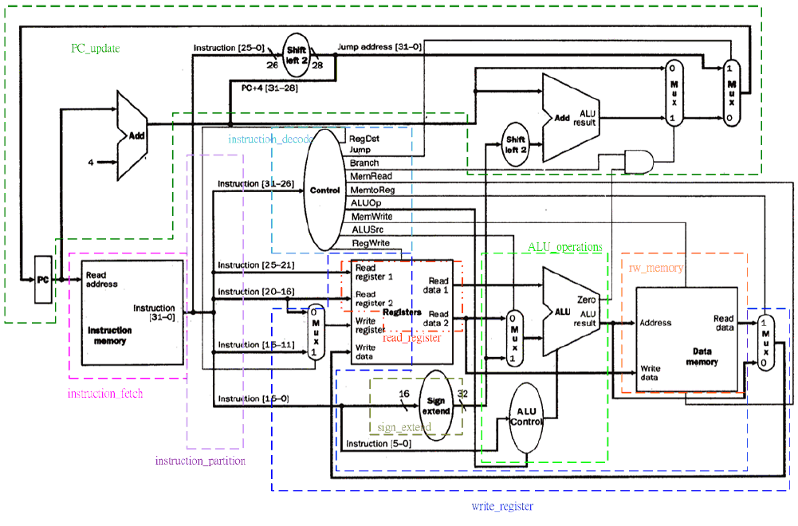

Figure 2: The single-cycle datapath to be implemented.

