Drought Stress Image Processing Summer Research Report

Austin Pursley

ECEN 491 – Dr. Xiaoning Qian

August 4, 2018

**Image Capturing**

Over the course of a week I captured multiple visible light (VL) and infrared (IR) images a day of plants. There were 6 plants, 2 each of 3 species, ones that were watered over the course of the week and those that were not. The hardware I used to capture the images was a Raspberry Pi and cameras on a bread board, held in place by a mini-vice and connected to my Windows Laptop with an ethernet cable. Power was provided by a portable power bank usually used for my phone. I also used a white poster board as a background as I thought this would make the data more uniform and the image processing easier. For software I wrote a capture program in Python that previewed the just-taken image. I could also accept the image and go onto another plant or retake the image for the current plant.

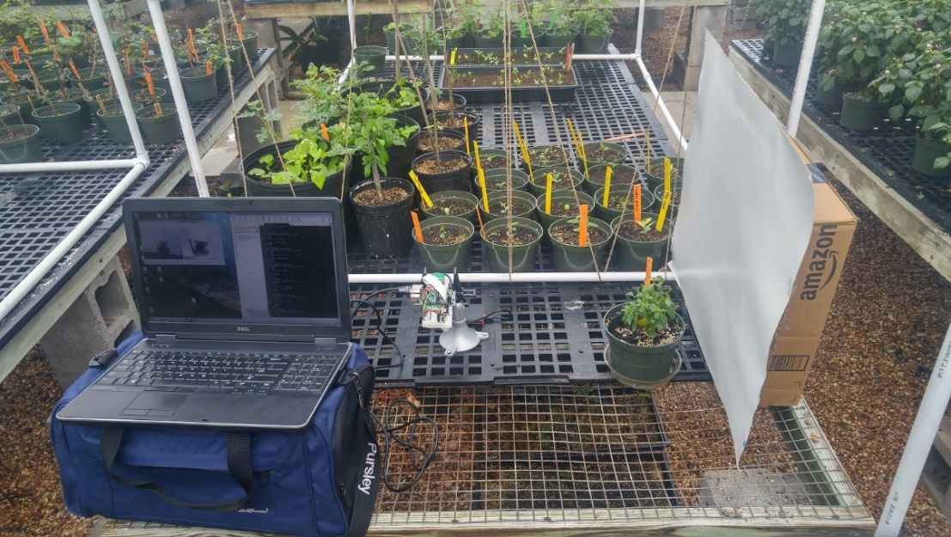

Figure 1: Pictures of the image capture set-up

**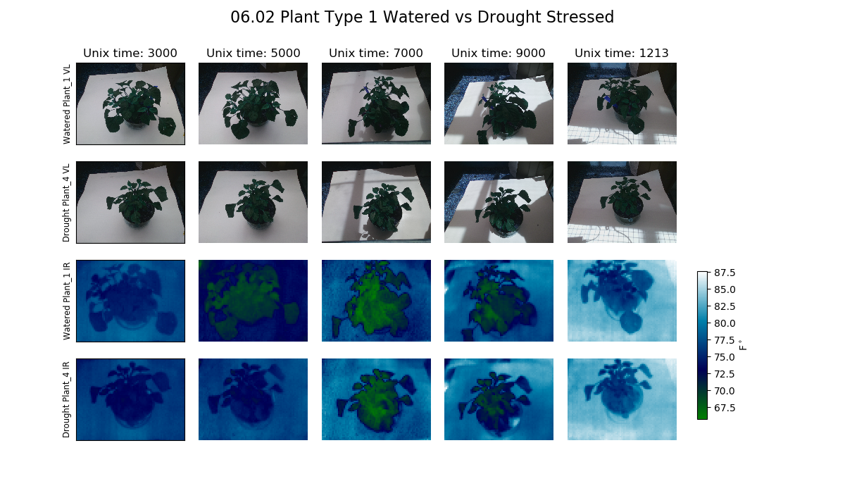**

Figure 2: Visual comparison between watered and drought plant.

**Calibrating Thermal Images**

The thermal camera used does not come calibrated for reading temperatures in Co/Fo. The raw values given are a 14 bit number that usually read around 7000-8000s. In order for these numbers to be calibrated, the temperature of the camera at the time the image was taken was needed. When I was collecting the images I also collected ambient temperature readings and those are what I used as an approximation of the camera’s temperature. Later I also took a thermal image of boiling and near-freezing water, whose temperature I knew by measuring them with a thermometer. So I had three camera-measured values (ambient, cold water, hot water) and their respective temperature readings in Fo. This was used to create a calibration equation. The values given out by the camera change with temperature so preferable this process would be done for several ambient room temperatures.

**Finding Plant Region of Interest (ROI)**

Given the raw images of the plants, the first step of analyzing them was to crop the image that just included the plant area. I first tried to do this automatically with a simple image processing Python script. The overall idea was to apply threshold and morphology operations to find the plant area, e.g. for VL images find the large green area of the image. However I had to adjust the threshold values several times to be able to do this. Therefore there was a manual element for image cropping that I did not figure out how to automate.

C:\Users\Austin Pursley\Projects\Summer-Research-Plant-Drought-Stress-Computer-Vision\process_imgs\1_feature_analysis\IR\output\0530140000_IR_IMG_0001_top.jpg C:\Users\Austin Pursley\Desktop\0530140000_IR_IMG_0001_top.jpg C:\Users\Austin Pursley\Desktop\0530140000_IR_IMG_0001_top_mask.jpg

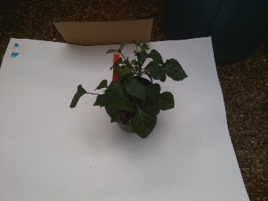 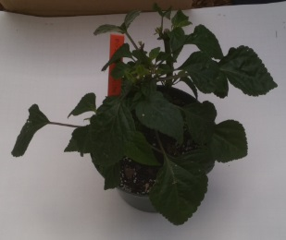 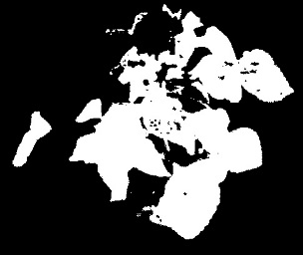

Figure 3: Example of image cropping step.

**Image Features Over Time**

With the ROIs I could find some image features. I first started with finding the mean and variance; for the IR imags it was just the temperature values as the image is just one single-channel, while for the VL images I analyzed the hue channel from the HSV color space. I plotted those two types of features over time and calculated correlation coefficient values to visually and empiracally determine a possible relationship. For example, below you can see the graphs for VL and IR mean (the other plots can be found in the GitHub). The result was that there appeared to be no strong correlation ( |r| > 0.7) of mean or variance with time for both VL and IR images.For thermal images, an additonal feature was looked at, the difference between the plant temperature and ambient temperature. However this also had a similar no correlated result.

**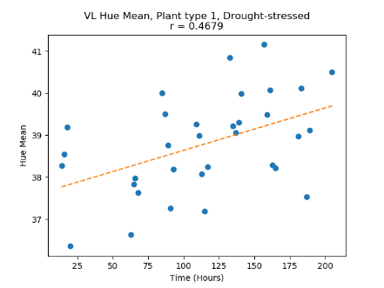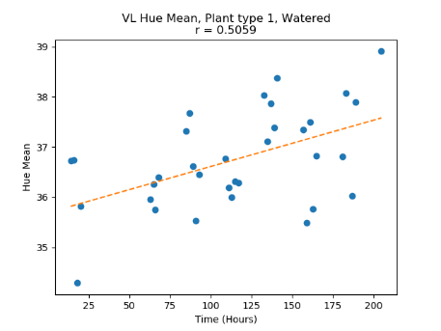**

**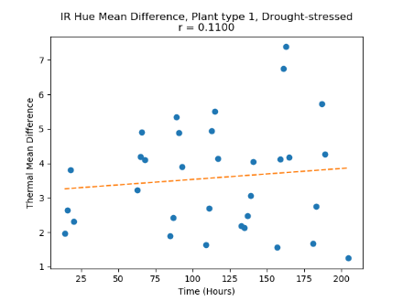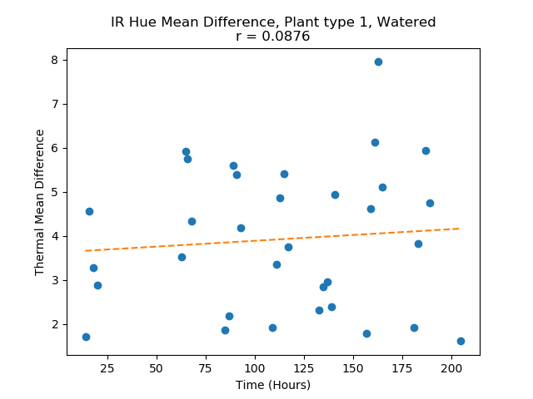**

Figure 4: Plots for mean value, same plant type. Drought-stressed in left column and watered on right (see GitHub for other plots).

**Conclusion and Future Improvements**

Because of the lack of correlation between time and the image features theanalysis seemed to be a null result. Therefore it doesn’t seem like machine learning could be applied here to predict how long it has been since a plant was watered. This non-ideal result naturally leads to thinking about future improvements. For image collection, the pot of the plants being a color other than green would make the VL image processing easier. Also, sunlight in some images had an effect and care could be taken to shade the plants when collecting images next time. The length of the image collection perido could be longer as the drought-stressed plants showed no signs of yellowing or death yet. For thermal images, a potential cause of error could have been the calibration of the thermal images; a thermal camera with automatic temperature calibration could be used to address this. Finally, more advanced image processing and image features coud be experimented with to discover trends.