Drought Stress Image Processing Summer Research Report
Austin Pursley
ECEN 491 – Dr. Xiaoning Qian
August 4, 2018

Introduction
This project was for a summer research course, May-July 2018. It was loosely tied to someone else’s research project of using drones equipped with multiple cameras to analyze plants from above in a way that could be helpful for agriculture. My goal was to gather data on some plants that had not been watered and find a way to determine how “thirsty” i.e. drought stressed they were.
Image Capturing
Over the course of a week I captured multiple visible light (VL) and infrared (IR) images a day of plants in a greenhouse. There were 6 plants, 2 each of 3 species. Half othem were watered over the course of the week and the others were not. The hardware I used to capture the images was a Raspberry Pi and VL and IR cameras, hooked up with jumper wires and a bread board. Power was provided by a portable power bank (usually used for my phone). That set-up was held in place by a mini-vice and connected to my Windows Laptop with an ethernet cable. A white poster board was used as a background to reduce variability in images for the experiment. For software, I wrote a Python script to streamline the image capturing process. The scipt could capture the images with a press of a button on my laptop keyboard and then preview the images on my laptop screen for acceptance or to reject and capture again. Both top and front facing images were taken for the 6 plants for each time of day images were taken.
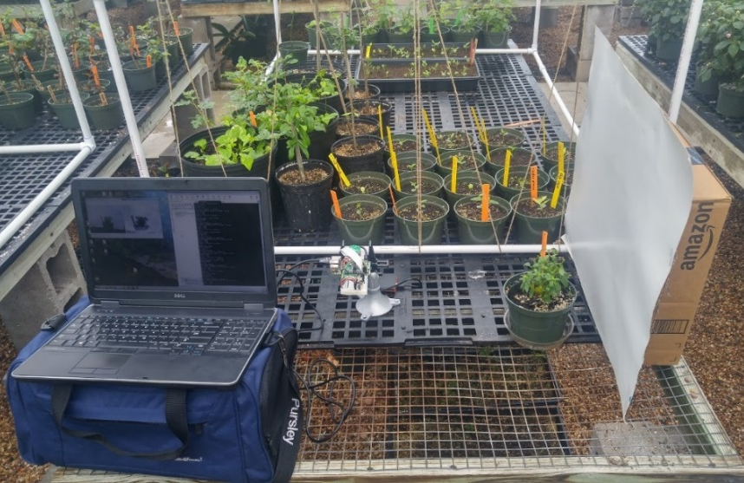

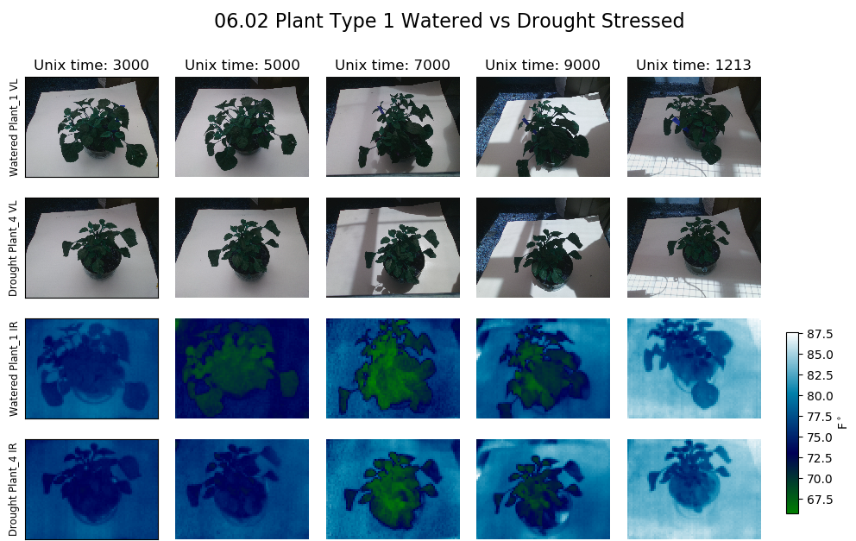
Figure 1: Pictures of the image capture set-up (top) and a collection of those VL and IR images (bottom).
Calibrating Thermal Images
The thermal camera used does not come calibrated for reading temperatures in Cº/Fº. The raw values given are a 14 bit number that usually read around 7000-8000. In order for these numbers to be calibrated, the temperature of the camera at the time the image was taken was needed. When I was collecting the images I also collected ambient temperature readings and used that as an approximation of the camera’s temperature. Later I also took a thermal image of boiling and near-freezing water, whose temperature I knew by measuring with a thermometer. With those three camera-measured values (ambient, cold water, hot water) and their respective temperature readings in Fº I calculated a calibration equation. Below is the chart of the values being plotted and the resulting calibration equation. Preferable this process would be done for several ambient room temperatures because the values given out by the camera changes with temperature.
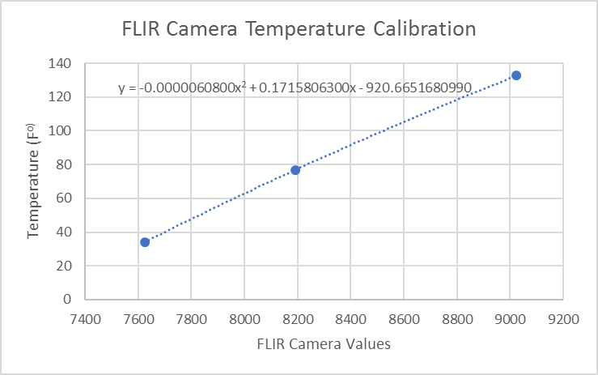
Figure 2: Calibration curve for FLIR Camera.
Finding Plant Region of Interest (ROI)
Given the images of the plants, I wanted to use image processing to find masks that corresponded to the plant outlines. I tried to do this automatically with a Python + OpenCV script. My process used threshold and morphology operations to find the plant area. For VL images I found the ROI by looking for range of green values in the hue channel of HSV color space. For thermal images, there was only one channel so it was a matter of experimenting with different threashold values. One threshold value did not work for all images and adjustments of that value had to be made to crop all the images. Therefore, there was a less-than-ideal manual element for finding the ROI.
An issue came up where the front facing VL images could not be automatically processed because the pot that contained the plants was in the same range of color as the leaves. Therefore, the ROI detection technique I was using would also include the pot as part of the plant in the mask. To save time, that half of the dataset was not analyzed further. Perhaps some manual cropping or another ROI technqieu of those images could have made them useful.
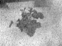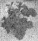
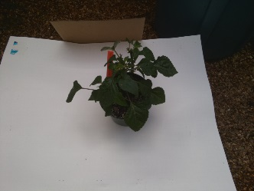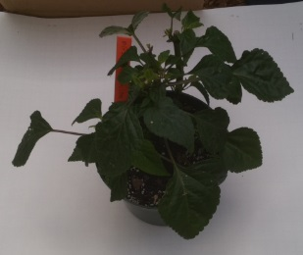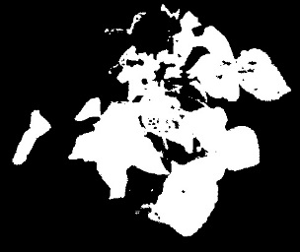
Figure 3: Example of finding ROIs

Image Features Over Time
With the ROIs, characteristics of the plant images could be determined. I first started with finding the mean and variance; for the IR images it was just the temperature values as the image is a single-channel. For the VL images I analyzed the hue channel from the HSV color space. When plants get drought stressed, they retain less water and the leaves start to turn yellow. Therefore, the expected realtionship was that the temperature would go up and the hue would go down torwards yellow for drought-stressed plants overtime. I plotted those two types of features and calculated correlation coefficients to visually and empiracally determine a possible relationship. For example, below you can see the graphs for mean VL and IR values (the other plots can be found in the GitHub). There appeared to be no strong correlation (|r| > 0.7) of mean or variance with time for both VL and IR images. For thermal images, an additonal feature was looked at, the difference between the plant temperature and ambient temperature; however this also had a similar no correlated result.
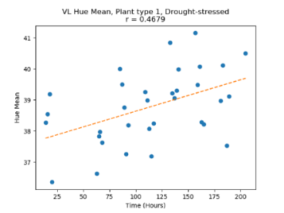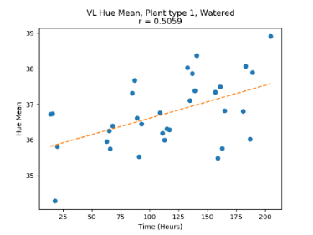
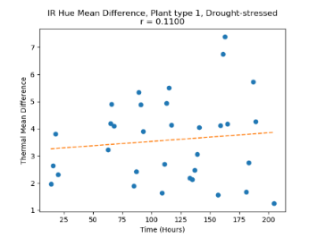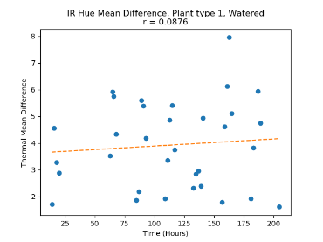
Figure 4: Plots for mean value, same plant type. Drought-stressed in left column and watered on right (see GitHub for other plots).
Conclusion and Future Improvements
Because the results were inconclusive, there is not anything you could say for certain about measuring plant drought stress effects with these technqiues. Going forward, many improvements could be made to make the experiments more fruitful.
What I would do differently:
- Higher quality cameras, espeically a thermal camera that could do automatic readings without calibration
- A plant detection technique that was not dependent on color. Probably something with machine learning.
- Create a set-up that could automatically capture images for the experiment. Related to that, preliminary experiments in enviornments where light, heat, and water could be controlled.
- Learn more about the effects of drought stress on plants and lighting effects of images.
- Lengthen the length of the experiment to the point where drought stressed plants die
I at least learned a lot from this project. I collected all the images myself and anlayzed those images to extract relevant features and that turned out to be an interesting hands-on look at how to gather quality data for analysis.

