1.1, 1.2, 1.3 1
2 4
3.1 5
3.2 5
3.3 6

1.1, 1.2, 1.3
x = load('SAMPLE_ECG.mat');
x = x.ECG_Data;
windowSize = 3;
h = (1/windowSize)*ones(1,windowSize);
a = 1;
y = filter(h,a,x);
figure
subplot(2,1,1)
plot(x)
axis([0 2000 100 220])
title('Unfiltered')
subplot(2,1,2)
plot(y)
axis([0 2000 100 220])
title('Filtered')
sgtitle('Problem 1.1')
h = [1/3, 1/3, 1/3];
yc = conv(x, h);
figure
subplot(2,1,1)
plot(y)
axis([0 2000 100 220])
title('Filter Function')
subplot(2,1,2)
plot(yc)
axis([0 2000 100 220])
title('Convolution')
sgtitle('Problem 1.2')
yf = convolution(x, h);
figure
subplot(2,1,1)
plot(y)
axis([0 2000 100 220])
title('Built In Convolution Function')
subplot(2,1,2)
plot(yc)
axis([0 2000 100 220])
title('My Convolution Function')
sgtitle('Problem 1.3')
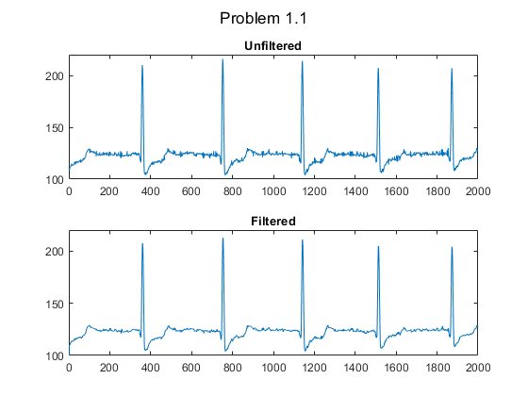
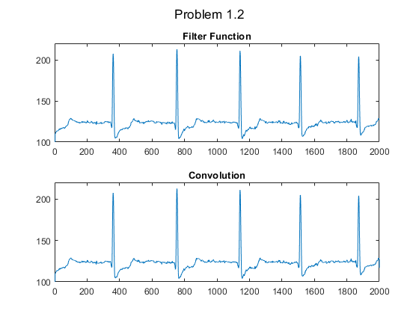
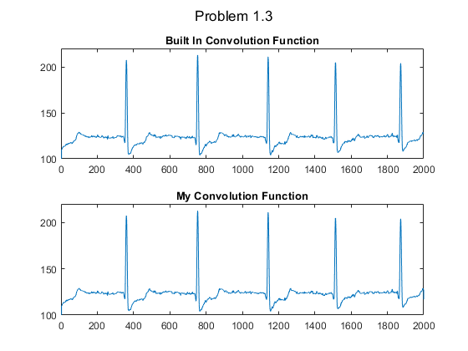

2
fs = 50;
t = 0:1/fs:1;
f1 = 10;
f2 = 60;
y1 = sin(2*pi*f1.*t);
y2 = sin(2*pi*f2.*t);
figure
subplot(2,1,1)
plot(t, y1)
title('10 Hz Rate')
grid('on')
subplot(2,1,2)
plot(t, y2, 'r')
title('60 Hz Rate')
grid('on')
sgtitle('Problem 2')
% The plots are slightly different because they have different frequncies
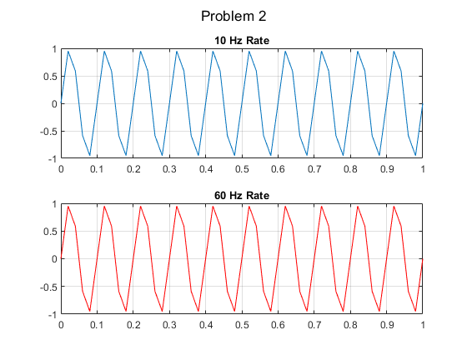

3.1
fs = 50000;
f = 2000;
t = 0:1/fs:1;
y = sin(2*pi*f*t);
figure
plot(t, y)
xlim([0,.1])
title('Problem 3.1'), xlabel('Time'), ylabel('Output')
sound(y, fs)
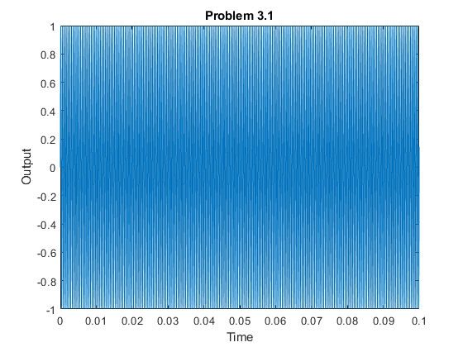

3.2
fs = 50000;
f = 6000;
t = 0:1/fs:1;
y = sin(2*pi*f*t);
figure
plot(t, y)
xlim([0,.1])
title('Problem 3.2'), xlabel('Time'), ylabel('Output')
sound(y, fs)
% The sound is higher pitched
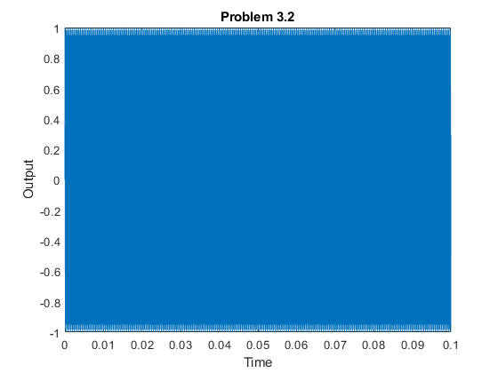

3.3
fs = 50000;
f = 25000;
t = 0:1/fs:1;
y = sin(2*pi*f*t);
figure
plot(t, y)
xlim([0,.1])
title('Problem 3.3'), xlabel('Time'), ylabel('Output')
sound(y, fs)
% I can no longer hear the sound
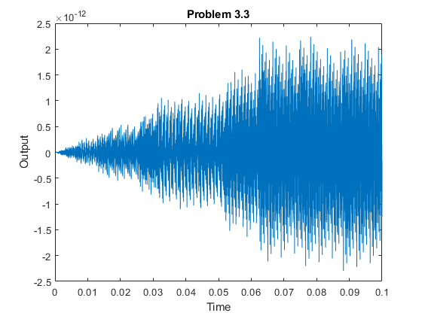
Published with MATLAB® R2020a
function y = convolution(x, h)
y = zeros(1,length(x) + length(h));
for i = 1:length(x)
for j = 1:length(h)
y(i+j) = y(i+j) + x(i) * h(j);
end
end
end

