Exercise 1
1. Disables the This will install... Do you wish to continue? prompt at the beginning of Setup.
/SILENT, /VERYSILENT
Instructs Setup to be silent or very silent.
/SUPPRESSMSGBOXES
Instructs Setup to suppress message boxes.
/LOG
Causes Setup to create a log file in the user's TEMP directory.
/LOG="filename"
Same as /LOG, except it allows you to specify a fixed path/filename to use for the log file.
/NOCANCEL
Prevents the user from cancelling during the installation process.
/NORESTART
Prevents Setup from restarting the system following a successful installation, or after a Preparing to Install failure that requests a restart.
/RESTARTEXITCODE=exit code
Specifies a custom exit code that Setup is to return when the system needs to be restarted.
/CLOSEAPPLICATIONS
Instructs Setup to close applications using files that need to be updated.
/NOCLOSEAPPLICATIONS
Prevents Setup from closing applications using files that need to be updated.
/RESTARTAPPLICATIONS
Instructs Setup to restart applications.
/NORESTARTAPPLICATIONS
Prevents Setup from restarting applications.
/LOADINF="filename"
Instructs Setup to load the settings from the specified file after having checked the command line.
/SAVEINF="filename"

There are several strings that say things like “Disables the This will install... Do you wish to continue? prompt at the beginning of Setup.” and “Instructs Setup to suppress message boxes”. This means that the program will run silently in the background. You can also see /LOG="filename", so you know that the prgram will be loggging to a file.

2. c027ce33c293f925324ba5477031e937
Several detection engines detect that this sample is a key logger.
The sample also attempts to contact several domains. It was successful for two of those.

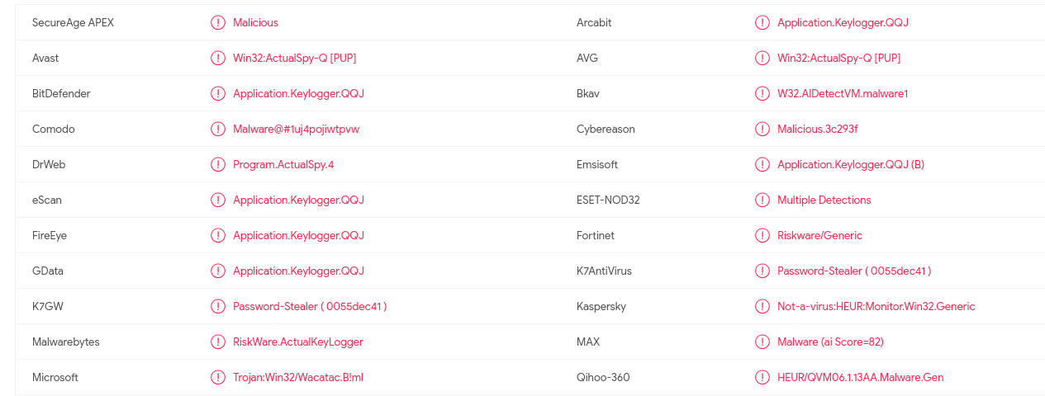

3.
Exercise 2
1.
