63d3fbc397585a45b01b456aab953abb

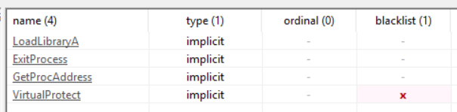
1.

There are very few imports which is very suspicious. Also the VirtualProtect function is used to change the read write permissions of a page.

2. All of the string except for the imports and the “this program cannot be run in dos mode” string are gibberish.

3. It is writable, executable, and self modifying. PE studio also flags the entry point as suspicious. In addition to this, the sections are labeled as UPX. This is a packer.

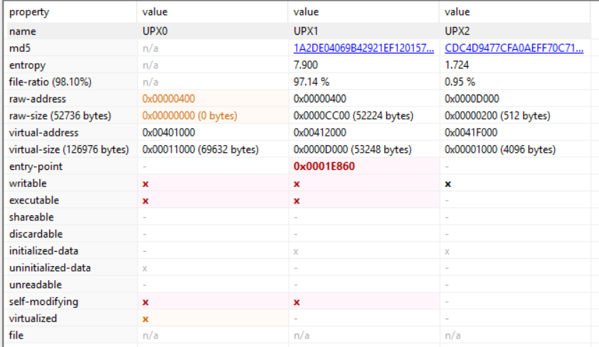
4. This sample is packed. Most of the strings are unreadable, it has self modifying sections, and the entry point is suspicious, and the sections names indicate UPX, a known packer.

F55663305088f33b013c5a86bc9520a6

1.
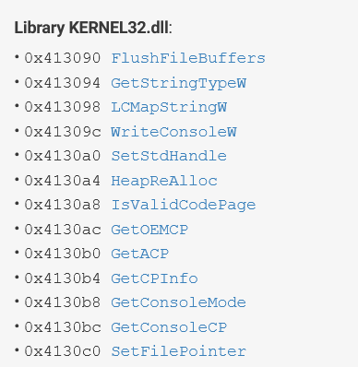

There are many imports visible so it is unlikely that the file is packed.

2. There are many strings that are readable. So it is unlikely that the entire sample is packed. There is however an area that has high entropy. This program is likely a Trojan that is carrying an encrypted file.

3. The sections table is much more typical in this sample. The section names and entry point are all normal.

4. The overall program is not packed, but there is definitely an encrypted or compressed file inside of of the program. This is because the program has a typical sections table and readable strings.

69f27b07404cf9c51dd2d2e40fca4d65

1. This file is likely packed. The file has atypical sections that are blacklisted.
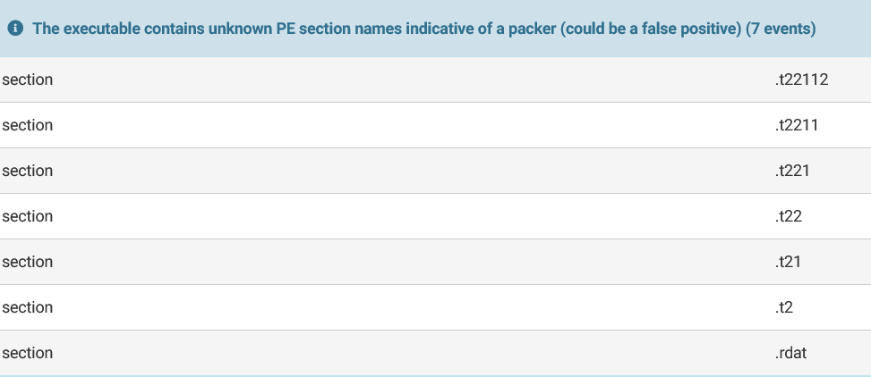
It also allocates read-write-executable memory. This is often used to unpack itself.

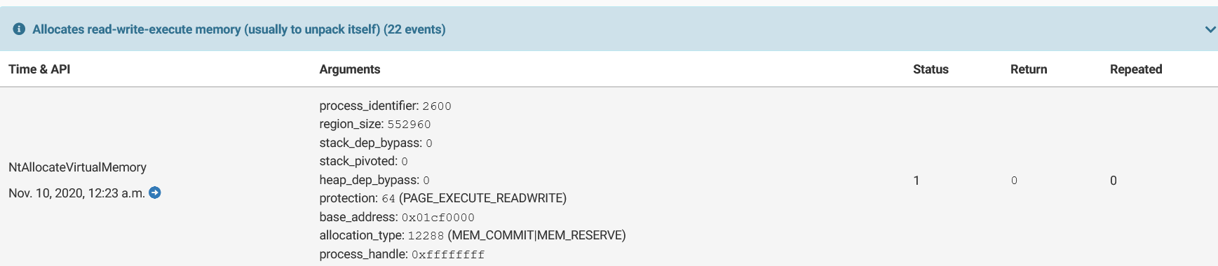

In addition to this all of the strings are unreadable.

