Exercise 1

1. About 100

2.
They appear to be 14 characers long. Other than that, I can’t see any pattern. They appear the be random

3. It generates new domains each time.

Exercise 2 Part 1

1. About 70.

2.
According to whatismyipaddress.com, they are all corparate addresses. Some of them for microsoft updates. They likely belong to hosting companies.

3. It performs GET and POST requests.

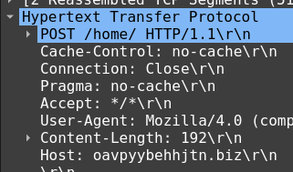

4. The sample was able to connect.

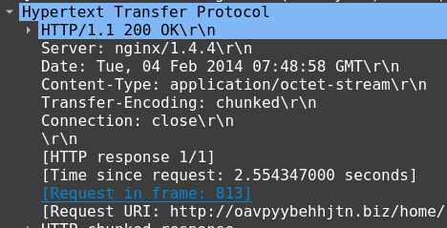

Exercise 2 Part 2
1.
It is connecting to microsoft services as well as a few suspicious sites such as bigdiscountsonline.info and endlessdeals.info.

2. It tries to request a text file.

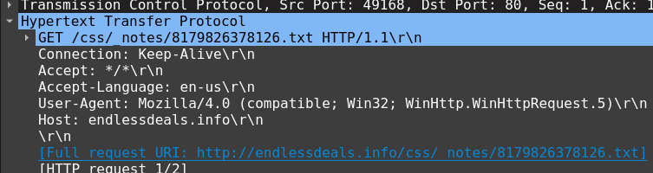
3. It is not successful.

