C1: The program simply takes a password as an argument and compares it to the string “hackadayu”.

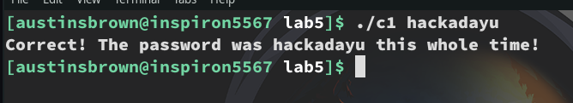
C2: The program takes a password as an input. If the password is less than 5 characters long then the program exits. Otherwise, it makes sure that the first character is h, and that the last character is u.

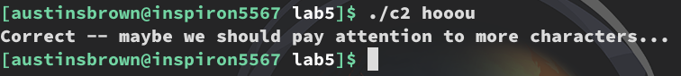
C3: The program takes a password as an input. If the password is less than 5 characters long then the program exits. It then checks to see if the third character is the lower case version of the fourth character. It does this by subtracting the two and seeing if the result is equal to 0x20.

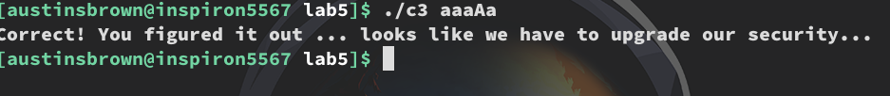
C4:The program takes a password as an input. If the password is less than 10 characters long then the program exits. Otherwise, the program iterates through the string “hackadayu” to see if your input is two characters shifted to the right. For example, a == c, h == j.

