Contents
- Query user for logfile
- Separate raw, bandpassed, and motion filtered data from scn structure
- Pull out the raw scans (if saved)
- Create the waterfall horizontal and vertical axes
% plotMrmRetLog.m
% This script prompts the user for a MRM-RET logfile, reads, parses, and
% produces a "waterfall plot" of the motion filtered scans and detection lists
% in the logfile
clear all; close all; clc %#ok<*CLALL>

Query user for logfile
%dnm = '.'; fnm = 'MRM_002.csv';
[fnmb,dnmb] = uigetfile('*.csv');
fprintf('Reading logfile %s\n',fullfile(dnmb,fnmb));
[cfgb,reqb,scnb,det] = readMrmRetLog(fullfile(dnmb,fnmb));

[fnmt,dnmt] = uigetfile('*.csv');
fprintf('Reading logfile %s\n',fullfile(dnmt,fnmt));
[cfgt,reqt,scnt,dett] = readMrmRetLog(fullfile(dnmt,fnmt));
Reading logfile C:\Users\austinsbrown\Dropbox\ee384\lab8\distance003.csv
Reading logfile C:\Users\austinsbrown\Dropbox\ee384\lab8\1m004.csv

Separate raw, bandpassed, and motion filtered data from scn structure
(only motion filtered is used)

Pull out the raw scans (if saved)
rawscansI = find([scnb.Nfilt] == 1);
rawscansV_background = reshape([scnb(rawscansI).scn],[],length(rawscansI))';

rawscansI1 = find([scnt.Nfilt] == 1);
rawscansV_target = reshape([scnt(rawscansI1).scn],[],length(rawscansI1))';

scan_difference = abs(rawscansV_background(1:10,:) - rawscansV_target(1:10,:));

Create the waterfall horizontal and vertical axes
Tbin = 32/(512*1.024); % ns
T0 = 0; % ns
c = 0.29979; % m/ns
Rbin = c*(Tbin*(0:size(scan_difference(1,:),2)-1) - T0)/2;% Range Bins in meters

rbin = 90;
%Background plot
% plot(rbin,rawscansV_background(10,:))
%Taget plot
figure; plot(Rbin,rawscansV_target(10,:))
% Difference plot
figure;plot(Rbin,scan_difference(10,:))

[a,i]=max(scan_difference(10,:));
distance=Rbin(i)

% 1+- .2 m
distance =

1.2351

Published with MATLAB® R2020a
Questions
1. The residual information is left over by other objects that are in the scan range.
2. [a,i]=max(scan_difference(10,:));
distance=Rbin(i)

4a. Equation:
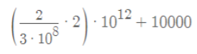

The scan stop that was calculated is 23333 ps.
4c. I saw my reflection at 23, 278 ps.
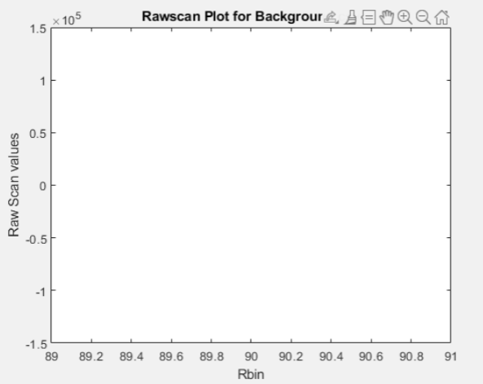

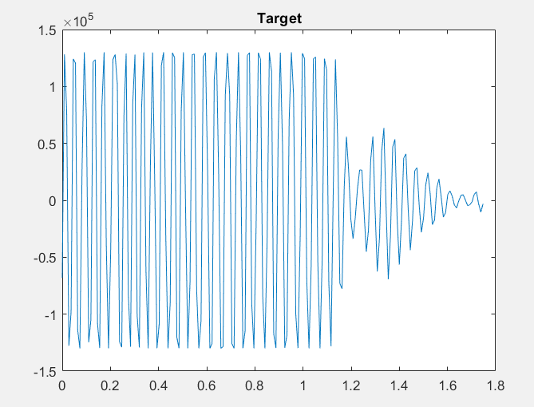

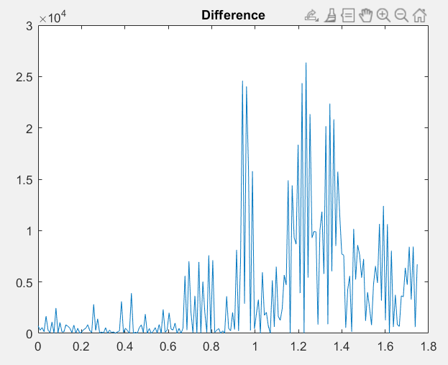

The calculated distance is 1.21.

