Contents
- Query user for logfile
- Separate raw, bandpassed, and motion filtered data from scn structure
- Pull out the raw scans (if saved)
- Create the waterfall horizontal and vertical axes
- Query user for logfile (1M)
- Separate raw, bandpassed, and motion filtered data from scn structure
- Pull out the raw scans (if saved)
- Create the waterfall horizontal and vertical axes
- Query user for logfile (1.5M)
- Separate raw, bandpassed, and motion filtered data from scn structure
- Pull out the raw scans (if saved)
- Create the waterfall horizontal and vertical axes
- Plotting scan differences and average power
% plotMrmRetLog.m
% This script prompts the user for a MRM-RET logfile, reads, parses, and
% produces a "waterfall plot" of the motion filtered scans and detection lists
% in the logfile
clear all; close all; clc

Query user for logfile
%dnm = '.'; fnm = 'MRM_002.csv';
[fnmb,dnmb] = uigetfile('*.csv');
fprintf('Reading logfile %s\n',fullfile(dnmb,fnmb));
[cfgb,reqb,scnb,det] = readMrmRetLog(fullfile(dnmb,fnmb));

[fnmt,dnmt] = uigetfile('*.csv');
fprintf('Reading logfile %s\n',fullfile(dnmt,fnmt));
[cfgt,reqt,scnt,dett] = readMrmRetLog(fullfile(dnmt,fnmt));
Reading logfile C:\Users\austinsbrown\Dropbox\ee384\lab9\background001.csv
Reading logfile C:\Users\austinsbrown\Dropbox\ee384\lab9\scan001.csv

Separate raw, bandpassed, and motion filtered data from scn structure
(only motion filtered is used)

Pull out the raw scans (if saved)
rawscansIb = find([scnb.Nfilt] == 1);
rawscansV_background = reshape([scnb(rawscansIb).scn],[],length(rawscansIb))';

rawscansIt = find([scnt.Nfilt] == 1);
rawscansV_target = reshape([scnt(rawscansIt).scn],[],length(rawscansIt))';

scan_difference05 = abs(rawscansV_background - rawscansV_target);

Create the waterfall horizontal and vertical axes
Tbin = 32/(512*1.024); % ns
T0 = 0; % ns
c = 0.29979; % m/ns
Rbin = c*(Tbin*(0:size(scan_difference05(1,:),2)-1) - T0)/2;% Range Bins in meters

%Background plot
% plot(Rbin,rawscansV_background(10,:))
%Taget plot
% figure; plot(Rbin,rawscansV_target(10,:))
% Difference plot
figure;plot(Rbin,scan_difference05(10,:))
title("0.5m Scan Difference");
xlabel("Meters (m)");
ylabel("Scan Values");

%[a05,i] = max(scan_difference(10,100:122)); %In a range of distance values
%distance=Rbin(i+99); %100=0.9m, 122=1.1m
[a05,i]=max(scan_difference05(10,:));
distance=Rbin(i);

pow05 =a05^2;

scan_difference05_avg = zeros(1,length(scan_difference05(1,:)));
for i=1:10
scan_difference05_avg = scan_difference05_avg+scan_difference05(i,:);
end
scan_difference05_avg=scan_difference05_avg/10;
[c05,i]=max(scan_difference05_avg);
distance05=Rbin(i)
distance05 =

0.6679

Query user for logfile (1M)
%dnm = '.'; fnm = 'MRM_002.csv';
[fnmb,dnmb] = uigetfile('*.csv');
fprintf('Reading logfile %s\n',fullfile(dnmb,fnmb));
[cfgb,reqb,scnb,det] = readMrmRetLog(fullfile(dnmb,fnmb));

[fnmt,dnmt] = uigetfile('*.csv');
fprintf('Reading logfile %s\n',fullfile(dnmt,fnmt));
[cfgt,reqt,scnt,dett] = readMrmRetLog(fullfile(dnmt,fnmt));
Reading logfile C:\Users\austinsbrown\Dropbox\ee384\lab9\background002.csv
Reading logfile C:\Users\austinsbrown\Dropbox\ee384\lab9\scan002.csv

Separate raw, bandpassed, and motion filtered data from scn structure
(only motion filtered is used)

Pull out the raw scans (if saved)
rawscansIb = find([scnb.Nfilt] == 1);
rawscansV_background = reshape([scnb(rawscansIb).scn],[],length(rawscansIb))';

rawscansIt = find([scnt.Nfilt] == 1);
rawscansV_target = reshape([scnt(rawscansIt).scn],[],length(rawscansIt))';

scan_difference1 = abs(rawscansV_background - rawscansV_target);

Create the waterfall horizontal and vertical axes
Tbin = 32/(512*1.024); % ns
T0 = 0; % ns
c = 0.29979; % m/ns
Rbin = c*(Tbin*(0:size(scan_difference1(1,:),2)-1) - T0)/2;% Range Bins in meters

%Background plot
% plot(Rbin,rawscansV_background(10,:))
%Taget plot
% figure; plot(Rbin,rawscansV_target(10,:))
% Difference plot
figure;plot(Rbin,scan_difference1(10,:))
title("1m Scan Difference");
xlabel("Meters (m)");
ylabel("Scan Values");

%[a05,i] = max(scan_difference(10,100:122)); %In a range of distance values
%distance=Rbin(i+99); %100=0.9m, 122=1.1m
[a1,i]=max(scan_difference1(10,:));
distance=Rbin(i);

pow1 =a1^2;

scan_difference1_avg = zeros(1,length(scan_difference1(1,:)));
for i=1:10
scan_difference1_avg = scan_difference1_avg+scan_difference1(i,:);
end
scan_difference1_avg=scan_difference1_avg/10;
[c1,i]=max(scan_difference1_avg);
distance1=Rbin(i)
distance1 =

1.2351

Query user for logfile (1.5M)
%dnm = '.'; fnm = 'MRM_002.csv';
[fnmb,dnmb] = uigetfile('*.csv');
fprintf('Reading logfile %s\n',fullfile(dnmb,fnmb));
[cfgb,reqb,scnb,det] = readMrmRetLog(fullfile(dnmb,fnmb));

[fnmt,dnmt] = uigetfile('*.csv');
fprintf('Reading logfile %s\n',fullfile(dnmt,fnmt));
[cfgt,reqt,scnt,dett] = readMrmRetLog(fullfile(dnmt,fnmt));
Reading logfile C:\Users\austinsbrown\Dropbox\ee384\lab9\background003.csv
Reading logfile C:\Users\austinsbrown\Dropbox\ee384\lab9\scan003.csv

Separate raw, bandpassed, and motion filtered data from scn structure
(only motion filtered is used)

Pull out the raw scans (if saved)
rawscansIb = find([scnb.Nfilt] == 1);
rawscansV_background = reshape([scnb(rawscansIb).scn],[],length(rawscansIb))';

rawscansIt = find([scnt.Nfilt] == 1);
rawscansV_target = reshape([scnt(rawscansIt).scn],[],length(rawscansIt))';

scan_difference15 = abs(rawscansV_background - rawscansV_target);

Create the waterfall horizontal and vertical axes
Tbin = 32/(512*1.024); % ns
T0 = 0; % ns
c = 0.29979; % m/ns
Rbin = c*(Tbin*(0:size(scan_difference15(1,:),2)-1) - T0)/2;% Range Bins in meters

%Background plot
% plot(Rbin,rawscansV_background(10,:))
%Taget plot
% figure; plot(Rbin,rawscansV_target(10,:))
% Difference plot
figure;plot(Rbin,scan_difference15(10,:))
title("1.5m Scan Difference");
xlabel("Meters (m)");
ylabel("Scan Values");

%[a05,i] = max(scan_difference(10,100:122)); %In a range of distance values
%distance=Rbin(i+99); %100=0.9m, 122=1.1m
[a15,i]=max(scan_difference15(10,:));
distance=Rbin(i);

pow15 =a15^2;

scan_difference15_avg = zeros(1,length(scan_difference15(1,:)));
for i=1:10
scan_difference15_avg = scan_difference15_avg+scan_difference15(i,:);
end
scan_difference15_avg=scan_difference15_avg/10;
[c15,i]=max(scan_difference15_avg);
distance15=Rbin(i)
distance15 =

1.7291

Plotting scan differences and average power
figure;
plot(Rbin, scan_difference05(10,:), Rbin, scan_difference1(10,:), Rbin, scan_difference15(10,:));
legend("0.5m", "1.0m", "1.5m");
title("Scan Differences Comparison");
xlabel("Meters (m)");

d = [0.5 1 1.5];
nAvg = [pow05 pow1 pow15];
Avg = [c05^2 c1^2 c15^2];
figure;
plot(d, nAvg, 'o');
hold on
plot(d, Avg, '*');
legend("Non-Average", "Average");
title("Average vs Non-Average Power");
xlabel("Meters (m)");
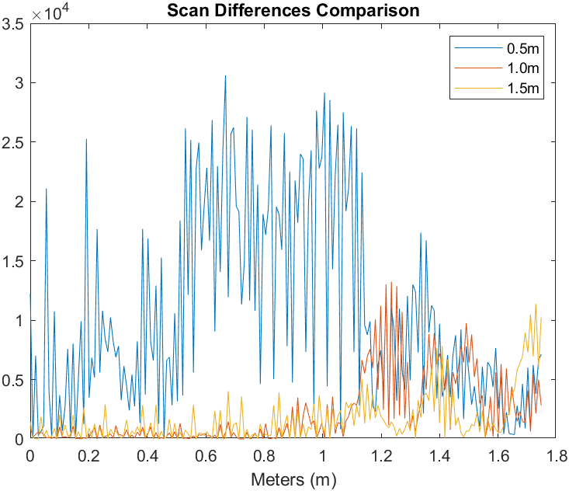
Published with MATLAB® R2020a

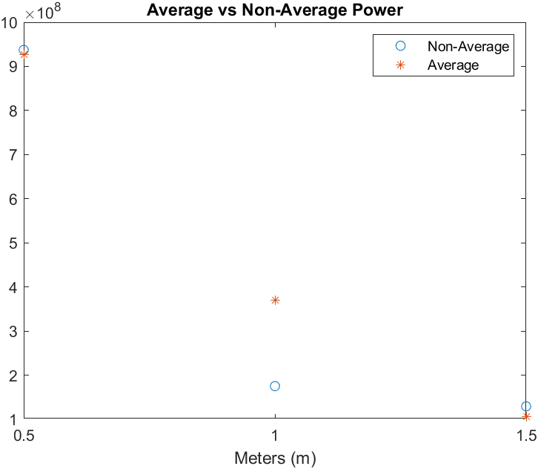

Questions
1. The scans were always pretty close to the prediction. The best way to increase the accuracy would be to get as close to the target distance as possible. However even with this there would always be some noise due to the lab environment.
2.P = 1/(r^4) The greater the distance, the less power that you receive. .0001
1.2345679012345679012345679012346e-6
We can increase this received signal power by shortening the distance/decreasing the range.
3. The values varied as expected. The power decreased as the distance increased.

Equation for solve for Scan Stop is:
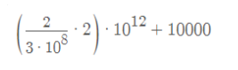
Scan Stop = 23,333ps

