**Main**

num=[1 -3 3+pi^2 -(1+pi^2)];

den=[1 3 3+pi^2 (1+pi^2)];

w=20;

freqresponse(num,den,w);

num1=[0 1 0 pi^2];

den1=den;

freqresponse(num1,den1,w);

num2=[0 0 1 -1];

den2=den;

freqresonse(num2,den2,w);

**Frequency Response**

function [w,Hm,Ha]=freqresponse(b,a,wmax)

w=0:0.01:wmax;

H=freqs(b,a,w);

Hm=abs(H);

Ha=angle(H)*180/pi;

figure

subplot(311)

plot(w,Hm)

subplot(312)

plot(w,Ha)

subplot(313)

splane(b,a)

**Splane**

function splane(num,den)

% function splane

% input: coefficients of numerator (num) and denominator (den) in

% decreasing order

% output: pole/zero plot

% use: splane(num,den)

z=roots(num);

p=roots(den);

A1=[min(imag(z)) min(imag(p))];

A1=min(A1)-1;

B1=[max(imag(z)) max(imag(p))];

B1=max(B1)+1;

N=20;

D=(abs(A1)+abs(B1))/N;

im=A1:D:B1;

Nq=length(im);

re=zeros(1,Nq);

A=[min(real(z)) min(real(p))];

A=min(A)-1;

B=[max(real(z)) max(real(p))];

B=max(B)+1;

stem(real(z),imag(z),'o:')

hold on

stem(real(p),imag(p),'x:')

hold on

%plot(re,im,'k');xlabel('\sigma');ylabel('j\Om ega')

grid

% axis([A -A min(im) max(im)])

axis([min(im) max(im) min(im) max(im)]); hold off

**H1(s) is an all pass filter**

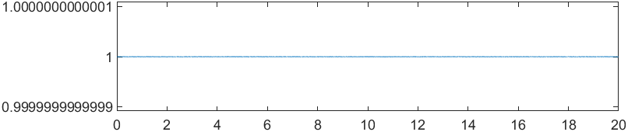

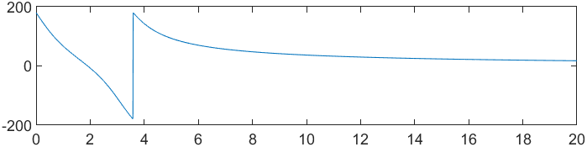

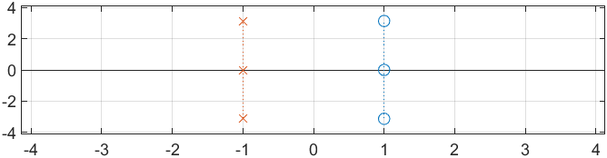

**H2(s) is a notch filter.**

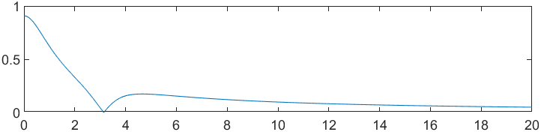

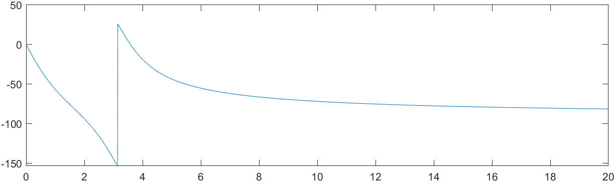

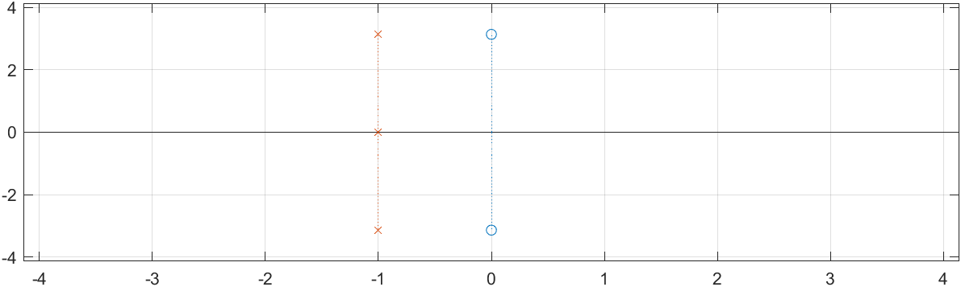

**H3(s) is a low pass filter.**

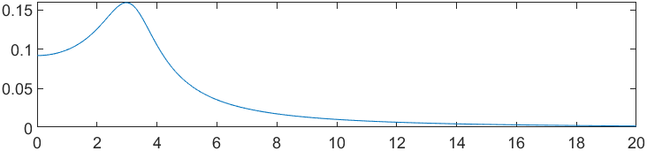

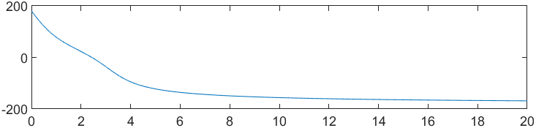

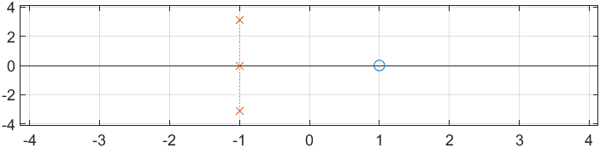

**Note: Part 3b is still non causal.**

