**1.**

|  |
| --- |
| #include <iostream>  #include <time.h>  using *namespace* std;  #define ARRSZE 20000  *int* main()  {  *struct* timespec start, stop;      clock_gettime(CLOCK_REALTIME, &start);  *int*\*\* array = new *int*\*[ARRSZE];      for(*int* i = 0; i < ARRSZE; ++i)          array[i] = new *int*[ARRSZE];  *int* i,j;      for(i=0;i<ARRSZE;i++)          for(j=0;j<ARRSZE;j++)              array[j][i]=0;*// cause cache misses*      for(*int* i = 0; i < ARRSZE; i++)          delete[] array[i];      delete[] array;      clock_gettime(CLOCK_REALTIME, &stop);  *unsigned* *long* *long* totalSeconds = (*long* *long*)(stop.tv_sec - start.tv_sec);  *unsigned* *long* totalNanoseconds = stop.tv_nsec - start.tv_nsec;      printf("Total execution time: %llu.%.9lu\n", totalSeconds, totalNanoseconds);      return 0;  } |

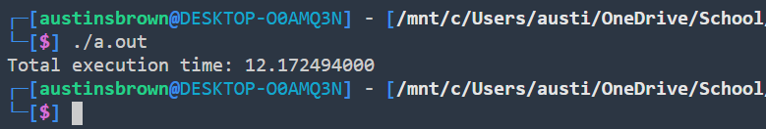

**1b.**

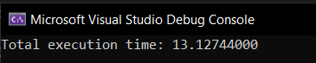

**1c.**

|  |
| --- |
| #include <stdlib.h>  #include <string.h>  #include <time.h>  #include <stdio.h>  #define ARRSZE 900000000  typedef *struct* *stride* *// will have a stride of 8 bytes instead for 5 if compiler optimizes for execution speed*  {  *int* a;  *char* b;  }*stride*;  *int* main()  {  *struct* *timespec* start, stop;      clock_gettime(CLOCK_REALTIME, &start);  *stride* *ptr = (*stride*\*)malloc(ARRSZE*sizeof(*stride*));      for(*int* i=0; i<ARRSZE; i++)      {          ptr[i].a = 0;          ptr[i].b = 0;      }      clock_gettime(CLOCK_REALTIME, &stop);  *unsigned* *long* *long* totalSeconds = (*long* *long*)(stop.tv_sec - start.tv_sec);  *unsigned* *long* totalNanoseconds = stop.tv_nsec - start.tv_nsec;      printf("Total execution time: %llu.%.9lu\n", totalSeconds, totalNanoseconds);      free(ptr);      return 0;  } |

I used the -03 optimization flag because it can cause the stride struct to take up more space than it is supposed to due to alignment.

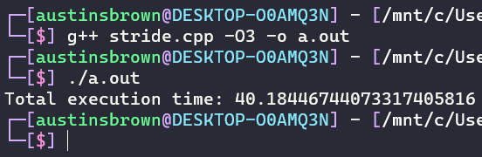

|  |  |  |
| --- | --- | --- |
| Virtual Machine (Seconds) | | Local Time (Seconds) |
| 1 | 2.18446744073272407916 | 1.319018000 |
| 2 | 1.463540000 | 2.18446744073439963416 |
| 3 | 2.18446744073451718116 | 1.395076500 |
| 4 | 2.18446744073393724516 | 1.676363200 |
| 5 | 2.18446744073374848116 | 1.362660400 |
| 6 | 2.590348000 | 1.416361900 |
| 7 | 2.18446744073492724116 | 2.18446744073605025116 |
| 8 | 1.654541200 | 1.439958800 |
| 9 | 2.18446744073328217216 | 1.674886400 |
| 10 | 1.610063400 | 1.404980300 |

The program on executed faster on the local machine for the most part.

**2.**

You could give 4 extra bits to the top level followed by an extra bit for the second and third level. This would be the optimal solution as it is enough space for the program, but little is wasted.